# **AIRLESSCO EXTENSIONS**

Extended reach tools are ideal for hard to reach areas like soffits, stairways and vaulted ceilings. Extend your range and spray more efficiently without ladders or scaffolding. Airless tip and pole extensions can be attached directly to an airless gun making them ideal for spraying ceilings, overhangs and decks.

---

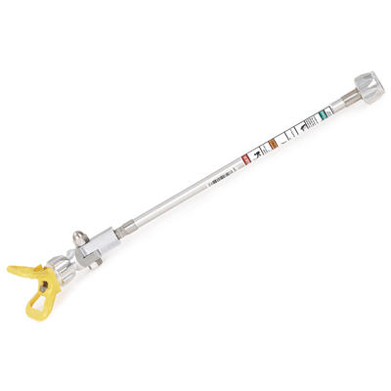

| Accessories Details | |
| --- | --- |
| **3400 Series with Rev-Tip Hand-Tight Base ("G" thread)** | |
| PART NUMBER: | 248233 - 6 in (15.2 cm) |
|  | 248234 - 12 in (30.5 cm) |
|  | 248235 - 18 in (45.7 cm) |
|  | 248236 - 24 in (61.0 cm) |
| AVAILABILITY: | North America, Central and South America, Europe, Middle East, Africa, Asia, Australia |
| PART NUMBER: | 255258 - 6 in (15.2 cm) |
|  | 255259 - 12 in (30.5 cm) |
|  | 255260 - 18 in (45.7 cm) |
|  | 255261 - 24 in (61.0 cm) |
| AVAILABILITY: | North America, Central and South America, Europe, Middle East, Africa, Asia, Australia |

---

| accessories-category | |
| --- | --- |
| title | **MORE ACCESSORIES** |
| types | sprayguns  \  spraytips  \  hoses  \  extensions  \  filters  \  fluids  \  striping  \  other |

| Metadata | |
| --- | --- |
| Title | Airlessco Extensions | Airlessco.com |
| Description | Airlessco Professional Airless Spray Equipment Built to Perform. Built to Last. |
| Locale | /na/en |