# **AIRLESSCO FLUIDS**

Airlessco fluids protect your equipment and keep them operating at peak performance. Airlessco fluids are approved for all airless spray pumps. MagiCLEAN safely removes paint from sprayers, hose, tips and guns. Pump Life protects pumps from corrosion and rust during short and long term storage. Stay Clean spray protectant prevents paint from sticking to equipment.

---

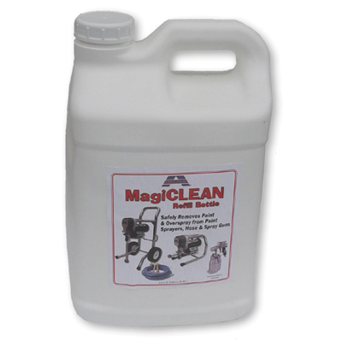

| Accessories Details | |
| --- | --- |
| **MagiCLEAN STARTER KIT** | |
| DESCRIPTION: | Safely removes paint from sprayers, hose, tips and guns |
|  | Makes 3 gallons |
| INCLUDES: | 1 gal (3.8 l) MagiCLEAN Concentrate, Strainer Basket, Residue Tray, 5 gal Pail |
| PART NUMBER: | 865657 |
| AVAILABILITY: | North America, Central and South America, Europe, Middle East, Africa, Asia, Australia |
| SDS: | English| French| Spanish |
| DESCRIPTION: | Refill for MagiCLEAN Starter Kit, Makes 3 gallons |
| INCLUDES: | 1 gal (3.8 l) MagiCLEAN Concentrate |
| PART NUMBER: | 865656 |
| AVAILABILITY: | North America, Central and South America, Europe, Middle East, Africa, Asia, Australia |
| SDS: | English| French| Spanish |

---

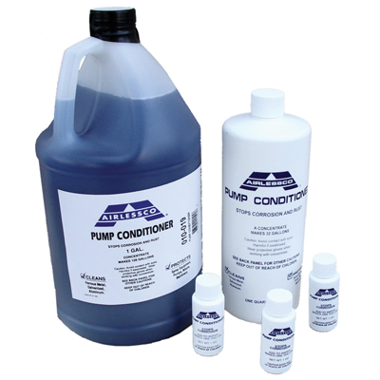

| Accessories Details | |
| --- | --- |
| **PUMP LIFE CONDITIONER** | |
| DESCRIPTION: | Prevents internal corrosion; lubricates check balls to prevent sticking |
| PART NUMBER: | 865714 - 32 oz (0.95 l) |
|  | 865715 - 1 gal (3.8 l) |
| AVAILABILITY: | North America, Central and South America, Europe, Middle East, Africa, Asia, Australia |
| SDS: | English |

---

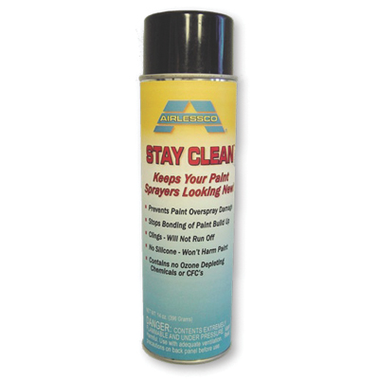

| Accessories Details | |
| --- | --- |
| **STAY CLEAN** | |
| DESCRIPTION: | Prevents paint from sticking to sprayer |
| PART NUMBER: | 865705 - 14 oz (0.4 l) |
| AVAILABILITY: | North America, Central and South America, Europe, Middle East, Africa, Asia, Australia |
| SDS: | English| Spanish |

---

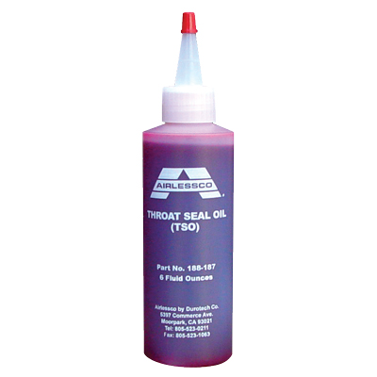

| Accessories Details | |
| --- | --- |
| **THROAT SEAL OIL** | |
| DESCRIPTION: | Prevents paint from drying on the piston and causing damage to upper packing |
| PART NUMBER: | 867670 - 6 oz (0.2 l) |
|  | 188392 - 32 oz (0.95 l) |
| AVAILABILITY: | North America, Central and South America, Europe, Middle East, Africa, Asia, Australia |
| SDS: | English| French| Spanish| Norwegian |

---

| Accessories Details | |
| --- | --- |
| **HYDRAULIC FLUID** | |
| DESCRIPTION: | Fluid in which power is transferred in hydraulic machinery |
| PART NUMBER: | 245425 - 32 oz (0.95 l) |
| AVAILABILITY: | North America, Central and South America, Europe, Middle East, Africa, Asia, Australia |
| SDS: | English |

---

| accessories-category | |
| --- | --- |
| title | **MORE ACCESSORIES** |
| types | sprayguns  \  spraytips  \  hoses  \  extensions  \  filters  \  fluids  \  striping  \  other |

| Metadata | |
| --- | --- |
| Title | Airlessco Fluids | Airlessco.com |
| Description | Airlessco Professional Airless Spray Equipment Built to Perform. Built to Last. |
| Locale | /na/en |