# **AIRLESSCO MISCELLANEOUS ACCESSORIES**

Airlessco provides a full range of repair kits and accessories to keep your equipment operating at peak performance and save time and labor on every job.

---

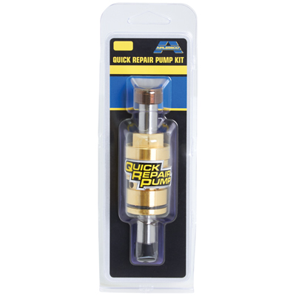

| Accessories Details | |
| --- | --- |
| **QUICK REPAIR PUMP KIT** | |
| PART NUMBER: | 17J720 |
| DESCRIPTION: | Fits SP340 and SP380 models |
| AVAILABILITY: | North America, Central and South America, Europe, Middle East, Africa, Asia, Australia |

---

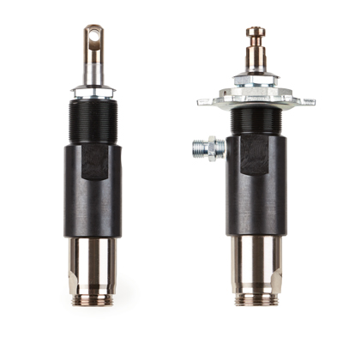

| Accessories Details | |
| --- | --- |
| **REPLACEMENT PUMPS** | |
| PART NUMBER: | 17M991 - Pro-Duty Flange mount |
| DESCRIPTION: | Fits MP and LP models |
| AVAILABILITY: | North America, Central and South America, Europe, Middle East, Africa, Asia, Australia |

---

| Accessories Details | |
| --- | --- |
| **PAINT HOPPER** | |
| PART NUMBER: | 17H171 |
| DESCRIPTION: | 1.5 gal (6 l) capacity |
| AVAILABILITY: | North America, Central and South America, Europe, Middle East, Africa, Asia, Australia |

---

| Accessories Details | |
| --- | --- |
| **GUN & HOSE CONNECTORS** | |
| PART NUMBER: | 4410 - 3/8 in NPT x 3/8 in NPT MBE |
| AVAILABILITY: | North America, Central and South America, Europe, Middle East, Africa, Asia, Australia |

---

| Accessories Details | |
| --- | --- |
| **GUN SWIVEL ASSEMBLY** | |
| Swivel assembly for all "G" thread spray guns | |
| PART NUMBER: | 865707 |
| AVAILABILITY: | North America, Central and South America, Europe, Middle East, Africa, Asia, Australia |

---

| Accessories Details | |
| --- | --- |
| **ANGLEHEAD SWIVEL** | |
| Includes Rev-Tip Hand-Tight Guard, "G" thread | |
| PART NUMBER: | 248247 |
| AVAILABILITY: | North America, Central and South America, Europe, Middle East, Africa, Asia, Australia |

---

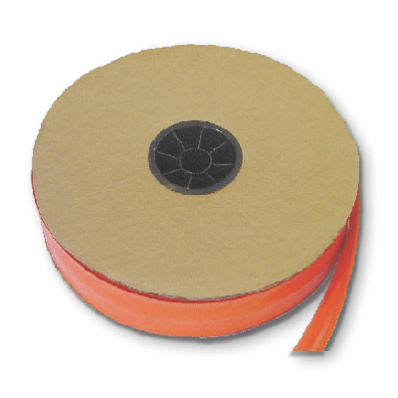

| Accessories Details | |
| --- | --- |
| **HOSE COVER** | |
| Protects your hose from paint and abrasion damage | |
| PART NUMBER: | 865696 - 1 roll, 1,000 ft (305 m) |
| AVAILABILITY: | North America, Central and South America, Europe, Middle East, Africa, Asia, Australia |

---

| accessories-category | |
| --- | --- |
| title | **MORE ACCESSORIES** |
| types | sprayguns  \  spraytips  \  hoses  \  extensions  \  filters  \  fluids  \  striping  \  other |

| Metadata | |
| --- | --- |
| Title | Airlessco Accessories | Airlessco.com |
| Description | Airlessco Professional Airless Spray Equipment Built to Perform. Built to Last. |
| Locale | /na/en |