# **AIRLESSCO REV-TIP SPRAY TIPS**

Reversible tip makes clearing a clog simple - self-centering feature snaps tip into place – tip handle simplifies installing and aligning of the seal – takes only seconds to assemble – micro-ground finish for extra long life, consistent size and spray pattern – hang tip for easy cleaning and storage

---

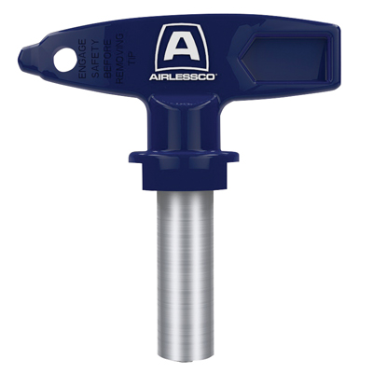

| Accessories Details | |
| --- | --- |
| **STANDARD TIPS** | |
| PART NUMBER: | ARVXXX |
| AVAILABILITY: | North America, Central and South America, Europe, Middle East, Africa, Asia, Australia |
| Loading, please wait... Material SprayedTip Size2 in5 cm4 in10 cm6 in15 cm8 in20 cm10 in25 cm12 in30 cm14 in35 cm16 in40 cm Stains / Varnishes0.007 in107207307 0.009 in109209309409 Lacquers / Protective Lacquers0.011 in111211311411511611 0.013 in113213313413513613 Primers / Interior & Exterior Paints0.015 in 215315415515615715815 0.017 in 217317417517617717817 0.019 in 219319419519619 819 0.021 in 221321421521621721821Heavy Exterior Paint / Light Premixed Plaster0.023 in 223323423523623723 0.025 in 225325425525625725 0.027 in 227327427527627 Premixed Plaster / Heavy Protective Coatings0.029 in 229 0.031 in 331431531631 831 0.035 in 335435535635 835 0.039 in 439 739 0.041 in 741 0.043 in 743 0.045 in 745 | |
| PART NUMBER: | 69-FFXXX |
| AVAILABILITY: | North America, Central and South America, Europe, Middle East, Africa, Asia, Australia |
| Seal easily installs without the need for any tools. The Rev-Tip seal is compatible with the full range of paints and solvents. | |
| PART NUMBER: | 248228 |

---

| accessories-category | |
| --- | --- |
| title | **MORE ACCESSORIES** |
| types | sprayguns  \  spraytips  \  hoses  \  extensions  \  filters  \  fluids  \  striping  \  other |

| Metadata | |
| --- | --- |
| Title | Airlessco Rev-Tip Spray Tips | Airlessco.com |
| Description | Airlessco Professional Airless Spray Equipment Built to Perform. Built to Last. |
| Locale | /na/en |