# **AIRLESSCO AIRLESS SPRAY GUNS**

Light trigger pull – trigger lock – hand tighten "no tools required" – easy-clean one-way filter with nylon reinforced core – extra large carbide ball and seat for long wear – durable stainless steel threads for tip attachments – long life needle seal.

---

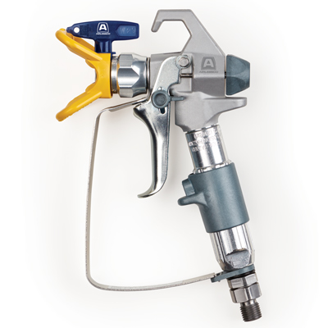

| Accessories Details | |
| --- | --- |
| **PROLIGHT 500 SERIES GUN** | |
| PART NUMBER: | 17N201 |
| INCLUDES: | 4-finger trigger (installed), 2-finger trigger, Rev-Tip 517 Tip & Guard |
| MAX WORKING PRESSURE: | 3,600 psi (248 bar) |
| REPAIR KIT: | 288817 |
| AVAILABILITY: | North America, Central and South America, Europe, Middle East, Africa, Asia, Australia |
| RESOURCES: | Operation/Repair Manual |

---

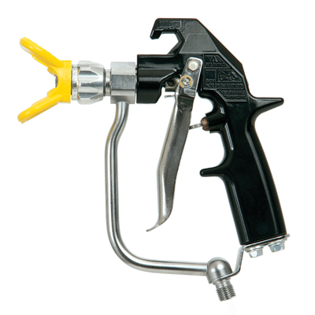

| Accessories Details | |
| --- | --- |
| **MASTIC TEXTURE GUN** | |
| PART NUMBER: | 24E470 |
| INCLUDES: | 4-finger trigger, Tip Guard |
| MAX WORKING PRESSURE: | 4,000 psi (276 bar) |
| REPAIR KIT: | 237260 |
| AVAILABILITY: | North America, Central and South America, Europe, Middle East, Africa, Asia, Australia |
| RESOURCES: | Operation/Repair/Parts Manual |

---

| Accessories Details | |
| --- | --- |
| **REV-TIP HAND-TIGHT BASE/GUARD** | |
| Quickly change from horizontal to vertical spray pattern. Easy no tools assembly. | |
| PART NUMBER: | 248200 - "G" Thread 7/8 in (22 mm) |

---

| Accessories Details | |
| --- | --- |
| **"F" TO "G" ADAPTER** | |
| Converts "F" thread to "G" thread. | |
| PART NUMBER: | 248248 |

---

| Accessories Details | |
| --- | --- |
| **MASTIC GUN AIR ATOMIZER KIT WITHOUT AIR HOSE** | |
| Minimum air compressor rating of 15 cfm at 90 psi (6 bar) needed. | |
| PART NUMBER: | 244233 |

---

| accessories-category | |
| --- | --- |
| title | **MORE ACCESSORIES** |
| types | sprayguns  \  spraytips  \  hoses  \  extensions  \  filters  \  fluids  \  striping  \  other |

| Metadata | |
| --- | --- |
| Title | Airlessco Airless Spray Guns | Airlessco.com |
| Description | Airlessco Professional Airless Spray Equipment Built to Perform. Built to Last. |
| Locale | /na/en |