# **AIRLESSCO STRIPING ACCESSORIES**

Airlessco offers high performance striping accessories to maximize job site productivity.

---

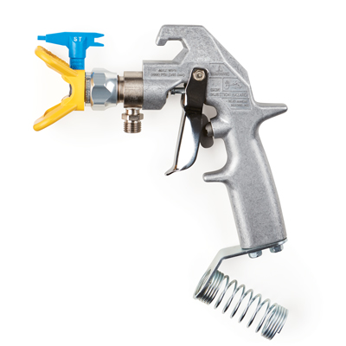

| Accessories Details | |
| --- | --- |
| **SURE STRIPE STRIPING GUN** | |
| PART NUMBER: | 25M223 |
| DESCRIPTION: | Fits Sure Stripe 3350, 4350 models |
| INCLUDES: | 317 Sure Stripe Tip, 319 Sure Stripe Tip, Sure Stripe Tip Guard |
| AVAILABILITY: | North America, Central and South America, Europe, Middle East, Africa, Asia, Australia |

---

| Accessories Details | |
| --- | --- |
| **2-GUN CONVERSION KIT** | |
| PART NUMBER: | 17P505 |
| DESCRIPTION: | Fits Sure Stripe 4350 model |
| INCLUDES: | Sure Stripe striping gun, hose cables, and brackets |
| AVAILABILITY: | North America, Central and South America, Europe, Middle East, Africa, Asia, Australia |

---

| Accessories Details | |
| --- | --- |
| **15-GALLON PAINT HOPPER** | |
| PART NUMBER: | 17P698 |
| DESCRIPTION: | Fits Sure Stripe 3350, 4350 models |
| INCLUDES: | Hopper and suction tube extension |
| AVAILABILITY: | North America, Central and South America, Europe, Middle East, Africa, Asia, Australia |

---

| Accessories Details | |
| --- | --- |
| **GRAVITY FEED GLASS BEAD DISPENSER** | |
| PART NUMBER: | 24Z726 - 6 in Dispenser |
| DESCRIPTION: | Fits Sure Stripe 3350, 4350 models |
| INCLUDES: | 6 in or 12 in dispenser, hopper, wind deflector, and brackets |
| AVAILABILITY: | North America, Central and South America, Europe, Middle East, Africa, Asia, Australia |

---

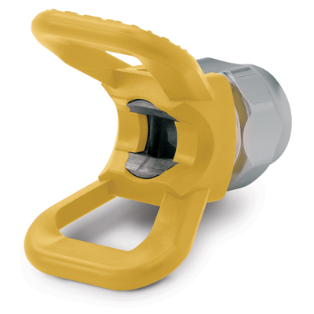

| Accessories Details | |
| --- | --- |
| **SURE STRIPE HAND-TIGHT TIP GUARD** | |
| Easy no tools assembly. | |
| PART NUMBER: | 248199 |

---

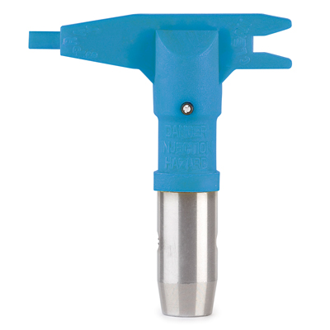

| Accessories Details | |
| --- | --- |
| **SURE STRIPE TIPS** | |
| PART NUMBER: | 69XXXST |
| AVAILABILITY: | North America, Central and South America, Europe, Middle East, Africa, Asia, Australia |

---

| accessories-category | |
| --- | --- |
| title | **MORE ACCESSORIES** |
| types | sprayguns  \  spraytips  \  hoses  \  extensions  \  filters  \  fluids  \  striping  \  other |

| Metadata | |
| --- | --- |
| Title | Airlessco Striping Accessories | Airlessco.com |
| Description | Airlessco Professional Airless Spray Equipment Built to Perform. Built to Last. |
| Locale | /na/en |