# TWOFISH ENCRYPTION/ DECRYPTION ALGORITHM IMPLMENTATION

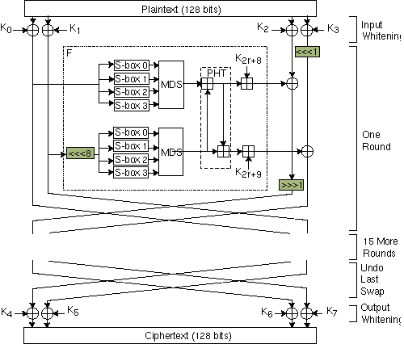

Input Whitening