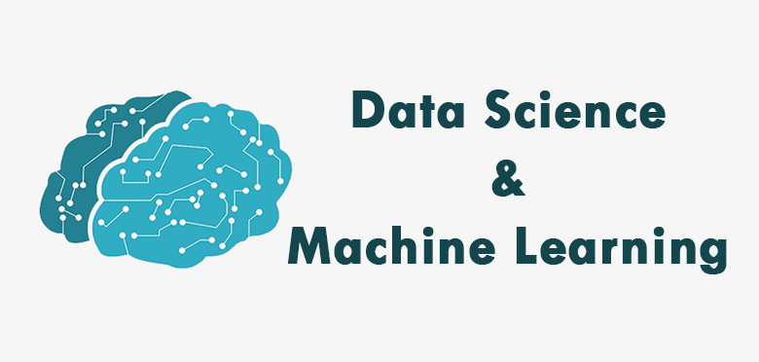

Module 1-3: Basic Python Programming

Week 1: Python Fundamentals Part 1
- Live Class 1: Unlocking the Power of Variables and Logic
  - Variables | Data Types | Dynamic Types | If Statements | Logical Operators | Comparison/Relational/Conditional Operators
- Live Class 2: Loops, Strings, and Smart Operations
  - For Loops | While Loops | Break & Continue | Strings | Arithmetic Operations | Operator Precedence | Math Functions
- Assessments: 1 Quiz, 1 Test

Week 2: Python Fundamentals Part 2
- Live Class 1: Understanding Data Structures and Functions
  - Lists | List Methods | Dictionaries | Functions | Parameters | Keyword Arguments | Default Parameter Value | Return Statement
- Live Class 2: Advanced Data Structures and Comparison
  - Sets (Union, Intersection, Difference) | Tuples | Unpacking | List vs Tuple
- Assessments: 1 Quiz, 1 Test

Week 3: Python Fundamentals Part 3
- Live Class 1: Introduction to OOP Concepts
  - OOP | Classes | Objects | Methods | Constructors (Default, Parameterized) | Pass Statement | Intro to Inheritance
- Live Class 2: Inheritance and Advanced OOP Features
  - Single | Hierarchical | Multilevel | Multiple Inheritance | Method Overloading & Overriding | Encapsulation | Polymorphism
- Assessments: 1 Quiz, 1 Test

Module 4: Database

Week 4: SQL Fundamentals
- Live Class 1: Introduction to SQL and Basic Queries
  - Understanding RDBMS | Database Normalization | SELECT | WHERE | ORDER BY
- Live Class 2: Advanced SQL Operations
  - JOIN Types (Inner, Left, Right, Full) | UNION | INTERSECT | EXCEPT
- Assessments: 1 Quiz, 1 Test

Module 5-6: Data Analysis

Week 5: NumPy & Pandas Part 1
- Live Class 1: Introduction to NumPy
  - NumPy Array Basics | List vs NumPy Array | Array Initialization | Indexing & Slicing | max() | min() | argmax() | argmin()
- Live Class 2: Introduction to Pandas
  - Pandas Data Structures | Series | DataFrames Basics (Creating DataFrames)
- Assessments: 1 Quiz, 1 Test

Week 6: NumPy & Pandas Part 2
- Live Class 1: Pandas Data Manipulation Basics
  - Loading Data (CSV, Excel) | Selecting & Filtering Data in DataFrames
- Live Class 2: NumPy Attributes and Advanced Pandas Operations
  - Data Cleaning | Handling Missing Data | Dropping & Filling Data | Basic Aggregations (sum, mean, median, count)
- Assessments: 1 Quiz, 1 Test

Module 7: Statistics

Week 7: Basic Statistics for Data Science
- Live Class 1: Understanding Data Types and Central Tendency
  - Qualitative vs Quantitative Data | Mean | Median | Mode
- Live Class 2: Dispersion, Distribution, and Correlation
  - Variance | Standard Deviation | Normal Distribution | Correlation Coefficient
- Assessments: 1 Quiz, 1 Test

Module 8-9: Data Visualization

Week 8: Data Visualization Part 1
- Live Class 1: Introduction to Data Visualization
  - Exploratory Data Analysis | Time Series Visualization | Geospatial Visualization
- Live Class 2: Advanced Visualization Techniques
  - Network Data Visualization | Interactive Data Visualization
- Assessments: 1 Quiz, 1 Test

Week 9: Data Visualization Part 2
- Live Class 1: Advanced Visualization Techniques
  - Text & Document Visualization | Multidimensional Data Visualization | Comparative Visualization
- Live Class 2: Dashboard and Visual Analytics
  - Dashboard Design | Visual Analytics
- Assessments: 1 Quiz, 1 Test

Module 10-15: Machine Learning (Basic to Advanced)

Week 10: ML - Feature Scaling & PCA
- Live Class 1: Introduction to ML and Evaluation Metrics
  - ML Basics | Supervised vs Unsupervised | Confusion Matrix | Precision | Recall | F1 Score
- Live Class 2: Feature Scaling and Data Transformation
  - Why Scaling? | Normalization | Standardization
- Assessments: 1 Quiz, 1 Test

Week 11: ML - Feature & Linear Engineering
- Live Class 1: Linear Regression and Outlier Detection
  - Simple & Multiple Linear Regression | Outlier Detection (STD, z-score, IQR)
- Live Class 2: Feature Engineering and Encoding
  - Feature Extraction | Encoding Techniques
- Assessments: 1 Quiz, 1 Test

Week 12: ML - Logistic Regression & KNN
- Live Class 1: Logistic Regression Models
  - Logistic Regression | Binary Logistic Regression
- Live Class 2: KNN Classifier
  - K-Nearest Neighbor Algorithm
- Assessments: 1 Quiz, 1 Test

Week 13: ML - Decision Tree & SVM
- Live Class 1: Decision Tree Classification
  - Introduction to Decision Trees
- Live Class 2: Support Vector Machine
  - SVM Basics & Implementation
- Assessments: 1 Quiz, 1 Test

Week 14: ML - K-Means Clustering & Time Series Analysis
- Live Class 1: K-Means Clustering Algorithm
- Live Class 2: Naive Bayes Classifier
- Assessments: 1 Quiz, 1 Test

Week 15: Introduction to Advanced Data Science
- Live Class 1: Introduction to Neural Networks
  - Biological & Artificial Neural Networks | ANN Architecture
- Live Class 2: Introduction to NLP and Its Applications
  - NLP Pipeline | NLU | Ambiguity | Applications of NLP
- Assessments: 1 Quiz, 1 Test

