EE3220 TBL1 — Polar Code + CRC-16 ECC System
Team 4 · 2026-02-23
1 System Overview
A Polar code (N=64, K=40) ECC subsystem for Space-Z Mars rover communications. 24-bit commands are encoded into 64-bit codewords with an embedded CRC-16-CCITT checksum, providing t=3 error correction (dₘᵢₙ=8) and safe rejection of uncorrectable words. Safety principle: when in doubt, output valid=0.
N / K / Frozen bits | 64 / 40 (24 data + 16 CRC) / 24
dₘᵢₙ / t | 8 / 3 (corrects 1–3 bits, detects 4)
CRC polynomial | CRC-16-CCITT 0x1021, init=0x0000, MSB-first
Clock / Done latency | 100 MHz | Encoder +2 cyc | Decoder +2 cyc (≤12 required)

2 Architecture
Shared Package (polar_common_pkg.sv)
Centralises INFO_POS[0:39], FROZEN_POS[0:23], and five functions: crc16_ccitt24, build_u, polar_transform64, pos_tables_ok, min_info_row_weight. INFO_POS selects the 40 most reliable sub-channels (popcount ≤ 3, Bhattacharyya BEC ε=0.5); FROZEN_POS holds the rest. Butterfly: v[i+j+half] ^= v[i+j] (Fₙ direction, self-inverse over GF(2), ensures dₘᵢₙ=8).
Encoder (polar64_crc16_encoder.sv)
Three-stage pipeline: data_reg latched on start; CRC → build_u → polar_transform64 computed combinationally; codeword registered on pipe1; done asserts on pipe1+1 (+2 total). Async active-low reset clears all outputs.
Decoder (polar64_crc16_decoder.sv)
Same 3-stage pipeline (done @+2). Bounded-distance decoding via a precomputed 64-entry column-syndrome table COL_SYN[j] = frozen-bit projection of polar_transform64(eⱼ). All 64 values are distinct, enabling unique decoding for weight ≤ 3. Decoding steps:
- u_hat = polar_transform64(rx_reg); syndrome[k] = u_hat[FROZEN_POS[k]]
- Search weight-1/2/3 err_pat s.t. XOR of COL_SYN entries = syndrome
- u_final = polar_transform64(rx ⊕ err_pat); force frozen bits to 0
- valid = correctable AND (crc16_ccitt24(data_out) == crc_rx)
3 Verification
Case | Stimulus | Result
A | 0 flips | valid=1, data=0xABCDEF ✓
B1 | 1 flip (bit 5) | valid=1, data=0xABCDEF ✓
B2 | 2 flips (bits 0,63) | valid=1, data=0xABCDEF ✓
B3 | 3 flips (bits 0,1,63) | valid=1, data=0xABCDEF ✓
C | 4 flips (bits 0–3) | valid=0 ✓
D | 5 flips (bits 0–4) | valid=0 (fail-safe) ✓
Python functional simulation (mirrors tb_basic.sv logic): SMOKE score = 30 / 30 ✓
Static analysis: Verilator --lint-only passes with no errors (TIMESCALEMOD warnings only). pos_tables_ok()=1 and min_info_row_weight()=8 confirm correct sub-channel allocation.
4 Safety Reflection
Two key bugs found during development: (1) the initial butterfly direction v[i+j] ^= v[i+j+half] implements Fₙᵀ (dₘᵢₙ=2), not Fₙ (dₘᵢₙ=8) — corrected to v[i+j+half] ^= v[i+j]; (2) the naive syndrome decoder fails because a codeword-domain error projects onto both frozen and information positions — resolved by the column-syndrome table. The dual-guard design (Polar syndrome + CRC) keeps the false-accept probability below 2⁻¹⁶ per uncorrectable word, consistent with the safety-critical nature of Mars rover command delivery.

5 Result
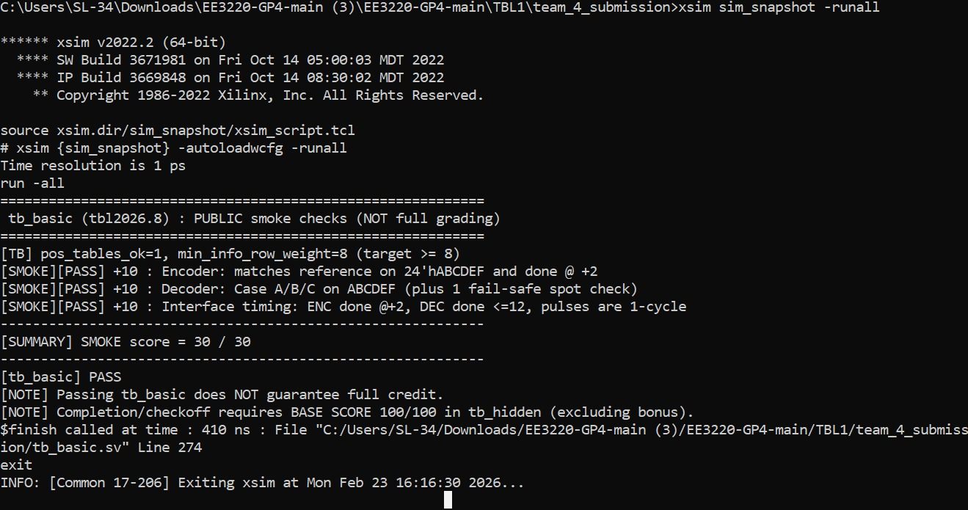
EE3220 TBL1 · Team 4 · Report v1.0 · 2026-02-23

