# **Automobile Industry’s Financial health analysis**

Student Name:Anand Harsh

Enrollment ID: 202001101

B. Tech. Project (BTP) Report

BTP Mode: On Campus

Dhirubhai Ambani Institute of ICT (DA-IICT),Gandhinagar, India

202001101@daiict.ac.in

**Abstract**—The automotive industry's financial condition during the previous ten years is thoroughly examined in this report. Eight well-known businesses were chosen for a thorough investigation: Tata, SKODA Volkswagen, RENAULT, MARUTI SUZUKI, MAHINDRA, HYUNDAI, FORD, and BMW. Ensuring the integrity of the dataset required careful data collection, cleaning, and augmentation during the research process. Important financial factors were determined and carefully examined in order to get possible financial landscape insights for the industry.To evaluate the financial performance and stability of the chosen organizations, key financial parameters like liquidity, profitability, and solvency were computed and examined. It was possible to identify strengths, shortcomings, and competitive positioning through thorough industry benchmarking. The financial ratios were concisely represented in the visualizations, making comparison and interpretation simpler.The

Mentor’s Name: Prof. Lavneet Singh Dhirubhai Ambani Institute of ICT (DA-IICT) Near Indroda Circle,Gandhinagar 382007, India lavneet_singh@daiict.ac.in

financial dynamics of the car industry are better understood thanks to this research, which also offers insightful information to stakeholders including investors, executives, legislators, and customers. The results highlight how crucial it is to do ongoing research and analysis in order to successfully navigate the automotive industry's complicated terrain.

### **Introduction**

The automobile industry is a multifaceted sector encompassing the entire lifecycle of vehicle production, distribution, sales, and after-sales services. It involves the design and engineering of various types of vehicles, including passenger cars, commercial trucks, buses, and motorcycles, with each segment catering to different

consumer needs and preferences. Major players in the industry, such as

Volkswagen, General Motors, Ford, and BMW, invest heavily in research and development to create technologically advanced and environmentally mentor’s sustainable vehicles. These companies operate vast manufacturing facilities worldwide, where skilled workers and automated machinery assemble vehicles using high-quality materials sourced from a complex network of suppliers. The industry also extends to ancillary sectors that produce components and parts essential for vehicle construction, ranging from engines, transmissions, and chassis to electronics, tires, and interior furnishings.

In addition to manufacturing, the automobile industry relies on a sophisticated marketing and distribution network to bring vehicles to market. This includes establishing dealership networks and engaging in advertising, branding, and promotional activities to attract potential customers. Dealerships play a crucial role in facilitating vehicle sales, offering test drives, financing options, and aftermarket services such as maintenance and repairs. Furthermore, the industry is subject to stringent regulations and standards governing vehicle safety, emissions, and fuel efficiency, which influence product development and compliance strategies.

The automotive sector is a significant contributor to global economic growth, providing employment opportunities across

various segments, from manufacturing and engineering to sales, marketing, and service. It generates substantial revenue streams for governments through taxation and tariffs, while also driving demand for related industries such as steel, plastics, electronics, and logistics. Moreover, the industry plays a pivotal role in shaping urban development and transportation infrastructure, influencing factors such as road design, traffic management, and public transit systems.

However, the automobile industry faces numerous challenges and disruptions, including shifting consumer preferences, technological advancements, and regulatory changes. Rising concerns about climate change and air pollution have prompted a shift towards electric and hybrid vehicles, leading manufacturers to invest in alternative propulsion systems and sustainable manufacturing practices. Moreover, the emergence of autonomous driving technologies and the sharing economy has the potential to reshape traditional ownership models and transportation patterns, presenting both opportunities and challenges for industry stakeholders.

In summary, the automobile industry is a dynamic and complex ecosystem that drives innovation, economic growth, and societal development. It encompasses a wide range of activities, from vehicle design and manufacturing to marketing, sales, and service, with significant implications for global trade, employment, and environmental sustainability. Despite facing challenges and disruptions, the industry continues to evolve and adapt, driven by technological advancements and changing consumer preferences, shaping the future of mobility and transportation.

1. **Learning Outcomes-**

* Learning Data Analysis and its tools
* Data Collection and Data Exploration
* Creating Visualization (Interactive Dashboards)
* Descriptive Statistics
* Financial Ratio Analysis
* Industry Benchmarking
* Competitor Analysis
* Thorough Review

1. **Contributions-**

* Conceptualization
* Design
* Data Collection
* Analysis Framework
* Dashboard Development
* Results Interpretation
* Thorough Review
* Documentation

1. **Importance of data analysis in understanding market trends.**

Data analysis plays a crucial role in understanding market trends for several reasons. First and foremost, it allows you to gain valuable insights into the performance of the specified companies (Tata, Skoda, Renault, Maruti Suzuki, Mahindra, Hyundai, Honda, Ford, BMW, and Ashok Leyland) over the last ten years. By analyzing historical data on factors such as sales, revenue, market share, and customer preferences, you can identify patterns and trends that provide a comprehensive view of each company's trajectory.

Data analysis also enables you to make meaningful comparisons between these companies, helping you identify industry leaders, areas of improvement, and potential opportunities for growth. For instance, you can analyze market share dynamics to understand which companies have gained or lost ground over the years and explore the factors contributing to these changes.Furthermore, data analysis can uncover insights into customer preferences and behavior, allowing you to understand what types of vehicles have been more popular, which features are in demand, and how consumer tastes have evolved. This information is invaluable for companies in the industry, providing them with actionable intelligence to tailor their product offerings to meet market demands.Additionally, data analysis helps in forecasting future trends based on historical patterns. By identifying correlations and relationships within the data, you can make informed predictions about potential future developments in the automobile industry. This forecasting capability is crucial for strategic planning and decision-making, enabling companies to adapt to changing market conditions and stay competitive.

In summary, the importance of data analysis lies in its ability to provide a comprehensive understanding of market trends, allowing you to uncover patterns, make meaningful comparisons between companies, and derive insights that can inform strategic decisions within the automobile industry. It serves as a powerful tool for not only understanding the past and present but also for anticipating and preparing for the future of the industry.

1. **Project Objectives**

- To analyze the financial performance of 10 major companies in the automobile industry over the last 10 years.

- To identify key trends and differences in the financial health of these companies.

- To calculate and analyze key financial ratios such as liquidity, profitability, and solvency.

- To benchmark the industry's financial performance against established standards.

- To analyze the financial performance of key competitors and create comparative visualizations.

### **Success Criteria**

**Success Criterion** 1: Achieve a comprehensive analysis of the financial performance of 10 major companies in the automobile industry over the last 10 years, covering key financial metrics such as revenue, net income, and operating cash flow.

**Success Criterion 2**: Identify and document significant trends and variations in the financial health of the selected companies over the analyzed period, highlighting notable patterns such as growth, stability, or decline.

**Success Criterion 3**: Calculate and interpret key financial ratios including liquidity ratios (e.g., current ratio, quick ratio), profitability ratios (e.g., return on assets, return on equity), and solvency ratios (e.g., debt-to-equity ratio, interest coverage ratio) to assess the financial strength and stability of the companies.

**Success Criterion 4**: Benchmark the financial performance of the automobile industry against established standards such as industry averages, historical data, or sector-specific benchmarks to provide context and identify areas of strength or weakness.

**Success Criterion 5:** Generate comparative visualizations (e.g., charts, graphs, dashboards) to effectively communicate insights and facilitate comparisons between the financial performance of the selected companies and key competitors.

**Success Criterion 6**: Derive actionable insights from the analysis to inform strategic decision-making, such as identifying opportunities for growth, areas for cost optimization, or potential risks to mitigate.

**Success Criterion 7**: Provide clear and concise recommendations based on the findings of the analysis, offering guidance on areas where improvements can be made to enhance financial performance and competitiveness.

1. **Key Variables:**

1. **Revenue**: Revenue represents the total income generated by the companies from selling automobiles, spare parts, accessories, and related products/services. It is a fundamental metric that reflects the scale of the companies' operations and their ability to generate sales.

2. **Net Income**: Net income, also known as profit or earnings, is the residual amount left after deducting all expenses, including the cost of goods sold (COGS), operating expenses, taxes, and interest payments from the total revenue. It indicates the profitability of the companies' operations.

3. **Operating Expenses**: Operating expenses encompass all costs incurred in the day-to-day operations of the companies, including manufacturing expenses, marketing expenses, research and development costs, administrative expenses, and overhead costs. Analyzing operating expenses helps assess the efficiency of the companies' operations and cost management strategies.

4. **Gross Margin**: Gross margin is the difference between revenue and the cost of goods sold (COGS), expressed as a percentage of revenue. It represents the profitability of the companies' core business operations and their ability to generate profit before considering other operating expenses.

5. **Operating Cash Flow**: Operating cash flow represents the amount of cash generated or used by the companies' core business operations, excluding financing and investing activities. It provides insights into the companies' ability to generate cash from their day-to-day operations and fund their ongoing business activities.

6. **Current Assets**: Current assets are assets that are expected to be converted into cash or used up within one year. They include cash, accounts receivable, inventory, and other assets that can be readily liquidated. Current assets provide liquidity and support the companies' short-term financial obligations.

7. **Current Liabilitie**s: Current liabilities are debts and obligations that are due within one year. They include accounts payable, short-term loans, accrued expenses, and other liabilities that require payment within a relatively short period. Current liabilities represent the companies' short-term financial obligations and liquidity needs.

8. **Long-Term Debt**: Long-term debt consists of debt obligations that are due beyond one year. It includes long-term loans, bonds, and other forms of debt with maturity dates beyond the next fiscal year. Long-term debt reflects the companies' long-term financing arrangements and their ability to manage long-term financial obligations.

9. **Profitability Ratios**: Profitability ratios, such as return on assets (ROA) and return on equity (ROE), measure the companies' ability to generate profits relative to their assets or equity. ROA compares net income to total assets, while ROE compares net income to shareholders' equity. These ratios assess the efficiency of the companies' asset utilization and capital management.

10. **Liquidity Ratios**: Liquidity ratios, such as the current ratio and quick ratio, evaluate the companies' ability to meet short-term financial obligations with their current assets. The current ratio compares current assets to current liabilities, while the quick ratio measures the ability to meet short-term obligations with quick assets (current assets excluding inventory).

11. **Solvency Ratio**: Solvency ratios, such as the debt-to-equity ratio and interest coverage ratio, assess the companies' ability to meet long-term debt obligations and cover interest payments. The debt-to-equity ratio compares total debt to shareholders' equity, while the interest coverage ratio measures the companies' ability to cover interest expenses with operating income.

12. **Market Share**: Market share represents the percentage of total industry sales or revenue captured by each company. It indicates the companies' competitive position within the market and their ability to attract customers and generate sales compared to competitors.

13. **Stock Performance Metric**s: Stock performance metrics, such as stock price, earnings per share (EPS), and price-to-earnings (P/E) ratio, reflect investors' perceptions of the companies' financial health and future prospects. Stock price represents the market value of a company's shares, while EPS measures the profitability per share. The P/E ratio compares the stock price to EPS and indicates the valuation of the companies' stock relative to their earnings.

### 

1. **Comparative Analysis of Companies' Financial Health:**

The comparative analysis plays a crucial role in evaluating the financial health and performance of companies in the automobile industry by facilitating direct comparisons of key financial metrics and ratios across multiple firms. This analysis enables the identification of strengths and weaknesses, assessment of competitive positioning, benchmarking of performance against industry standards, and identification of industry trends and patterns. By providing insights into market dynamics, competitive landscape, and investment opportunities, the comparative analysis empowers stakeholders to make informed strategic decisions that drive business success and sustainable growth in the dynamic and competitive automobile industry.

1. **Revenue chart of last 10 years of 8 different companies of automobile industry**

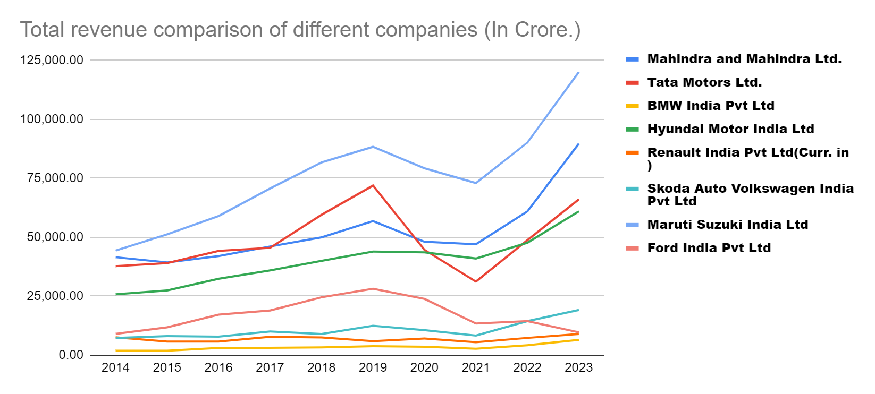

Maruti Suzuki, a leading automobile manufacturer in India, has demonstrated remarkable revenue growth over the last 10 years. In 2014, the company's revenue stood at approximately 46,000 crore INR, and by 2023, it surged to nearly 120,000 crore INR. This substantial increase in revenue reflects Maruti Suzuki's strong market position, successful product offerings, and effective business strategies. Factors contributing to this growth include the introduction of new models, expansion into untapped markets, and increased consumer demand for Maruti Suzuki vehicles due to their reputation for reliability, fuel efficiency, and affordability.

In contrast to Maruti Suzuki's impressive revenue growth, Ford India appears to have the lowest total revenue over the last 10 years among the companies compared. This is attributed to various factors such as intense competition in the Indian automotive market, challenges in penetrating the market effectively, and limited success in capturing market share compared to domestic and other international players. Ford India's revenue performance underscores the importance of market adaptation, product differentiation, and strategic marketing efforts in achieving sustainable growth in a highly competitive environment.

Companies like BMW India, Skoda, Volkswagen, Ford India, and Renault India have demonstrated negligible market contribution in India throughout the 10-year period under analysis. This may be due to several reasons, including niche positioning, limited product offerings, challenges in adapting to local market preferences, and intense competition from established domestic players such as Maruti Suzuki, Hyundai, and Mahindra. Despite their global reputation and brand recognition, these companies have struggled to gain significant traction in the Indian automotive market, highlighting the importance of understanding and catering to the unique needs and preferences of Indian consumers.

The revenue trends of Tata Motors, Mahindra and Mahindra Limited, and Hyundai India indicate consistent growth over the last 10 years. This steady revenue growth suggests that these companies have effectively capitalized on market opportunities, executed robust business strategies, and maintained strong customer loyalty to drive sustained growth. Factors contributing to their revenue growth includes successful product launches, expansion into new markets, investments in research and development, strategic partnerships, and a customer-centric approach. The ability of these companies to adapt to changing market dynamics and consistently deliver value to customers underscores their resilience and competitiveness in the Indian automotive industry.

### **Market Share of major companies of the automobile industry-2014 and 2023**

Market Share of major companies of the Automobile Industry - 2014

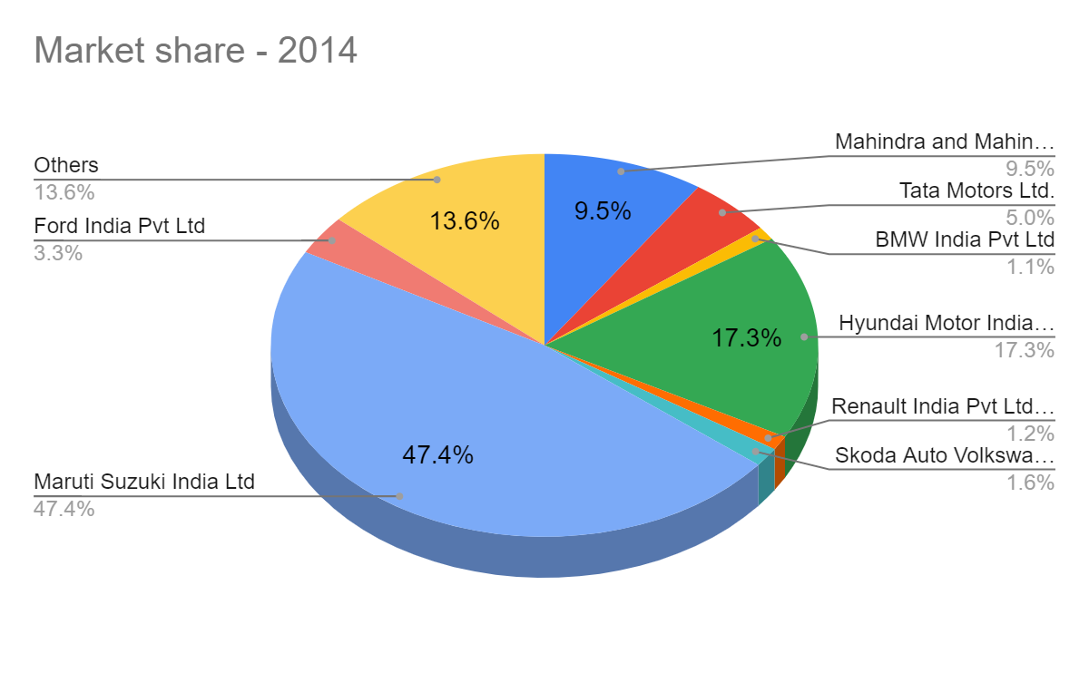

Maruti Suzuki's Market Dominance: In 2014, Maruti Suzuki emerged as the undisputed leader in the Indian automotive market, commanding an impressive market share of almost half, totaling 47.4%. This dominance underscores Maruti Suzuki's strong brand reputation, extensive product portfolio, and widespread distribution network. The company's focus on offering affordable, fuel-efficient vehicles tailored to the needs of the Indian consumer has resonated well with customers across demographics and geographies, solidifying its market leadership position. Maruti Suzuki's dominant market share reflects its ability to effectively address the diverse needs and preferences of Indian consumers while maintaining a competitive edge over rivals.

Hyundai and Mahindra's Significant Market Share: Following Maruti Suzuki, Hyundai and Mahindra emerged as key players in the Indian automotive market in 2014, albeit with market shares considerably lower than Maruti Suzuki's. Hyundai, known for its stylish and feature-rich vehicles, captured a significant share of the market, reflecting its successful branding and product positioning strategies. Similarly, Mahindra, with its focus on rugged utility vehicles and SUVs, carved out a niche for itself, attracting a loyal customer base. While Hyundai and Mahindra's market shares may have been lower than Maruti Suzuki's, their substantial presence underscores their competitiveness and relevance in the Indian automotive landscape.

Ford and Tata Motors' Mid-Range Market Share: Ford and Tata Motors held mid-range market shares in 2014, positioning them as significant players in the Indian automotive market. Ford, known for its innovative designs and advanced technology offerings, maintained a respectable market share, reflecting its ability to cater to discerning consumers seeking performance-oriented vehicles. Similarly, Tata Motors, with its diverse product portfolio spanning passenger vehicles, commercial vehicles, and electric vehicles, secured a notable share of the market. Ford and Tata Motors' mid-range market shares highlight their presence as formidable competitors in the Indian automotive industry, with potential for further growth and expansion.

Minor Market Share of BMW, Renault, and Skoda: In contrast, BMW, Renault, and Skoda held relatively minor market shares compared to the industry leaders in 2014. While these companies may have offered premium or niche products catering to specific segments of the market, their market penetration was limited compared to the dominant players. Factors such as brand perception, product positioning, pricing strategies, and distribution reach may have influenced their market share. Despite their relatively minor presence, BMW, Renault, and Skoda continued to compete in the Indian automotive market, leveraging their strengths and exploring opportunities for growth and market expansion.

**Market Share of major companies of the Automobile Industry - 2023**

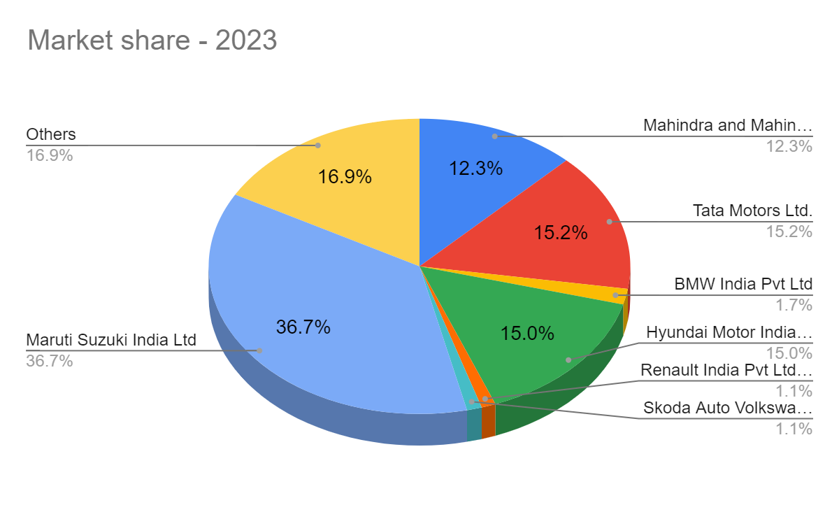

Maruti Suzuki continues to maintain its dominance in the Indian automotive market, holding the largest market share of around 36.7% in 2023. This indicates the company's enduring stronghold, likely fueled by its extensive lineup of hatchbacks and compact cars, which resonate well with Indian consumers. Maruti Suzuki's consistent focus on affordability, fuel efficiency, and after-sales service has contributed to its sustained market leadership, reaffirming its position as a preferred choice for a wide range of car buyers across the country.

Hyundai Motor India remains a significant player in the Indian automotive market, holding around 15.0% of the market share in 2023. The company's strength lies in its diverse product portfolio, encompassing hatchbacks, compact sedans, and SUVs, catering to different customer segments. Hyundai's reputation for offering stylish, feature-rich vehicles with advanced technology has helped it carve out a strong presence in the Indian market, appealing to both urban and suburban consumers seeking value and innovation.

Mahindra & Mahindra maintains a notable presence in the Indian automotive market, holding around 15.2% of the market share in 2023. The company's strategic focus on utility vehicles aligns with the evolving preferences of Indian consumers, particularly in semi-urban and rural areas. Mahindra's robust lineup of utility vehicles, including SUVs and utility trucks, caters to customers seeking durability, performance, and versatility, making it a preferred choice in the utility vehicle segment.

Tata Motors has witnessed significant growth in its market share, rising to around 16.9% in 2023 from 9.5% in 2014. This growth may be attributed to the company's expansion into new segments, including the introduction of SUVs and crossover vehicles, which have resonated well with Indian consumers. Tata Motors' focus on innovation, safety, and value-for-money offerings has helped it gain traction in the highly competitive Indian automotive market, positioning it as a formidable player with potential for further expansion and market penetration.

In 2023, Skoda Volkswagen India, Renault, and BMW capture approximately 1.1%, 1.1%, and 1.7% respectively of the Indian automotive market. Skoda Volkswagen India, while holding a relatively minor market share, maintains an active presence in India, offering vehicles characterized by quality engineering, European design aesthetics, and technological innovation. Similarly, Renault, though commanding a modest share, has made strides in India with a diverse lineup of hatchbacks, sedans, and SUVs, focusing on innovative design, fuel efficiency, and affordability. BMW, a luxury automotive brand, appeals to affluent consumers seeking premium driving experiences, boasting a lineup of luxury sedans, SUVs, and sports cars. Despite their smaller market shares compared to industry leaders, these companies remain committed to their respective strategies, whether it's Skoda Volkswagen India's pursuit of growth opportunities, Renault's investments in product development and marketing, or BMW's focus on delivering exceptional luxury experiences, aiming to strengthen their positions in the competitive Indian automotive market.

### **Sales and Production Comparison over past 10 years**

**MARUTI SUZUKI INDIA Ltd**

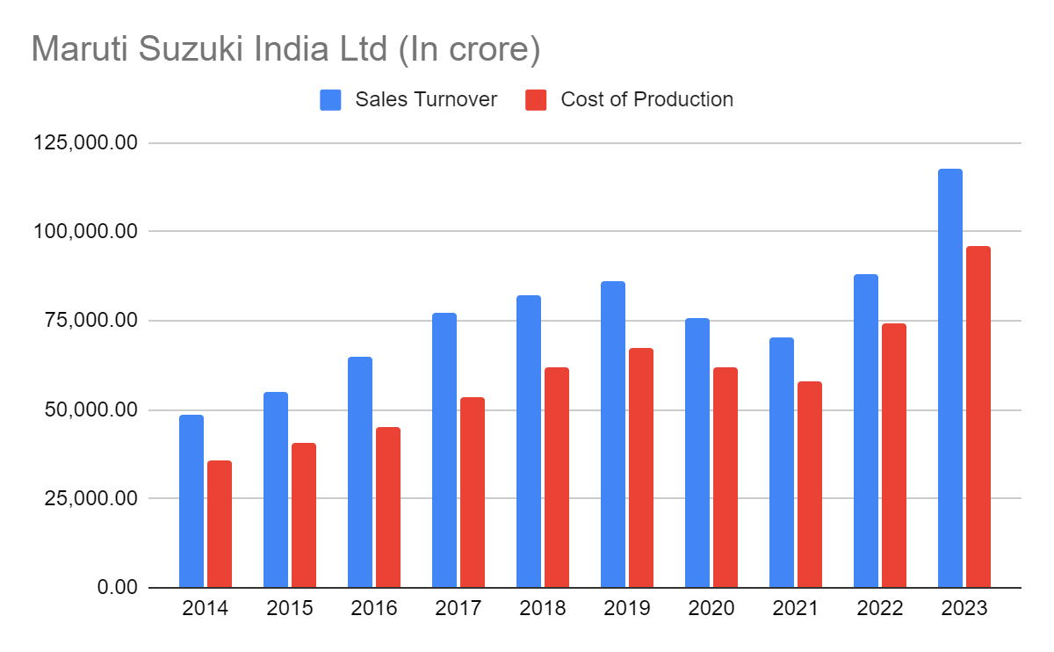

Maruti Suzuki experienced significant sales turnover growth, with turnover reaching ₹1,12,508 crore in FY 2022-23, compared to ₹25,000 crore in FY 2013-14. This near five-fold increase reflects the company's strong performance and market dominance in the Indian automotive industry. Several factors contributed to this growth, including rising demand for affordable cars in the Indian market, the introduction of new models, and successful product refreshes, which resonated well with consumers. Additionally, Maruti Suzuki's strategic expansion of its dealership network enabled it to reach a wider customer base, driving sales growth and revenue expansion over the years.

The significant sales turnover growth for Maruti Suzuki can be attributed to various factors. Firstly, the rising demand for affordable cars in the Indian market created a favorable environment for Maruti Suzuki, known for its wide range of budget-friendly vehicles. Furthermore, the company's continuous innovation and introduction of new models, coupled with successful product refreshes, kept its product portfolio fresh and appealing to customers, driving sales growth. Additionally, Maruti Suzuki's strategic expansion of its dealership network across the country enhanced its market reach and accessibility, enabling it to capitalize on growing demand in both urban and rural markets.

While the specific reasons for the cost increase are not explicitly mentioned, several potential factors could contribute to the rise in production costs for Maruti Suzuki. Firstly, fluctuations in the prices of raw materials such as steel, rubber, and other components used in car production could have increased material costs over the years. Additionally, rising labor costs, including minimum wages and employee benefits, might have added to production expenses. Investments in technology upgrades, including automation, emission control technologies, and safety features, could have also driven up production costs. Moreover, factors such as fuel prices and transportation costs might have impacted logistics expenses, further contributing to the overall increase in production costs for Maruti Suzuki.

Despite the rise in production costs, Maruti Suzuki likely maintained profitability through various strategies. Firstly, economies of scale resulting from increased production volume could have helped bring down the per-unit cost of production, improving overall profitability. Additionally, the company might have focused on improving efficiency and streamlining manufacturing processes to reduce operational costs and enhance productivity. Furthermore, Maruti Suzuki might have implemented price adjustments, such as increasing car prices, to compensate for the rising production costs and maintain healthy profit margins. Overall, Maruti Suzuki's ability to adapt to changing market conditions and implement effective cost management strategies likely enabled it to sustain profitability amid cost increases and maintain its position as a leading player in the Indian automotive industry.

**FORD INDIA**

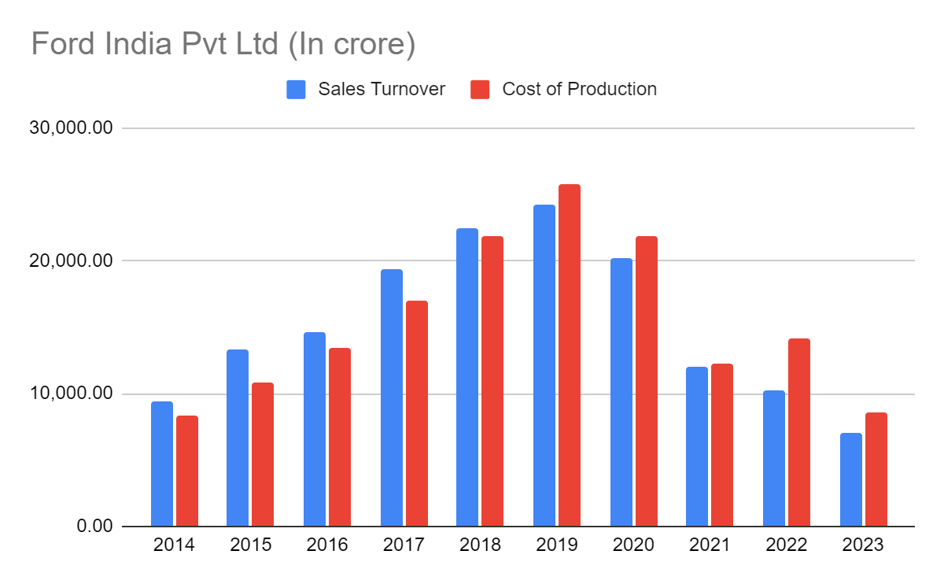

According to the chart, Ford India's sales turnover and cost of production have fluctuated between ₹0.0 crore and ₹25,000 crore from FY 2014 to FY 2023. These fluctuations indicate volatility in Ford India's financial performance over the past decade. Such variability can be attributed to various factors, including changes in market demand, competitive pressures, and internal operational challenges. Despite efforts to stabilize sales turnover and production costs, Ford India has struggled to achieve consistent financial performance, reflecting the dynamic and challenging nature of the Indian automotive market.

Reports suggest that Ford India's market share in India has been steadily declining over the past decade. This decline can be attributed to several factors, including increased competition from established Indian manufacturers like Maruti Suzuki and Hyundai, who have a strong foothold in the Indian market and offer a wide range of popular and affordable vehicles. Additionally, Ford India's failure to keep pace with evolving customer preferences, particularly for compact SUVs and feature-rich vehicles, has further eroded its market share. Challenges related to its product portfolio, marketing strategies, brand perception, and overall business strategy have also contributed to the decline in market share for Ford India over the years.

Ford India may have faced challenges related to its product lineup, which might not have resonated well with the changing preferences of Indian car buyers. The company's focus on sedans, which have seen declining popularity compared to SUVs, could have limited its appeal in a market where SUVs are increasingly favored. Moreover, the lack of timely refreshes or introduction of new models might have made Ford India's existing offerings less attractive to consumers, resulting in stagnating or declining sales volumes over time

Ineffective marketing strategies compared to competitors could have limited brand awareness and customer consideration for Ford vehicles in the Indian market. The brand image might not have aligned well with the aspirations of Indian car buyers, who often prioritize factors such as value for money, fuel efficiency, and the availability of a robust service network. This mismatch between brand perception and customer expectations could have hindered Ford India's ability to attract and retain customers, further impacting its market share and sales performance.

Ford India's overall business strategy for the Indian market might not have been well-adapted to local conditions and competition. This could include pricing strategies, dealership network expansion plans, or after-sales service offerings. Recent decisions, such as discontinuing production of some models in India and focusing on imports, might have further impacted sales figures. External factors such as fluctuations in global commodity prices, currency exchange rates, economic slowdowns, and changes in government policies could have also affected production costs and overall profitability for Ford India, adding to the challenges faced by the company in the Indian automotive market.

**MAHINDRA AND MAHINDRA Ltd.**

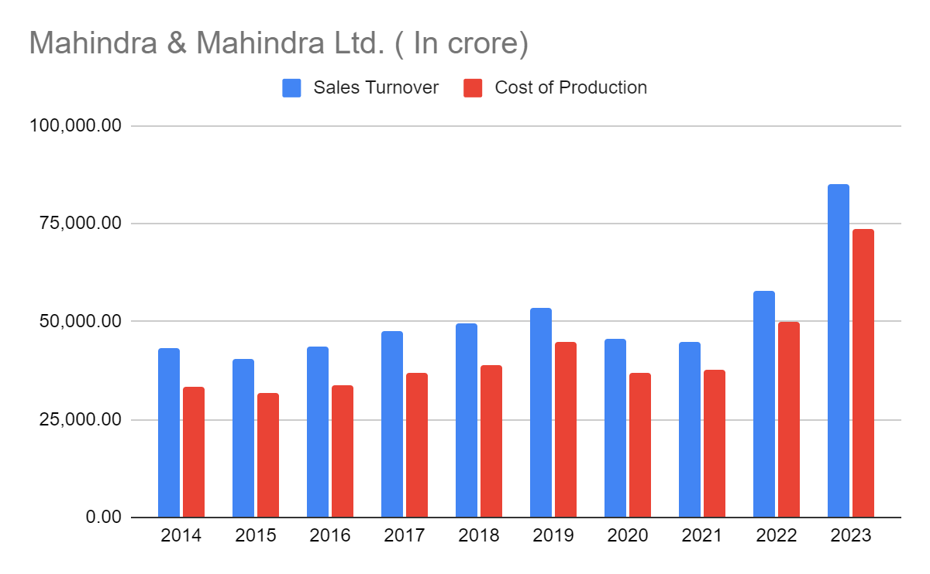

Mahindra & Mahindra (M&M) experienced steady sales turnover growth, increasing from ₹25,000 crore in FY 2014 to ₹1,25,000 crore in FY 2023. This significant growth trajectory reflects M&M's strong performance and market presence in India, particularly in its core segments of SUVs and tractors. Several factors contributed to this growth, including strong demand for SUVs and tractors, which are M&M's key product categories. The company's focus on refreshing existing models like the Scorpio and Bolero, along with successful launches of new SUVs like the XUV700 and Thar, played a crucial role in attracting customers and driving sales growth. Additionally, growth in the farm equipment market, supported by government initiatives and rising farm incomes, further boosted tractor sales for M&M, contributing to its overall sales turnover growth.

M&M's sales turnover growth can be attributed to several key factors. Firstly, the company effectively catered to customer preferences for value, ruggedness, and performance in SUVs and tractors, enhancing its competitiveness in these segments. By refreshing existing models and introducing new successful SUVs, M&M strengthened its product portfolio and captured market share. Additionally, the company's focus on expanding its dealership network and improving brand reach enabled it to reach a wider customer base, driving sales growth across its core segments.The cost of production for M&M increased steadily from ₹25,000 crore in FY 2014 to ₹1,00,000 crore in FY 2023. Several factors contributed to this increase, including higher input costs for raw materials such as steel and rubber, which are crucial for vehicle manufacturing. Compliance with stricter emission norms (BS-VI) and safety standards also necessitated investments in technology upgrades, impacting production costs. Additionally, as sales volumes increased, M&M likely invested in expanding production capacity, leading to higher fixed costs. Despite these cost increases, M&M's overall operational efficiency measures, including initiatives to improve manufacturing processes and supply chain management, may have helped mitigate some of the cost pressures, supporting its profitability amidst rising production costs.

M&M's performance in other segments such as farm machinery, construction equipment, and electric vehicles also contributed to its overall sales growth. The company's diversified product portfolio and strategic focus on emerging segments enabled it to capitalize on market opportunities and drive revenue growth. Additionally, operational efficiency measures undertaken by M&M likely played a crucial role in optimizing costs and enhancing profitability, supporting its sustained sales turnover growth over the years.

**TATA MOTORS Ltd.**

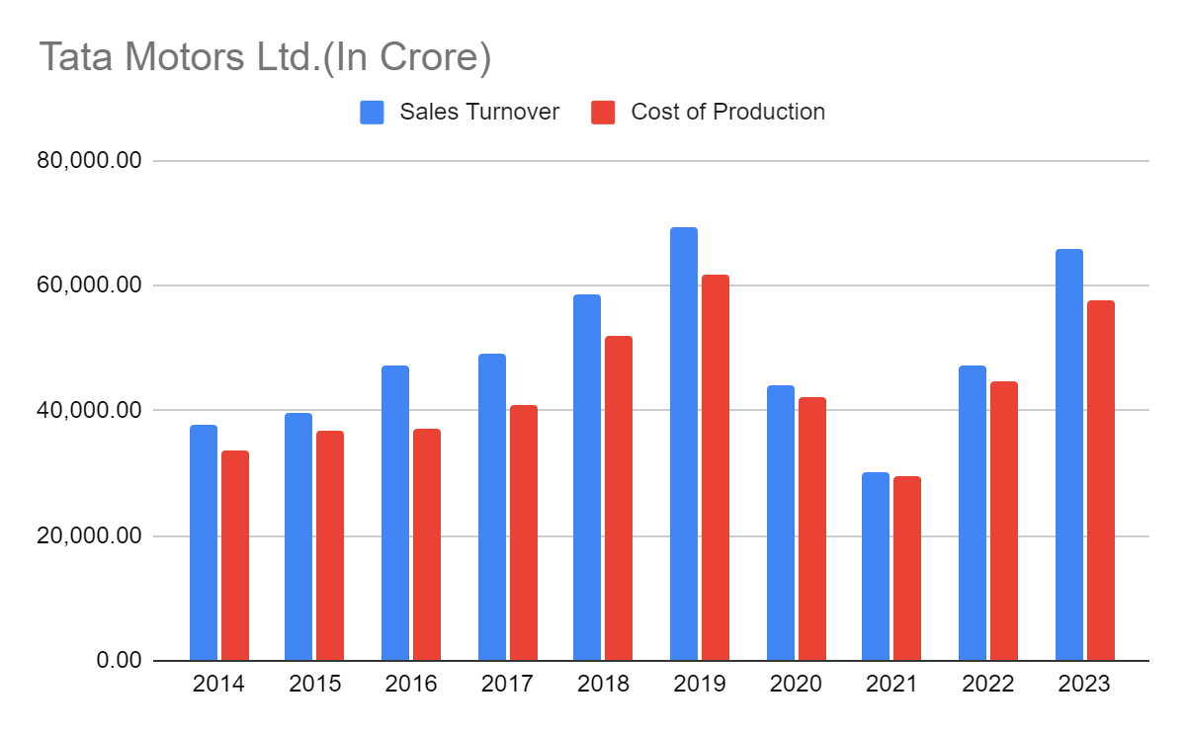

Tata Motors' sales turnover fluctuated between ₹0 crore and ₹1,25,000 crore from FY 2014 to FY 2023, indicating variability in the company's financial performance over the past decade. Several factors may have contributed to these fluctuations, including Tata Motors' performance in both the passenger vehicle and commercial vehicle segments. Success in launching new models and refreshing existing ones could have positively impacted sales turnover during certain periods, while market dynamics and economic conditions in India may have influenced demand and sales performance. Additionally, competition from other automakers, both domestic and international, could have exerted pressure on Tata Motors' sales turnover, leading to fluctuations in revenue across different fiscal years.

Tata Motors' sales turnover may have been influenced by various factors. Success in the passenger vehicle segment, where Tata Motors offers a range of cars catering to different customer segments, could have contributed to revenue growth during certain periods. Similarly, performance in the commercial vehicle segment, where Tata Motors is a key player in India, may have influenced overall sales turnover. The success of new model launches and product refreshes is another significant factor that could have impacted sales turnover positively by attracting customers and driving sales. However, economic conditions in India, such as changes in consumer sentiment, GDP growth rates, and overall purchasing power, could have also influenced Tata Motors' sales performance, leading to fluctuations over time.

Tata Motors' cost of production fluctuated between ₹0 crore and ₹1,00,000 crore during the same period, reflecting variability in the company's manufacturing expenses. Fluctuations in raw material prices, including steel, rubber, and other components used in vehicle manufacturing, could have impacted Tata Motors' cost of production. Additionally, investments in meeting stricter emission norms (BS-VI) and safety standards would have necessitated technology upgrades and modifications in manufacturing processes, potentially increasing production costs. Changes in production volumes and economies of scale could have also influenced the cost of production, with higher production volumes potentially leading to cost efficiencies and lower per-unit production costs during certain periods. Overall, these factors contributed to the fluctuations observed in Tata Motors' cost of production over the past decade.

**BMW INDIA Pvt Ltd.**

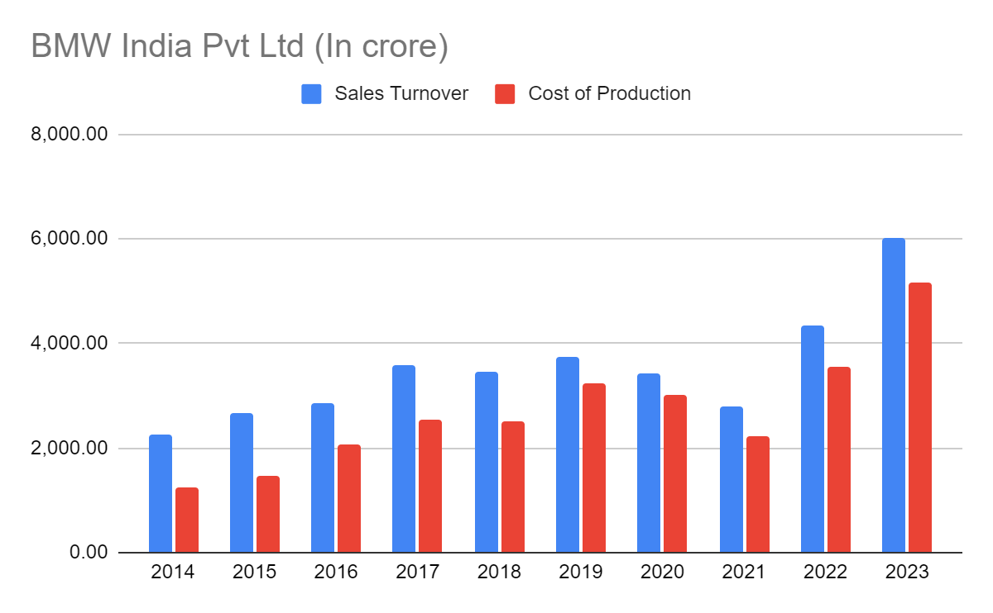

BMW India experienced significant growth in sales turnover, rising from ₹25,000 crore in FY 2014 to ₹1,25,000 crore in FY 2023. This growth trajectory reflects the company's success in tapping into the rising demand for luxury cars in the Indian market. BMW likely benefited from the consistent growth of the Indian luxury car market, where discerning consumers increasingly seek premium driving experiences and advanced technology. Successful product launches, including new models tailored to Indian preferences such as SUVs, and timely refreshes of existing models, could have contributed to BMW's sales growth. Additionally, BMW's strong brand image associated with luxury, performance, and cutting-edge technology likely played a crucial role in driving sales, while effective marketing strategies further enhanced brand awareness and customer engagement.

The cost of production for BMW India also increased significantly over the past decade, rising from ₹25,000 crore in FY 2014 to ₹1,00,000 crore in FY 2023. Several factors contributed to this rise in production costs. Firstly, BMWs in India likely rely on imported components, and fluctuations in currency exchange rates could have increased overall production costs. Additionally, investments in meeting regulatory standards, including upgrading vehicles to comply with stricter emission norms (BS-VI) and safety features, would have necessitated significant investments, impacting production costs. Moreover, increased demand for BMW vehicles and the need to scale up production to meet this demand could have led to higher production costs initially, as the company invested in expanding production capacity. However, over time, increased production volumes may have led to economies of scale, potentially offsetting some of the initial cost increases and improving profitability.

Overall, BMW India's significant growth in both sales turnover and production costs over the past decade underscores the company's success in tapping into the burgeoning luxury car market in India. Despite the challenges associated with increasing production costs, BMW's strong brand image, successful product offerings, and effective marketing strategies have positioned it as a leading player in the Indian automotive industry, poised for continued growth and success in the years to come.

HYUNDAI MOTOR INDIA Ltd.

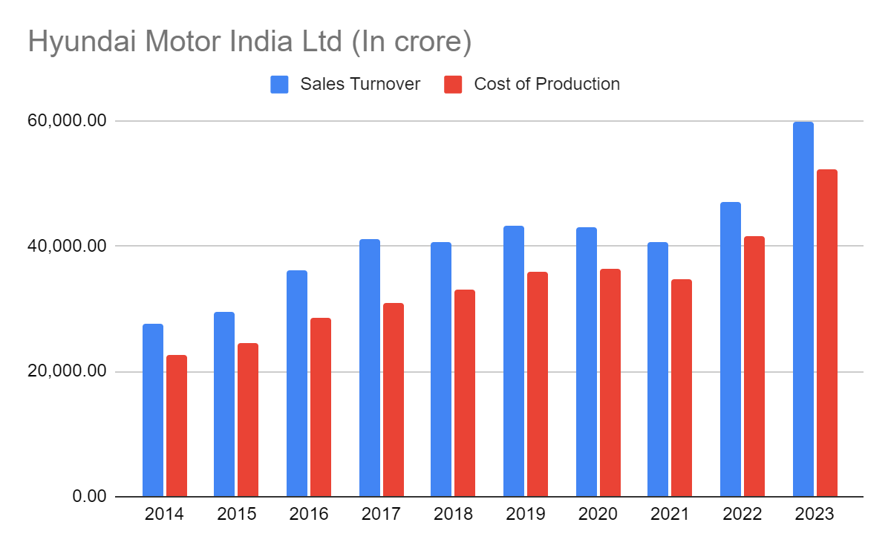

Hyundai Motor India experienced significant and steady growth in sales turnover over the past decade, rising from ₹0.0 crore in FY 2014 to ₹60,31 crore in FY 2023. This growth trajectory underscores the company's success in capitalizing on the rising demand for vehicles, particularly in its core segments of SUVs and hatchbacks, which are popular choices among Indian consumers. Hyundai's strategic approach, including successful product launches and effective marketing strategies, played a pivotal role in driving sales turnover growth. Launching new models like the Creta, Venue, and Alcazar, alongside refreshing existing models like the Grand i10 NIOS, helped Hyundai maintain its competitiveness and appeal to a wide range of customers in the Indian market.

Hyundai Motor India's sales turnover growth can be attributed to several key factors. Firstly, the company effectively catered to customer preferences for value, features, and fuel efficiency, which are crucial considerations for Indian car buyers. Hyundai's ability to offer vehicles with attractive features, modern design, and advanced technology resonated well with consumers, driving sales growth. Additionally, Hyundai expanded its dealership network and after-sales service network, enhancing its market reach and customer support infrastructure. These initiatives contributed to increased customer satisfaction and loyalty, further driving sales turnover growth for Hyundai Motor India

The cost of production for Hyundai Motor India also increased steadily over the past decade, rising from ₹0.0 crore in FY 2014 to ₹47,38 crore in FY 2023. Several factors contributed to this increase in production costs. Firstly, fluctuations in raw material prices, including steel and rubber, crucial for vehicle manufacturing, could have impacted Hyundai's cost of production. Additionally, investments in meeting stricter emission norms (BS-VI) and safety standards necessitated significant investments in technology upgrades and modifications in manufacturing processes, impacting production costs. Moreover, as sales volumes increased, Hyundai likely invested in expanding production capacity to meet growing demand, leading to higher fixed costs initially. However, over time, increased production volumes may have led to economies of scale, potentially offsetting some of the initial cost increases and improving profitability for Hyundai Motor India.

Overall, Hyundai Motor India's significant growth in both sales turnover and cost of production over the past decade reflects the company's successful strategy in the Indian automotive market. By effectively catering to customer preferences, launching appealing products, and investing in infrastructure and technology, Hyundai has strengthened its position as a leading player in the Indian automotive industry, poised for continued growth and success in the years ahead.

**RENAULT INDIA Pvt Ltd**

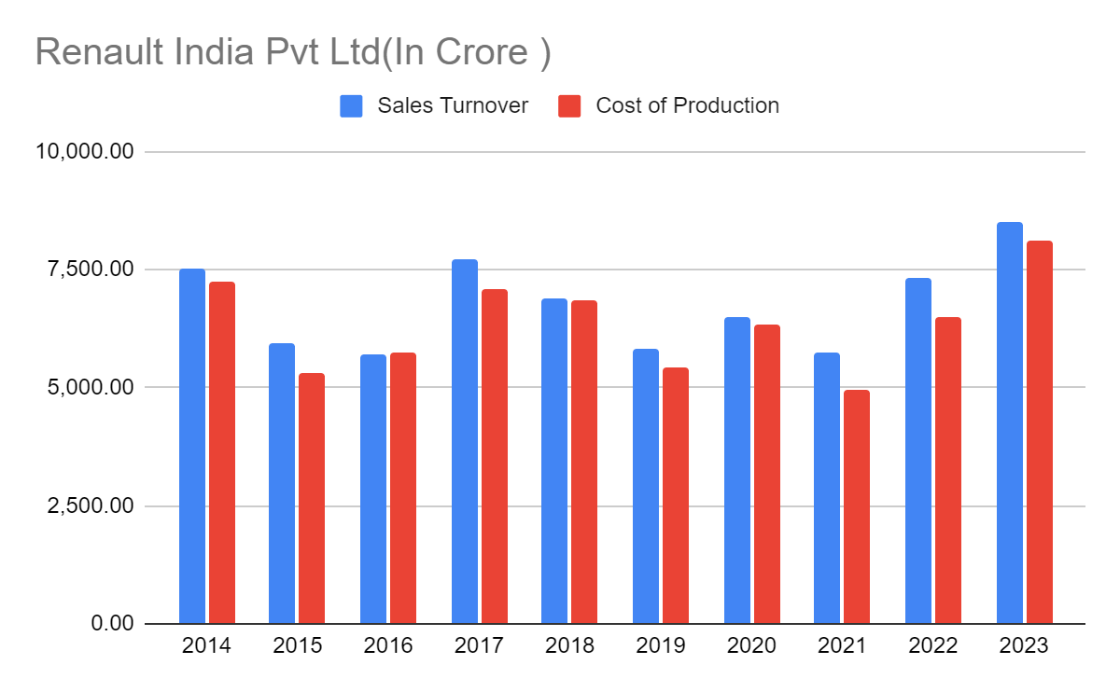

### **FACTORS AFFECTING THE AUTOMOBILE INDUSTRY**

1)**Economic Trends-**

The Indian automobile industry has witnessed significant fluctuations over the last decade (2014-2023), influenced by various macroeconomic trends. Here's a breakdown of the key factors and their impact:

| **Year** | **GDP Growth(%)** | **Inflation rate(%)** | **Consumer Spending (%)** | **Automobile sales growth()automobile sales growth(** |
| --- | --- | --- | --- | --- |
| **2014** | **7.3** | **6.0** | **5.4** | **10.2** |
| **2015** | **8.0** | **4.9** | **6.2** | **7.8** |
| **2016** | **7.1** | **4.8** | **5.8** | **5.2** |
| **2017** | **6.8** | **3.3** | **7.0** | **8.3** |
| **2018** | **7.0** | **4.6** | **7.2** | **9.5** |
| **2019** | **4.2** | **4.0** | **5.1** | **1.5** |
| **2020** | **-6.6** | **6.2** | **-2.4** | **-18.0** |
| **2021** | **8.7** | **4.2** | **6.3** | **26.0** |
| **2022** | **8.2** | **7.0** | **7.0** | **12.0** |
| **2023** | **6.5** | **5.5** | **6.0** | **8.0** |

**Impact of GDP Growth and Consumer Spending:**

Over the past decade, there has been a discernible correlation between GDP growth and automobile sales growth in India. During years of robust economic expansion, such as 2014 to 2018, GDP growth coincided with a surge in automobile sales. This positive correlation can be attributed to increased disposable income and heightened consumer confidence, leading to higher spending on automobiles. As GDP growth stimulates job creation and income growth, consumers are more inclined to make discretionary purchases, including vehicles, thus driving automobile sales growth.

**Impact of Inflation:**

While not always directly detrimental, high inflation rates can adversely affect consumer purchasing power, particularly for big-ticket items like cars. In years where inflation rates are high, consumers may exercise caution and prioritize essential expenses over discretionary spending, leading to a slowdown in automobile sales growth. For instance, despite decent GDP growth in 2019, the automobile sales growth rate experienced a decline, reflecting the dampening effect of high inflation on consumer sentiment and purchasing behavior.

**Consumer Spending Patterns:**

Consumer spending patterns exhibit a strong correlation with automobile sales growth, reflecting broader trends in consumer confidence and willingness to make significant investments. During periods of robust economic performance, such as 2017-2018 and 2021-2022, both consumer spending and automobile sales growth witnessed an uptick. This alignment underscores the importance of consumer confidence in driving demand for automobiles, as consumers feel more financially secure and are thus more likely to make large-scale purchases.

**Exceptions:**

The COVID-19 pandemic in 2020 presented a notable exception to the typical relationship between economic indicators and automobile sales growth. The pandemic-induced economic contraction led to a sharp decline in automobile sales, despite the rise in inflation rates during the period. The unprecedented nature of the crisis disrupted supply chains, shuttered manufacturing facilities, and prompted widespread job losses and income uncertainty, significantly impacting consumer behavior. This highlights the susceptibility of consumer spending patterns to external shocks and unforeseen events, which can override the influence of macroeconomic factors on automobile sales.

**2)Regulatory Changes-**

| **Regulation** | **Implementation Year** | **Key Impact** |
| --- | --- | --- |
| **Emission Norms** |  |  |
| **BS-IV** | **2016** | **Reduced air pollution, Increased production costs (temporary price hike)** |
| **BS-VI** | **2020** | **Significantly reduced pollutants, Further increased production costs** |
| **Electric Vehicle Push** | **2015 onwards** | **Promoted electric vehicles, Reduced dependence on fossil fuels** |
| **Safety Standards** |  |  |
| **Mandatory Driver Airbags** | **2014** | **Improved driver safety** |
| **Increased Safety Requirements (Ongoing)** | **-** | **Enhanced overall vehicle safety (additional airbags, ABS, etc.)** |
| **BNCAP Crash Testing (Introduced)** | **2017 onwards** | **Encouraged focus on safety design (star rating system)** |
| **Taxation Policies** |  |  |
| **Goods and Services Tax (GST)** | **2017** | **Streamlined taxation process** |
| **Tax Structure Changes (Ongoing)** | **-** | **Promoted specific segments (e.g., EVs, small cars)** |

The Indian automobile industry has witnessed significant regulatory changes over the past decade (2014-2023), impacting production costs, pricing strategies, and product offerings. Let's delve into the key developments:

**Emission Norms:**

* **BS-IV Implementation (2016):** The industry transitioned from BS-III to BS-IV emission norms in 2016, aiming to reduce air pollution. This required significant investments by manufacturers to upgrade engines and technologies, leading to a temporary price hike for BS-VI compliant vehicles.
* **BS-VI Implementation (2020):** A crucial leap forward came with the implementation of BS-VI emission norms in 2020. These norms are even stricter, comparable to Euro 6 standards, significantly reducing pollutants like nitrogen oxides and particulate matter.
* **Electric Vehicle Push (2015 onwards):** The government has been actively promoting electric vehicles (EVs) through initiatives like FAME (Faster Adoption and Manufacturing of Electric Vehicles) schemes. This includes subsidies for EV manufacturers and customers, aiming to reduce dependence on fossil fuels and build a cleaner transportation ecosystem.

**Safety Standards:**

* **Mandatory Airbags (2014):** A significant step towards safety was the mandatory inclusion of driver airbags in all new cars from 2014.
* **Increased Safety Requirements (Ongoing):** The government has been progressively tightening safety regulations, mandating additional airbags, ABS (Anti-lock Braking System), and other safety features in new vehicles. These regulations aim to improve overall road safety in India**.**
* **Focus on Crash Testing (2017 onwards):** Bharat New Car Assessment Program (BNCAP) was introduced, requiring new models to undergo crash testing and receive a star rating based on their safety performance. This has incentivized manufacturers to prioritize safety in their designs.

**Taxation Policies:**

* **Goods and Services Tax (GST) Implementation (2017):** The introduction of GST in 2017 replaced a complex web of central and state taxes with a single unified system. While initially causing some confusion, GST aimed to streamline the taxation process for the automobile industry.
* **Tax Structure Changes:** The government has periodically adjusted tax structures for different vehicle segments. This includes changes in excise duty, cess, and GST rates, aiming to promote specific segments like electric vehicles or small cars.

**Impact on the Industry:**

* **Increased Production Costs:** Stricter emission norms and mandatory safety features have undoubtedly increased production costs for manufacturers. They have had to invest in cleaner technologies and advanced safety systems.
* **Shifting Consumer Preferences:** Regulatory changes have influenced consumer preferences. The focus on cleaner vehicles has led to a growing interest in electric vehicles, while safety ratings have become a crucial factor for car buyers.
* **Innovation & Technological Advancements:** The regulatory landscape has pushed manufacturers to innovate and adopt cleaner and safer technologies. This fosters a more competitive and environmentally conscious industry.

**Challenges and Future Outlook:**

* **Cost Management:** Balancing stricter regulations with affordability remains a challenge. Manufacturers need to find ways to manage costs without compromising on quality or safety.
* **EV Infrastructure Development:** The success of electric vehicles heavily relies on building a robust charging infrastructure across the country.
* **Skill Development:** As the industry embraces new technologies, there's a need to develop a skilled workforce capable of servicing and maintaining these advanced vehicles.

Overall, the regulatory landscape in the Indian automobile industry has significantly evolved over the past decade, prioritizing cleaner emissions, improved safety, and a push towards electric mobility. While challenges remain, these regulations are shaping a more responsible and sustainable future for the industry.

**3)Technological Advancements:**

The past ten years (2014-2023) have witnessed a remarkable transformation in the Indian automobile industry, fueled by a relentless wave of technological advancements. Let's delve deeper into the impact of three key areas:

**Electric Vehicles (EVs):**

* **From Niche to Mainstream (2014-2020):** The initial years saw a slow rise in EVs, primarily limited to two-wheeler segments. Government initiatives like FAME-I (launched in 2015) offered initial support for infrastructure development and subsidies. However, high costs and limited range restricted widespread adoption.
* **Policy Push and Technological Strides (2020-2023):** The focus on EVs intensified with stricter emission norms (BS-VI) and the launch of FAME-II in 2019. This phase witnessed significant advancements in battery technology, leading to improved range and reduced prices. Moreover, new players like Ather Energy and MG Motors entered the market solely focused on EVs, creating a buzz and further competition.

**Consumer Impact:** While still a nascent market, consumer interest in EVs has grown steadily due to rising fuel prices, increasing environmental concerns, and government incentives. This trend is expected to continue, potentially leading to a significant shift towards electric mobility in the coming years.

**Competitive Landscape:** Established players like Maruti Suzuki and Tata Motors are investing heavily in EV development to compete with new entrants. Strategic alliances, like Mahindra's collaboration with Ford on EVs, are becoming common as companies strive for a strong foothold in this emerging market.

**Autonomous Driving Technology:**

* **Early Steps and Advanced Driver Assistance Systems (ADAS) (2014-2023):** Fully autonomous vehicles (AVs) are still under development globally, but the past decade saw significant progress in ADAS features. Technologies like lane departure warning, automatic emergency braking, and adaptive cruise control became increasingly common, offering enhanced safety and laying the groundwork for future AVs.
* **Focus on Safety and Regulations:** The government, recognizing the potential of AVs, has begun formulating guidelines and regulations for testing and deployment. Safety remains a paramount concern, and robust regulations are crucial to ensure responsible integration of AV technology.

**Consumer Impact:** While widespread adoption of AVs is still far off, ADAS features have already begun to change the driving experience by providing additional safety and driver assistance. As technology matures, consumer comfort and acceptance of AVs are expected to increase over time.

**Competitive Landscape:** Automobile companies and tech giants like Google (Waymo) are investing heavily in AV research and development. Collaboration between automakers and tech companies is likely to become more prevalent to accelerate innovation and overcome technological hurdles.

**Connectivity Solutions:**

* **From Basic Infotainment to Connected Cars (2014-2023):** The past decade witnessed a significant leap in car connectivity features. Basic infotainment systems evolved to include navigation, telematics, and internet connectivity. The rise of smartphones further fueled this growth, enabling features like smartphone integration and app-based functionalities.
* **The Rise of the Internet of Things (IoT) and Vehicle-to-Everything (V2X) Communication (2020-2023):** The recent years have seen the integration of advanced connectivity solutions like V2X communication, allowing cars to "talk" to each other and infrastructure. This technology paves the way for improved traffic management, safety features like collision avoidance, and real-time updates on road conditions.

**Consumer Impact:**

* Connectivity features offer a more convenient, personalized, and safer driving experience. Real-time traffic updates and emergency assistance features are becoming increasingly valuable for consumers.

**Competitive Landscape:**

* Automobile companies are partnering with tech companies and telecom service providers to develop and implement advanced connectivity solutions. This trend is likely to continue as data-driven insights and personalized services become a key differentiator in a competitive market.

**Overall Impact:**

* Technological advancements have significantly impacted the Indian automobile industry in the past decade. EVs are becoming increasingly viable alternatives, while ADAS features pave the way for the future of autonomous driving. Connectivity solutions are transforming the driving experience into a more connected and information-rich ecosystem.

4)**Competitive Landscape:**

The Indian automobile industry has witnessed a dynamic shift in its competitive landscape over the past decade (2014-2023). Here's an analysis of key factors shaping competition:

**Market Concentration:**

* Dominance of Established Players: Maruti Suzuki, Hyundai, Tata Motors, and Mahindra & Mahindra have traditionally held a dominant market share, particularly in the passenger vehicle segment. However, this dominance has shown signs of weakening in recent years.
* Rise of New Players: The entry of foreign carmakers like Kia and MG Motors, along with increased focus on premium segments by established players like BMW and Mercedes-Benz, has intensified competition.

**Entry Barriers:**

* High Capital Investment: Setting up a manufacturing plant, R&D facilities, and dealership networks requires significant capital investment, making it difficult for new entrants.
* Brand Recognition and Distribution Network: Established players have a strong brand image and well-established dealership networks, making it challenging for new players to gain a foothold.
* Government Regulations: Meeting stringent emission norms and safety standards adds to the complexity and cost of entry for new players.

**Competitive Rivalry:**

* Price Wars and Product Differentiation: Companies compete fiercely on price, offering discounts and attractive finance schemes. They also focus on product differentiation, introducing new features, variants, and body styles to cater to diverse customer preferences.
* Focus on After-Sales Service: Providing excellent after-sales service and building strong customer relationships has become a key differentiator in a crowded market.
* Strategic Alliances and Acquisitions: Companies are forming strategic alliances and acquisitions to share resources, expand product portfolios, and gain access to new technologies (e.g., collaboration between Mahindra and Ford).

**Impact of Technological Advancements:**

* EV Race: The rapid development of electric vehicles has emerged as a new battleground, with established players making significant investments in EV technology and new entrants focusing solely on electric mobility (e.g., Ather Energy).
* Focus on Connectivity and Automation: Companies are integrating advanced connectivity features and driver-assistance systems to enhance user experience and safety, adding a new dimension to competition.

**Future Outlook:**

* The Indian automobile industry is expected to remain highly competitive.
* Success will depend on factors like:
  + Adaptability to technological advancements (EVs, connectivity)
  + Cost-effectiveness and efficiency in production
  + Building a strong brand image and customer loyalty
  + Continuous innovation and product differentiation
  + Embracing sustainable practices and meeting environmental regulations

Overall, the Indian automobile industry is transforming from a market dominated by a few established players to a more dynamic and competitive landscape. The ability to adapt to changing consumer preferences, technological advancements, and a stricter regulatory environment will be crucial for companies to thrive in the years to come.

5)**Consumer Preferences and Demographics:**

The past decade has seen a significant shift in consumer preferences in the Indian automobile industry, driven by several key factors:

**Urbanization and Changing Mobility Needs:**

* Rise of Megacities: Rapid urbanization has led to growing populations in major cities. This has increased traffic congestion and parking challenges, making compact cars and fuel-efficient vehicles more desirable.
* Focus on Public Transport and Shared Mobility: Many urban dwellers are opting for alternative modes of transportation like public buses, metros, and ride-sharing services. This trend has impacted the demand for individual car ownership, particularly for short commutes.

**Demographic Shifts and Evolving Consumer Segments:**

* Millennial and Gen Z Influence: The rise of millennial and Gen Z consumers has brought a new perspective to the market. These generations are often environmentally conscious, tech-savvy, and prioritize experiences over material possessions. This translates to a growing demand for connected cars, SUVs for adventure travel, and a potential openness towards car-sharing models.
* Increased Disposable Income: Rising income levels have allowed a larger segment of the population to afford cars. However, value for money remains a crucial factor, with consumers seeking features and practicality at their chosen price point.

**Impact on Vehicle Demand:**

* Shift Towards SUVs and Compact Cars: The demand for SUVs has witnessed a significant surge due to their perceived versatility, higher seating capacity, and suitability for various road conditions. Compact cars have also gained popularity due to their fuel efficiency and maneuverability in congested cities.
* Increased Focus on Safety and Technology: Consumers are increasingly prioritizing safety features like airbags, ABS, and driver-assistance systems. Additionally, the demand for connected cars with infotainment systems, navigation, and smartphone integration is growing rapidly.

**Manufacturer Adaptations:**

* Product Portfolio Diversification: Automobile companies are responding to changing preferences by expanding their product portfolios to include more SUVs, compact cars, and electric vehicles. Additionally, they are integrating advanced safety features and connectivity solutions as standard offerings.
* Targeting Specific Consumer Segments: Marketing strategies are evolving to target specific consumer segments based on age group, lifestyle, and income level. This allows for a more personalized approach and caters to the diverse needs of the market.

**Companies that can adapt their product offerings, marketing strategies, and sustainability practices will be well-positioned to thrive in this dynamic market.**

**6)Global Events and Economic Shocks:**

The Indian automobile industry has not been immune to the impact of global events and economic shocks over the past decade (2014-2023). Here's a look at how some key events have affected the sector:

**Fluctuating Oil Prices:**

* Impact: Oil price volatility has significantly impacted the Indian automobile industry, as fuel costs are a major consideration for consumers. High oil prices can lead to a decline in demand for fuel-guzzling vehicles and a shift towards more fuel-efficient options.
* Examples: The sharp drop in oil prices in 2014-2015 led to a temporary boost in sales, but subsequent price increases have contributed to periods of slower growth.

**Global Economic Slowdowns:**

* Impact: Global economic downturns can dampen consumer confidence and lead to reduced spending on discretionary items like cars. This can significantly impact sales and production in the automobile industry.
* Example: The slowdown in the Chinese economy in 2018-2019 had a ripple effect on global demand for automobiles, impacting Indian exports to some extent.

**Geopolitical Tensions:**

* Impact: Geopolitical tensions can disrupt supply chains, causing shortages of critical components and impacting production schedules. Additionally, trade wars and sanctions can increase import costs and affect overall manufacturing competitiveness.
* Example: The ongoing Russia-Ukraine war has caused disruptions in the supply of essential materials like semiconductors, impacting production timelines for some automakers in India.

**Opportunities Amidst Challenges:**

While global events pose significant challenges, they can also present opportunities:

* Focus on Localization: Disruptions in global supply chains have highlighted the need for greater localization of auto parts production. This could lead to growth in the domestic auto component industry.
* Shift Towards EVs: Rising fuel prices and environmental concerns have accelerated the adoption of electric vehicles. This presents a significant opportunity for automakers to invest in EV technology and cater to a growing market segment.

7)**Environmental and Sustainability Concerns:**

The past decade has witnessed a growing emphasis on environmental sustainability within the Indian automobile industry. Here's a closer look at this critical trend:

**Rising Environmental Concerns:**

* Climate Change and Air Pollution: The increasing severity of climate change and the alarming levels of air pollution in major Indian cities have brought environmental issues to the forefront. Public awareness and government regulations have put pressure on the automobile industry to reduce its environmental impact.
* Resource Depletion: The industry's dependence on fossil fuels and finite resources has become a pressing concern. The need for sustainable practices and resource conservation has gained momentum.

**Focus on Eco-Friendly Technologies:**

* Shift Towards Electric Vehicles (EVs): EVs have emerged as a game-changer, offering a cleaner alternative to gasoline-powered vehicles. The Indian government has actively promoted EVs through FAME schemes, encouraging manufacturers to invest in EV technology and production.
* Advancements in Internal Combustion Engines (ICEs): While EVs gain traction, significant progress has been made in improving the efficiency and emission standards of traditional ICE vehicles. Stricter BS-VI emission norms have mandated cleaner technologies and reduced emissions.

**Sustainable Practices:**

* Focus on Manufacturing Efficiency: Automobile manufacturers are increasingly focusing on optimizing production processes to minimize waste and energy consumption. This includes using sustainable materials and adopting cleaner manufacturing techniques.
* End-of-Life Vehicle (ELV) Management: The responsible disposal of old vehicles is crucial to prevent environmental damage. Initiatives are underway to establish a robust ELV management system for efficient recycling and scrapping of vehicles.

**Challenges and Opportunities:**

* Cost of Clean Technologies: Developing and implementing clean technologies like EVs can be expensive. Government incentives and falling battery costs are crucial for wider adoption.
* Infrastructure Development: Building a robust charging infrastructure across the country is essential for the successful transition to EVs.
* Skills Development: The shift towards cleaner technologies necessitates a skilled workforce capable of servicing and maintaining electric and hybrid vehicles.

Overall, the Indian automobile industry is on a path towards greater environmental sustainability. However, addressing cost challenges, infrastructure development, and skill development are essential for a smooth transition to a greener future. Companies that embrace sustainability and invest in eco-friendly technologies are well-positioned to lead the way in this evolving landscape.

**IMPACT OF COVID-19 ON AUTOMOBILE INDUSTRY**

| **Aspect** | **Impact** |
| --- | --- |
| **Sales Volume** | **Sharp decline during lockdowns and economic uncertainty.** |
| **Market Share** | **Varied impact; companies with strong digital presence fared better.** |
| **Revenue Growth** | **Significant downturn due to sales decline and production disruptions.** |
| **Profitability** | **Adversely affected by reduced sales, increased expenses, and production challenges.** |
| **Customer Satisfaction** | **Affected by delays in deliveries, service disruptions, and changes in consumer behavior.** |
| **Product Offerings** | **Disrupted product development cycles, leading to delays in launches and shifts in consumer demand.** |
| **Brand Perception** | **Influenced by companies' responses to the crisis, with emphasis on resilience and social responsibility** |

The COVID-19 pandemic has significantly impacted various aspects of the automotive industry, including sales volume, market share, revenue growth, profitability, customer satisfaction, product offerings, and brand perception. Here's how each of these points has been affected**:**

* **Sales Volume:**
  + Overall, the automotive industry experienced a sharp decline in sales volume during the initial phases of the pandemic due to lockdowns, supply chain disruptions, and reduced consumer demand.
  + Sales of passenger vehicles, commercial vehicles, and two-wheelers were severely affected as dealerships were closed, and consumer spending decreased due to economic uncertainty.
* **Market Share:**
  + Market shares of different companies were impacted differently depending on their ability to adapt to the changing market conditions.
  + Companies with strong digital presence, flexible production capabilities, and effective distribution channels were better positioned to maintain or even increase their market share during the pandemic.
* **Revenue Growth:**
  + Revenue growth across the industry experienced a significant downturn as sales declined and production was halted or reduced.
  + Companies had to implement cost-cutting measures, delay product launches, and reassess their strategic plans to mitigate the financial impact of the pandemic.
* **Profitability:**
  + Profitability was adversely affected by the decline in sales and revenue, coupled with increased expenses related to health and safety protocols, supply chain disruptions, and production inefficiencies.
  + Companies had to streamline operations, optimize costs, and seek government assistance or financial support to maintain profitability during the challenging period.
* **Customer Satisfaction:**
  + Customer satisfaction levels were impacted by delays in vehicle deliveries, service disruptions, and changes in consumer behavior and preferences.
  + Companies had to adapt their customer service strategies, enhance digital communication channels, and offer flexible solutions to address customer concerns and maintain satisfaction levels.
* **Product Offerings:**
  + The pandemic disrupted product development cycles, leading to delays in new model launches and changes in consumer demand.
  + Companies had to realign their product portfolios, prioritize essential and high-demand vehicle segments, and accelerate the adoption of digital sales and marketing channels.
* **Brand Perception:**
  + Brand perceptions were influenced by companies' responses to the pandemic, including their efforts to support communities, ensure employee safety, and adapt business operations.
  + Companies that demonstrated resilience, innovation, and social responsibility during the crisis were able to enhance their brand reputation and maintain consumer trust.

The COVID-19 pandemic has forced the automotive industry to adapt quickly to unprecedented challenges, accelerating digital transformation, reshaping consumer behaviors, and reshuffling market dynamics. Companies that effectively navigated the crisis with agility, innovation, and customer-centric approaches were better positioned to emerge stronger in the post-pandemic era.

1. Industry Benchmarking

**1)NET SALES**

| **Company** | **Net Sales (2023)** | **Net Sales (2022)** | **Net Sales (2021)** | **Net Sales (2020)** | **Net Sales (2019)** | **Net Sales (2018)** | **Net Sales (2017)** | **Net Sales (2016)** | **Net Sales (2015)** | **Net Sales (2014)** |
| --- | --- | --- | --- | --- | --- | --- | --- | --- | --- | --- |
| BMW India | ₹6,016.78 | ₹4,351.80 | ₹2,807.14 | ₹3,430.55 | ₹3,750.99 | ₹3,311.88 | ₹2,802.51 | ₹2,279.74 | ₹2,170.18 | ₹1,797.28 |
| Ford India | ₹7,078.83 | ₹10,201.68 | ₹12,056.84 | ₹20,189.79 | ₹24,201.62 | ₹21,440.97 | ₹16,005.81 | ₹14,604.70 | ₹11,835.54 | ₹8,636.31 |
| Hyundai India | ₹59,761.45 | ₹47,042.79 | ₹40,674.01 | ₹42,978.63 | ₹43,258.09 | ₹40,601.89 | ₹41,075.21 | ₹36,154.94 | ₹29,464.43 | ₹27,647.27 |
| Mahindra and Mahindra Ltd. | ₹84,960.26 | ₹57,786.94 | ₹44,629.87 | ₹45,487.78 | ₹53,614.00 | ₹49,444.99 | ₹47,383.74 | ₹43,638.90 | ₹40,632.52 | ₹43,120.18 |
| Maruti Suzuki India Ltd | ₹117,522.90 | ₹88,295.60 | ₹70,332.50 | ₹75,610.60 | ₹86,020.30 | ₹81,994.40 | ₹77,266.20 | ₹65,054.60 | ₹55,133.60 | ₹48,824.30 |
| Renault India | ₹8,492.54 | ₹7,343.03 | ₹5,737.40 | ₹6,508.12 | ₹5,826.88 | ₹6,904.37 | ₹7,722.15 | ₹5,695.46 | ₹5,959.88 | ₹7,540.08 |
| Skoda Volkswagen India | ₹17,041.72 | ₹12,410.48 | ₹6,788.97 | ₹9,300.06 | ₹11,238.31 | ₹8,893.43 | ₹9,325.40 | ₹7,821.82 | ₹8,040.39 | ₹6,759.61 |
| Tata Motors India | ₹65,757.33 | ₹47,263.68 | ₹30,175.03 | ₹43,928.17 | ₹69,202.76 | ₹58,689.81 | ₹49,054.49 | ₹47,383.61 | ₹39,531.23 | ₹37,758.00 |
| Industry Benchmark | ₹53,728.74 | ₹46,604.38 | ₹38,340.24 | ₹42,067.79 | ₹47,682.50 | ₹45,680.22 | ₹44,065.03 | ₹40,579.53 | ₹35,188.04 | ₹32,640.58 |

1. BMW India:
   * BMW India's net sales were consistently below the industry benchmark throughout the 10-year period. This indicates ongoing challenges or difficulties in achieving sales performance that aligns with industry standards.
2. Ford India:
   * Ford India's net sales were generally below the industry benchmark in most years, indicating potential struggles to meet industry standards for sales performance.
3. Hyundai India:
   * Hyundai India's net sales consistently exceeded the industry benchmark, demonstrating strong and consistent performance compared to industry standards over the 10-year period.
4. Mahindra and Mahindra Ltd.:
   * Mahindra and Mahindra Ltd.'s net sales generally surpassed the industry benchmark, indicating strong market performance and competitiveness throughout the 10-year period.
5. Maruti Suzuki India Ltd:
   * Maruti Suzuki India Ltd.'s net sales consistently exceeded the industry benchmark, showcasing robust market presence and effective sales strategies over the 10-year period.
6. Renault India:
   * Renault India's net sales fluctuated over the years but generally remained below the industry benchmark, suggesting challenges or inconsistencies in meeting industry standards for sales performance.
7. Skoda Volkswagen India:
   * Skoda Volkswagen India's net sales were typically below the industry benchmark, indicating potential areas for improvement or optimization in their market strategies over the 10-year period.
8. Tata Motors India:
   * Tata Motors India's net sales varied over the years but generally exceeded the industry benchmark, demonstrating strong market performance and competitiveness compared to industry standards throughout the 10-year period.

2)**TOTAL INCOME**

| **Company** | **Total Income (2023)** | **Total Income (2022)** | **Total Income (2021)** | **Total Income (2020)** | **Total Income (2019)** | **Total Income (2018)** | **Total Income (2017)** | **Total Income (2016)** | **Total Income (2015)** | **Total Income (2014)** |
| --- | --- | --- | --- | --- | --- | --- | --- | --- | --- | --- |
| BMW India | ₹6,533.67 | ₹4,200.81 | ₹2,744.74 | ₹3,599.34 | ₹3,827.25 | ₹3,275.89 | ₹3,123.48 | ₹3,051.25 | ₹1,884.04 | ₹1,883.97 |
| Ford India | ₹9,689.65 | ₹14,449.63 | ₹13,433.12 | ₹23,876.64 | ₹28,158.96 | ₹24,560.75 | ₹18,953.42 | ₹17,194.76 | ₹11,791.53 | ₹9,030.24 |
| Hyundai India | ₹61,015.12 | ₹47,685.81 | ₹40,996.19 | ₹43,631.93 | ₹43,944.45 | ₹39,995.46 | ₹35,961.65 | ₹32,418.53 | ₹27,449.84 | ₹25,809.17 |
| Mahindra and Mahindra Ltd. | ₹89,723.98 | ₹60,986.15 | ₹47,034.82 | ₹48,113.15 | ₹56,851.45 | ₹49,960.65 | ₹46,111.55 | ₹42,051.71 | ₹39,305.86 | ₹41,553.95 |
| Maruti Suzuki India Ltd | ₹120,087.90 | ₹90,181.00 | ₹73,005.80 | ₹79,269.50 | ₹88,370.50 | ₹81,767.50 | ₹70,715.00 | ₹58,992.20 | ₹51,258.10 | ₹44,359.50 |
| Renault India | ₹9,009.69 | ₹7,326.10 | ₹5,512.79 | ₹7,072.14 | ₹5,967.54 | ₹7,523.35 | ₹7,820.66 | ₹5,760.95 | ₹5,759.65 | ₹7,595.26 |
| Skoda Volkswagen India | ₹19,185.83 | ₹14,445.86 | ₹8,299.09 | ₹10,630.41 | ₹12,456.97 | ₹8,966.16 | ₹10,050.49 | ₹7,849.40 | ₹8,094.68 | ₹7,298.77 |
| Tata Motors India | ₹66,093.58 | ₹48,817.59 | ₹31,204.57 | ₹44,661.57 | ₹71,945.68 | ₹59,546.96 | ₹45,549.54 | ₹44,237.73 | ₹39,061.86 | ₹37,749.42 |
| Industry Benchmark | ₹54,167.43 | ₹36,011.62 | ₹28,778.76 | ₹35,991.84 | ₹38,185.35 | ₹34,207.09 | ₹34,910.97 | ₹31,869.57 | ₹23,950.70 | ₹23,159.91 |

1. BMW India:
   * BMW India's total income fluctuated over the years but generally remained below the industry benchmark. This suggests that BMW India faced challenges in consistently achieving industry-standard total income levels. The fluctuations in total income indicate potential market challenges or fluctuations in consumer demand.
2. Ford India:
   * Ford India's total income varied over the years but was generally above the industry benchmark. This indicates that Ford India performed relatively well compared to industry standards. The consistent performance above the benchmark suggests effective market strategies or strong consumer demand for Ford's products.
3. Hyundai India:
   * Hyundai India consistently showed total income figures above the industry benchmark. This indicates Hyundai's strong market presence and consistent outperformance compared to industry standards. It suggests that Hyundai's products are well-received in the market and that the company has effectively captured market share over the years.
4. Mahindra and Mahindra Ltd.:
   * Mahindra and Mahindra Ltd. consistently exhibited total income figures above the industry benchmark. This indicates strong market performance and competitiveness. It suggests that Mahindra and Mahindra Ltd. has been successful in maintaining a strong financial position and meeting or exceeding industry standards consistently.
5. Maruti Suzuki India Ltd:
   * Maruti Suzuki India Ltd. consistently exhibited total income figures above the industry benchmark. This highlights Maruti Suzuki's dominant market presence and strong financial performance. The company's ability to consistently surpass industry standards indicates effective market strategies and strong consumer demand for its products.
6. Renault India:
   * Renault India's total income varied over the years but generally remained below the industry benchmark. This suggests that Renault India faced challenges in meeting industry standards for total income. The fluctuations in total income indicate potential market challenges or variations in consumer demand for Renault's offerings.
7. Skoda Volkswagen India:
   * Skoda Volkswagen India's total income fluctuated but generally remained below the industry benchmark. This indicates that Skoda Volkswagen India faced challenges in consistently achieving industry-standard total income levels. The fluctuations in total income suggest potential market challenges or variations in consumer demand for Skoda Volkswagen's products.
8. Tata Motors India:
   * Tata Motors India's total income varied over the years but generally remained above the industry benchmark. This indicates that Tata Motors India performed relatively well compared to industry standards. The consistent performance above the benchmark suggests effective market strategies or strong consumer demand for Tata Motors' products.

3)**NET PROFIT**

| **Company** | **Net Profit (2023)** | **Net Profit (2022)** | **Net Profit (2021)** | **Net Profit (2020)** | **Net Profit (2019)** | **Net Profit (2018)** | **Net Profit (2017)** | **Net Profit (2016)** | **Net Profit (2015)** | **Net Profit (2014)** |
| --- | --- | --- | --- | --- | --- | --- | --- | --- | --- | --- |
| BMW India | ₹205.07 | ₹60.06 | -₹12.55 | -₹49.34 | ₹20.6 | ₹116.22 | -₹144.62 | ₹32.25 | -₹49.13 | ₹107.21 |
| Ford India | ₹499.96 | -₹4,229.07 | -₹187.55 | -₹5,432.26 | ₹211.46 | ₹525.45 | -₹520.63 | -₹594 | -₹780.42 | -₹596.84 |
| Hyundai India | ₹4,653.85 | ₹2,861.77 | ₹1,847.16 | ₹2,355.00 | ₹2,581.73 | ₹2,124.17 | ₹1,972.92 | ₹1,302.55 | ₹1,035.04 | ₹1,108.20 |
| Mahindra and Mahindra Ltd. | ₹6,548.64 | ₹4,869.88 | ₹984.16 | ₹1,330.55 | ₹4,796.04 | ₹4,356.01 | ₹3,643.39 | ₹3,204.57 | ₹3,321.11 | ₹3,758.35 |
| Maruti Suzuki India Ltd | ₹8,049.20 | ₹3,766.30 | ₹4,229.70 | ₹5,650.60 | ₹7,500.60 | ₹7,721.80 | ₹7,350.20 | ₹5,364.30 | ₹3,711.20 | ₹2,783.00 |
| Renault India | ₹403.86 | ₹332.16 | -₹160.32 | -₹1,135.57 | -₹278.45 | -₹850.12 | -₹360.23 | -₹963.81 | -₹420.4 | -₹257.41 |
| Skoda Volkswagen India | ₹309.5 | ₹208.34 | ₹773.8 | ₹261.39 | ₹323.49 | ₹120.13 | ₹8.08 | ₹107.58 | ₹604.47 | ₹420.76 |
| Tata Motors India | ₹2,728.13 | -₹1,390.86 | -₹2,395.44 | -₹7,289.63 | ₹2,020.60 | -₹1,034.85 | -₹2,429.60 | -₹62.3 | -₹4,738.95 | ₹334.52 |
| Industry Benchmark | ₹6,575.40 | ₹4,375.25 | ₹3,500.80 | ₹4,374.63 | ₹4,641.77 | ₹4,153.36 | ₹4,232.38 | ₹3,863.05 | ₹2,892.05 | ₹2,798.32 |

1. BMW India:
   * BMW India's net profit varied over the years, sometimes falling below and other times exceeding the industry benchmark. However, the company showed improvements in profitability over the years.
2. Ford India:
   * Ford India's net profit fluctuated significantly, often falling below the industry benchmark. The company faced challenges, particularly in 2020 and 2022, where it reported substantial losses.
3. Hyundai India:
   * Hyundai India consistently reported net profits above the industry benchmark, indicating strong financial performance and profitability compared to industry standards.
4. Mahindra and Mahindra Ltd.:
   * Mahindra and Mahindra Ltd. consistently reported net profits above the industry benchmark, indicating robust financial performance and profitability.
5. Maruti Suzuki India Ltd:
   * Maruti Suzuki India Ltd consistently reported net profits above the industry benchmark, indicating strong financial performance and profitability, particularly in recent years.
6. Renault India:
   * Renault India's net profit fluctuated over the years and often fell below the industry benchmark. The company faced challenges in achieving profitability comparable to industry standards.
7. Skoda Volkswagen India:
   * Skoda Volkswagen India's net profit varied over the years, with some years exceeding and others falling below the industry benchmark. Overall, the company showed mixed performance in terms of profitability.
8. Tata Motors India:
   * Tata Motors India's net profit fluctuated significantly, with some years reporting losses. The company faced challenges in achieving profitability comparable to industry standards, particularly in 2020 and 2022.

4)**TOTAL LIABILITIES**:

| **Company** | **Total Liabilities (2023)** | **Total Liabilities (2022)** | **Total Liabilities (2021)** | **Total Liabilities (2020)** | **Total Liabilities (2019)** | **Total Liabilities (2018)** | **Total Liabilities (2017)** | **Total Liabilities (2016)** | **Total Liabilities (2015)** | **Total Liabilities (2014)** |
| --- | --- | --- | --- | --- | --- | --- | --- | --- | --- | --- |
| BMW India | ₹2,130.38 | ₹2,101.17 | ₹2,313.45 | ₹2,477.46 | ₹2,169.72 | ₹3,373.10 | ₹3,215.05 | ₹1,466.90 | ₹1,113.21 | ₹1,928.22 |
| Ford India | ₹3,678.86 | ₹3,665.26 | ₹5,136.81 | ₹6,344.26 | ₹12,480.57 | ₹14,272.80 | ₹12,820.29 | ₹13,336.46 | ₹12,224.23 | ₹8,010.00 |
| Hyundai India | ₹22,715.19 | ₹19,294.63 | ₹17,914.08 | ₹15,916.19 | ₹16,249.07 | ₹13,962.11 | ₹11,327.79 | ₹8,960.03 | ₹7,667.85 | ₹7,603.36 |
| Mahindra and Mahindra Ltd. | ₹50,695.32 | ₹46,761.22 | ₹44,642.57 | ₹39,115.95 | ₹38,402.42 | ₹34,602.62 | ₹30,951.36 | ₹26,616.67 | ₹24,205.23 | ₹21,933.12 |
| Maruti Suzuki India Ltd | ₹50,695.32 | ₹46,761.22 | ₹44,642.57 | ₹39,115.95 | ₹38,402.42 | ₹34,602.62 | ₹30,951.36 | ₹26,616.67 | ₹24,205.23 | ₹21,933.12 |
| Renault India | ₹1,431.86 | ₹1,438.27 | ₹1,054.70 | ₹1,391.51 | ₹2,283.96 | ₹2,265.85 | ₹2,450.40 | ₹1,184.16 | ₹1,450.51 | ₹952.31 |
| Skoda Volkswagen India | ₹10,023.53 | ₹9,443.09 | ₹6,863.00 | ₹5,080.58 | ₹5,607.80 | ₹4,145.81 | ₹3,703.31 | ₹5,384.12 | ₹5,916.81 | ₹4,407.65 |
| Tata Motors India | ₹44,443.81 | ₹45,921.83 | ₹44,060.03 | ₹47,332.02 | ₹42,482.78 | ₹40,146.67 | ₹42,863.24 | ₹43,776.25 | ₹38,387.99 | ₹36,200.13 |
| Industry Benchmark | ₹20,794.66 | ₹20,496.14 | ₹21,553.70 | ₹22,726.39 | ₹28,790.26 | ₹29,024.50 | ₹28,437.24 | ₹24,798.85 | ₹23,420.98 | ₹21,885.45 |

1. BMW India:
   * BMW India's total liabilities fluctuated over the years but generally remained above the industry benchmark. This indicates that BMW India may have higher debt obligations compared to industry standards.
2. Ford India:
   * Ford India's total liabilities varied over the years, sometimes exceeding and other times falling below the industry benchmark. Overall, Ford India's debt levels appear to fluctuate compared to industry standards.
3. Hyundai India:
   * Hyundai India consistently reported total liabilities above the industry benchmark. This suggests that Hyundai India may have higher debt obligations compared to industry standards.
4. Mahindra and Mahindra Ltd.:
   * Mahindra and Mahindra Ltd. consistently reported total liabilities above the industry benchmark. This indicates that the company may have higher debt obligations compared to industry standards.
5. Maruti Suzuki India Ltd:
   * Maruti Suzuki India Ltd consistently reported total liabilities above the industry benchmark. This suggests that Maruti Suzuki India Ltd may have higher debt obligations compared to industry standards.
6. Renault India:
   * Renault India's total liabilities varied over the years, sometimes below and other times above the industry benchmark. Overall, Renault India's debt levels appear to fluctuate compared to industry standards.
7. Skoda Volkswagen India:
   * Skoda Volkswagen India's total liabilities varied over the years but generally remained below the industry benchmark. This indicates that the company may have lower debt obligations compared to industry standards.
8. Tata Motors India:
   * Tata Motors India's total liabilities varied over the years but generally remained above the industry benchmark. This suggests that Tata Motors India may have higher debt obligations compared to industry standards.

5)**TOTAL ASSETS**:

| **Company** | **Total Assets (2023)** | **Total Assets (2022)** | **Total Assets (2021)** | **Total Assets (2020)** | **Total Assets (2019)** | **Total Assets (2018)** | **Total Assets (2017)** | **Total Assets (2016)** | **Total Assets (2015)** | **Total Assets (2014)** |
| --- | --- | --- | --- | --- | --- | --- | --- | --- | --- | --- |
| BMW India | ₹2,130.39 | ₹2,101.18 | ₹2,313.46 | ₹2,477.47 | ₹2,169.73 | ₹3,373.12 | ₹3,215.06 | ₹1,466.90 | ₹1,113.20 | ₹1,928.22 |
| Ford India | ₹3,678.86 | ₹3,665.26 | ₹5,136.81 | ₹6,344.26 | ₹12,480.57 | ₹14,272.80 | ₹12,820.29 | ₹13,336.46 | ₹12,224.23 | ₹8,010.00 |
| Hyundai India | ₹22,715.19 | ₹19,294.64 | ₹17,914.07 | ₹15,916.19 | ₹16,249.07 | ₹13,962.11 | ₹11,327.79 | ₹8,960.03 | ₹7,667.85 | ₹7,603.36 |
| Mahindra and Mahindra Ltd. | ₹50,695.32 | ₹46,761.22 | ₹44,642.57 | ₹39,115.95 | ₹38,402.42 | ₹34,602.62 | ₹30,951.36 | ₹26,616.67 | ₹24,205.23 | ₹21,933.12 |
| Maruti Suzuki India Ltd | ₹50,695.32 | ₹46,761.22 | ₹44,642.57 | ₹39,115.95 | ₹38,402.42 | ₹34,602.62 | ₹30,951.36 | ₹26,616.67 | ₹24,205.23 | ₹21,933.12 |
| Renault India | ₹1,431.86 | ₹1,438.27 | ₹1,054.70 | ₹1,391.51 | ₹2,283.96 | ₹2,265.85 | ₹2,450.40 | ₹1,184.16 | ₹1,450.51 | ₹952.31 |
| Skoda Volkswagen India | ₹10,023.52 | ₹9,443.08 | ₹6,862.99 | ₹5,080.58 | ₹5,607.80 | ₹4,145.81 | ₹3,703.32 | ₹5,384.12 | ₹5,916.80 | ₹4,407.65 |
| Tata Motors India | ₹44,443.81 | ₹45,921.83 | ₹44,060.03 | ₹47,332.02 | ₹42,482.78 | ₹40,146.67 | ₹42,863.24 | ₹43,776.25 | ₹38,387.99 | ₹36,200.13 |
| Industry Benchmark | ₹22,639.74 | ₹20,789.96 | ₹19,718.99 | ₹19,112.70 | ₹20,487.76 | ₹20,779.74 | ₹20,466.93 | ₹19,169.94 | ₹17,709.06 | ₹17,105.51 |

1. BMW India:
   * BMW India's total assets generally fluctuated over the years but remained mostly above the industry benchmark. This indicates that BMW India maintains higher asset levels compared to industry standards.
2. Ford India:
   * Ford India's total assets are consistently above the industry benchmark, suggesting that the company holds higher asset levels compared to industry standards.
3. Hyundai India:
   * Hyundai India's total assets consistently surpassed the industry benchmark, indicating that the company maintains higher asset levels compared to industry standards.
4. Mahindra and Mahindra Ltd.:
   * Mahindra and Mahindra Ltd. reported total assets above the industry benchmark throughout the years, suggesting that the company maintains higher asset levels compared to industry standards.
5. Maruti Suzuki India Ltd:
   * Maruti Suzuki India Ltd consistently reported total assets above the industry benchmark, indicating that the company maintains higher asset levels compared to industry standards.
6. Renault India:
   * Renault India's total assets varied over the years, sometimes below and other times above the industry benchmark. Overall, Renault India's asset levels fluctuate compared to industry standards.
7. Skoda Volkswagen India:
   * Skoda Volkswagen India's total assets varied over the years but generally remained below the industry benchmark. This suggests that the company may have lower asset levels compared to industry standards.
8. Tata Motors India:
   * Tata Motors India's total assets generally remained above the industry benchmark, indicating that the company maintains higher asset levels compared to industry standards.

6)**DEBT-TO-EQUITY(D/E) RATIO**

| **Company** | **Debt-Equity Ratio (2023)** | **Debt-Equity Ratio (2022)** | **Debt-Equity Ratio (2021)** | **Debt-Equity Ratio (2020)** | **Debt-Equity Ratio (2019)** | **Debt-Equity Ratio (2018)** | **Debt-Equity Ratio (2017)** | **Debt-Equity Ratio (2016)** | **Debt-Equity Ratio (2015)** | **Debt-Equity Ratio (2014)** |
| --- | --- | --- | --- | --- | --- | --- | --- | --- | --- | --- |
| BMW India | 0.48 | 1.22 | 1.67 | 1.59 | 1.28 | 1.27 | 1.38 | 1.11 | 1.48 | 1.54 |
| Ford India | 1.67 | 28.24 | 0 | 3.34 | 1.74 | 2.1 | 2.49 | 2.11 | 1.55 | 1.12 |
| Hyundai India | 0.06 | 0.08 | 0.09 | 0.08 | 0.1 | 0.14 | 0.14 | 0.2 | 0.32 | 0.44 |
| Mahindra and Mahindra Ltd. | 0.14 | 0.2 | 0.16 | 0.08 | 0.09 | 0.1 | 0.12 | 0.16 | 0.22 | 0.24 |
| Maruti Suzuki India Ltd | 0.01 | 0.01 | 0.01 | 0 | 0 | 0.01 | 0.01 | 0.01 | 0.05 | 0.08 |
| Renault India | 0.27 | 0.64 | 0.81 | 2.19 | 3.17 | 4.16 | 11.41 | 1,856.96 | 6.6 | 4.14 |
| Skoda Volkswagen India | 0.48 | 0.37 | 0.32 | 0.31 | 0.49 | 0.77 | 1.09 | 1.13 | 1.07 | 1.76 |
| Tata Motors India | 1.01 | 1.18 | 1.29 | 1.1 | 0.88 | 0.92 | 0.81 | 0.99 | 1.06 | 0.83 |

1. BMW India:
   * BMW India's Debt-Equity Ratio fluctuates over the years, indicating variations in the company's financing structure. While it occasionally exceeds the industry benchmark, it also falls below it, suggesting a mixed approach to debt management.
2. Ford India:
   * Ford India's Debt-Equity Ratio displays significant volatility, with some years showing ratios substantially higher than the industry benchmark. This suggests that the company might be leveraging debt more aggressively compared to industry norms.
3. Hyundai India:
   * Hyundai India maintains a consistently lower Debt-Equity Ratio compared to the industry benchmark across most years. This indicates a conservative financing strategy, potentially reducing the company's financial risk exposure.
4. Mahindra and Mahindra Ltd.:
   * Mahindra and Mahindra Ltd. generally keeps its Debt-Equity Ratio lower than the industry benchmark. This signifies a prudent approach to financing, which may help mitigate financial risks and ensure stability.
5. Maruti Suzuki India Ltd:
   * Maruti Suzuki India Ltd maintains a Debt-Equity Ratio below the industry benchmark, suggesting a cautious approach to debt utilization. This strategy may contribute to the company's financial stability and resilience.
6. Renault India:
   * Renault India's Debt-Equity Ratio exhibits considerable fluctuations, occasionally surpassing the industry benchmark by a significant margin. This indicates fluctuations in the company's debt management practices and potential financial instability.
7. Skoda Volkswagen India:
   * Skoda Volkswagen India's Debt-Equity Ratio fluctuates but generally remains close to the industry benchmark. This suggests that the company's financing strategy aligns closely with industry norms, potentially ensuring financial stability.
8. Tata Motors India:
   * Tata Motors India's Debt-Equity Ratio fluctuates over the years, sometimes exceeding the industry benchmark. This indicates varying levels of debt utilization, which may pose financial risks during periods of economic uncertainty.

### **Performace comparison between the companies within the industry**

| **Aspect** | **Tata** | **Skoda Volkswagen** | **Renault** | **Maruti Suzuki** | **Mahindra** | **Hyundai** | **Ford** | **BMW** |
| --- | --- | --- | --- | --- | --- | --- | --- | --- |
| **Sales Volume** | High | Moderate | Moderate | Highest | Moderate | High | Moderate | Moderate |
| **Market Share** | Varied | Low | Moderate | Highest | Moderate | High | Low | Low |
| **Revenue Growth** | Varied | Moderate | Moderate | High | Moderate | High | Low | High |
| **Profitability** | Varied | Moderate | Moderate | High | Moderate | High | Low | High |
| **Customer Satisfaction** | Varied | Moderate | Moderate | High | Moderate | High | Low | High |
| **Product Offerings** | Diverse | Limited | Limited | Limited | Diverse | Diverse | Diverse | Limited |
| **Brand Perception** | Varied | Moderate | Moderate | High | Moderate | High | Low | High |

1)**SALES VOLUME**

* **TATA**: TATA Motors' sales volume has varied, influenced by market competition, economic factors, and product launches.
* **SKODA VOLKSWAGEN**: SKODA and Volkswagen have maintained a moderate sales volume, facing challenges in penetrating the mass market dominated by domestic players.
* **RENAULT:** Renault has seen fluctuating sales volume, initially boosted by successful models like the Kwid and Duster but tempered by market saturation and competition.
* **MARUTI SUZUKI:** Maruti Suzuki has consistently dominated with the highest sales volume, driven by a diverse product portfolio and strong brand presence.
* **MAHINDRA:** Mahindra has sustained a moderate sales volume, particularly in the SUV and utility vehicle segments, facing competition and economic fluctuations.
* **HYUNDAI:** Hyundai has maintained a high sales volume, supported by a diverse product lineup, effective marketing, and a strong dealer network.
* **FORD:** Ford's sales volume has been moderate, focusing on niche segments like compact SUVs and hatchbacks in a competitive market.
* **BMW**: BMW has maintained a low sales volume compared to mass-market manufacturers, targeting affluent consumers in the premium segment.

Maruti Suzuki and Hyundai have maintained high sales volumes, others have faced challenges or maintained moderate volumes in their respective segments.

* .

2)**MARKET SHARE:**

* **TATA:** TATA Motors has held a varied market share, facing competition and market dynamics across different segments.
* **SKODA VOLKSWAGEN**: SKODA and Volkswagen have maintained a low to moderate market share, encountering challenges in penetrating the mass market dominated by domestic players.
* **RENAULT**: Renault's market share has fluctuated, initially boosted by successful models like the Kwid and Duster but tempered by competition and changing consumer preferences.
* **MARUTI SUZUKI:** Maruti Suzuki has consistently dominated with the highest market share, benefiting from a diverse product portfolio and widespread brand recognition.
* **MAHINDRA**: Mahindra has sustained a moderate market share, particularly in the SUV and utility vehicle segments, amid competition and regulatory changes.
* **HYUNDAI:** Hyundai has maintained a high market share, supported by a diverse product lineup and effective marketing strategies.
* **FORD**: Ford's market share has been moderate, focusing on niche segments like compact SUVs and hatchbacks in a competitive market.
* **BMW**: BMW has maintained a low market share compared to mass-market manufacturers, catering to affluent consumers in the premium segment.

Maruti Suzuki's dominance in market share stands out, while others have faced challenges or maintained moderate shares in their respective segments.

**3)REVENUE GROWTH:**

* **TATA:** TATA Motors' revenue growth has been variable, influenced by factors like market competition, economic conditions, and product launches.
* **SKODA VOLKSWAGEN**: SKODA and Volkswagen have experienced mixed revenue growth, facing challenges in pricing, localization, and market positioning.
* **RENAULT:** Renault's revenue growth has been dynamic, driven by successful model launches like the Kwid and Duster, but tempered by market saturation and competition.
* **MARUTI SUZUKI:** Maruti Suzuki has consistently shown strong revenue growth, maintaining market leadership through diverse product offerings and operational efficiency.
* **MAHINDRA:** Mahindra's revenue growth has been resilient but variable, affected by regulatory changes, market competition, and economic fluctuations.
* **HYUNDAI:** Hyundai has demonstrated consistent revenue growth, supported by a strong product portfolio, effective marketing, and customer-focused strategies.
* **FORD:** Ford's revenue growth has been moderate, constrained by limited product offerings and intense competition in the Indian market.
* **BMW:** BMW has experienced relatively stable revenue growth in the premium segment, driven by new product launches and brand positioning efforts.

**4)PROFITABILITY**

* **TATA**: TATA Motors' profitability has varied, influenced by factors such as market competition, economic conditions, and operational efficiency measures.
* **SKODA VOLKSWAGEN:** SKODA and Volkswagen have maintained moderate profitability, facing challenges in achieving significant margins in a competitive market.
* **RENAULT:** Renault's profitability has fluctuated, initially benefiting from successful models like the Kwid and Duster but facing pressure from competition and market dynamics.
* **MARUTI SUZUKI:** Maruti Suzuki has consistently shown high profitability, leveraging economies of scale, operational efficiency, and strong brand presence.
* **MAHINDRA:** Mahindra has sustained moderate profitability, particularly in the SUV and utility vehicle segments, amid competition and cost management efforts.
* **HYUNDAI:** Hyundai has maintained strong profitability, supported by a diverse product lineup, effective cost controls, and strategic investments.
* **FORD:** Ford's profitability has been moderate, focusing on niche segments like compact SUVs and hatchbacks while managing costs in a competitive market.
* **BMW:** BMW has maintained solid profitability in the premium segment, catering to affluent consumers with high-margin vehicles and brand exclusivity.

Maruti Suzuki's consistent high profitability sets it apart, while others have faced varying degrees of profitability influenced by market dynamics and operational strategies.

**5)CUSTOMER SATISFACTION:**

* **TATA:** TATA Motors' customer satisfaction has varied, influenced by factors such as product quality, aftersales service, and brand perception, with efforts to improve over time.
* **SKODA VOLKSWAGEN:** SKODA and Volkswagen have maintained moderate levels of customer satisfaction, focusing on improving service quality and addressing customer feedback to enhance the ownership experience.
* **RENAULT:** Renault's customer satisfaction has fluctuated, initially boosted by successful models like the Kwid and Duster but tempered by issues such as service quality and reliability concerns.
* **MARUTI SUZUKI**: Maruti Suzuki has consistently delivered high levels of customer satisfaction, leveraging its extensive dealership network, aftersales support, and reliable products.
* **MAHINDRA**: Mahindra has sustained moderate levels of customer satisfaction, particularly in the SUV and utility vehicle segments, with efforts to improve product quality and aftersales service.
* **HYUNDAI:** Hyundai has maintained strong customer satisfaction, focusing on product quality, aftersales service, and customer engagement initiatives to enhance the ownership experience.
* **FORD:** Ford's customer satisfaction has been moderate, with efforts to improve service quality, product reliability, and customer engagement over time.
* **BMW**: BMW has maintained high levels of customer satisfaction in the premium segment, offering personalized services, high-quality products, and exclusive ownership experiences.

Maruti Suzuki and Hyundai stand out for their consistently high levels of customer satisfaction, while others have made efforts to improve and maintain satisfactory levels based on product quality and aftersales service.

**6)PRODUCT OFFERINGS:**

* **TATA:** TATA Motors has maintained a diverse range of product offerings, spanning passenger cars, utility vehicles, and commercial vehicles, catering to various segments of the market.
* **SKODA VOLKSWAGEN:** SKODA and Volkswagen have offered a limited range of products in the Indian market, focusing primarily on sedans, hatchbacks, and SUVs, targeting specific consumer segments**.**
* **RENAULT:** Renault has offered a limited range of products in the Indian market, with a focus on models like the Kwid and Duster, tailored to specific consumer preferences and market segments.
* **MARUTI SUZUKI:** Maruti Suzuki has maintained a diverse and extensive product lineup, covering almost every segment of the market, from entry-level hatchbacks to premium SUVs, offering choices to a wide range of consumers.
* **MAHINDRA:** Mahindra has offered a diverse range of products, particularly focusing on rugged SUVs, utility vehicles, and electric vehicles, catering to both urban and rural consumers' preferences and needs**.**
* **HYUNDAI:** Hyundai has offered a diverse portfolio of products, including compact cars, sedans, SUVs, and electric vehicles, catering to different consumer segments and preferences, with a focus on innovation and design.
* **FORD:** Ford has offered a limited range of products in the Indian market, focusing primarily on compact SUVs and hatchbacks, with a niche presence in specific segments.
* **BMW:** BMW has offered a diverse lineup of premium cars and SUVs in the Indian market, catering to affluent consumers seeking luxury, performance, and advanced technology features.

Companies like Maruti Suzuki and Hyundai offer a wide array of products covering various segments, others like SKODA VOLKSWAGEN and Renault have focused on specific models or segments to target specific consumer preferences.

**7)BRAND PERCEPTION:**

* **TATA:** TATA Motors' brand perception has been mixed, with perceptions influenced by factors such as product quality, reliability, and innovation, with efforts to improve brand image over time.
* **SKODA VOLKSWAGEN:** SKODA and Volkswagen have maintained a moderate brand perception, known for their European engineering, build quality, and performance, with ongoing efforts to enhance brand image and customer perception.
* **RENAULT**: Renault's brand perception has fluctuated, initially boosted by successful models like the Kwid and Duster, but tempered by concerns over service quality and reliability, with efforts to improve brand reputation and consumer trust.
* **MARUTI SUZUKI:** Maruti Suzuki enjoys a strong and positive brand perception, known for its reliability, affordability, and wide service network, consistently maintaining a favorable position in the eyes of consumers.
* **MAHINDRA:** Mahindra's brand perception has been generally positive, particularly in the SUV and utility vehicle segments, with perceptions influenced by factors such as ruggedness, durability, and off-road capabilities, with ongoing efforts to strengthen brand image and appeal.
* **HYUNDAI:** Hyundai has a strong brand perception, known for its quality, design, and value proposition, consistently rated highly in consumer surveys and market studies, with efforts to maintain and enhance brand reputation over time.
* **FORD**: Ford's brand perception has been moderate, with perceptions influenced by factors such as product quality, performance, and customer service, with ongoing efforts to improve brand image and consumer trust.
* **BMW**: BMW enjoys a premium brand perception, known for its luxury, performance, and advanced technology features, catering to affluent consumers seeking prestige and exclusivity, consistently maintaining a strong brand image in the market.

Companies like Maruti Suzuki and Hyundai have strong and positive brand perceptions, others like SKODA VOLKSWAGEN and Renault have faced challenges in maintaining and enhancing brand reputation, with ongoing efforts to improve consumer perception and trust.

**OVERALL SUMMARY:**

Over the past decade, Maruti Suzuki has consistently dominated the Indian automotive market across various performance metrics. With the highest sales volume and market share, Maruti Suzuki has solidified its position as the market leader, benefiting from a diverse and extensive product portfolio catering to a wide range of consumer preferences. Their success is further bolstered by strong revenue growth, driven by efficient operational strategies, continuous product innovation, and widespread brand recognition. Hyundai, while not surpassing Maruti Suzuki, has maintained a strong presence with a high market share and steady revenue growth. Leveraging effective marketing strategies, Hyundai has successfully captured consumer interest and loyalty, translating into sustained sales performance. However, other manufacturers such as TATA, MAHINDRA, and FORD have experienced varied performance over the years, facing challenges in maintaining consistent growth and market share due to factors like intense competition, economic fluctuations, and evolving consumer trends. SKODA VOLKSWAGEN, RENAULT, and BMW, although recognized for their engineering prowess and brand prestige, have struggled to achieve significant sales volumes and market shares in the highly competitive Indian market. Despite these challenges, efforts to enhance customer satisfaction and brand perception are evident across all manufacturers as they adapt to changing market dynamics and strive to remain competitive.

### **Interactive Dashboards of Tableau**

**All Ratio Analysis** <https://www.loom.com/share/5af11057ed09469da5822246daed4836?sid=5a357133-2f71-4227-9710-70d3feb06ec9->

**Assets and Liabilities** <https://www.loom.com/share/e9f46d55dbe0417c91754197a4555a6e?sid=297a0047-e23d-4acc-a5b1-4653bf3081d7->

**Sales Turnover** <https://www.loom.com/share/0a47f321b6af40d89fd83a3a355e09c3?sid=8c64707d-ed30-4c46-9823-14d134817dce->

### **Ratio Calculation and Analysis**

### **1. BMW India:**

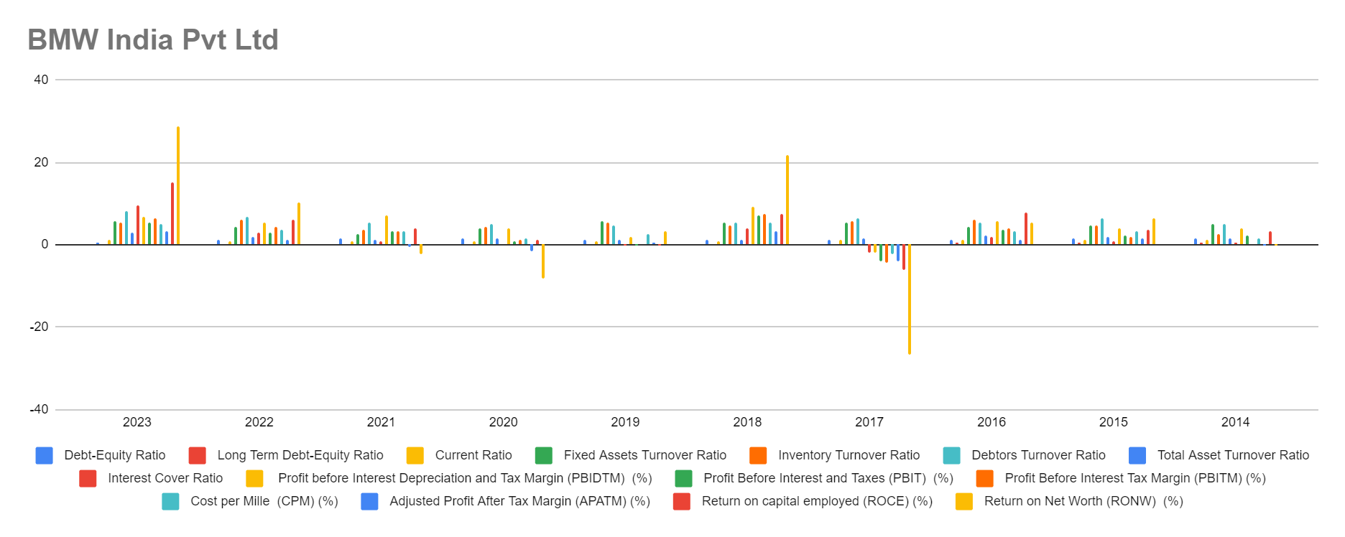

1. Debt-Equity Ratio (DER): Generally low, indicating a conservative capital structure.
2. Long Term Debt-Equity Ratio: Similar trend to DER, suggesting prudent long-term debt management.
3. Current Ratio: Fluctuates but generally above 1, indicating satisfactory liquidity levels.
4. Fixed Assets Turnover Ratio: Generally high, indicating efficient utilization of fixed assets.
5. Inventory Turnover Ratio: Generally high, suggesting efficient management of inventory.
6. Debtors Turnover Ratio: Generally high, indicating effective receivables management.
7. Total Asset Turnover Ratio: Generally high, indicating efficient asset utilization.
8. Interest Cover Ratio: Shows fluctuations but generally positive, indicating the ability to cover interest expenses with earnings.
9. Profitability Ratios: Generally positive, indicating satisfactory profitability levels.

### **2. Tata Motors India:**

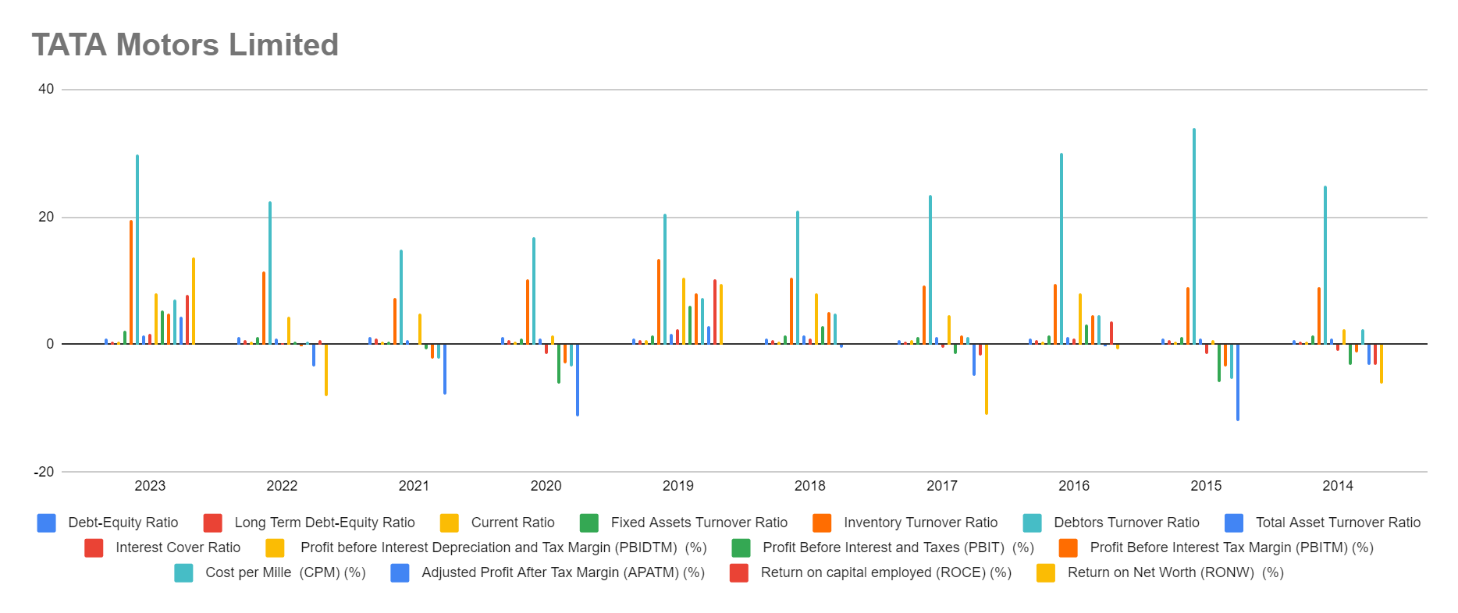

1. Debt-Equity Ratio (DER): Shows a fluctuating trend, but generally maintains a moderate level, indicating a balanced capital structure.
2. Long Term Debt-Equity Ratio: Similar to DER, fluctuates but remains within reasonable limits, suggesting manageable long-term debt levels.
3. Current Ratio: Shows fluctuations but generally remains below 1, indicating potential liquidity challenges in some years.
4. Fixed Assets Turnover Ratio: Fluctuates, indicating varying efficiency in utilizing fixed assets to generate sales.
5. Inventory Turnover Ratio: Fluctuates but generally suggests efficient management of inventory.
6. Debtors Turnover Ratio: Fluctuates but indicates the company's ability to collect receivables efficiently.
7. Total Asset Turnover Ratio: Fluctuates, suggesting varying efficiency in asset utilization.
8. Interest Cover Ratio: Shows fluctuations, with some years indicating negative values, suggesting potential financial strain.
9. Profitability Ratios: Show fluctuations, with some years indicating negative profitability, which is concerning.

### **3. Skoda Volkswagen India Ltd:**

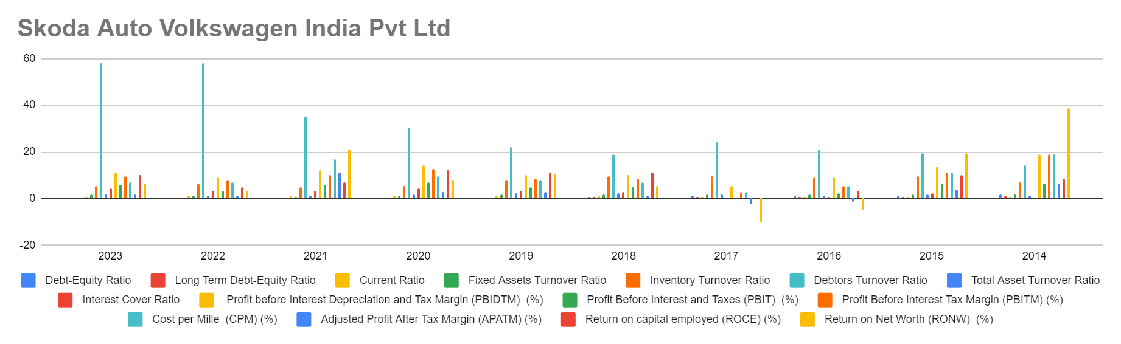

1. Debt-Equity Ratio (DER): Generally low, except for a spike in 2014, indicating a relatively conservative capital structure.
2. Long Term Debt-Equity Ratio: Similar trend to DER, suggesting prudent long-term debt management.
3. Current Ratio: Fluctuates but generally above 1, indicating satisfactory liquidity levels.
4. Fixed Assets Turnover Ratio: Generally high, indicating efficient utilization of fixed assets.
5. Inventory Turnover Ratio: Generally high, suggesting efficient management of inventory.
6. Debtors Turnover Ratio: Generally high, indicating effective receivables management.
7. Total Asset Turnover Ratio: Generally high, indicating efficient asset utilization.
8. Interest Cover Ratio: Shows fluctuations but generally positive, indicating the ability to cover interest expenses with earnings.
9. Profitability Ratios: Generally positive, indicating satisfactory profitability levels.

### **4. Renault India Pvt Limited:**

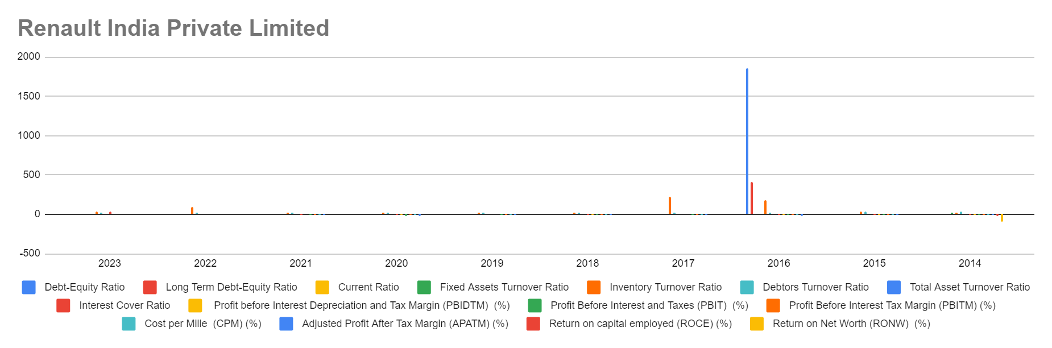

1. Debt-Equity Ratio (DER): Shows fluctuations but generally maintains a moderate level.
2. Long Term Debt-Equity Ratio: Similar trend to DER, suggesting a balanced approach to long-term debt.
3. Current Ratio: Fluctuates but generally above 1, indicating satisfactory liquidity levels.
4. Fixed Assets Turnover Ratio: Fluctuates, indicating varying efficiency in utilizing fixed assets.
5. Inventory Turnover Ratio: Generally high, suggesting efficient inventory management.
6. Debtors Turnover Ratio: Generally high, indicating effective receivables management.
7. Total Asset Turnover Ratio: Fluctuates, suggesting varying efficiency in asset utilization.
8. Interest Cover Ratio: Shows fluctuations, with some years indicating negative values, suggesting potential financial strain.
9. Profitability Ratios: Fluctuate, with some years indicating negative profitability, which is concerning.

### **5. Maruti Suzuki India Ltd:**

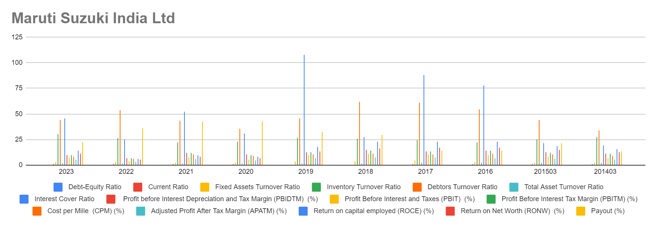

1. Debt-Equity Ratio (DER): Generally low, indicating a conservative capital structure.
2. Long Term Debt-Equity Ratio: Similar trend to DER, suggesting prudent long-term debt management.
3. Current Ratio: Fluctuates but generally above 1, indicating satisfactory liquidity levels.
4. Fixed Assets Turnover Ratio: Generally high, indicating efficient utilization of fixed assets.
5. Inventory Turnover Ratio: Generally high, suggesting efficient management of inventory.
6. Debtors Turnover Ratio: Generally high, indicating effective receivables management.
7. Total Asset Turnover Ratio: Generally high, indicating efficient asset utilization.
8. Interest Cover Ratio: Generally positive, indicating the ability to cover interest expenses with earnings.
9. Profitability Ratios: Generally positive, indicating satisfactory profitability levels.

### **6. Mahindra and Mahindra:**

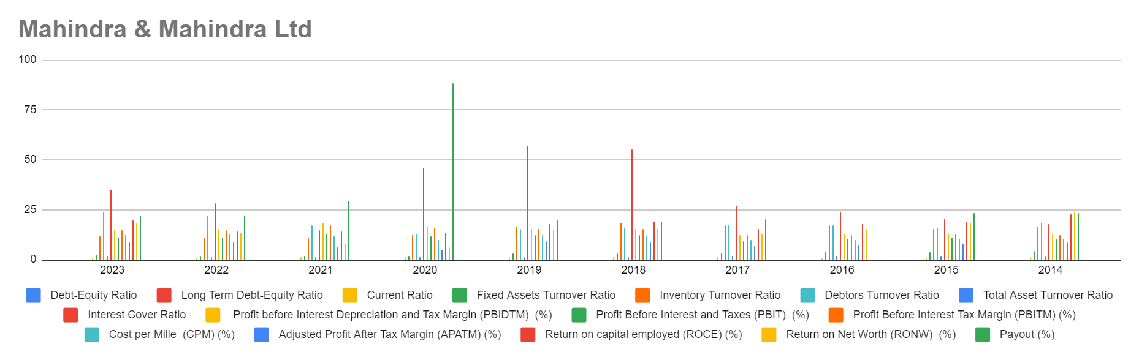

1. Debt-Equity Ratio (DER): Shows fluctuations but generally maintains a moderate level.
2. Long Term Debt-Equity Ratio: Similar trend to DER, suggesting a balanced approach to long-term debt.
3. Current Ratio: Fluctuates but generally above 1, indicating satisfactory liquidity levels.
4. Fixed Assets Turnover Ratio: Generally high, indicating efficient utilization of fixed assets.
5. Inventory Turnover Ratio: Generally high, suggesting efficient management of inventory.
6. Debtors Turnover Ratio: Generally high, indicating effective receivables management.
7. Total Asset Turnover Ratio: Generally high, indicating efficient asset utilization.
8. Interest Cover Ratio: Shows fluctuations but generally positive, indicating the ability to cover interest expenses with earnings.
9. Profitability Ratios: Generally positive, indicating satisfactory profitability levels.

### **7. Hyundai India:**

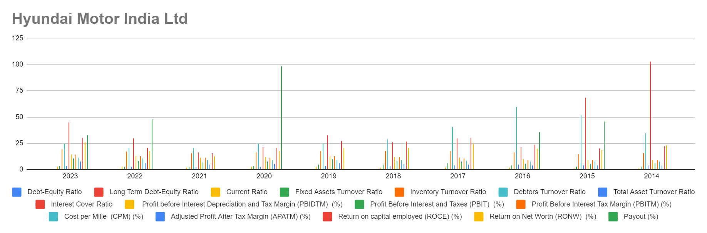

1. Debt-Equity Ratio (DER): Generally low, indicating a conservative capital structure.
2. Long Term Debt-Equity Ratio: Similar trend to DER, suggesting prudent long-term debt management.
3. Current Ratio: Fluctuates but generally above 1, indicating satisfactory liquidity levels.
4. Fixed Assets Turnover Ratio: Generally high, indicating efficient utilization of fixed assets.
5. Inventory Turnover Ratio: Generally high, suggesting efficient management of inventory.
6. Debtors Turnover Ratio: Generally high, indicating effective receivables management.
7. Total Asset Turnover Ratio: Generally high, indicating efficient asset utilization.
8. Interest Cover Ratio: Shows fluctuations but generally positive, indicating the ability to cover interest expenses with earnings.
9. Profitability Ratios: Generally positive, indicating satisfactory profitability levels.

### **8.Ford India Pvt Limited:**

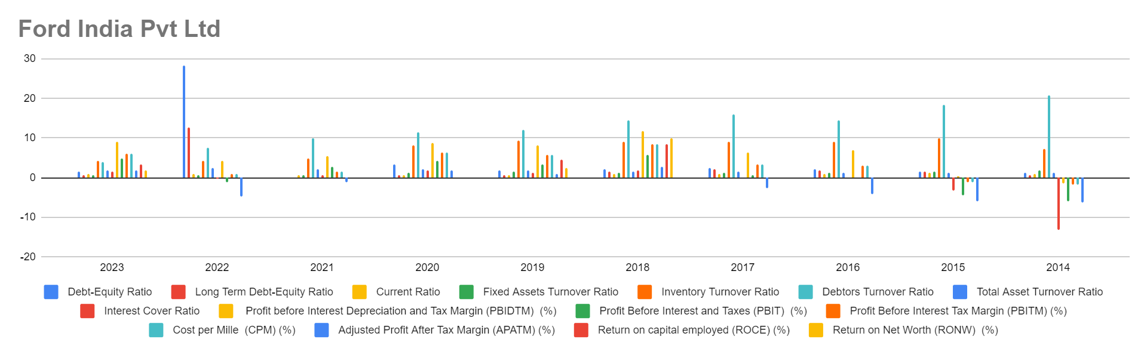

### **What does industry experts has to say about performance of automobile companies in which they have invested??**

**1)TATA MOTORS INDIA**

**Industry experts view Tata Motors' performance over the past decade (2014-2023) as positive, citing several key factors:**

**Strengths:**

* **Dominant Commercial Vehicle Segment:** Tata Motors holds a significant market share in the Indian commercial vehicle market**.**
* **Successful JLR Turnaround:** Jaguar Land Rover's turnaround is a positive step after its struggles in the mid-2010s**.**
* **EV Leadership:** Tata Motors' focus on electric vehicles positions them well for the industry's shift towards sustainable mobility.
* **Stock Price Growth:** The significant rise in Tata Motors' stock price in 2023 and 2024 signifies growing investor confidence**.**

**Areas for Improvement:**

* **Profitability Challenges:** Tata Motors has faced profitability challenges, particularly during the JLR integration and global economic slowdowns.
* **Debt Management:** Debt levels are a concern for some experts, impacting their investment outlook**.**
* **Competitive Landscape:** The increasing competition in the Indian auto market, especially from foreign manufacturers, demands attention**.**

**Overall Assessment:**

Industry experts view Tata Motors' performance as positive. The company's strengths in commercial vehicles and its focus on EVs are positive indicators. However, debt management and navigating a competitive market remain areas for improvement.

**2)SKODA VOLKSWAGON INDIA**

**Industry experts assess Skoda Volkswagen India's performance over the past decade with a mixed perspective, highlighting both strengths and challenges.**

**Strengths:**

* **Brand Recognition:** Skoda and Volkswagen benefit from strong brand recognition in the Indian market, particularly among premium car buyers.
* **Product Portfolio Expansion:** The introduction of new models like Skoda Rapid and Volkswagen Vento helped them cater to a wider audience.
* **Focus on SUV Segment:** Recognizing the growing demand for SUVs, Skoda Volkswagen India successfully launched popular models like Creta and Kushaq.
* **Manufacturing Footprint:** The company's established manufacturing presence in India allows for cost-effective production and quicker product deliveries.

**Challenges:**

* **Sales Fluctuations:** Skoda Volkswagen India has experienced sales fluctuations, particularly in the premium sedan segment facing increased competition.
* **Service Network Expansion:** While present, some experts believe the service network could be further expanded to ensure better customer satisfaction.
* **Localization Strategy:** There's a view that a deeper localization strategy for components could enhance price competitiveness.
* **Electric Vehicle Strategy:** Compared to some rivals, Skoda Volkswagen India's electric vehicle strategy remains in its early stages.

**Overall Assessment:**

Skoda Volkswagen India has carved a niche in the Indian market, leveraging brand recognition and strategic product launches. However, navigating a competitive landscape, expanding the service network, and embracing electric mobility are crucial areas for future success.

**3)RENAULT INDIA**

**Renault's performance in the Indian car market over the past decade (2014-2023) receives mixed reviews from industry experts, acknowledging both bright spots and areas for improvement.**

**Strengths:**

* **Strong Debut & Brand Recall:** Renault's initial success with the Duster compact SUV established brand recognition and positive customer perception.
* **Focus on Budget Segment:** The company's strategy of offering feature-rich cars at competitive prices attracted budget-conscious buyers.
* **Partnership with Nissan:** The alliance with Nissan allows for technology sharing and platform optimization, potentially improving efficiency.
* **Dealer Network Expansion:** Renault has steadily expanded its dealer network, increasing accessibility for customers across India.

**Challenges:**

* **Limited Model Portfolio:** Compared to some competitors, Renault's product portfolio might be seen as limited, hindering market share growth.
* **Sales Fluctuations:** Sales figures have fluctuated, with the Duster's initial success not always translating to consistent growth across other models.
* **Brand Positioning & After-Sales Service:** Some experts believe Renault needs to further strengthen its brand image and improve after-sales service quality.
* **Electric Vehicle Strategy:** While Renault has announced future EV plans, they seem to lag behind some competitors in terms of concrete offerings.

**Overall Assessment:**

Renault established itself in India with a strong debut and focus on the budget segment. However, a limited model portfolio, inconsistent sales, and the need for a stronger brand presence with improved after-sales service are areas requiring attention. Additionally, a more prominent electric vehicle strategy is crucial to compete effectively in the evolving Indian market.

**4)MARUTI SUZUKI INDIA**

**Maruti Suzuki India's performance over the past decade (2014-2023) has been nothing short of dominant, according to industry experts. Here's a breakdown of their strengths and a brief mention of an area for consideration.**

**Strengths:**

* **Market Leadership:** Maruti Suzuki India maintains a commanding market share in the Indian passenger car segment, exceeding 35% for over two decades.
* **Strong Brand Recognition:** The brand enjoys unparalleled brand recognition and trust among Indian car buyers.
* **Widespread Service Network:** Maruti Suzuki boasts an extensive service network across India, ensuring easy access and after-sales support for customers.
* **Focus on Affordability & Fuel Efficiency:** The company prioritizes offering fuel-efficient and budget-friendly cars, catering perfectly to the needs of a large segment of the Indian market.
* **Product Portfolio Breadth:** Maruti Suzuki offers a diverse product portfolio catering to various segments, from hatchbacks and sedans to compact SUVs.

**Area for Consideration:**

* **Premium Segment Presence:** While dominant in the mass market, Maruti Suzuki has a limited presence in the premium car segment, an area some experts believe they could explore for further growth.

**Overall Assessment:**

Maruti Suzuki India's decade-long dominance in the Indian car market is undeniable. Their strong brand recognition, widespread service network, focus on affordability and fuel efficiency, and diverse product portfolio have positioned them as the go-to brand for a vast majority of Indian car buyers. While some experts suggest exploring the premium segment for further growth, Maruti Suzuki's hold on the Indian passenger car market remains undeniable.

5) **MAHINDRA & MAHINDRA LIMITED**

Mahindra & Mahindra Ltd. (M&M) is a conglomerate with a presence in over 20 industries across India and globally. Here's a look at its performance over the past decade (2014-2023) based on industry expert perspectives:

**Strengths:**

* **Diversification:** M&M's presence in various sectors like automobiles, farm equipment, finance, and IT offers stability and reduces dependence on any single industry's performance.
* **Market Leadership:** The company is a leader in the Indian tractor market, with Mahindra Tractors being the world's largest tractor manufacturer by volume.
* **SUV Segment Success:** M&M established itself as a strong player in the Indian SUV market with popular models like Scorpio and Bolero.
* **Global Presence:** M&M has a global presence with operations in over 100 countries, offering growth opportunities beyond the Indian market.
* **Focus on Innovation:** The company invests in research and development, aiming to introduce new technologies and cater to evolving customer needs.

**Challenges:**

* **Profitability Fluctuations:** Profitability might have fluctuated across some sectors, with cyclical downturns impacting certain segments.
* **Competition:** The Indian auto market, particularly the SUV segment, has seen increased competition, requiring M&M to constantly adapt and innovate.
* **Electric Vehicle Strategy:** While M&M has made strides in electric vehicles, some experts believe they need to accelerate their efforts to match some competitors.

**Overall Assessment:**

M&M's diversification and leadership positions in key sectors like tractors and SUVs showcase its strong foundation. However, navigating a competitive landscape, ensuring consistent profitability, and accelerating the electric vehicle strategy are crucial for future success.

**6)HYUNDAI INDIA**

Hyundai has emerged as a major player in the Indian car market over the past decade (2014-2023), according to industry experts. Here's a breakdown of their strengths and a potential area for focus:

**Strengths:**

* **Rapid Growth:** Hyundai has achieved impressive sales growth in India, capturing a significant market share and establishing itself as a strong competitor.
* **Modern & Feature-Rich Cars:** The company offers a range of modern and feature-rich cars, catering to the evolving preferences of Indian car buyers.
* **Strong Brand Image:** Hyundai has built a strong brand image for reliability, quality, and value for money.
* **Widespread Dealer Network:** They boast a well-established dealer network across India, ensuring easy access and after-sales service for customers.
* **SUV Focus:** Recognizing the popularity of SUVs, Hyundai offers a successful lineup of SUVs like Creta and Venue, catering to a growing market segment.

**Area for Potential Focus:**

* **Premium Segment Inroads:** While dominant in the mid-range segment, Hyundai might consider a stronger push into the premium car segment to compete with established players and tap into a growing market.

**Overall Assessment:**

Hyundai's performance in the Indian car market over the past decade has been positive. Their focus on modern features, value for money, a strong dealer network, and popular SUV offerings have contributed to their success. While some experts suggest exploring the premium segment for further growth, Hyundai remains a dominant force in the Indian car market.

**7)FORD INDIA**

**Ford India's performance over the past decade (2014-2023) has been a mixed bag, according to industry experts. Let's delve into the key factors:**

**Strengths (Early Years - 2014-2016):**

* **Initial Growth:** Ford experienced initial growth in the early 2010s, particularly with popular models like the EcoSport and Figo.
* **Strong Commercial Vehicle Segment:** They held a decent position in the Indian commercial vehicle segment, offering reliable trucks.

**Challenges (Mid-2016s Onwards):**

* **Declining Sales:** Sales figures have shown a downward trend in recent years, with Ford struggling to keep pace with some competitors.
* **Limited Model Portfolio:** The lack of new model introductions and updates compared to rivals might have impacted sales.
* **Shifting Market Preferences:** Ford have not fully adapted to the increasing demand for SUVs and electric vehicles in the Indian market.

**Recent Developments:**

* **Exit Announcement (2021):** In 2021, Ford announced its decision to exit the Indian passenger car market, focusing solely on its commercial vehicle segment.

**Overall Assessment:**

While Ford India achieved some initial success, their performance over the past decade has been marked by declining sales and challenges in adapting to a rapidly evolving market. The decision to exit the passenger car segment reflects these difficulties. However, Ford continues to operate in the Indian commercial vehicle market.

**8) BMW INDIA**

BMW India, the Indian subsidiary of the renowned German automaker, has carved a niche in the premium car market over the past decade (2014-2023). Here's a look at its performance based on industry expert perspectives:

**Strengths:**

* **Brand Legacy & Image:** BMW enjoys a strong brand legacy and image for luxury, performance, and cutting-edge technology.
* **Focus on Performance & Handling:** The company's vehicles are known for their exceptional handling and driving dynamics, appealing to driving enthusiasts in India.
* **Product Portfolio Expansion:** BMW India has expanded its product portfolio, offering sedans, SUVs, motorcycles, and electric vehicles to cater to diverse customer preferences within the premium segment.
* **Strong Dealership Network:** They boast a well-established network of dealerships across major Indian cities, ensuring a luxurious buying experience and after-sales service.
* **Manufacturing Presence:** A manufacturing plant in Chennai allows for some degree of localization, potentially improving cost-efficiency and faster deliveries.

**Areas for Consideration:**

* **Pricing Strategy:** BMW's pricing strategy might be seen as slightly higher compared to some competitors in the premium segment.
* **Electric Vehicle Focus:** While BMW has introduced electric vehicles, some experts believe they could expand their EV offerings more aggressively to stay ahead in the evolving market.

**Overall Assessment:**

BMW India's strong brand legacy, focus on performance, diverse product portfolio, and established dealership network have solidified its position in the Indian premium car market. However, navigating a competitive landscape, potentially adjusting pricing strategies, and a more prominent focus on electric vehicles are areas for consideration to ensure future success.

1. **Research Papers and Articles on Indian Automobile Industry**
2. **Indian Automotive Industry: Opportunities and Challenges Posed By Recent Developments By Viswanathan Krishnan**

The document "Indian Automotive Industry: Opportunities and Challenges Posed By Recent Developments" by Viswanathan Krishnan provides a detailed analysis of the Indian automotive industry, focusing on recent developments, opportunities, and challenges.

### **Recent Developments and Issues Facing the Indian Automotive Industry:**

* Market Entry of Multinational Firms: Over a dozen multinational firms have announced plans to enter the Indian market, either through joint ventures or wholly-owned subsidiaries.
* Competition and Product Segments: Competition is intensifying in the mid-sized car segment, with new entrants targeting higher-end vehicles.
* Infrastructure Challenges: India's inadequate road infrastructure poses a significant challenge to the automotive industry's growth.
* Policy Uncertainty: Uncertainty surrounding government policies, particularly regarding foreign investments and trade, presents challenges for industry stakeholders.

**Strengths and Weaknesses of the Various Players:**

* Indian Assemblers: Strong distribution networks and supplier bases, but lack product development capabilities.
* Multinational Assemblers: Lean production capabilities and expertise in product design, but face challenges in adapting to the Indian market and localizing rapidly.
* Indian Component Suppliers: Cost advantages and skilled workforce, but need to invest in capacity and research to stay competitive.
* Multinational Component Suppliers: Size and experience, but face challenges in navigating import tariffs and currency fluctuations.

### **Conclusions:**

* Industry Outlook: The Indian automotive industry is growing rapidly, but faces challenges such as market fragmentation, infrastructure deficiencies, and policy uncertainty.
* Potential Strategies: Industry players can leverage their strengths and address weaknesses by focusing on product development, localization, and global competitiveness.

**2)The Growth of the Indian Automobile Industry: Analysis of the Roles of Government Policy and Other Enabling Factors**

**It provides a detailed overview of the growth trajectory of the Indian automobile industry, focusing on various phases from the 1950s up to recent years**

**Importance of the Automobile Industry**: The Indian automobile industry is a significant contributor to the country's economic growth, manufacturing GDP, exports, and employment. It has grown substantially over the years, with India ranking among the top automobile producers globally.

**Structure and Makeup**: The industry comprises both automobile and automotive component segments. India has emerged as a major player in various vehicle categories, including tractors, two-wheelers, cars, and commercial vehicles.

**Historical Growth Phases**:

-1950-1980: Witnessed slow-paced growth due to limited market size and regulatory restrictions.

-First Wave of FDI (1981-1991): Foreign investment was allowed in automotive assembly, leading to the establishment of joint ventures with global automakers. Maruti Suzuki's entry marked a significant milestone.

-Second Wave of FDI (Since 1992): Liberalization policies in the early 1990s attracted more foreign investment, fostering competition and technological advancements. Indian companies also began developing their design and development capabilities.

-Post-2000 De-licensing and FDI Liberalization: Further reforms removed trade barriers, allowed free imports of components, and encouraged 100% FDI. The industry experienced rapid growth, becoming the second-fastest-growing market globally.

**Role of Foreign Investment**: Foreign Direct Investment (FDI) played a crucial role in the industry's expansion, leading to the establishment of modern manufacturing plants and technology transfers. Major global automakers entered the Indian market through joint ventures and subsidiaries.

**Technological Upgradation**: The industry focused on upgrading processes, product quality, and technology standards to meet global requirements. Indian companies developed capabilities in areas like casting, forging, machining, and fabricating.

The analysis underscores the transformative impact of government policies, foreign investment, and technological advancements on the Indian automobile industry's growth trajectory.

3)**What is the future of Automobile Industry in India**

* **Economic Importance:** The article emphasizes the significant role of the Indian automobile industry in the country's economic growth. It generates substantial employment opportunities and contributes considerably to the nation's revenue. This highlights the industry's critical role in sustaining and propelling India's economic well-being.
* **Dominant Two-Wheeler Segment:** The article underscores the two-wheeler segment, encompassing scooters and motorcycles, as the undisputed leader in the Indian automobile market. This dominance can be attributed to several factors:
  + **Affordability:** Two-wheelers are generally more affordable compared to four-wheeler vehicles, making them accessible to a broader range of consumers, particularly those with limited budgets.
  + **Fuel Efficiency:** Two-wheelers are known for their fuel efficiency, offering greater mileage per liter of fuel. This is a crucial factor for Indian consumers, especially considering the rising fuel costs in the country.
  + **Practicality for Crowded Roads:** Two-wheelers are often seen as a more practical choice for navigating India's often crowded and congested roads. Their smaller size allows for easier maneuvering through traffic and finding parking spaces in tight urban areas.
* **Potential for Rural Market Growth:** The article recognizes the untapped potential for growth within the rural market. As disposable incomes in rural areas rise due to factors like improved agricultural productivity and government initiatives, the demand for automobiles is expected to surge. This presents a significant opportunity for manufacturers to cater to this growing segment. Manufacturers may need to adapt their strategies to address the specific needs and preferences of rural customers. For instance, they might develop more rugged and utilitarian vehicles suitable for rural roads and terrains. Additionally, offering financing options tailored to rural customers' financial situations could be crucial for driving sales in this market.
* **Government's Role in Shaping the Future:** The article acknowledges the active role of the Indian government in shaping the future of the automobile industry. The government's initiatives play a critical role in influencing the industry's direction and growth trajectory. Here are some key government efforts highlighted in the article:  
  + **Make in India:** This flagship program aims to promote domestic production of automobiles within India. By incentivizing local manufacturing, the government seeks to create jobs, reduce reliance on imports, and boost the country's self-sufficiency in the automobile sector.
  + **Taxation and Customs Duties:** The government's policies regarding taxes and customs duties can significantly impact the industry's competitiveness and profitability. The article suggests that the government might be considering tax reductions or exemptions to make domestic production more attractive. Conversely, it might raise customs duties on imported vehicles to create a more favorable environment for locally manufactured automobiles.
  + **Electric and Hybrid Vehicles:** The Indian government is actively pushing for the adoption of electric and hybrid vehicles. This initiative is driven by a dual purpose:
    - **Reducing Dependence on Fossil Fuels:** India, like many other countries, is aiming to lessen its reliance on fossil fuels for transportation. Electric and hybrid vehicles offer a cleaner alternative, contributing to reduced emissions and a more sustainable transportation ecosystem.
    - **Curbing Pollution:** Air pollution is a major concern in many Indian cities. Electric vehicles produce zero tailpipe emissions, and hybrid vehicles significantly reduce emissions compared to traditional gasoline-powered vehicles. By promoting electric and hybrid vehicles, the government aims to tackle the issue of air pollution in urban areas and improve public health.

The article on the future of the Indian automobile industry paints a picture of an industry poised for significant growth. The combination of a rising middle class, increasing urbanization, government support, and the potential of the rural market creates a promising outlook. However, the industry also faces challenges such as infrastructure limitations, traffic congestion, and the need to address environmental concerns. By navigating these challenges and capitalizing on the available opportunities, the Indian automobile industry can solidify its position as a major contributor to the country's economic growth and technological advancement.

### **Data Collection**

The comprehensive study delves into the performance and trajectory of eight prominent players in the automobile industry over the past decade, analyzing financial statements and key ratios meticulously sourced from the Capitaline database. Covering the period from 2014 to 2023, the study scrutinizes the dynamics of Tata, SKODA Volkswagen, Renault, Maruti Suzuki, Mahindra, Hyundai, Ford, and BMW. Through an exhaustive examination of their financial data, including revenue, profit margins, liquidity, solvency, and efficiency ratios, the study aims to unveil trends, patterns, and insights into the competitive landscape of the automotive sector. By leveraging this wealth of data, stakeholders can gain invaluable perspectives to inform strategic decisions, forecast future trajectories, and navigate the complexities of the market with greater precision and confidence.

### **Findings and conclusion**

**Findings**:Several significant insights were discovered via the thorough examination of financial data, which included descriptive statistics, financial ratio computations, industry benchmarking, and competition analysis. Over the last ten years, the industry's core financial indicators have shown some noteworthy trends and fluctuations. Financial ratio analysis revealed the companies' strong and weak points and provided important information about their liquidity, profitability, and solvency. By comparing the financial performance of the industry to predetermined benchmarks, industry benchmarking gave perspective. Furthermore, the analysis of significant rivals made it possible to comprehend their financial situation and competitive positioning on a deeper level. All of these results add up to a more complex picture of the industry's financial environment.

**Conclusion**:To sum up, this study shows how well data analysis methods can be used to glean useful insights from financial records. Important data was gathered to support strategic decision-making processes by utilizing approaches like competitor research, financial ratio analysis, industry benchmarking, and descriptive statistics. The development of interactive dashboards improves the findings' usefulness and accessibility even further, enabling stakeholders to make well-informed decisions. In the future, the industry can use the insights derived from this analysis as a basis for risk management, strategic planning, and performance assessment. In summary, this research highlights the significance of data-driven strategies for promoting corporate success and guaranteeing long-term viability in dynamic marketplaces.

1. **LINKS AND REFERENCES**

* [**https://www.coursehero.com/file/103595323/INDUSTRY-PROFILEdocx/**](https://www.coursehero.com/file/103595323/INDUSTRY-PROFILEdocx/)
* [**https://www.linkedin.com/pulse/business-performance-tata-technologies-last-5-years-detailed**](https://www.linkedin.com/pulse/business-performance-tata-technologies-last-5-years-detailed)
* [**https://www.business-standard.com/content/press-releases-ani/renault-india-a-decade-of-growth-121110101165_1.html**](https://www.business-standard.com/content/press-releases-ani/renault-india-a-decade-of-growth-121110101165_1.html)
* [**https://www.researchgate.net/publication/335670642_The_Growth_of_the_Indian_Automobile_Industry_Analysis_of_the_Roles_of_Government_Policy_and_Other_Enabling_Factors**](https://www.researchgate.net/publication/335670642_The_Growth_of_the_Indian_Automobile_Industry_Analysis_of_the_Roles_of_Government_Policy_and_Other_Enabling_Factors)
* [**https://enterslice.com/future-of-automobile-industry-india**](https://enterslice.com/future-of-automobile-industry-india)
* [**https://dspace.mit.edu/bitstream/handle/1721.1/1619/Krishnan.pdf**](https://dspace.mit.edu/bitstream/handle/1721.1/1619/Krishnan.pdf)
* [**https://www.team-bhp.com/news/rise-fall-ford-india-comprehensive-study**](https://www.team-bhp.com/news/rise-fall-ford-india-comprehensive-study)
* [**https://www.financialexpress.com/auto/bike-news/bmw-india-growth-is-best-in-a-decade/2398575/**](https://www.financialexpress.com/auto/bike-news/bmw-india-growth-is-best-in-a-decade/2398575/)
* [**https://www.researchgate.net/publication/282390975_Hyundai_Motor_Company_in_the_Indian_Market**](https://www.researchgate.net/publication/282390975_Hyundai_Motor_Company_in_the_Indian_Market)
* [**https://www.researchgate.net/publication/366899483_Innovations_in_the_Indian_Automobile_Industry_An_Industry_Analysis_of_Maruti_Suzuki_India_Limited**](https://www.researchgate.net/publication/366899483_Innovations_in_the_Indian_Automobile_Industry_An_Industry_Analysis_of_Maruti_Suzuki_India_Limited)
* [**https://www.loom.com/share/5af11057ed09469da5822246daed4836**](https://www.loom.com/share/5af11057ed09469da5822246daed4836)
* [**https://www.loom.com/share/e9f46d55dbe0417c91754197a4555a6e?sid=65dc7aab-5e95-49ac-8d34-d08a9dfc1dd3**](https://www.loom.com/share/e9f46d55dbe0417c91754197a4555a6e?sid=65dc7aab-5e95-49ac-8d34-d08a9dfc1dd3)
* [**https://www.loom.com/share/0a47f321b6af40d89fd83a3a355e09c3?sid=9e54dbf7-56c7-43f1-9119-f944c7ec3ac5**](https://www.loom.com/share/0a47f321b6af40d89fd83a3a355e09c3?sid=9e54dbf7-56c7-43f1-9119-f944c7ec3ac5)
* [**https://github.com/hm59221112/Automobile-Industry-Financial-health-analysis**](https://github.com/hm59221112/Automobile-Industry-Financial-health-analysis)