Chirag H M-(6373750)

**Hands on 1**

**Create a Spring Web Project using Maven**   
  
Follow steps below to create a project: 

1. Go to <https://start.spring.io/>
2. Change Group as “com.cognizant”
3. Change Artifact Id as “spring-learn”
4. Select Spring Boot DevTools and Spring Web
5. Create and download the project as zip
6. Extract the zip in root folder to Eclipse Workspace
7. Build the project using ‘mvn clean package -Dhttp.proxyHost=proxy.cognizant.com -Dhttp.proxyPort=6050 -Dhttps.proxyHost=proxy.cognizant.com -Dhttps.proxyPort=6050 -Dhttp.proxyUser=123456’ command in command line
8. Import the project in Eclipse "File > Import > Maven > Existing Maven Projects > Click Browse and select extracted folder > Finish"
9. Include logs to verify if main() method of SpringLearnApplication.
10. Run the SpringLearnApplication class.

Solution:

Follow the above steps and run the main method in the SpringLearnApplication which contains the below code:

package com.cognizant.spring_learn;

import org.springframework.boot.SpringApplication;

import org.springframework.boot.autoconfigure.SpringBootApplication;

@SpringBootApplication

public class SpringLearnApplication {

public static void main(String[] args) {

System.out.println("STARTING APP");

SpringApplication.run(SpringLearnApplication.class, args);

System.out.println("APP STARTED");

}

}

Output:

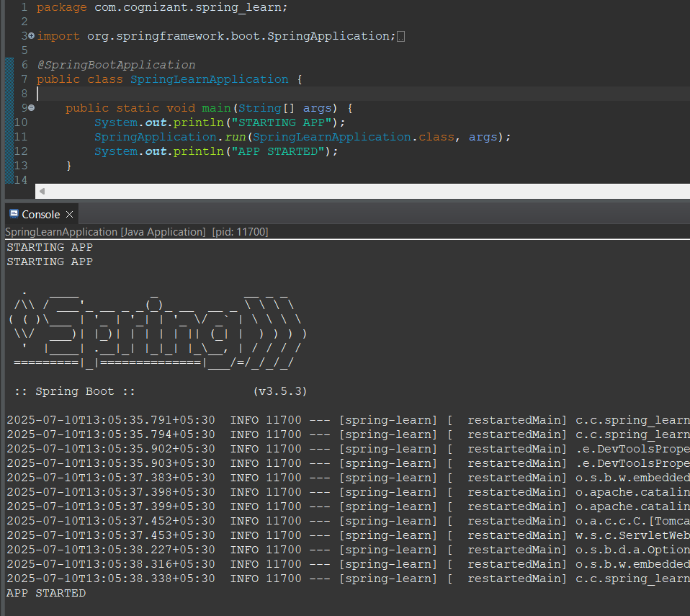

**Hands on 2**

**Spring Core – Load SimpleDateFormat from Spring Configuration XML**   
  
SimpleDateFormat with the pattern ‘dd/MM/yyyy’ is created in multiple places of an application. To avoid creation of SimpleDateFormat in multiple places, define a bean in Spring XML Configuration file and retrieve the date.  
  
Follow steps below to implement:

* Create spring configuration file date-format.xml in src/main/resources folder of 'spring-learn' project
* Open https://docs.spring.io/spring-framework/docs/current/spring-framework-reference/core.html#beans-factory-metadata
* Copy the XML defined in the section of previous step URL and paste it into date-format.xml
* Define bean tag in the XML with for date format. Refer code below.

<?xml version="1.0" encoding="UTF-8"?>

<beans xmlns="http://www.springframework.org/schema/beans"

    xmlns:xsi="http://www.w3.org/2001/XMLSchema-instance"

    xsi:schemaLocation="http://www.springframework.org/schema/beans

        https://www.springframework.org/schema/beans/spring-beans.xsd">

<bean id="dateFormat" class="java.text.SimpleDateFormat">

<constructor-arg value="dd/MM/yyyy" />

</bean>

</beans>

* Create new method displayDate() in SpringLearnApplication.java
* In displayDate() method create the ApplicationContext. Refer code below:

ApplicationContext context = new ClassPathXmlApplicationContext("date-format.xml");

* Get the dateFormat using getBean() method. Refer code below.

SimpleDateFormat format = context.getBean("dateFormat", SimpleDateFormat.class);

* Using the format variable try to parse string '31/12/2018' to Date class and display the result using System.out.println.
* Run the application as 'Java Application' and check the result in console log output.

**Troubleshooting Tips**   
  
If the tomcat port has a conflict and the server is not starting include the below property in application.properties file in src/main/resources folder.

Solution:

After creating the xml file in the resource folder then further add the below code into the SpringLearnApplication.java

package com.cognizant.spring_learn;

import java.text.ParseException;

import java.text.SimpleDateFormat;

import java.util.Date;

import org.springframework.context.ApplicationContext;

import org.springframework.context.support.ClassPathXmlApplicationContext;

import org.springframework.boot.SpringApplication;

import org.springframework.boot.autoconfigure.SpringBootApplication;

*@SpringBootApplication*

public class SpringLearnApplication {

public static void main(String[] args) {

SpringApplication.*run*(SpringLearnApplication.class, args);

*displayDate*();

}

public static void displayDate() {

ApplicationContext context = new ClassPathXmlApplicationContext("date-format.xml");

SimpleDateFormat format = context.getBean("dateFormat", SimpleDateFormat.class);

try {

Date parsedDate = format.parse("31/12/2018");

System.***out***.println("Parsed Date: " + parsedDate);

} catch (ParseException e) {

e.printStackTrace();

}

}

}

Output:

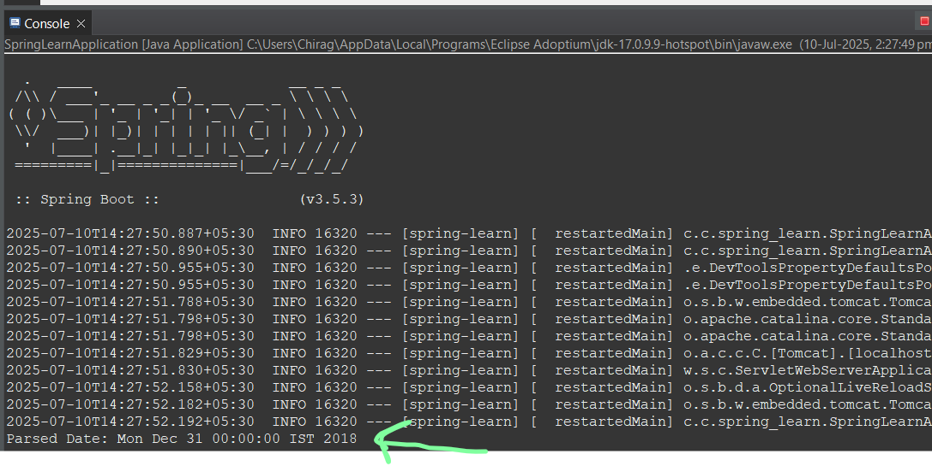

**Hello World RESTful Web Service**   
  
Write a REST service in the spring learn application created earlier, that returns the text "Hello World!!" using Spring Web Framework. Refer details below:  
  
**Method:** GET  
**URL:** /hello  
**Controller:** com.cognizant.spring-learn.controller.HelloController  
**Method Signature:** public String sayHello()  
**Method Implementation:** return hard coded string "Hello World!!"  
**Sample Request**: http://localhost:8083/hello  
**Sample Response:** Hello World!!   
  
**IMPORTANT NOTE**: Don't forget to include start and end log in the sayHello() method.  
  
Try the URL http://localhost:8083/hello in both chrome browser and postman.  
  
SME to explain the following aspects:

* In network tab of developer tools show the HTTP header details received
* In postman click on "Headers" tab to view the HTTP header details received

Solution:

create a new controller package and add HelloController method into it as follow:

com.cognizant.spring-learn.controller.HelloController

HelloController.java

package com.cognizant.spring_learn.controller;

import org.slf4j.Logger;

import org.slf4j.LoggerFactory;

import org.springframework.web.bind.annotation.GetMapping;

import org.springframework.web.bind.annotation.RestController;

*@RestController*

public class HelloController {

private static final Logger ***LOGGER*** = LoggerFactory.*getLogger*(HelloController.class);

*@GetMapping*("/hello")

public String sayHello() {

***LOGGER***.info("START - sayHello()");

String message = "Hello World!!";

***LOGGER***.info("END - sayHello()");

return message;

}

}

Add the port number to properties file in resources and then run the main file.

Output:

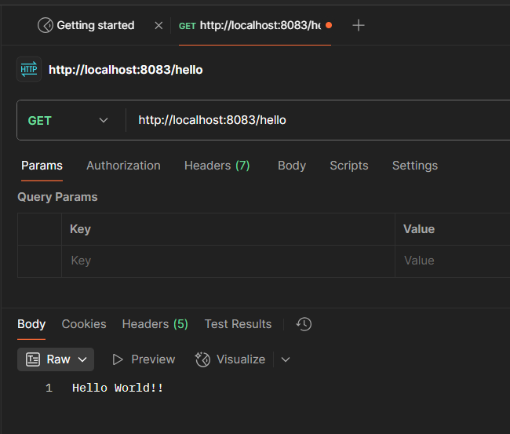

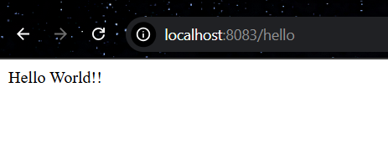

**REST - Country Web Service**   
  
Write a REST service that returns India country details in the earlier created spring learn application.  
  
**URL**: /country  
**Controller**: com.cognizant.spring-learn.controller.CountryController  
**Method Annotation**: @RequestMapping  
**Method Name**: getCountryIndia()  
**Method Implementation**: Load India bean from spring xml configuration and return  
**Sample Request**: http://localhost:8083/country  
**Sample Response**:

{

  "code": "IN",

  "name": "India"

}

SME to explain the following aspects:

* What happens in the controller method?
* How the bean is converted into JSON reponse?
* In network tab of developer tools show the HTTP header details received
* In postman click on "Headers" tab to view the HTTP header details received

Solution:

Create a new package model in com.cognizant.spring_learn and new class inside model called Country.

package com.cognizant.spring_learn.model;

public class Country {

private String code;

private String name;

public Country() {

}

public Country(String code, String name) {

this.code = code;

this.name = name;

}

public String getCode() {

return code;

}

public void setCode(String code) {

this.code = code;

}

public String getName() {

return name;

}

public void setName(String name) {

this.name = name;

}

}

Create a country.xml in src/main/resources

<?xml version="1.0" encoding="UTF-8"?>

<beans xmlns="http://www.springframework.org/schema/beans"

xmlns:xsi="http://www.w3.org/2001/XMLSchema-instance"

xsi:schemaLocation="

http://www.springframework.org/schema/beans

https://www.springframework.org/schema/beans/spring-beans.xsd">

<bean id="in" class="com.cognizant.spring_learn.model.Country">

<property name="code" value="IN"/>

<property name="name" value="India"/>

</bean>

</beans>

Add the following line into the main file i.e SpringLearnApplication

*@ImportResource*({"classpath:date-format.xml", "classpath:country.xml"})

Create a new class CountryController inside controller package

package com.cognizant.spring_learn.controller;

import com.cognizant.spring_learn.model.Country;

import org.springframework.context.ApplicationContext;

import org.springframework.context.support.ClassPathXmlApplicationContext;

import org.springframework.web.bind.annotation.RequestMapping;

import org.springframework.web.bind.annotation.RestController;

*@RestController*

public class CountryController {

*@RequestMapping*("/country")

public Country getCountryIndia() {

ApplicationContext context = new ClassPathXmlApplicationContext("country.xml");

Country country = (Country) context.getBean("in");

return country;

}

}

Test the Endpoint for output:

Run the main file then go for the endpoint <http://localhost:8083/country>

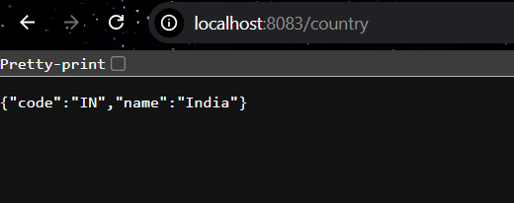

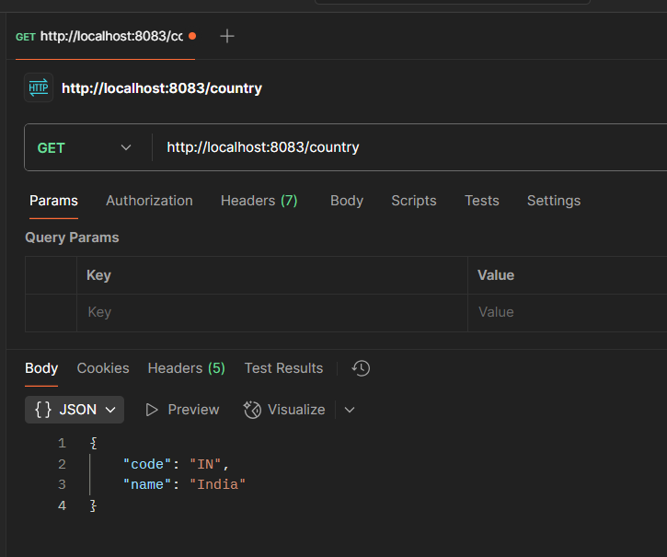

**REST - Get country based on country code**   
  
Write a REST service that returns a specific country based on country code. The country code should be case insensitive.  
  
**Controller**: com.cognizant.spring-learn.controller.CountryController  
**Method Annotation:** @GetMapping("/countries/{code}")  
**Method Name**: getCountry(String code)  
**Method Implemetation**: Invoke countryService.getCountry(code)   
**Service Method:**com.cognizant.spring-learn.service.CountryService.getCountry(String code)  
  
**Service Method Implementation**:

* Get the country code using @PathVariable
* Get country list from country.xml
* Iterate through the country list
* Make a case insensitive matching of country code and return the country.
* Lambda expression can also be used instead of iterating the country list

**Sample Request**: http://localhost:8083/country/in  
  
**Sample Response**:

{

  "code": "IN",

  "name": "India"

}

Solution:

Create a service package in the com.cognizant.spring_learn and a class CountryService inside it.

package com.cognizant.spring_learn.service;

import com.cognizant.spring_learn.model.Country;

import org.springframework.context.ApplicationContext;

import org.springframework.context.support.ClassPathXmlApplicationContext;

import org.springframework.stereotype.Service;

import java.util.List;

*@Service*

public class CountryService {

public Country getCountry(String code) {

ApplicationContext context = new ClassPathXmlApplicationContext("country.xml");

*@SuppressWarnings*("unchecked")

List<Country> countries = (List<Country>) context.getBean("countries");

return countries.stream()

.filter(c -> c.getCode().equalsIgnoreCase(code))

.findFirst()

.orElse(null); // You can throw an exception instead

}

}

Run the main method after maven update project.

Check the port at <http://localhost:8083/countries/in>

Output:

