Crypto Lab - 2

Name: H M Mythreya

SRN: PES2UG20CS130

1) Create and display a file SRN.txt with following contents:

*EXCITED ABOUT HIS NEWLY-EARNED POWERS, MIDAS STARTED TOUCHING every surrounding objects like stones, grass, trees and cart, TURNING EACH ITEM INTO PURE GOLD. BUT SOON, MIDAS BECAME HUNGRY. AS HE PICKED UP A PIECE OF FOOD, HE FOUND HE COULD NOT EAT IT. IT HAD TURNED TO GOLD IN HIS HAND.*

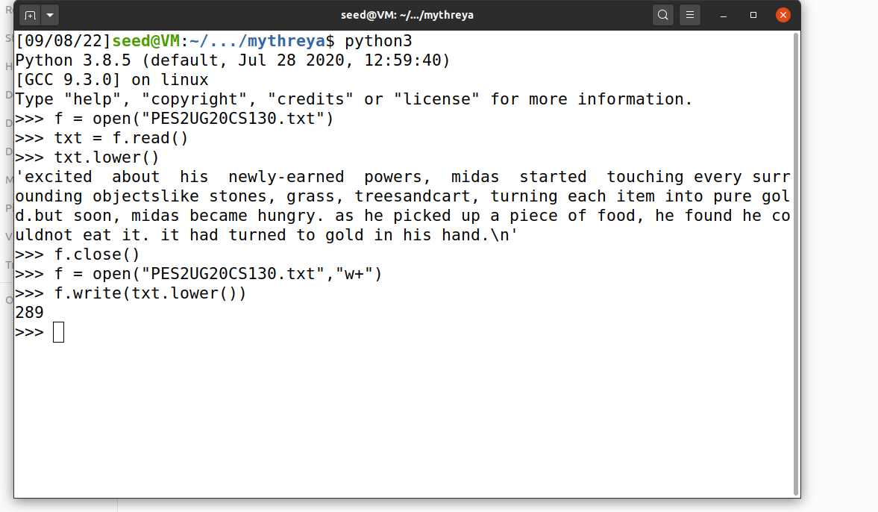*In file SRN.txt, convert uppercase letters to lowercase and find the frequencies of following words:*

* 1. *he*
  2. *h*
  3. *ed*
  4. *oo*
  5. *a*
  6. *As*

**Highlight the words given in question 2.**

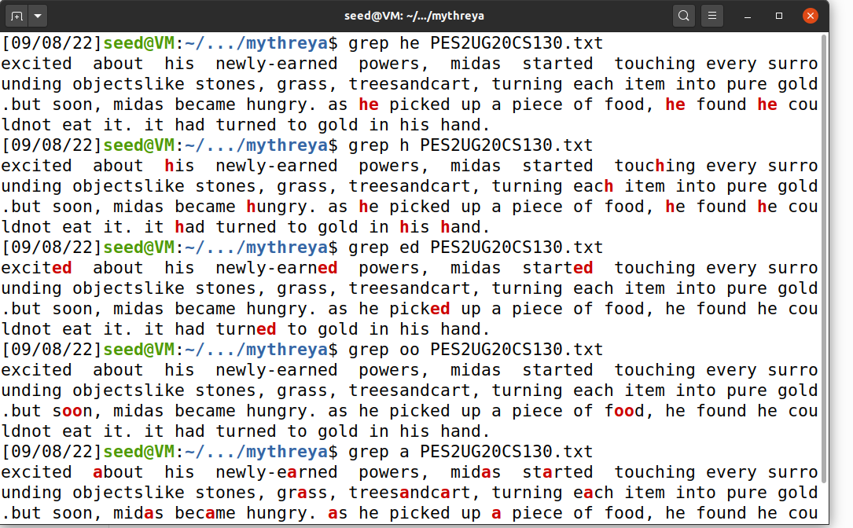

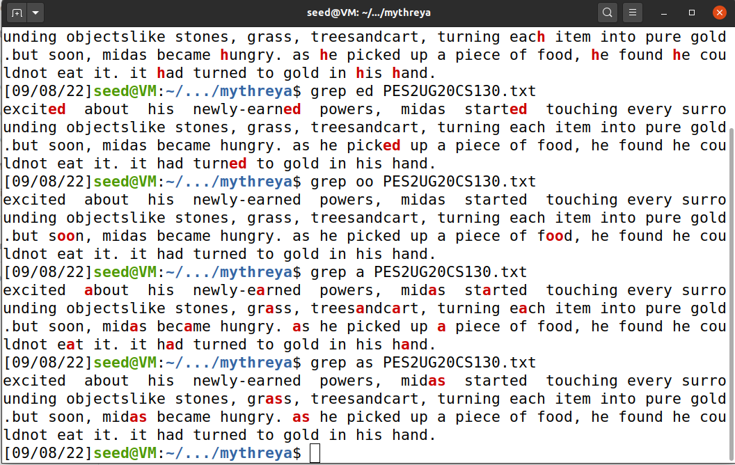

1. **Generate the substitution cipher key.**



1. **Generate the cipher text using the key generated in question 3.**

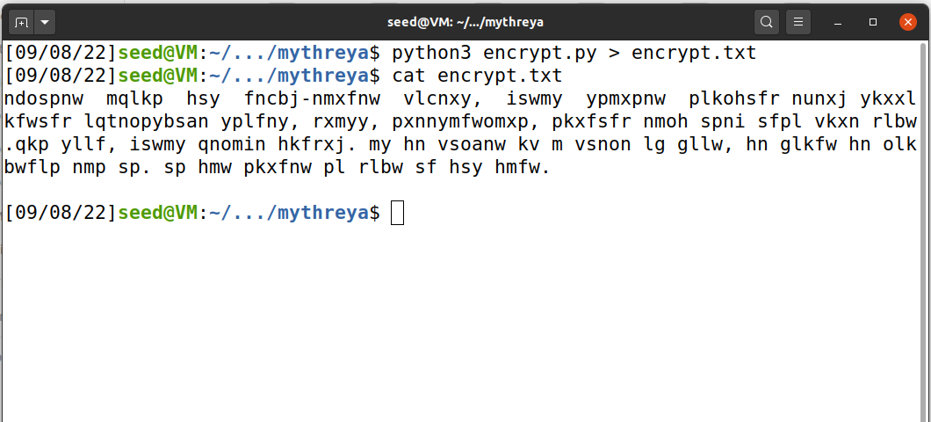

1. **Decrypt the cipher text back to plain text.**

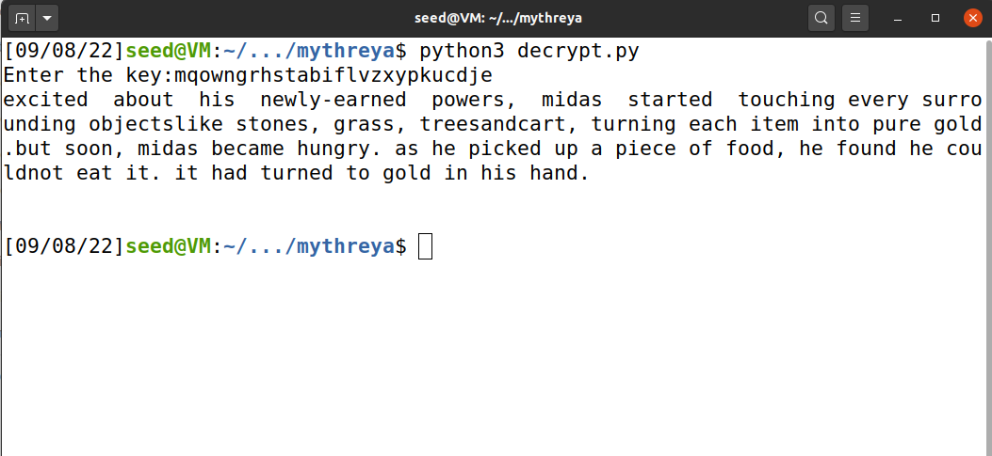

1. **Suppose the input file is :**

*Hungry, Midas groaned, “I’ll starve! Perhaps this was not such an excellent wish after all!”…*

Comment on the cipher text generated.

