DBMS LAB

Week-8

# Name: J Chethana Datta SRN: PES2UG20CS148

**Section: C**

# Date: 08/11/2022

1. Write a function to find the number of tickets booked by a customer. If no of tickets is more than 3 for the current month then display error message as “cannot purchase tickets current limit is over”.

Code for the function:

DELIMITER $$

CREATE FUNCTION no_of_tkts(U_ID varchar(255))

RETURNS VARCHAR(50)

DETERMINISTIC

BEGIN

    DECLARE result VARCHAR(50);

    DECLARE ticket_count int;

    SELECT count(PNR) into ticket_count

    FROM Ticket

    WHERE User_ID = U_ID AND

    MONTH(Travel_date) = MONTH(sysdate()) AND

    YEAR(Travel_date) = YEAR(sysdate());

    IF ticket_count > 3 THEN

        SET result = 'cannot purchase tickets current limit is over”';

    ELSE

        SET result = 'can purchase tickets';

    END IF;

        RETURN result;

END; $$

DELIMITER ;

Query:

SELECT User_ID, no_of_tkts(User_ID) FROM Users;

Output:

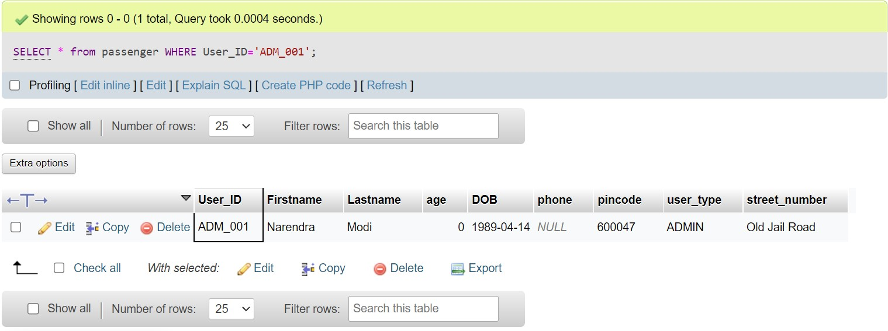

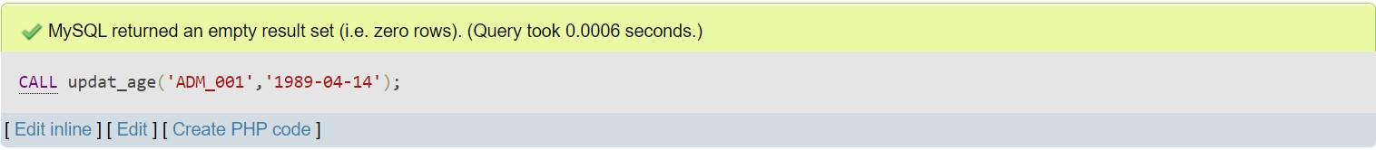

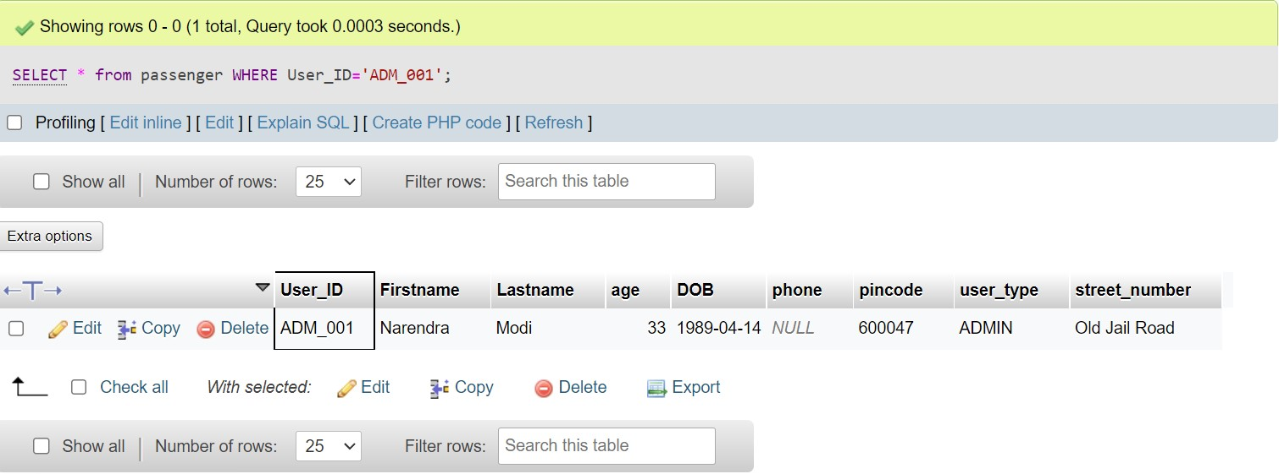

1. Write a stored procedure to calculate the age of the customer when the date of birth is given. Update the column named age in the customer table.

Code for the stored procedure:

DELIMITER $$

CREATE procedure updat_age(IN U_ID varchar(30), IN DOB DATE)

BEGIN

DECLARE new_age int;

SET new_age = FLOOR(DATEDIFF(CURRENT_DATE,DOB)/365);

UPDATE Users set Age = new_age where User_ID = U_ID;

END;$$

DELIMITER ;

Query:

SELECT * from USERS WHERE User_ID='ADM_001' ;

CALL updat_age('ADM_001','1989-04-14');

SELECT * from USERS WHERE User_ID='ADM_001' ;

Output:

