Crypto Lab - 4
Name: H M Mythreya
SRN: PES2UG20CS130

Task 1: A Complete Example of BIGNUM

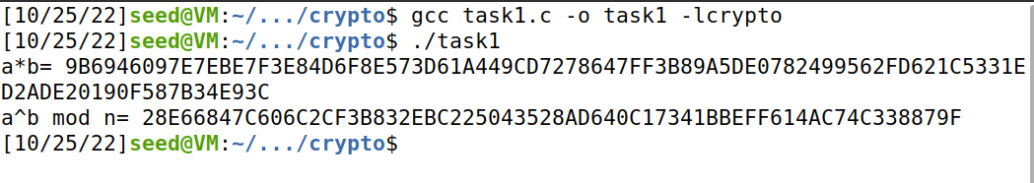

Task 2: Deriving the Private Key
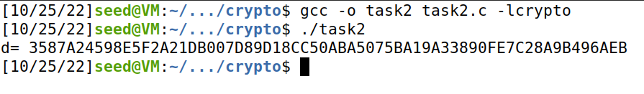

Task 3: Encrypting a message

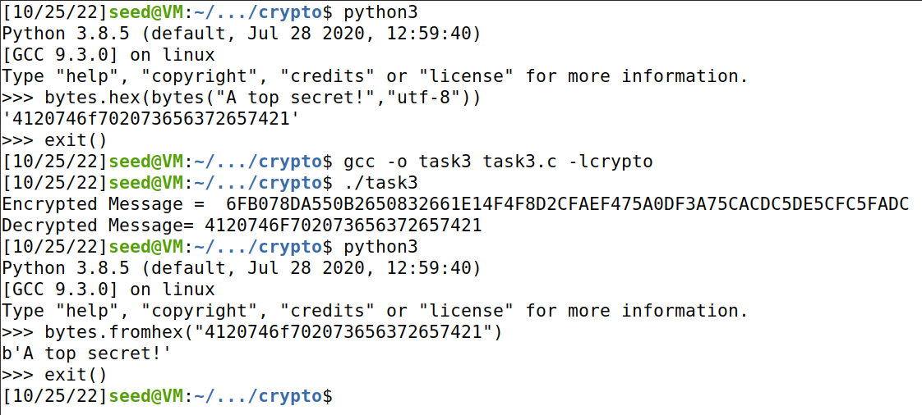

Task 4: Decrypting a Message

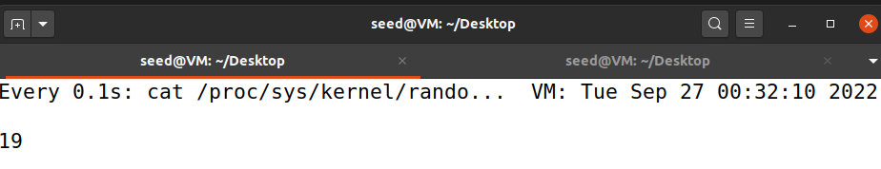
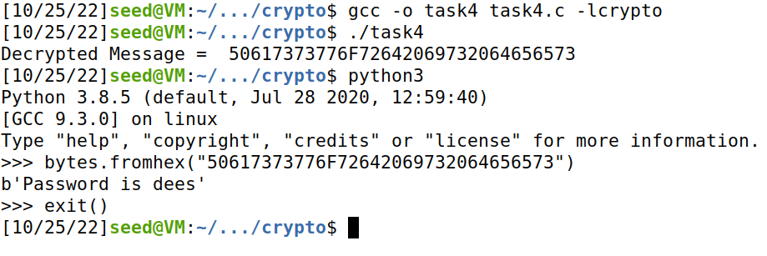

Task 5: Signing a Message
Message 1: “I owe you $2000.”
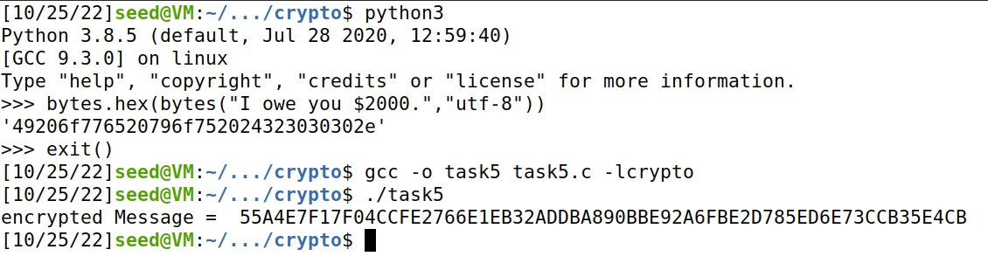

Message 2: “I owe $3000”
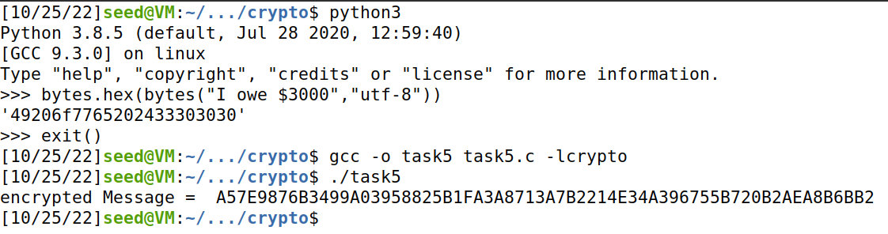

Task 6: Verifying a Signature
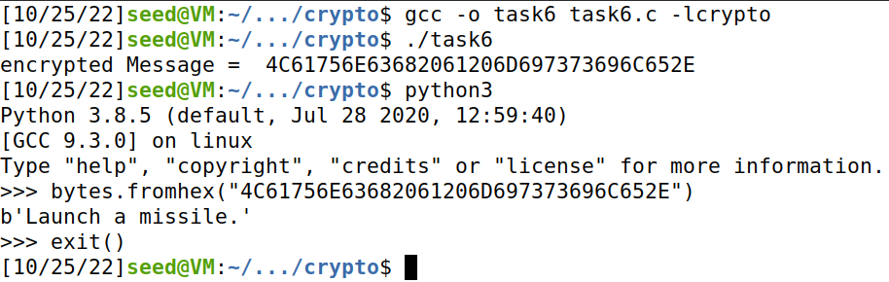

Task 7: Manually verifying an X.509 Certificate

c0.pem – Server c1.pem - Issuer
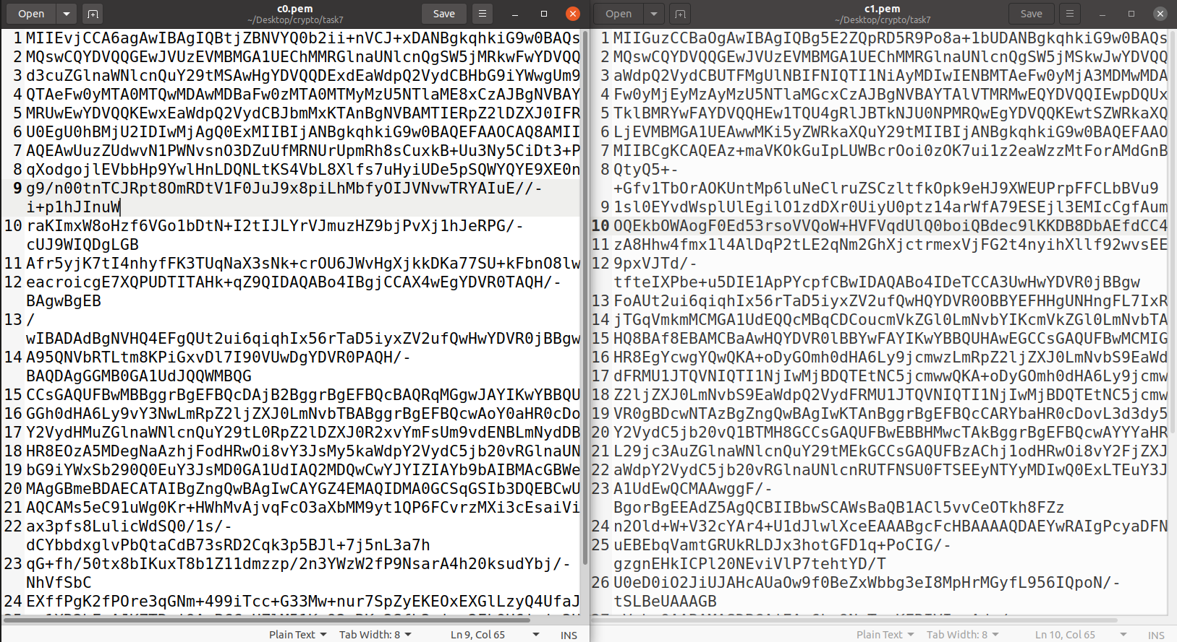

Extracting public key from issuer certificate.
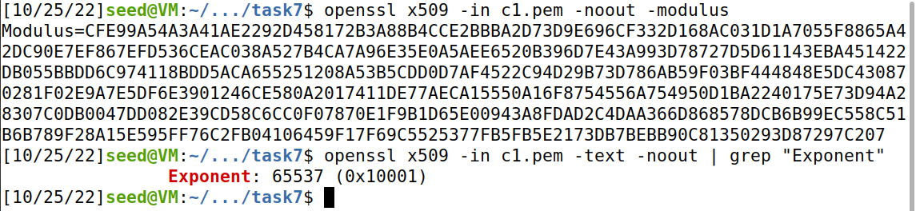

Extracting signature from server certificate.
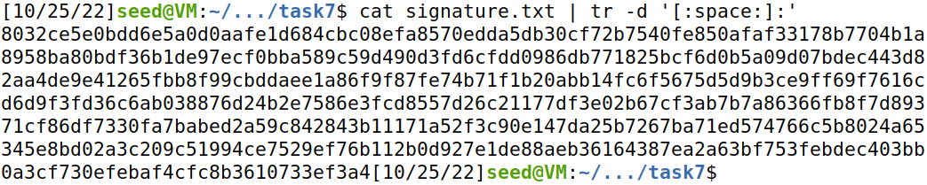

Extracting body of the server’s certificate
Verifying the signature.

