Crypto Lab - 3
Name: H M Mythreya
SRN: PES2UG20CS130

Task 1: Generate Encryption Key in a Wrong Way

With random seed
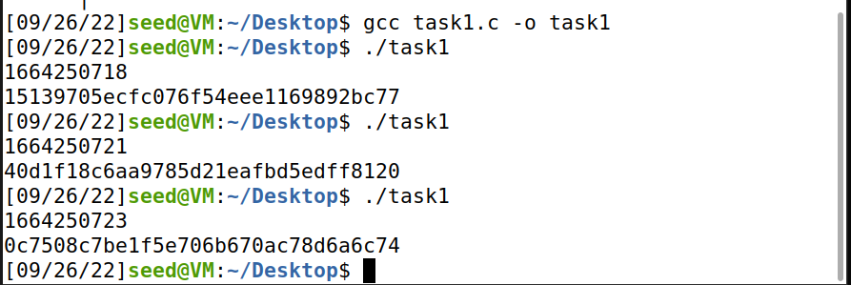IWith same seed
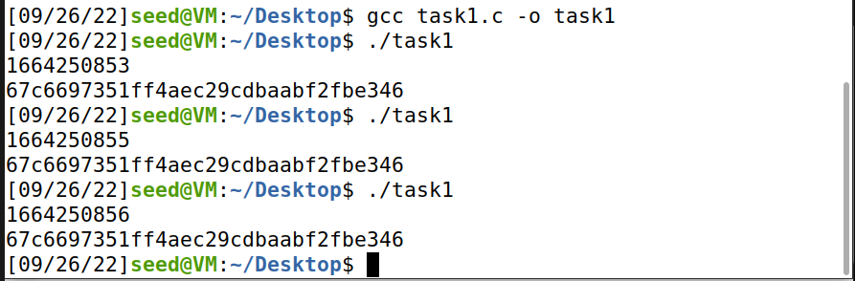
In computers, there is no such thing as random, only pseudo or false random. If we use the same seed to call the random function, the output is the same since the random function is simply a mathematical function designed to output false randoms.

As seen above, when the seed is set the same, the output isn’t random.

Task 2: Guessing the Key
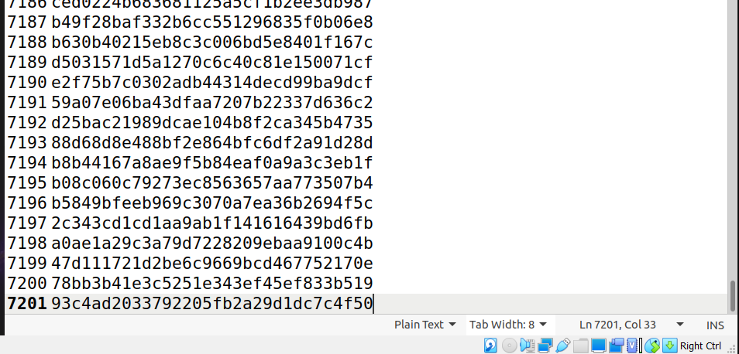
Since the seed used by the host is based on time, using the timestamp, we can bruteforce all possible combinations of the seed that could’ve been used in the timeframe. As seen above, there are only 7201 possible keys from the timestamp which isn’t safe since modern computers can brute-force millions of keys a second.

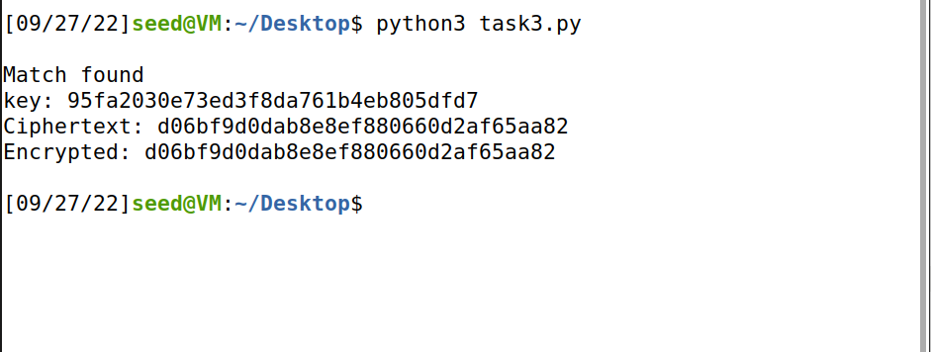

By trying every key out of the 7200 keys, we can easily crack the encryption.

Task 3: Measure the Entropy of Kernel

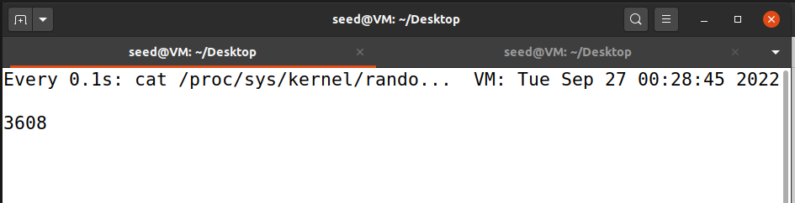
Task 4: Get Pseudo Random Numbers from /dev/random

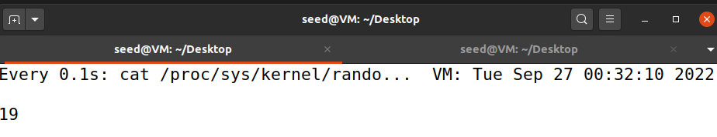

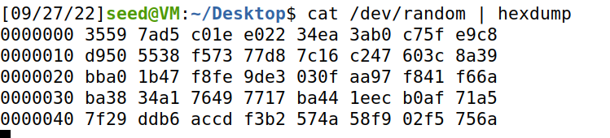

The entropy of the kernel depends on the state of the system. When there is no activity, i.e, keyboard or mouse movement, there is no change. When there is an activity, the entropy changes.

Task 5: Get Pseudo Random Numbers from /dev/urandom
Entropy of kernel and the hexdump output when using /dev/urandom:
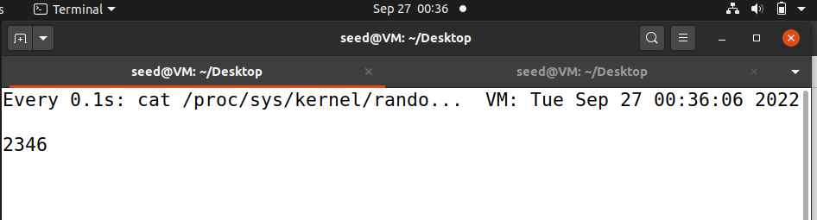
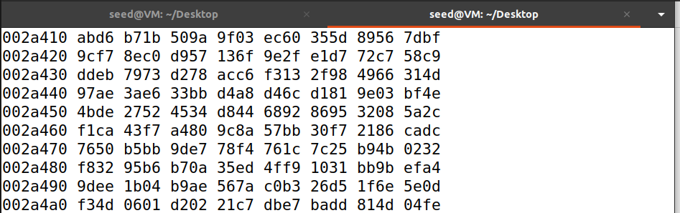
Here we are checking the quality of the randomness using ent
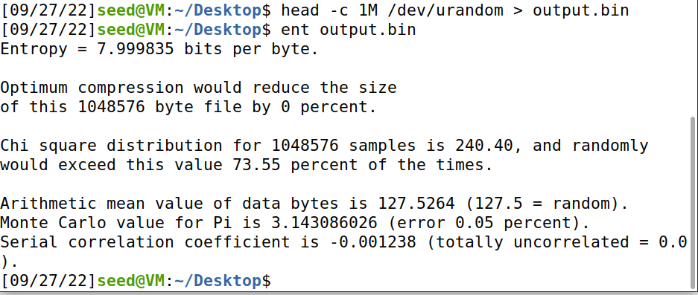

Instead of using time for a random seed, we can use the entropy of the kernel with dev/urandom for better randomness and hence make it harder to break the encryption.
