DATE: 25-08-2022
LAB 01: Working with classical ciphers

NAME | H M Mythreya
SRN | PES2UG20CS130
SECTION | C

For the given questions, write a python code and attach the snapshots.
1. | For the given input, perform Caesar cipher encryption and decryption.  Plain text: “CRYPTOGRAPHY”  Key: 10
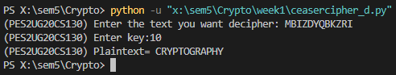  SOL | 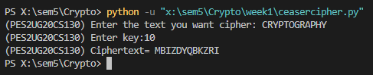
2. | For the plaintext given in question 1, apply Play Fair cipher encryption with key “WORK”.
SOL | 