CNS Lab - 7
Name: H M Mythreya
SRN: PES2UG20CS130

Labsetup
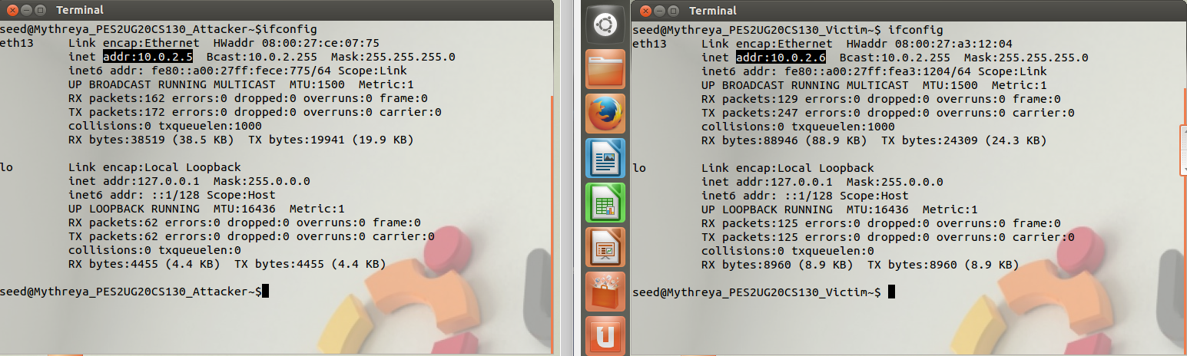
Attacker: 10.0.2.5 Victim: 10.0.2.6

Step1: Configure DNS Server on Attacker machine
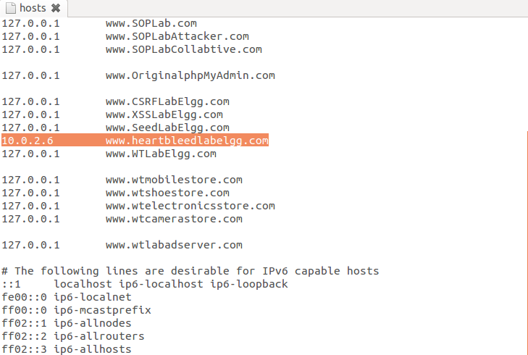
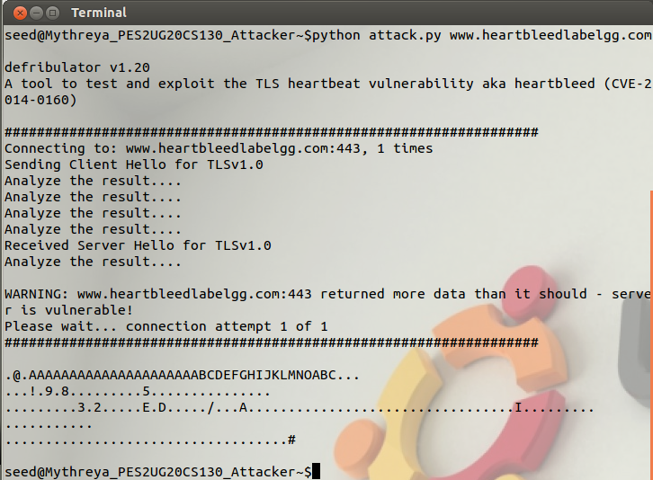
Step2: Warmup exercise

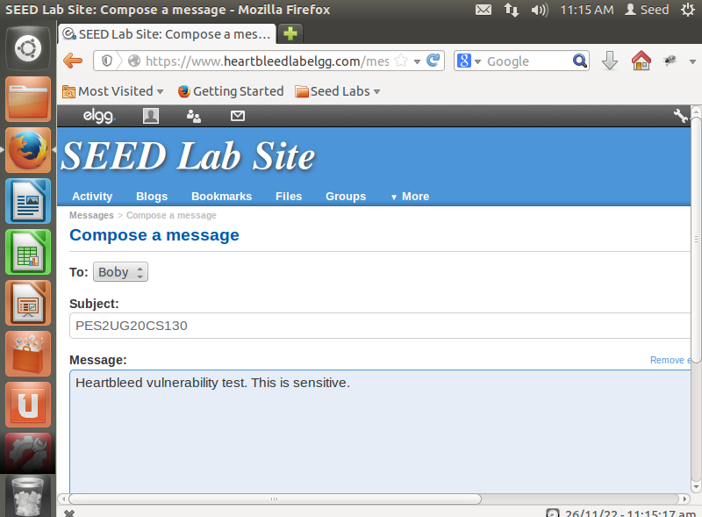
Step2a: Login and send boby a message
Step2b: Run attack.py code until sensitive information can be found
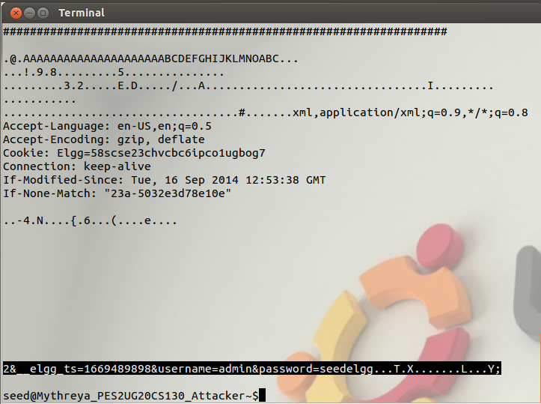
Login details is leaked

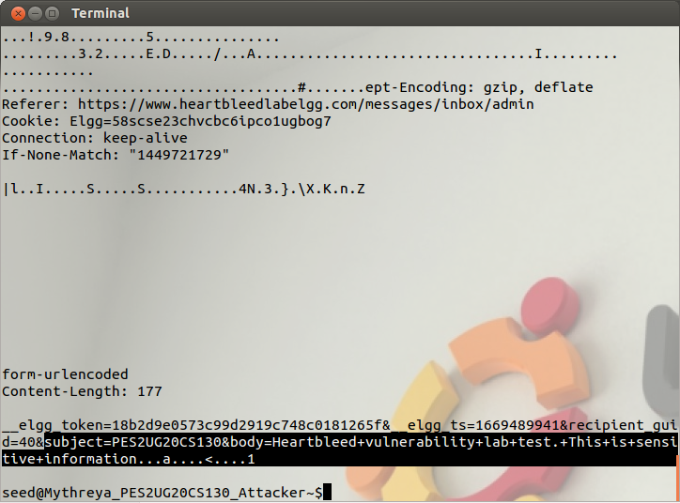
Running a few more times, the private message is also leaked

Step3:Investigate the fundamental cause of the Heartbleed attack
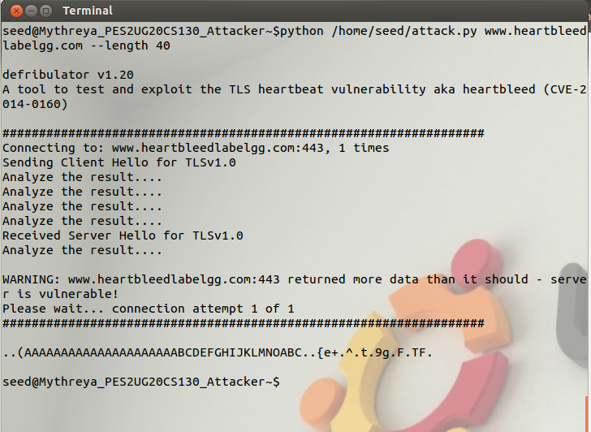
python /home/seed/attack.pywww.heartbleedlabelgg.com --length 40
(Only 40 bytes of extra data is captured)
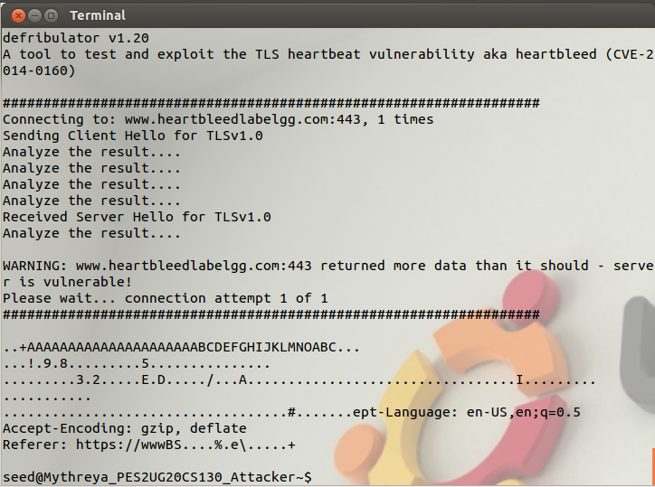

python /home/seed/attack.pywww.heartbleedlabelgg.com --l 0x012B
(0x012B=299 bytes)
Step4:Find the boundary value of the payload length variable.

