Crypto Lab - 9
Name: H M Mythreya
SRN: PES2UG20CS130

Setting up docker

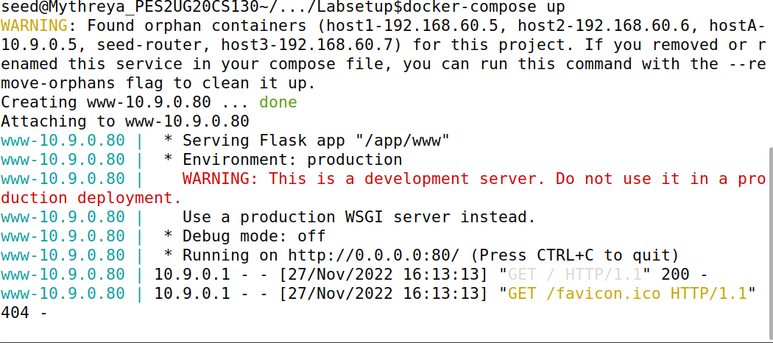
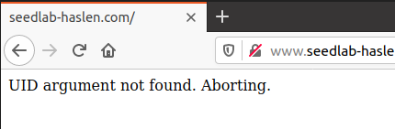

Task 1: Accessing website with proper mac
Calculating mac using sha256sum
uid:key pair used → 1005:xciujk
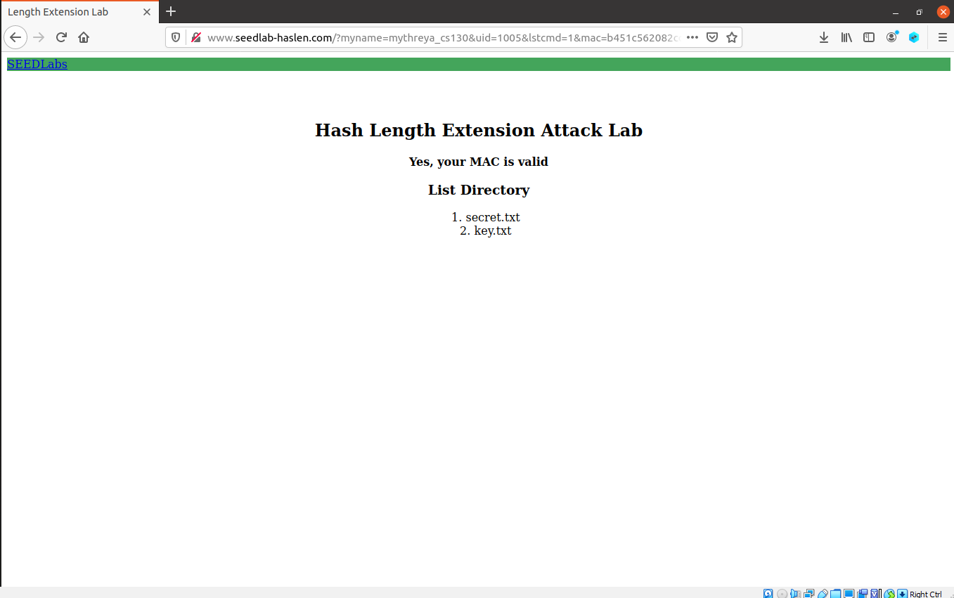

We can see the contents of secret.txt by sending a query “download=secret.txt”
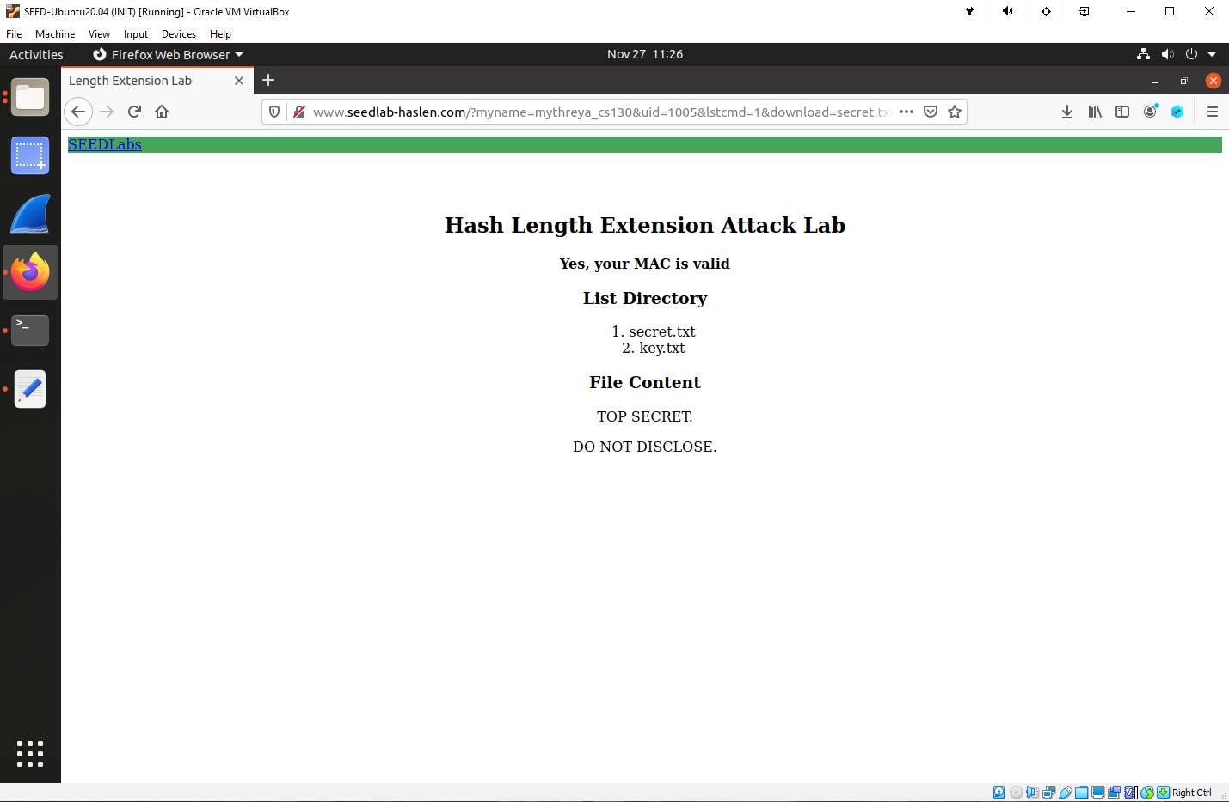
Task 2: Construct padding for sha256
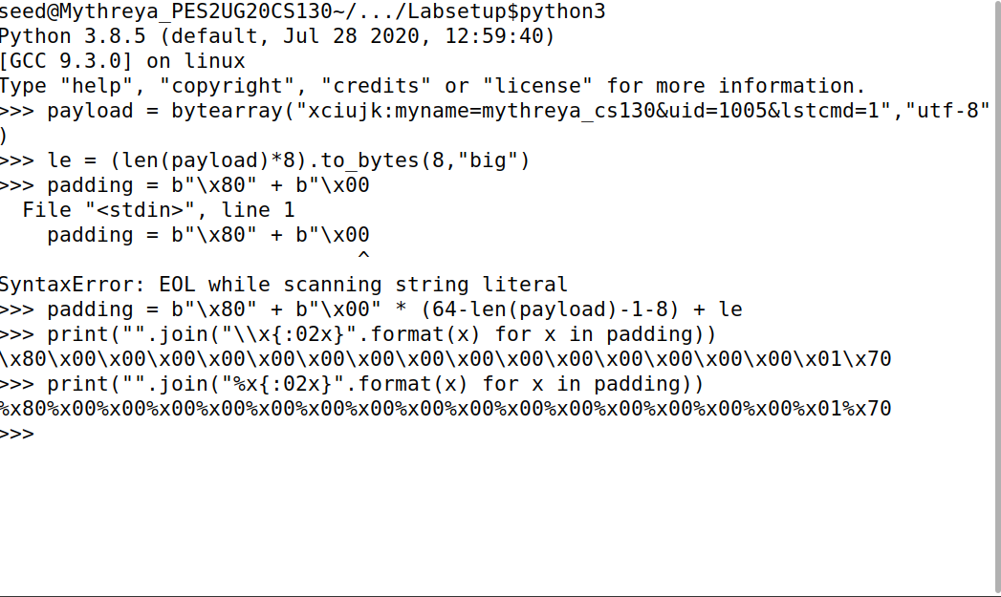

Task 3

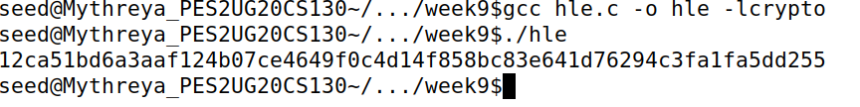
New hash generated after padding:
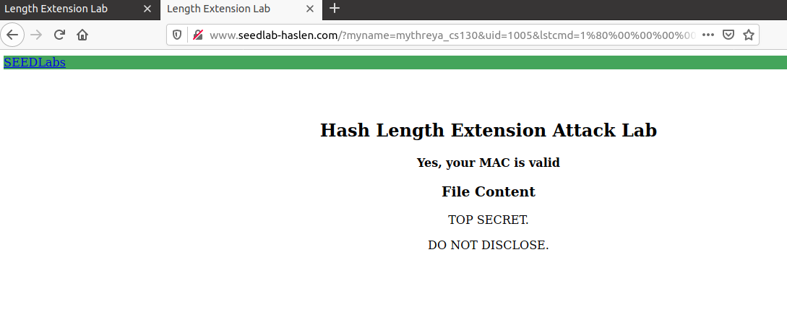

Generating Hash without uid:key pair
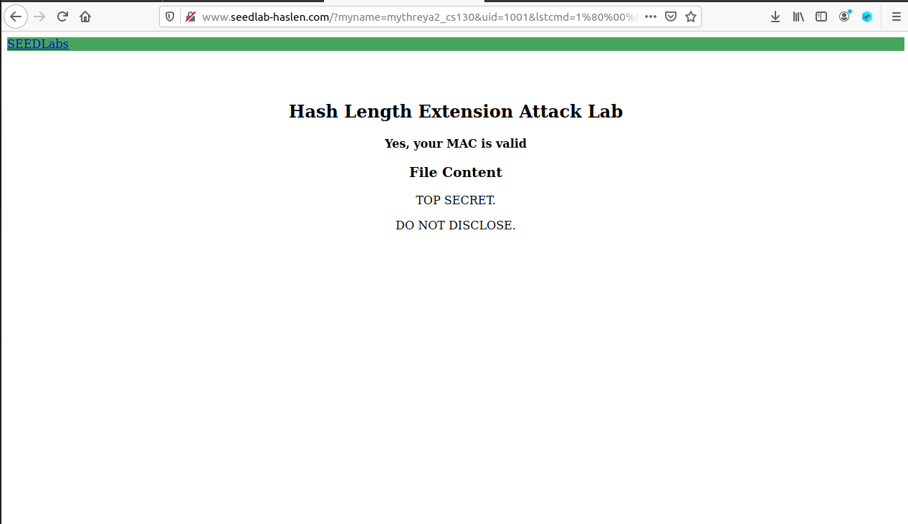
With the help of sha256 padding we can access the secret.txt without the need to know uid:key pair.

