DBMS Review 5 Assignment
Name: H M Mythreya
SRN: PES2UG20CS130

Q) Check whether the below given schedule S is conflict serializable or not.
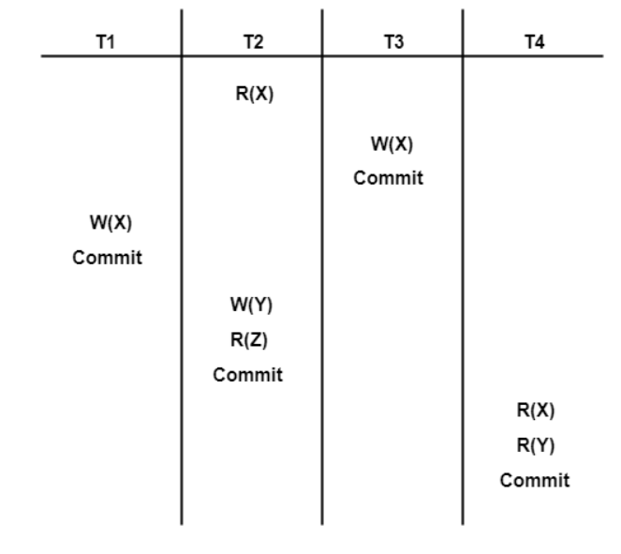
Ans: Listing all the conflict operations and determining the dependency between transactions:
R2(X), W3(X) (T2->T3) R2(X), W1(X) (T2->T1) W3(X), W1(X) (T3->T1) W3(X), ‌⁤‌⁢⁣‌‍⁡⁡‍⁡⁡⁢‍⁢⁡‍‌⁡‍‌⁡‌⁤⁢‌⁡‍⁡⁢‍⁢⁢⁡⁢⁢‌⁡⁢⁢⁢⁤‍‌‍⁡‌⁤⁡‍⁡⁢⁡⁢‍⁢‍⁡‍‌⁢‌⁢⁣⁡‍⁢⁤⁢⁡‍⁡‌‍⁢⁢‍⁡‌‍⁣⁡‌‍‌⁤⁡‍⁣⁡⁢‌⁡⁢⁡⁡⁡⁣‌‍⁡⁡⁡R4(X) (T3->T4) W1(X), R4(X) (T1->T4) W2(X), R4(X) (T2->T4)

After drawing the precedence graph, we can see that there is no cycle present.

Therefore, the given schedule S in conflict serializable.

Q2. Consider the following transaction involving two bank accounts x and y.
read (x); x:=x-50; write(x);
read(y); y:=y+50; write(y)
Explain in detail, which constraint of ACID properties will satisfy the below statement:
The sum of the accounts x and y should remain constant.
Ans: Consistency will satisfy the statements. Data is in a consistent state when a transactions starts and when it ends. ⁣‍‌⁡⁢‍‌‍⁢‍⁢⁡‍⁤‍⁢‍⁡⁡⁡⁡‌‍⁡‌‌⁢‌⁢‌‌‍‌⁤‌‌⁢‍‌‍‌⁡⁡⁣⁡⁡⁡⁣⁤‍⁢‍⁤‌‍⁡⁤‌⁣‌⁤⁢‍‌‍⁢‍⁡‌⁡⁢‌‍⁢‍⁡‍⁢⁡⁣⁤⁡⁡‌⁢⁣‌‌‍⁡⁤⁣‍⁢‍⁡‌⁡⁣For example, in an application that transfers funds from one account to another, the consistency property ensures that the total value of funds in both the accounts is the same at the start and end of each transaction.

Q3 . Consider a database with objects X and Y and assume that there are two transactions T1 and T2. Transaction T1 reads objects X and Y and then writes object X. Transaction T2 reads objects X and Y, then reads X once more, and finally writes objects X and Y (i.e. T1: R(X), R(Y), W(X); T2: R(X), R(Y), R(X), W(X), W(Y))
a) Give an example schedule with actions of transactions T1 and T2 on objects X and Y that results in a write-read conflict.
b) Give an example schedule with actions of transactions T1 and T2 on objects X and Y that results in a read-write conflict.
c) Give an example schedule with actions of transactions T1 and T2 on objects X and Y that results in a write-write conflict.
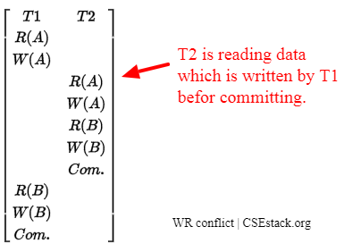
reading uncommitted data
Transaction T2 is writing data which is previously read by transaction T1.
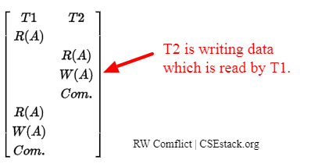
Here Transaction T2 is writing data which is already written by other transaction T1. T2 overwrites the data written by T1. It is also called as a blind write option.
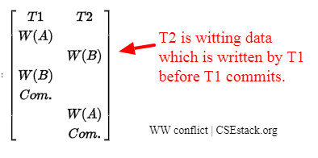
Data written by T1 has vanished. So it is data update loss.

Q4. Consider a collection posts which has fields: _id, post_text, post_author, post_timestamp, post_tags etc. Write a query which retrieves ONLY the key named post_text from the first document retrieved?
Ans: db.posts.finOne({},{_id:0,post_text:1})

Q5. Consider the Movie database for Neo4j.Write CQL to retrieve all the movies that have released after year 2000 and return only title of the movie and votes.
Ans: MATCH (m:movie) where m.year>2000 RETURN m.title,m.votes

