# Auto Draws

This tool provides following functionalities:

1. Variable configuration as shown in Figure 1. You can tune the variables to whatever you need to. This tool provides default values for each variable as shown in Figure 1. You can tune them freely to meet the needs of your prediction. Once you done the variable configuration, click submit button and the new group of numbers will be generated. The only difference between this tool and *Predict Draws* in variable configuration panel is that the generated draw numbers are not depending on **sum min/max** and **number of odd** as shown in *Predict Draws*. Instead, they depend on selection of algorithm. The details of each algorithm are shown in Figure 2 and 3 below. The explanation of each algorithm selected shown as below:

* Semi Hot Numbers – tool will select 3 numbers in random from Semi Hot Number group and rest of numbers of the target draw will be chosen from other groups in random.
* Hot Numbers - tool will select 3 numbers from Hot Number group in random and the rest of numbers of the target draw will be chosen in random from other groups.
* Mix – tool will select all draw numbers in random from whole groups.
* Number Range – a new selection list will be visible under the algorithm selection list, in which number range shown up, referring to the Figure 3 below. For each number range, the tool will select 3 numbers from that range and the rest of the numbers for the target draw will be chosen from other groups. This algorithm, therefore, is number range oriented. According to analysis and research on the other statistics on other tabs, the trend that draw numbers fallen in certain number ranges can be caught, ***Statistics 1*** typically for this purpose and from which you can analyze what would be the next number ranges in which the next draw may fall. Let’s say you know at least two to three numbers might be possible fall in to number ranges 1 – 9 for instance, after analyzing on ***Statistics 1,*** you can choose number ranges 1 – 9 in this selection list and let nature to select the remaining numbers for the next draw. This way, you bucks might be invested more profitably and you also can choose different number range for each ticket you going to buy to cover all possible missing guess. Well this would depend on how many tickets you want to buy, the more you buy, the more numbers may get hit for the next draw. This tool particularly works for those group-ticket-buyers, which will increase chances enormously in hitting range of breakdown prices, even a Jackpot.

1. The other difference from the *Predict Draws* is that since the generated draw numbers are not directly from so called *alternative numbers* (which generated based on variable configuration panel) but from selected algorithm, some of the generated draw numbers (in RED color) may not appear in the alternative number group. As you may noticed in Figure 4 below, only five numbers in RED color and some time fewer than that but you can find the all generated draw numbers on the bottom of tablet. The point is that alternative numbers some time may miss some number that tool suppose to be **DEAD** number, but actually those numbers may hit the next draw because of the nature of randomness. Therefore this tool can be considered as supplement to the *Predict Draws*. Consequently you might need to run both tools to compare the results before you make final decision.
2. To start a draw number generating, enter an integer value in target draw text box. This value indicates that which target draw you want to generate for, if the text box is left empty while clicking submit button, the target draw would be the next draw. You also can enter a past draw number, which you can find in ***Statistics 7***, to run and test how much you can match the past target draw pretending not knowing the result to the selected past draw. This is one of important functionalities for this tool. By doing this practice, you can accumulate your skills and experience on how to select right numbers in future draws.
3. Next, select a lottery that may be available to you or of your interest. This tool provides the lotteries shown in Figure 1 in *Predict Draws*. This list is keeping increasing. It may include more lotteries in North American and European famous Lotteries, such as EuroMillions, Asian Lotteries, *OZ*Lotto eventually in near future.
4. You can get new generated draw numbers (in RED color) by clicking submit button each time. If you do not satisfy the generated set of draw numbers, just keep clicking **submit** button (Warning: don’t click too fast – every 1-2 seconds interval at least, for the sake of server response time) and different set of draw numbers, as well as new group of alternative number would be generated – this is another difference from *Predict Draws* where alternative numbers remain unchanged until you tune a new value in configuration panel.
5. Value for **R** indicates *relative distance*, which means this number was last hit is number value of draws ago. For instance, **19 R(4)** refers that number 19 was hit 4 draws ago. That shows up that 19 is a hot number according to the definition of variable configuration in Figure 2. Value for **S** indicates *saved distance,* which means how many draws ago this number got hit prior to the last hit. For instance **19 R(4) S(16)** refers that number 19 got hit prior to last hit was 19 draws ago and the last hit to now is 4 draws ago. Therefore, in this case **19 R(4) S(16)** indicates that 19 was once cold number and became hot after last hit. This indication may be very helpful in choosing which number should be your last choice. The 4 and 16 here are defined as **distance** for the rest of documents. ***Statistics 3*** provides longer history of each numbers and better go through that statistics before making any final decision
6. All numbers generated, either in RED or in WHITE, are based on proprietary algorithms which are supposed to have been filtering out those *DEAD* numbers in order to narrow down the range of number for selection. This will increase the hit possibility and save money from spending on those virtually no-hope, *DEAD* numbers. This is also one of reasons why you must use LottoTry™ analysis tools for your adventure on making unthinkable to be thinkable.

Definitions for **HOT, VERY HOT**, **SEMI HOT**, **SEMI COLD**, **COLD**, **VERY COLD**. Values of Min/Max are in DISTANCE. 1, for instance, means any numbers hit on last draw, while 5 means any number hit on 5 draws ago. In this example, for selecting 20 HOT numbers which are got hit between last draw and 5 draws ago. For selecting 5 Semi HOT numbers, which got hit between 5 draws and 9 draws ago, and so on for other types of numbers.

Current selected Tab of which represents LottoTry™ analysis and statistics tools

Choose using which algorithm for the tool to generate draw numbers and alternative numbers. For detailed selection list refer to Figure 2 below.

Select a Lotto of your interest.

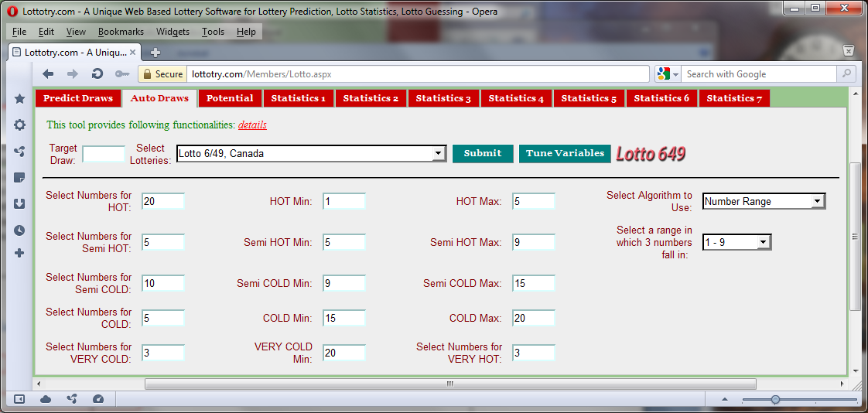

Select values for various type of number

Input next draw number or past known draw number

Figure : Variables Configuration

Only when **Number Range** isselected in Algorithm selection list, will this number range selection list be visible. For the detail of this number range, refer to Figure 3 below.

|  |  |
| --- | --- |
| Figure Algorithm Selection List | Figure Number Range Selection List |

Number Range: 1-9:the tool will select 3 numbers in random from this group for the next draw and the remaining numbers from other groups in random. This applies to other number ranges selected. This drop down list is popped up when **Number Range** is selected in Algorithm selection list shown in Figure 2.

Selecting **Semi Hot Numbers** will allow the tool to select 3 numbers from Semi Hot Number group in random and rest of the number (3) will be chosen from other groups in random. Selecting  **Hot Numbers** will allow the tool to select 3 numbers in random from Hot Number group and other numbers chosen from the rest of groups in random. **Mix** will allow the tool to select all numbers for next draw from whole number groups in random filtered out by the software. Selecting **Number Range** will popup another selection drop list as shown in Figure 3. By selecting one of ranges, the tool will choose 3 numbers from that range in random and the rest of the numbers from other groups.

This one of generated draw number in RED color. **R:** relative distance, which means this number got hit 3 draws ago. **S:** saved distance, which means when this number (3) last time got hit from which its previous hit was 4 draws ago. **R** and **S** infer the recent history of this number to provide valuable info to the user in determining if this number is one of best choices or not, ***Statistics 3*** provides longer history of each numbers and better go through that statistics before making any final decision.

The numbers in WHITE color means that they are selected as potential alternatives for the draw numbers. They were generated because they have equally chance to hit the jack-pot as the RED one, they are in WHITE color only because they were not being chosen by generator this time. Therefore, when you select your final draw numbers, this group numbers must be considered equally to those RED ones. Go through other Statistics and tools before you make final decision.

Whole numbers from which draw numbers are generated. In Lotto 6/49 the number range is 1 – 49, while Mega Millions is 1 – 56 and Power Ball is 1 – 59, etc.

Each time **sumbit** button clicked new goupe of numbers would be generated. You can do it as many time as you like until you satisfy.

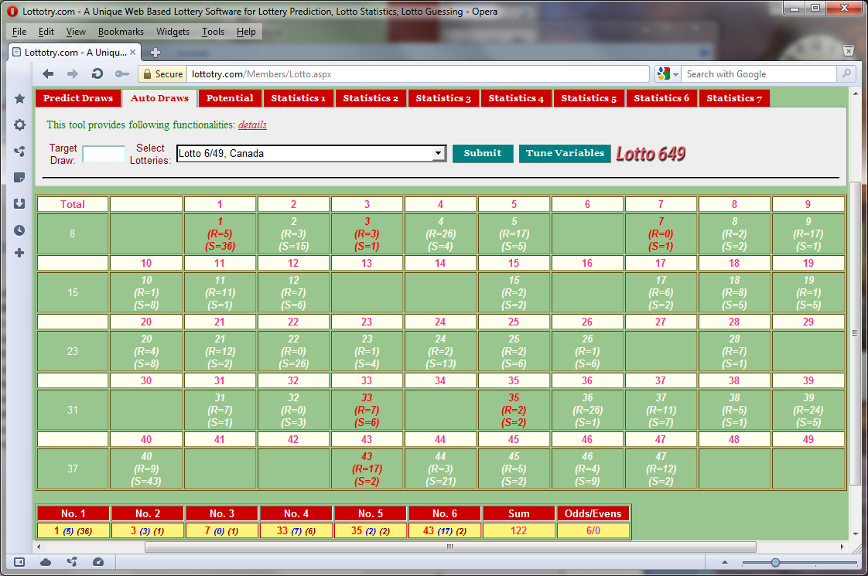

Tune Variables button to switch back to Variable Configuraton page.

Sum of all draw numbers. This is one of factor to consider when making final decision. ***Statistics 7*** provides history of all draws **Sum** info from which you can analysis the frequency or trend of these factors in the past.

Total numbers generated. 10 means accumulated number so far along each row of the tablet. 30 here is the total generated numbers for this submit. This number based on your configuration.

Figure Auto Draw Tool

Generated draw numbers. For instance, **33***(7)(6),* (***7***) here is **R**: **Relative Distance** and which means this number got hit 14 draws ago. Here (***6***) is **S**: **Saved Distance.** This indicates that when number 33 last time got hit (7 draws ago) of its previous hit was 6 draws ago. **R** and **S** refer to the recent history of this number to provide valuable info to the user in determining if this number is one of best choices or not, ***Statistics 3*** provides longer history of each numbers and better go through that statistics before making any final decision.

Blank means these numbers were filtered out. Because these numbers (in Blank) are considered as ‘DEAD’ by the tool. But don’t always think that way as HUMAN, considering the lotto’s randomness and un-predictability, these numbers could also be possible hitting the Jack-Pot. You need to go through and analysis other statistics and tools on other tabs to make final pick up and one or more of these blank may be considered to be ‘LIVE’ one.

Shows the Odd and Even numbers in generated draw. This is one of important factor to consider when you facing dilemma on choosing which numbers. ***Statistics 7*** provides history of all draws **Odds/Evens** info from which you can analysis the frequency or trend of these factors in the past.