# Potential Draws

This tool provides the following functionalities:

1. Variable configuration as shown in Figure 1. You can tune the variables to whatever you need to. This tool provides default values for each variable as shown in Figure 1. You can tune them freely to meet the needs of your prediction. Once you done the variable configuration, click submit button and the new group of numbers will be generated.
2. This tool is different from other two random generating tools (Predict/Auto Draws) on that it works not for future – next draw, but provides indications for a given past draw. It works like this: once **submit** button clicked, the tool will run into a loop and each of which does the same random generating as other two tools do until a group of generated numbers contains the whole given target numbers, it then stop and output this group of numbers as shown in Figure 3 below. The number of loops it’s been running also got output as shown on top of the table in Figure 3 (in this example, the number of loops is ***28***).
3. The objective of this magic tool is to let user realize that not every random generating can cover all given target draw numbers, you might need to run multiple rounds in order to generate an ideal group of numbers which would be s short range as possible, meanwhile covers all numbers provide by a target draw.
4. Therefore given draw numbers (in RED color, must be past known draw) are always remain unchanged upon each new run only alternative numbers and number loops are changing. You can re-configure those variables and re-run it to optimize and improve the random generating by watching the number loops each run results. Then you may apply a best configuration you think to other two tools to do the real challenge. Because they all utilize the same random generating algorithm. This is another important motivation why we create this tool.

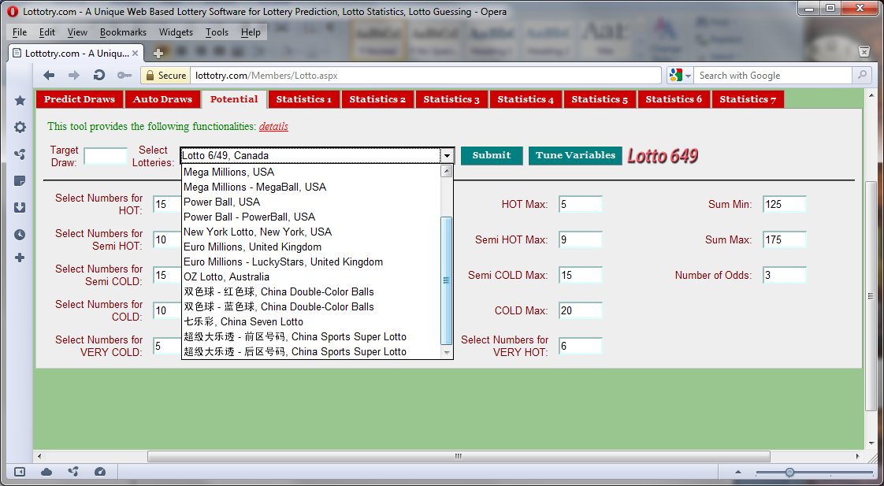

Figure Lotto Selection

Lotto selection that this tool provides analysis and statistics

Definitions for **HOT, VERY HOT**, **SEMI HOT**, **SEMI COLD**, **COLD**, **VERY COLD**. Values of Min/Max are in DISTANCE. 1, for instance, means any numbers hit on last draw, while 5 means any number hit on 5 draws ago. In this example, for selecting 20 HOT numbers which are got hit between last draw and 5 draws ago. For selecting 5 Semi HOT numbers, which got hit between 5 draws and 9 draws ago, and so on for other types of numbers.

**Sum** means sum of all numbers of generated draw. The scope of sum is defined by **sum min** and **sum max** of these two fields. That means the sum of generated draw must fall in between these two values.

Current selected Tab of which represents LottoTry™ analysis and statistics tools

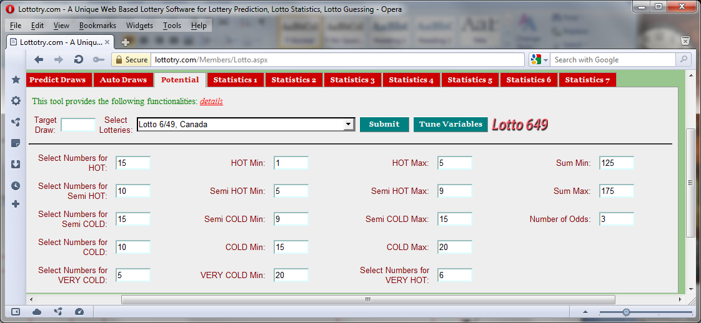

Input a past draw number. If left empty, this value default as last draw number

Select a Lotto of your interest.

Figure : Variables Configuration

**Odds** means number of odd numbers in a generated draw can be allowed. Value 3 tells the tool that any draw generated must include 3 odd numbers (therefore 3 even numbers as well).

Select number for each type of definitions

This value (28) indicates that after 28 rounds of random generating, this group of generated numbers contains specified all draw numbers (in READ color, of course these draw numbers must have already been known). The loop value (28 for this example) might be varied upon each running. This indicated that not every random generating, as you may do in Predict Draws and Auto Draws, covers the whole draw numbers. And also indicates that in order to generate a group of shorter range of numbers, which make you guess easier, meanwhile they also cover the whole next draw numbers, you may need to run random generating multiple times. This example shows that you need 28 rounds of generating in order to contain the whole give target numbers in a generated number group.

The alternative numbers (in WHITE color) indicate that they are selected as potential alternatives for the draw numbers. They were generated because they have equally chance to hit the jack-pot as the RED ones, they are in WHITE color only because they were not being chosen by generator on this run. Therefore, when you select your final draw numbers, this group numbers must be considered equally to those RED ones. Go through other Statistics and tools before you make final decision. This group of number will be changed on every new run.

Whole numbers from which draw numbers are generated. In Lotto 6/49 the number range is 1 – 49, while Mega Millions is 1 – 56 and Power Ball is 1 – 59, as in this example.

Each time **submit** button clicked new group of numbers would be generated. You can do it as many time as you like until you satisfy.

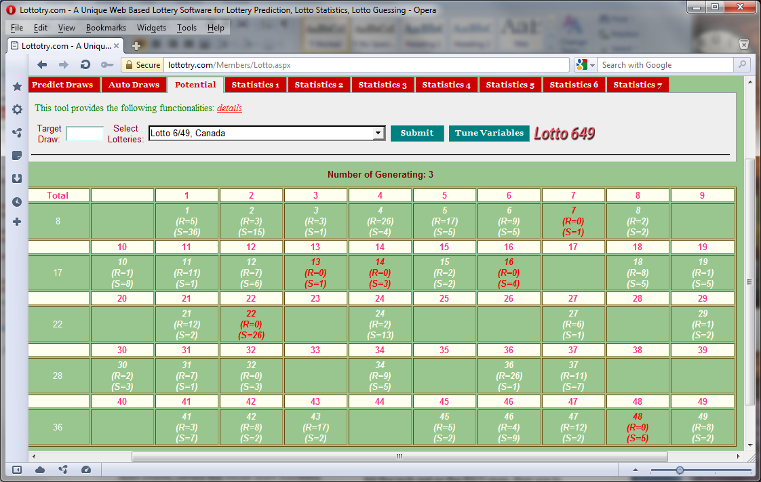

Input a past draw number. If left empty, this value default as last draw number

Tune Variables button to switch back to Variable Config. panel.

Figure : Generated a new Draw

Total numbers generated, 21 means accumulated number so far come down along each row of the tablet. Here 36 is the total generated numbers for this round of generating. This number may vary on each run. That means current run generated 36 numbers out of 49. 36 numbers are those we consider to select from for the candidate numbers.

The draw numbers (in RED color) displayed in this panel are not generated but from past draw. They are the real draw specified by draw number entered by user in the Target Draw field. Therefore, each run, these numbers remain unchanged.

Blank means these numbers were filtered out. Because these numbers (in Blank) are considered as ‘DEAD’ by the tool. But don’t always think that way as HUMAN, considering the lotto’s randomness and un-predictability, these numbers could also be possible hitting a jackpot. You need to go through and analysis other statistics and tools on other tabs to make final pick-up and one or more of these blanks may be considered to be ‘LIVE’ one.