# Predict Draws

This Tab provides the following functionalities:

1. Variable configuration as shown in Figure 2. You can tune the variables to whatever you need to. This tool provides default values for each variable as shown in Figure 2. You can tune them freely to meet the needs of your prediction. Once you done the variable configuration, click submit button and the new group of numbers will be generated.
2. To start a draw number generating, enter an integer value in target draw text box. This value indicates that which target draw you want to predict, if the text box is left empty while clicking submit button, the target draw would automatically be the next draw. You also can enter a past draw number, which you can find in ***Statistics 7***, to run and test how much you can match the past target draw. This is one of important functionalities for this tool. By doing this practice, you can accumulate your experience on how to select right numbers in future draws.
3. Next, select a lottery that may be available to you or of your interest. This tool provides the lotteries shown in Figure 1 in *Predict Draws*. It lists major lotteries in North American and EuroMillions of UK, *OZ* Lotto of Australia.
4. Actual generating draw numbers for target draw (could be next draw, or any past draws as long as it is legal) as shown in Figure 3. The generated numbers (in RED) are based on user input as shown in text boxes of **Sum Min**, **Sum Max** and **Number of Odds** displayed in Figure 2 of Variable Configuration page. These three values determine the generated draw numbers, i.e. the sum of six draw numbers must be greater than **Sum Min** andless than **Sum Max**. And there must contain same amount of odd numbers as the values entered in **Number of Odds** text box. ***Statistics 7*** provides history of draws and statistics related to sum and odd/even. You may refer that tab first to research the trend then come back to make decision what values you may enter in these text boxes. These are parts of important factors on making final decision. No matter how randomness of each draw, some trend still can be caught and followed. LottoTry™ provides sufficient indications and statistics and rest of thing is up to your wisdom to conquer the lottery, if you don’t want to waste your life-time to buy tickets from retailer and waiting for lotto numbers to catch up you.
5. You can get new generated draw numbers (in RED color) by clicking submit button each time. If you do not satisfy the generated set of draw numbers (ex. for Lotto 6/49, the set draw number is 6, for Mega Millions, is 5, etc.), just keep clicking **submit** button (Warning: don’t click too fast – every 1-2 seconds interval at least, for the sake of server responsive time) and different set of draw numbers, along with a group of number (in White), would be generated. Those numbers come up with each generating (in WHITE color, called **alternative numbers** in the rest of documents) for referencing will also be changed on each clicking of submit button. That means you also can pick up some numbers from this group for your final choice. Most of time the final draw numbers you may pick are from both groups. Don’t just simply pick the generated set of numbers (in RED). To choose which numbers, usually you have to base on analysis from other tools and statistics on other tabs.
6. Value for **R** indicates *relative distance*, which means this number was last hit is number value of draws ago. For instance, **19 (R=4)** refers that number 19 was hit 4 draws ago. This indicates that 19 is a hot number according to the definition of variable configuration in Figure 2. Value for **S** indicates *saved distance,* which means how many draws ago this number got hit prior to the last hit. For instance **19 (R=4) (S=16)** refers that number 19 got hit prior to last hit was 19 draws ago and the last hit to now is 4 draws ago. Therefore, in this case **19 (R=4) (S=16)** indicates that 19 was once cold number and became hot after last hit. This indication may be very helpful in choosing which number should be your last choice. The 4 and 16 here are defined as **distance** for the rest of documents. ***Statistics 3*** provides longer history of each numbers and better go through that statistics before making any final decision.
7. All numbers generated, either in RED or in WHITE, are based on proprietary algorithms which are supposed to have been filtering out those *DEAD* numbers in order to narrow down the range of number for selection. This will increase the hit possibility and save money from spending on those virtually no-hope *DEAD* numbers. This is also one of reasons why you must use LottoTry™ analysis tools for your adventure on making unthinkable to be thinkable.

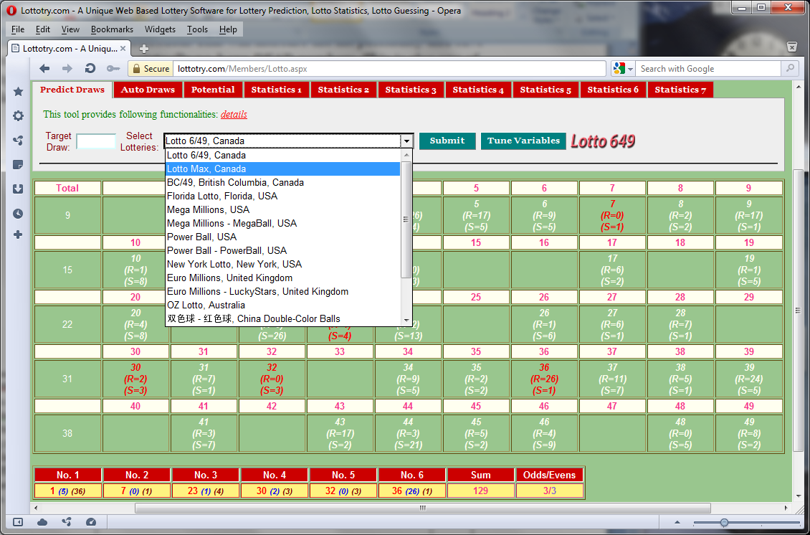

Figure Lotto Selection

Lotto selection that this tool provides analysis and statistics

Definitions for **HOT, VERY HOT**, **SEMI HOT**, **SEMI COLD**, **COLD**, **VERY COLD**. Values of Min/Max are in DISTANCE. 1, for instance, means any numbers hit on last draw, while 5 means any number hit on 5 draws ago. In this example, for selecting 20 HOT numbers which are got hit between last draw and 5 draws ago. For selecting 5 Semi HOT numbers, which got hit between 5 draws and 9 draws ago, and so on for other types of numbers.

Current selected Tab of which represents LottoTry™ analysis and statistics tools

**Sum** means sum of all numbers of generated draw. The scope of sum is defined by **sum min** and **sum max** of these two fields. That means the sum of generated draw must fall in between these two values.

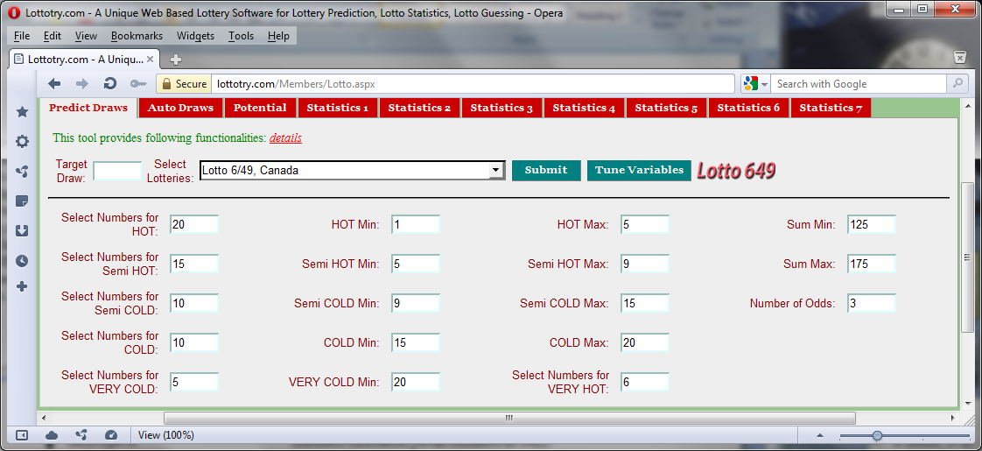

Select a Lotto of your interest.

Figure : Variables Configuration

**Odds** means number of odd numbers in a generated draw can be allowed. Value 3 tells the tool that any draw generated must include 3 odd numbers (therefore 3 even numbers as well).

Input next draw number (or left empty also for next draw number) or input a past known draw number

Select number for each type of definitions

This one of generated draw number in RED color. **R:** relative distance, which means this number got hit 3 draws ago. **S:** saved distance, which means this number got hit 15 draws ago prior to the last hit which was 3 draws ago from now. **R** and **S** indicate the recent history of this number to provide valuable info to the user in determining if this number is one of best choices or not, ***Statistics 3*** provides longer history of each numbers and better go through that statistics before making any final decision.

The numbers in WHITE color means that they are selected as potential alternatives for the draw numbers. They were generated because they have equally chance to hit the jack-pot as the RED one, they are in WHITE color only because they were not being chosen by generator this time. Therefore, when you select your final draw numbers, this group numbers must be considered equally to those RED ones. Go through other Statistics and tools before you make final decision.

Whole numbers from which draw numbers are generated. In Lotto 6/49 the number range is 1 – 49, while Mega Millions is 1 – 56 and Power Ball is 1 – 59, etc.

Each time **sumbit** button clicked new goupe of numbers would be generated. You can do it as many time as you like until you satisfy.

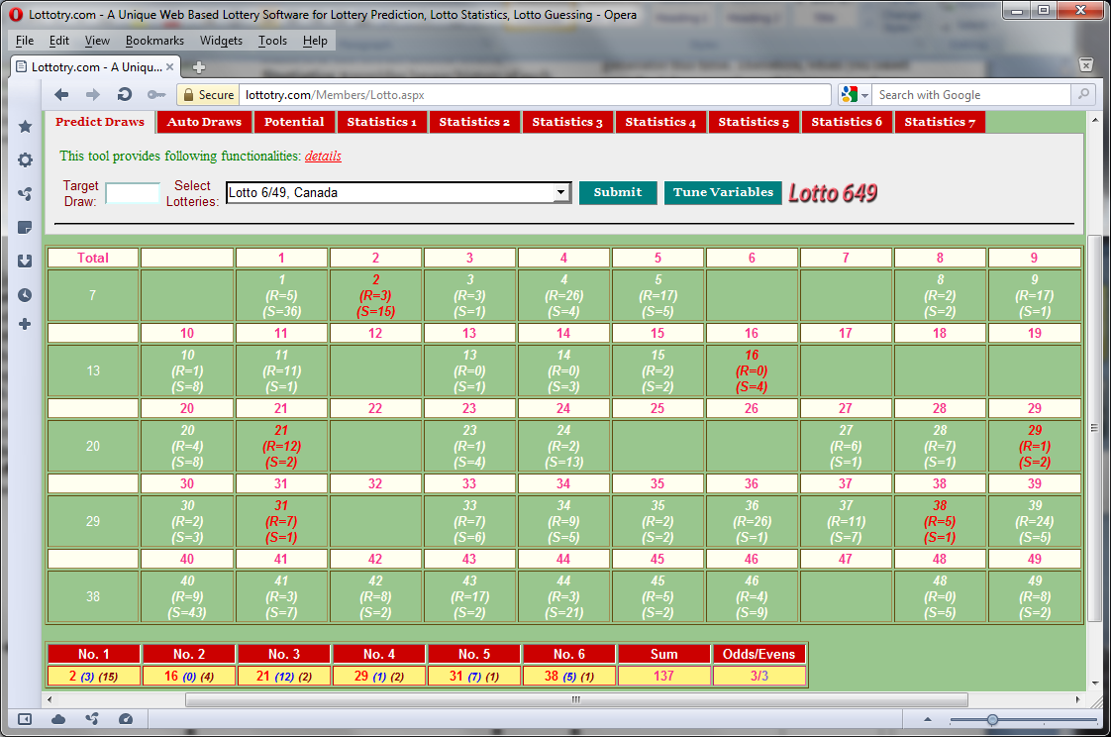

Blank means these numbers were filtered out. Because these numbers (in Blank) are considered as ‘DEAD’ by the tool. But don’t always think that way as HUMAN, considering the lotto’s randomness and un-predictability, these numbers could also be possiblely drawn. You need to go through and analysis other statistics and tools on other tabs to make final pick up and one or more of these blank may be considered to be ‘LIVE’ one (or upon next click of submit button).

Tune Variables button to switch back to Variable Configuraton page.

Total numbers generated. 10 means accumulated number so far along each row of the tablet. 30 here is the total generated numbers for this generating. This number varied on your configuration tune.

Shows the Odd and Even numbers in generated draw. This is one of important factor to consider when you facing dilemma on choosing which numbers. ***Statistics 7*** provides history of all draws **Odds/Evens** info from which you can analysis the frequency or trend of these factors in the past.

Figure : A newly generated draw numbers

Generated draw numbers. For instance, **21***((12)(2),* (1*2*) here is **R**: **Relative Distance** and which means this number got hit 1 draws ago. (*2*) here is **S**: **Saved Distance.** This indicates that when number 26 last time got hit (12 draws ago) of its previous hit was 2 draws ago. **R** and **S** refer to the recent history of this number to provide valuable info to the user in determining if this number is one of best choices or not, ***Statistics 3*** provides longer history of each numbers and better go through that statistics before making any final decision.

Sum of all draw numbers. This is one of factor to consider when making final decision. ***Statistics 7*** provides history of all draws **Sum** info from which you can analysis the frequency or trend of these factors in the past.