# Statistics 1

This tool provides the following statistics:

1. This tool provides valuable statistics to facilitate users on predicting which ranges the next hit numbers might be falling in after researching the previous draws of this statistics.
2. It provides distributions of hit numbers for each past draws in perspective of number ranges. The number ranges are classified as ***1 – 9, 10 – 19, 20 – 29, 30 – 39, 40 – 49,*** in case of *Lotto 6/49*. After analysis the statistics shown in Figure 2, common sense and instinct tell you that most possible hit numbers, for the next draw, *possibly* come out or may be their turn, from number-range ***of 1 – 9*** and ***10 – 19*** and at least they should be watched in near future. In contrast, chances for numbers range of 30s and 40s getting hit probability may be slim on next draw after research the history of these two number-ranges. With these hints in mind go through the other statistics and random generating tools, you can concentrate on these two number ranges while pay less attention on other numbers ranges. Or whenever you face dilemma on multiple choices, this statistics may play key role in making final decision.
3. Though, you may always keep in mind with the nature of randomness and unpredictability of lottery, next draw probably still not following this common sense, but one thing is pretty sure that one of next few draws might prove that you common sense will get paid-off. And what you can do is just watch and catch.
4. You can select range of draws by filling start draw with a past draw number. If leave it empty, it will start from 25 draws ago as default. Select a target draw, if leave it empty, next draw number will be selected.

Currently selected Tab – Statistics 1

Select a target draw, if leave it empty, next draw will be selected as default.

Select a start draw, if leave it empty, it will start from 25 draws ago as default.

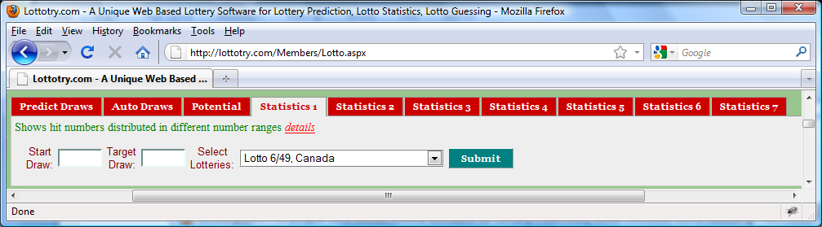

Figure User Input Panel

Click **Submit** button to display ***Statistics 1*** as shown in Figure 2. No matter how many you may click the **Submit** button, the statistics will remain unchanged as long as input values remain unchanged.

Select a lotto of your interest. Refer to Figure 1 in **Predict Draws** for the details of what lotteries are available.

2 indicates that 2 numbers which are in range of 30 to 39 were hit in draw number of 2890. Same thing can be inferred for other columns of same row.

Number range, for this example, total 49 numbers divided into 5 number-ranges and Statistics 1 shows which number-range the hit numbers belong to for each past draws. This provides you valuable statistics from one angle in analysis and predicting the next draw.

Blank means no numbers in current draw hit in this number range.

Figure Statistics 1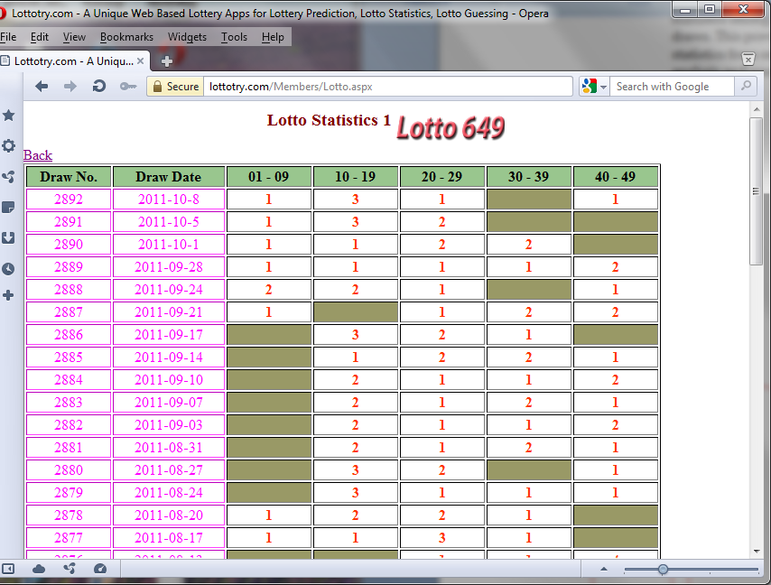

Draw numbers for the past draws

Draw Date for the past draws