# Statistics 2

This tool provides the following statistics:

1. Statistics 2 is a distance oriented statistics. It provides info on each hit numbers for the past draws with respective of each number’s distance. The definition of distance is the number of draws since a number last got hit. For instance, number 4 got hit on last 7 draws ago, therefore, number 4’s distance is 7. After analysis the Statistics 2 shown in Figure 2, you may notice that 5 out of 6 numbers in draw 2850 were falling into distance range of less than 10. Not only this, when you trace back history you also can get similar conclusion. Further, you may find that when distance getting less, the hit numbers getting more concentrated (hot or semi hot numbers). These are important hint to us and when making final decisions or facing dilemma, we may need to put these factors into consideration.
2. Another hint this statistics provides is that when consecutive blanks presented on a particular distance range all the way to the current draw, this distance range should be watched for the next draw or next couple of draws, because it may be this distance range's turn to get hit soon.
3. Based on the facts above mentioned, you may discover some valuable trends from analyzing past draws from this statistics. You may ask yourself a simple question: if these trends happened repeatedly before why not it would be happened again in future? With this question in mind, when you make final decision, number's distance should be put into consideration and may resolve your dilemma when you facing multiple choices.
4. Statistics 2 provides us another angle in analyzing lottery trends and predicting next coming draw.

Select a target draw, if leave it empty, next draw will be selected as default.

Currently selected Tab – Statistics 2

Select a start draw, if leave it empty, it will start from 25 draws ago as default.

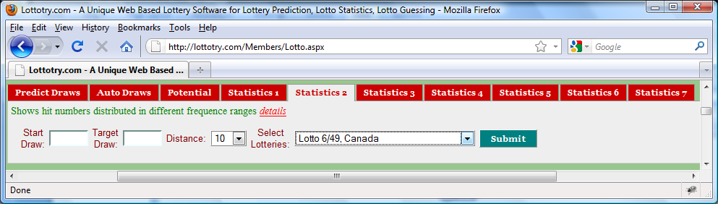

Click **Submit** button to display ***Statistics 1*** as shown in Figure 2. No matter how many you may click the **Submit** button, the statistics will remain unchanged as long as input values remain unchanged.

Figure User Input Panel

Distance as mentioned before, is defined as to a number how many draws since last got hit till it got hit again or to current draw. For in stance, if number 4 was got hit 9 draws ago, 4’s distance is 9. Here Distance, set to be 10 as default, is used to fragment table in distances - any number who’s distance greater than 10 and it got hit on current draw would not be visible in Figure 2. Some numbers, distance equals to 1, 2, 3, 7 got hit in draw 2850, are visible in Figure 2.

Select a lotto of your interest. Refer to Figure 1 in **Predict Draws** for the details of what lotteries are available.

Draw numbers for the past draws

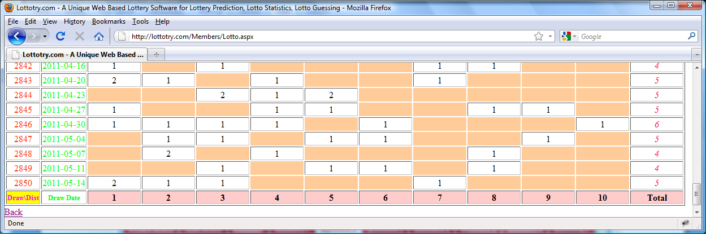

Figure Statistics 2

Distance range number. Any number got hit on current draw which’s distance equals to 7 falls in this range, same thing for other columns on each row.

This value shows total 5 numbers who’s distance less than or equals to ***10*** got hit on draw ***2850***.

Blank means no numbers in current draw get hit in this distance fragment.

Draw Date for the past draws

One number which’s distance equals to 2 got hit on draw 2850.