# Statistics 3

This statistics provides the following functionalities and is the most important one for LottoTryTM:

All numbers (49 in case of Lotto 6/49) have been divided into number of ***Scales*** from left to right in ascending order based on frequency (see the top and bottom of rows of table in the figures below)

1. The default ***scales*** are 7 and you can choose other value you like. Each scale contains 7 columns in this case.
2. ***Statistics 3*** provides a panorama of the whole numbers with their distance info attached to each number. One more important thing is that each number maintains different colors to distinguish between hit and not hit in a particular draw. Further, the location of each number (in columns) is indicating the frequency of hit rate. For instance, from Figure 2/3 you can tell which numbers are hot, semi-hot, semi-cold, cold, very cold and very hot, etc., through the distance value(inside parentheses) attached to each number. You also can tell which numbers are inactive and which are most active by colored scale bands (both on top and bottom of generated table). With these statistics in mind, you can easily determine which numbers are most possibly the best candidates for the next coming draw. In fact, you may feel too many numbers which you think so close to be the candidate numbers for the next draw and would like to choose, you will be facing dilemma. Therefore, you need to combine your selection here with the conclusions of other statistics and tools in other tabs to come up with a final decision.
3. ***Statistics 3*** also provides you with a good visual facility on analyzing of past draws and chances to research on past hit numbers and in what conditions they got hit. You may find some trends being followed and happened again and again in the past. You may raise a question – It happened again and again in the past why not will be happened again in future? Good question, this is the core of objectives and motivation the ***statistics 3*** designated to facilitate users in discovering these kind of trends from virtually unthinkable random world.
4. Hit numbers fall into which colored scale bands in current draw also provides hints to the user that the attention might be paid on those scale bands, which got no hit numbers on current draw. There may be some numbers in these bands get hit for the next coming draw, because God is fare to everyone. This also applies to the cases the other way around.
5. You also can practice your number-picking skill by guessing/predicting past draws and then compare the result retrieved from database.

Currently selected Tab – Statistics 3

Select a target draw, if leave it empty, next draw will be selected as default.

Select a start draw, if leave it empty, it will start from 25 draws ago as default.

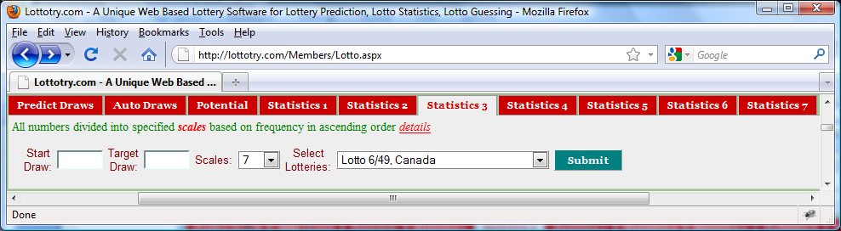

Click **Submit** button to display ***Statistics 1*** as shown in Figure 2. No matter how many you may click the **Submit** button, the statistics will remain unchanged as long as input values remain unchanged.

Figure User Input Panel

Scales value will be used to divide whole numbers (49 for Lotto 6/49) into fragment based on frequency of hit rate of each number. Thereby, 7, as default value, will fragment 49 number into 7 groups in the table shown in Figure 2/3.

Select a lotto of your interest. Refer to Figure 1 in **Predict Draws** for the details of what lotteries are available.

Draw numbers for the past draws

All numbers being arranged in this table in ascending order in terms of hit rates calculated from day 1.

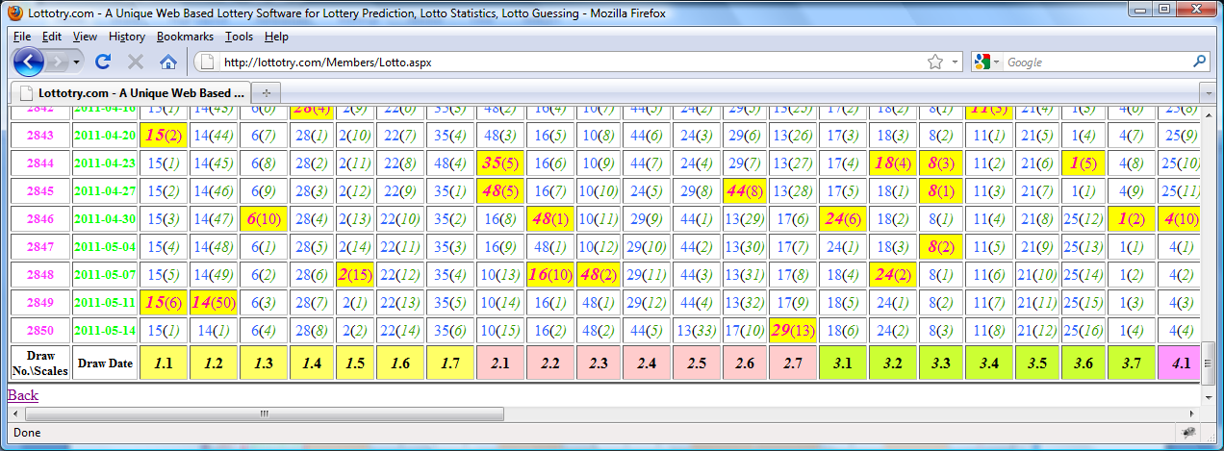

Figure Statistics 3 part 1

44(*5*) indicates that number 44 is not got hit on current draw and it’s distance, up to date, is 5 (i.e. its last hit was 5 draws ago. Same explanation also applied to part 2 in Figure 3.

Number 29(*13*) indicates that number 29 got hit on current draw and its last hit was 13 draws ago (distance equals to 13). Same explanation also applied to part 2 in Figure 3.

Each color band represents a scale of fragment based on frequency of hit rate. I.e. for draw 2850, number 15 is the most inactive number and number 34 shown in Figure 3 part 2 is the most active number among 49 numbers (in example of Lotto 6/49). Same explanation also applied to part 2 in Figure 3.

Draw Date for the past draws

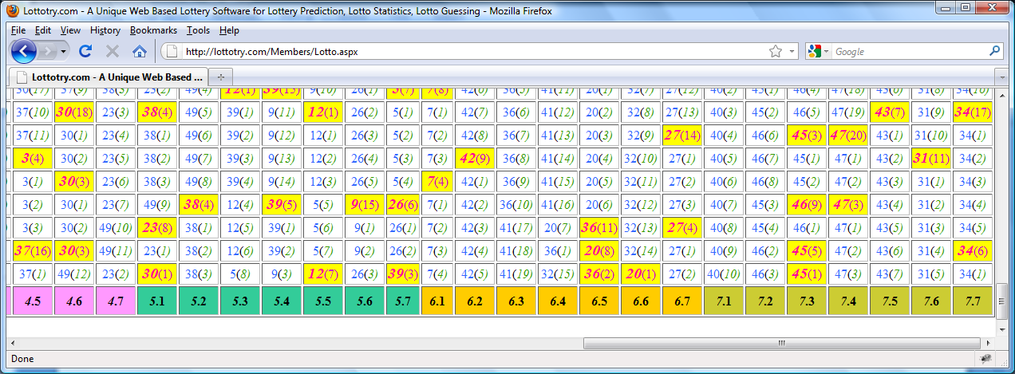

Figure Statistics 3 part 2

All numbers being arranged in this table in ascending order in terms of hit rates calculated from day 1.