# Statistics 4

This statistics provides the following functionalities:

1. ***Statistics 4*** provides a panorama of the whole numbers grouped by their distances. The grouped numbers will facilitate users in finding which numbers belong to which distance group distinctly and visually. It also facilitates users to find out how many numbers and which numbers belong to a distance group quickly. Left side of table, in Figure 2, shows all hit numbers from past draws all the way to the current draw and you can easily infer that these numbers’ distance be zero as well as on the left side of the table have shorter distance than those on the right side of table (see the value inside parentheses attached to each number).
2. Since number’s *temperature (hot number, … cold number, etc)* based on their distance, ***Statistics 4*** enables users to find out *hot*, *cold*, *very cold*, etc. quickly and easily.
3. Usually, analysis results of ***Statistics 4*** are used to combine with other statistics and analysis tools in selecting number candidates for the next coming draw.
4. Whole numbers appeared in each rows (each draws) of table enable users to have panorama view and better idea on whole numbers which made the comparison among numbers, as well as among different draws, in one screen possible.
5. The history of the draws visually exposes some trends which may not be easily or possibly detected for the most of similar analysis tools venders out there to provide. Dedicated users may even dig deeper to find out more helpful and valuable info from this statistics.

Select a target draw, if leave it empty, next draw will be selected as default.

Select a start draw, if leave it empty, it will start from 25 draws ago as default.

Currently selected Tab – Statistics 4

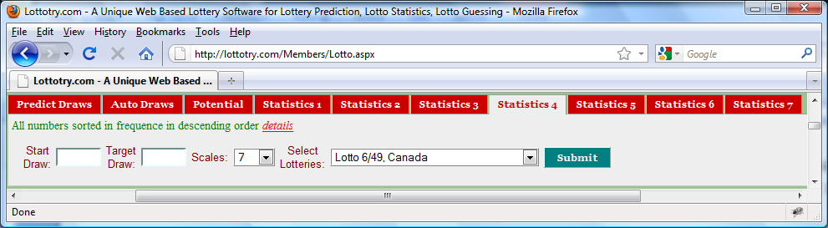

Click **Submit** button to display ***Statistics 1*** as shown in Figure 2. No matter how many you may click the **Submit** button, the statistics will remain unchanged as long as input values remain unchanged.

Figure User Input Panel

Obsolete and not being used in this statistics.

Select a lotto of your interest. Refer to Figure 1 in **Predict Draws** for the details of what lotteries are available.

Draw numbers for the past draws

All numbers being arranged in this table in ascending order in distance

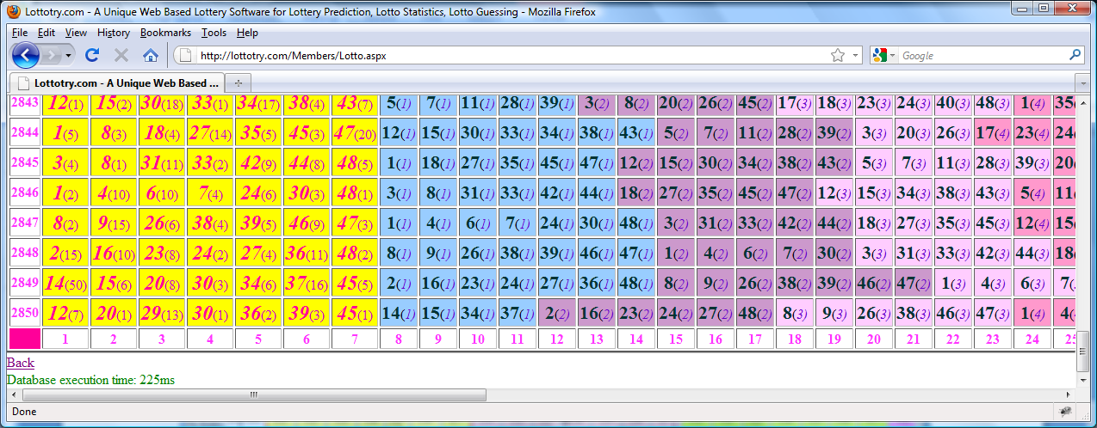

Figure Statistics 4 part 1

Numbers got hit on each draws with the distance info attached when got hit and their new distance is set 0 for the current draw.

Number order, in this example, the number are from 1 to 49.

Numbers grouped by their distance, the numbers in this group (2) got hit 2 draws ago. Same inference applied to all other distance groups

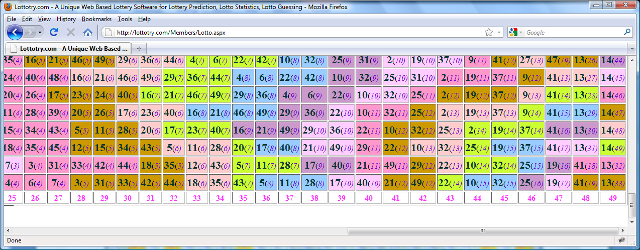

Figure Statistics 4 part 2

All numbers being arranged in this table in ascending order in distance