# Statistics 5

This statistics provides the following functionalities:

1. There are multiple tables displayed in ***Statistics 5*** and each provides certain statistics from different perspectives. There are two tables in Fig. 2, one for showing the hottest numbers and for coldest numbers up to current selected draw. With a quick glance of Fig. 2, you would have whole idea of which numbers are hot and which are cold – you don’t have to go through all 49 (even 59 in case of Power Ball) as well as a range of past draws to look up in order to find these info – very time-consuming, tedious job.
2. Fig. 3 and 4 listed all numbers with distance and frequency info mapping to each numbers. It also high-lighted which numbers got hit on current draw. All numbers are ordered by their frequencies and scaled into fragments. You can easily find active/inactive numbers from this table. Combined with Fig. 5, users may have idea which groups got hit numbers (how many) and which are not (in blank). This is one of factors that you may keep in mind when make a final decision. Considering a blank column (scale fragment) presenting in the current draw might indicate you that this column must be watched for the next (or next couple of) coming draw(s) and you may go ahead to pick some numbers from that scale fragment. The other way around also indicates same thing, such as the case that several numbers got hit in same scale fragment may hint you to pay less attention to numbers inside that scale fragment.
3. ***Statistics 5*** can also be cross-referenced with ***Statistics 3***, because they all share the same scale-fragment concept. Only difference on that the ***Statistics 3*** displays all past draws selected all the way to the current draw.

The distance value will be used to define how many rows will be displayed for the matrix shown in Figure 5 below where along the rows going down, the distance going farther. 30 is default value, it means any numbers which distance less than 30 will be displayed in that matrix

Currently selected Tab ***Statistics 5***

Select a target draw, if leave it empty, next coming draw will be selected as default.

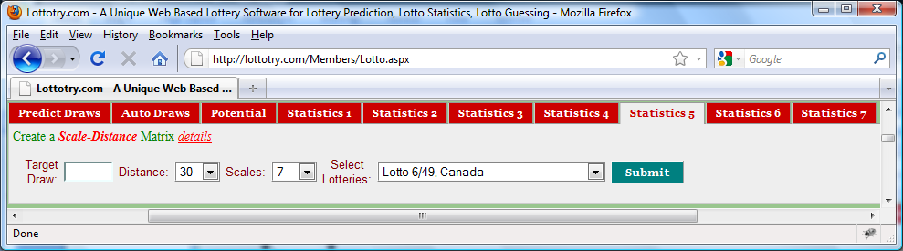

Figure 1 User Input Panel

Click **Submit** button to display ***Statistics 5*** as shown in Figures followed. No matter how many you may click the **Submit** button, the statistics will remain unchanged as long as input values remain unchanged.

Select a lotto of your interest. Refer to Figure 1 in **Predict Draws** for the details of what lotteries are available.

Scales value will be used t o divide whole numbers (49 for Lotto 6/49) into fragment based on frequency of hit rate of each number. Thereby, 7 as default value will fragment 49 numbers into 7 groups in the table shown in Figure 3, 4, 5 below.

All values appear in this rows are frequency of hit rate of that number, i.e. 407 means number 19 got hit 407 times since the lottery started.

Numbers appear in this row of the table are all have distance less than or equal to ***4***, the so called **very hot**, **hot** numbers.

All values appear in this row are distances belong to the number in the same column

Numbers appear in this row of the table are all have distance greater than or equal to ***10***, the so called **cold**, **very cold** numbers.

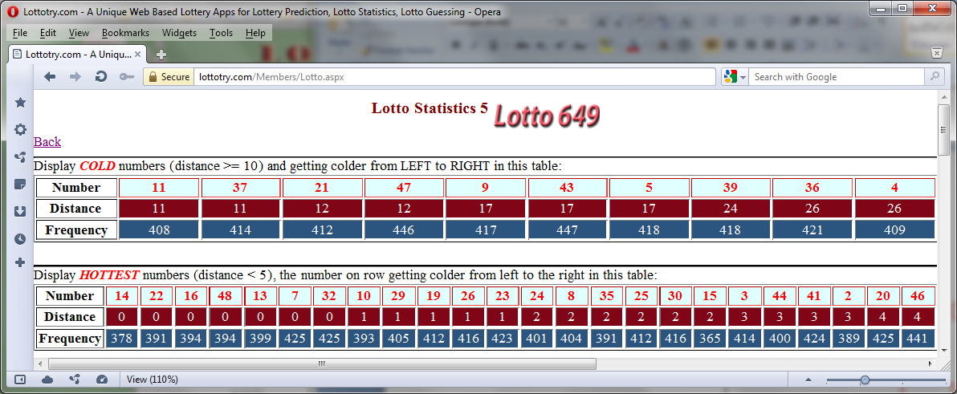

Figure 2 Numbers Ordered by Distance, above in descending order, below in ascending order

Table for **coldest** numbers, sorted by distance

Table for **hottest** numbers, sorted by distance

Number’s frequency, its getting higher from left to the right of the table

Since 29 got hit on current draw, in RED color and its new distance is reset to 0 and its saved distance is 13 which tells that its last hit was 13 draws ago.

49 numbers are divided into 7 groups and ordered by **Frequency**, number 15 is the most inactive and number 34 is the most active one.

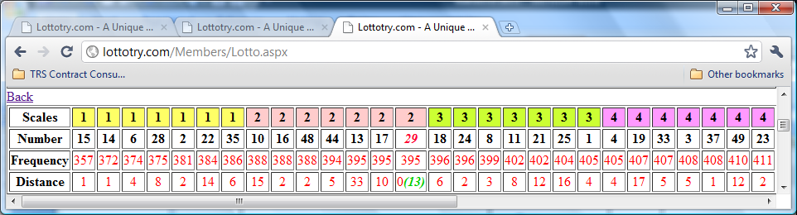

Most **inactive** number

Figure 3 Numbers Ordered by Frequency

Number’s distance

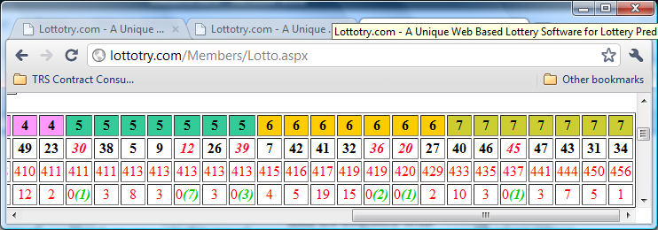

Most **active** number

Figure 4 Numbers Ordered by Frequency – Continued

3 numbers in this group got hit for the current draw. What other numbers in the group can be found in Fig. 3 and 4 above.

Blank: no numbers in this group got hit for current draw

Distance value.

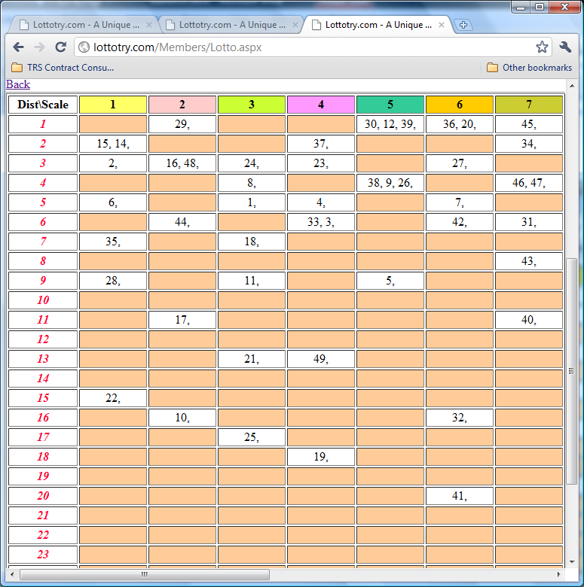

Number 41 last got hit was 19 draws ago – a quite cold number

49 numbers divided by 7 results 7 groups, what numbers in each group can be found in Fig. 3 and 4 above.

Figure 5 Distance/Scale Matrix