# Statistics 6

This Tab provides the following statistics:

1. Statistics 6 provides a panorama view of whole numbers with the nature number order so that you can easily go to the number you are interested in and find its history. You also can easily compare one number to others in terms of their history. The range of past draws are default as 50, usually that is far past enough, if you want to trace back the history further past, you can set start draw value whatever you want, but one thing might be kept in mind, the bigger range, the time you get your statistics displayed would be longer.

Select a start draw, if leave it empty, last 50 draws as default value.

Select a target draw, if leave it empty, next coming draw will be selected as default

Currently selected Tab ***Statistics 6***

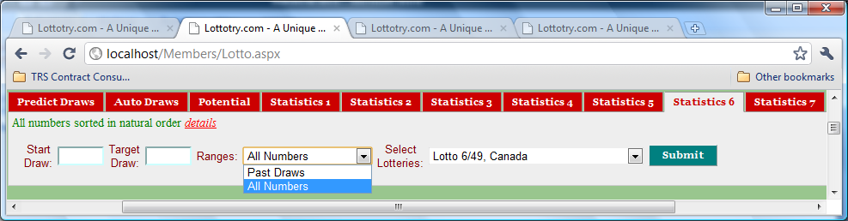

Figure 1 User Input Panel

Two selections for the Ranges: **Past Draws** and **All Numbers**. Past Draws will only display hit numbers in each past draws and the range past draws is defined in Start Draw and Target Draw fields. All Numbers will display all 49 (or 56, 59, etc.) numbers in a nature number order but attached distance to each and high-lighted those got hit on each draws

Select a lotto of your interest. Refer to Figure 1 in **Predict Draws** for the details of what lotteries are available.

Click **Submit** button to display ***Statistics 6*** as shown in Figures followed. No matter how many you may click the **Submit** button, the statistics will remain unchanged as long as input values remain unchanged.

Draws number

Draw Dates

Numbers appear in this row of the table are all numbers in nature order (ascending) with relative distance attached to each of the number. It is high-lighted in RED color when it got hit in that draw.

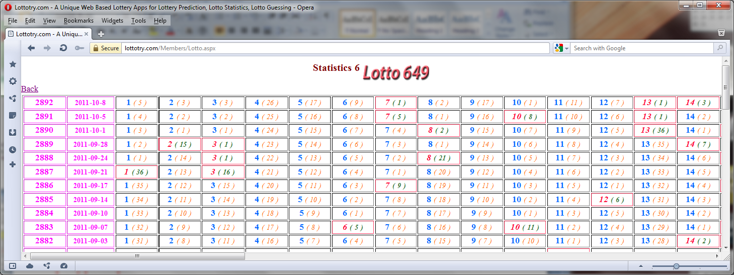

Figure 2 Whole numbers ordered in one row for the past range of draws

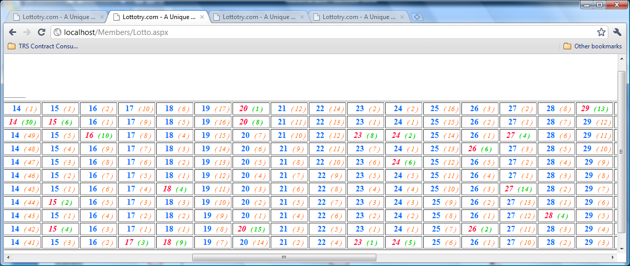

Figure 3 Whole numbers ordered in one row for the past range of draws - continued

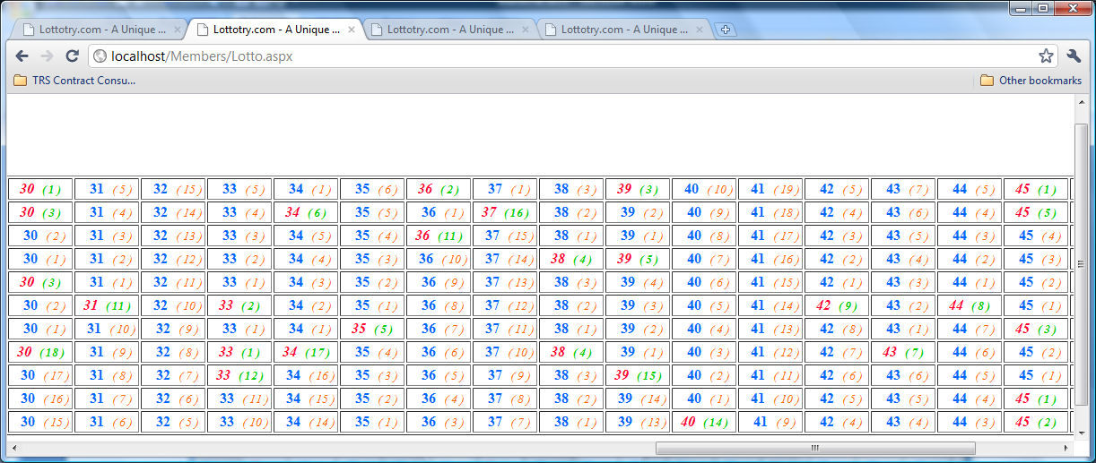

Figure 4 Whole numbers ordered in one row for the past range of draws - continued

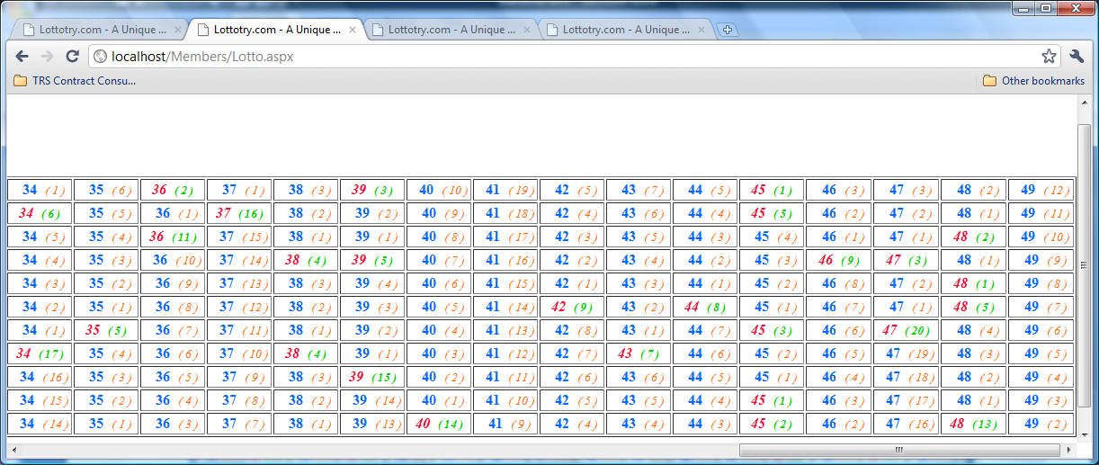

Last number

Figure 5 Whole numbers ordered in one row for the past range of draws - continued

Number 41 last got hit was 19 draws ago – a quite cold number