# Statistics 7

This Tab provides the following statistics:

1. *Statistics 7* introduce the new *key words*, such as, **Sum**, frequency of **Sum**, ratio of **Odd/Even**, rate of **Odd/Even**, accumulated ratio of **Odds/Evens**. The definition of and usage of these key words are as followings:
   * Sum is sum of all hit numbers to a particular draw. It is hard to have exact same sum value between two draws in its whole history of any lotteries. But they could be very close or far away in terms of sum in a neighboring draws (which user may particularly pay attention to). For instance last couple of draws achieved consecutively large sums, statistics tells us we might expect small sum for the next coming draw. How small you may need to go through other statistics then may come back with some idea about the exact value the sum. As mentioned above, no two draws have had exact same sum (it may happened before, but extremely rare), the ***Statistics 7*** scales sum value from 90 to 210 into 12 divisions – 10 as interval. For instance, if a draw’s sum is 124, then we treat the sum as 120, and so on.
   * Frequency of **Sum** is about counting how many time a sum of draws fall into a division. Continue to the above example since this draw’s sum is 124, frequency of 120 will be increment by 1. There are **Sum** frequencies of 90, 100 … and all the way to 210 and the last is all above the 220. Frequency of Sum indicates which sum value is the most popular and which is the most unpopular and which are regular, etc. Based on this info you can pick one sum in accordingly. Once you have a sum value in mind you can determine the *Sum Min* and *Sum Max* in **Predict Draws** and **Potential Draws** number generating tools where you can generate more accurate draw numbers for the next coming draw.
   * Ratioof **Odds/Evens** provides another hint in determining what kind of number you may choose for the next draw. It is based on a very basic rule of probability that odd numbers and even numbers each should have 50% chance to show up in any draws, but in reality and short period of time, each draws are not following the rule exactly – this statistics can tell that. But one thing you may need to follow up is that after couple of draws in which consecutively 4 **Odd** numbers in each draw, next draw probably will be the **Even**’s turn to overwhelming the **Odd** numbers. This is the core of motivation that ratios of **Odds/Evens** are provided by this statistics. This information may impact your final decision on certain situation.
   * Accumulated Ratioof **Odds/Evens** allows you to figure out which’s turn next according to the probability in long term.

Currently selected Tab ***Statistics 7***

Select a **start draw**, if leave it empty, last 50 draws as default value.

Select a **target draw**, if leave it empty, next coming draw will be selected as default

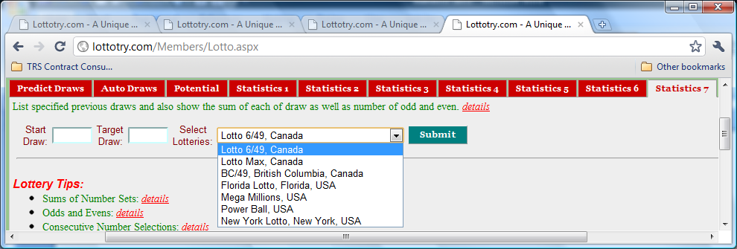

Figure 1 User Input Panel

Select a **lotto** of your interest.

Click **Submit** button to display ***Statistics 7*** as shown in Figures followed. No matter how many you may click the **Submit** button, the statistics will remain unchanged as long as input values remain unchanged.

Sequence number of draw

Draws

Draw Dates

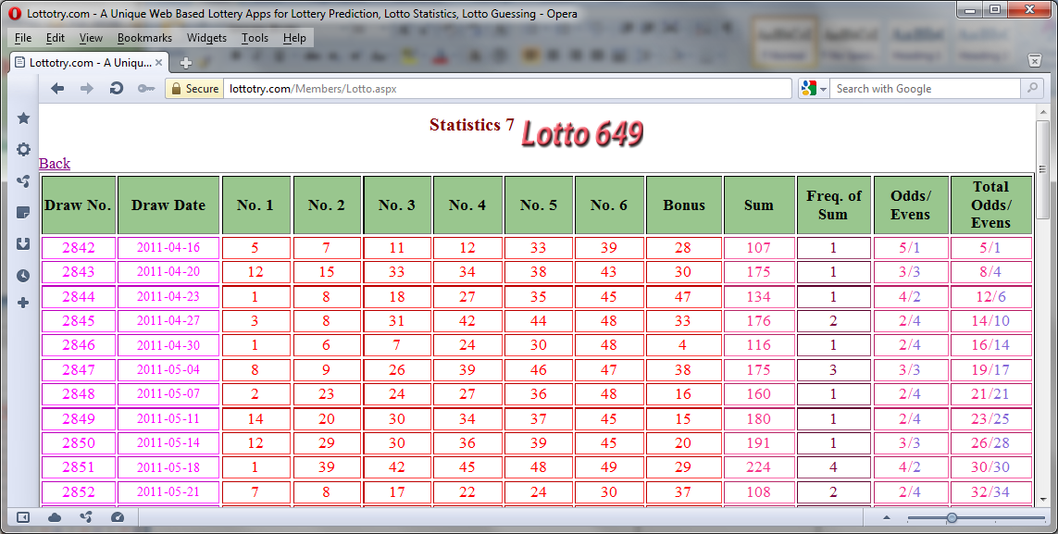

Figure 2 Whole numbers ordered in one row for the past range of draws

The **sum** of all hit numbers in a draw.

Ratio of **Odd** and **Even** numbers for the current draw

Hit numbers in a draw. Each attached with distance which indicating number of draws has passed since last hit.

Accumulated ratio of **Odd** and **Even** numbers since the start draw that user entered in input panel in Fig. 1

Frequency of **sum**, example: if current draw’s sum is 166 then 160’s frequency increased by 1, if the sum is 104 then 100’s frequency increased by 1, and so on.

Number 41 last got hit was 19 draws ago – a quite cold number