**Exploration about the data**

This data has 8 attributes and two responses

Variable Name Description

X1 Relative Compactness

X2 Surface Area

X3 Wall Area

X4 Roof Area

X5 Overall Height

X6 Orientation

X7 Glazing Area

X8 Glazing Area Distribution

y1 Heating Load

y2 Cooling Load

The image of X1 and Y1

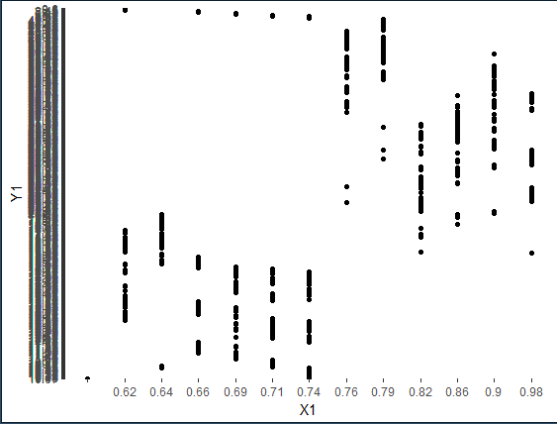

**Data preprocessing**

1. Divide the data into the training set and testing set

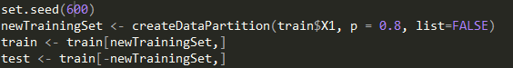

**Decision Tree models**

C:\Users\HMACCE~1\AppData\Local\Temp\1519012986(1).png

Params Description

Y1~… formula

Method=”anova” If want to make decision tree regression, the parameter must be avona

C:\Users\HMACCE~1\AppData\Local\Temp\1519013130(1).png

Besides, I drawled the picture of the decision tree

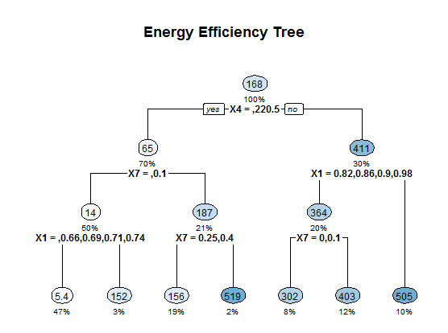

**Evaluation of models**

In order to calculate the accuracy, I write a function:

