CUSTOMER CHURN
& SUBSCRIPTION ANALYTICS
Project Report | Data Analysis, Business Questions & Findings

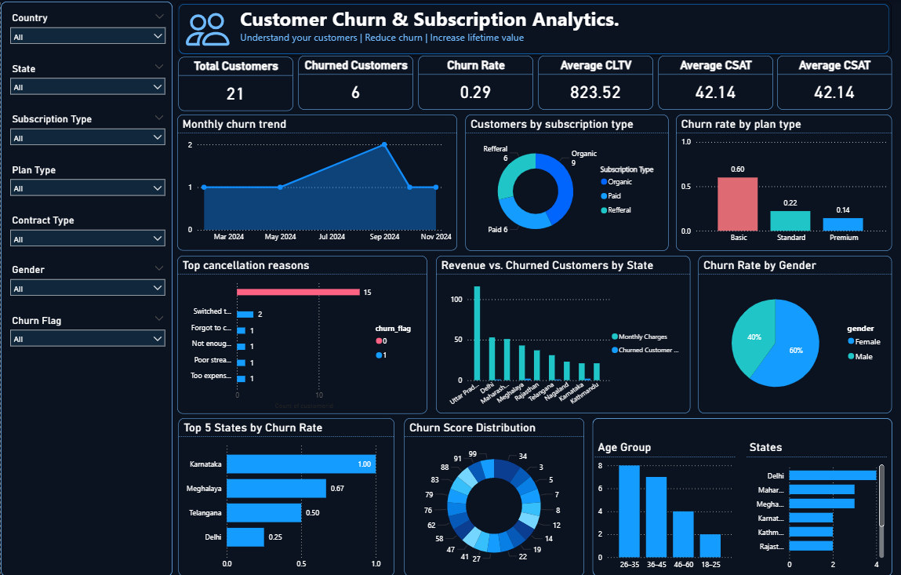
Prepared from the provided dashboard screenshot, Jupyter notebook, and exported customer dataset

1. Executive Summary
This project examines customer churn and subscription patterns in the supplied dataset. The exported CSV contains 21 customer records, of which 6 are marked as churned and 15 are marked as not churned. The observed churn rate is 28.6%. Average customer lifetime value (CLTV) is 823.52, while average monthly charges are 18.85.
Metric | Result | How to read it
Total customers | 21 | Number of customer rows in the exported dataset.
Churned customers | 6 | Rows where churn_flag = 1.
Customers not marked churned | 15 | Rows where churn_flag = 0.
Overall churn rate | 28.6% | Churned customers divided by all customer rows.
Average CLTV | 823.52 | Mean of the cltv field; currency is not specified in the file.
Average monthly charges | 18.85 | Mean of monthly_charges; currency is not specified.
Average churn score | 43.29 | Mean of the churn_score field.
CSAT records available | 7 of 21 | CSAT is populated for only a subset of records; average of available values is 42.14.

Headline finding: Basic plans have the highest observed churn rate among plan types, while the referral subscription group has a high churn rate in this small sample. These are descriptive findings, not proof that plan or acquisition source causes churn.

2. Project Objectives
- Measure overall customer churn and the size of the retained customer group.
- Compare churn across plan type, subscription type, gender, and state.
- Summarize recorded cancellation reasons.
- Review customer value and customer satisfaction fields.
- Turn the analysis into practical, testable retention recommendations.

3. Dataset & Method
The provided CSV has 21 rows and 21 columns. Fields include customer identifiers, subscription and renewal dates, plan and contract types, cancellation details, monthly charges, CLTV, churn score/flag, country/state, gender, date of birth, complaint details, and CSAT.
Analysis item | Approach / definition
Churn flag | Treat churn_flag = 1 as churned and 0 as not churned.
Churn rate | Number of churned records divided by total records in the relevant group.
Group comparisons | Count customers and churned records within each plan, subscription source, gender, and state.
Cancellation reasons | Count non-empty cancellation_reason values only.
Missing values | Use available values for averages; note the field's non-null sample size.
Scope limitation | The dataset has only 21 rows, so group percentages can change substantially with one customer.

Tools evidenced in the supplied notebook include Python, pandas, NumPy, Matplotlib, Seaborn, and SQLite. The report's numerical tables are recalculated from the supplied exported CSV.

4. Key Business Questions & Results
Q1. What is the overall churn rate? | 28.6% (6 of 21 customers)
15 customers (71.4%) are not marked as churned. The result is a snapshot of this small exported dataset.
Q2. Which plan type has the highest churn rate? | Basic: 60.0%
The Basic plan has the highest observed rate. Check the group sizes before making policy decisions.
Plan type | Customers | Churned | Churn rate | Average CLTV
Basic | 5 | 3 | 60.0% | 195.40
Standard | 9 | 2 | 22.2% | 589.11
Premium | 7 | 1 | 14.3% | 1,573.57

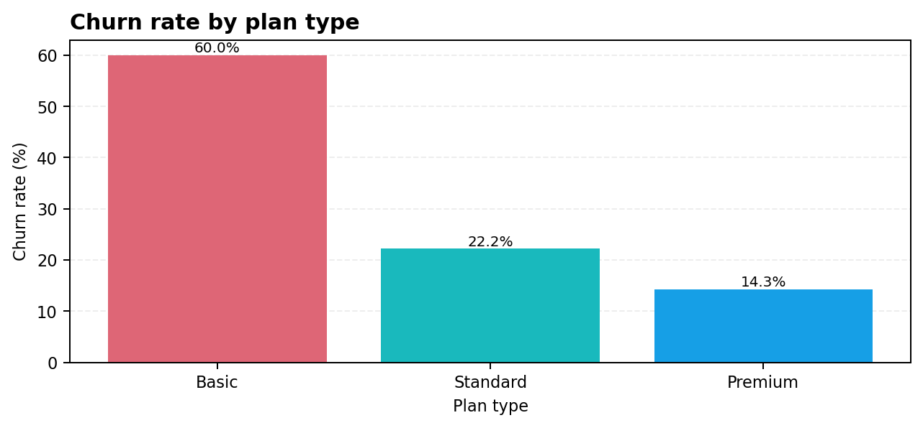
Q3. Which subscription type has the highest churn rate? | Refferal: 83.3%
The source label is written as “Refferal” in the CSV; it is preserved here rather than silently corrected. Five of the six records in this group are marked churned.
Subscription type (source label) | Customers | Churned | Churn rate
Refferal | 6 | 5 | 83.3%
Paid | 6 | 1 | 16.7%
Organic | 9 | 0 | 0.0%

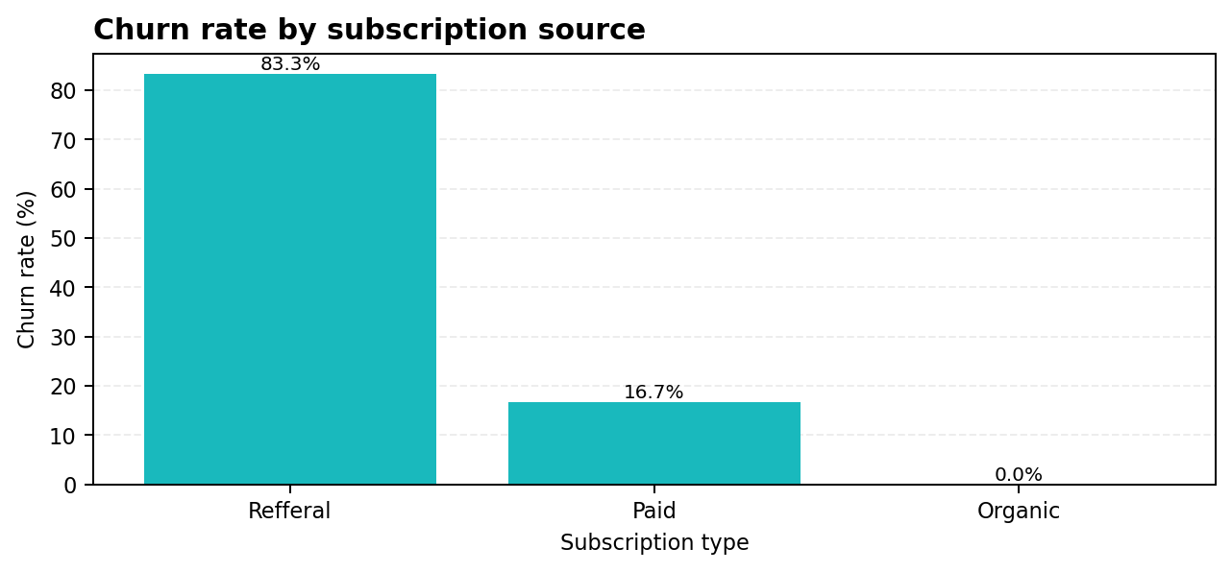
Q4. What cancellation reasons are recorded most often? | Switched to competitor (2 records)
Only six records have a cancellation reason. Two say “Switched to competitor”; each other listed reason appears once.
Cancellation reason | Records
Switched to competitor | 2
Too expensive | 1
Not enough content | 1
Poor streaming quality | 1
Forgot to cancel trial | 1

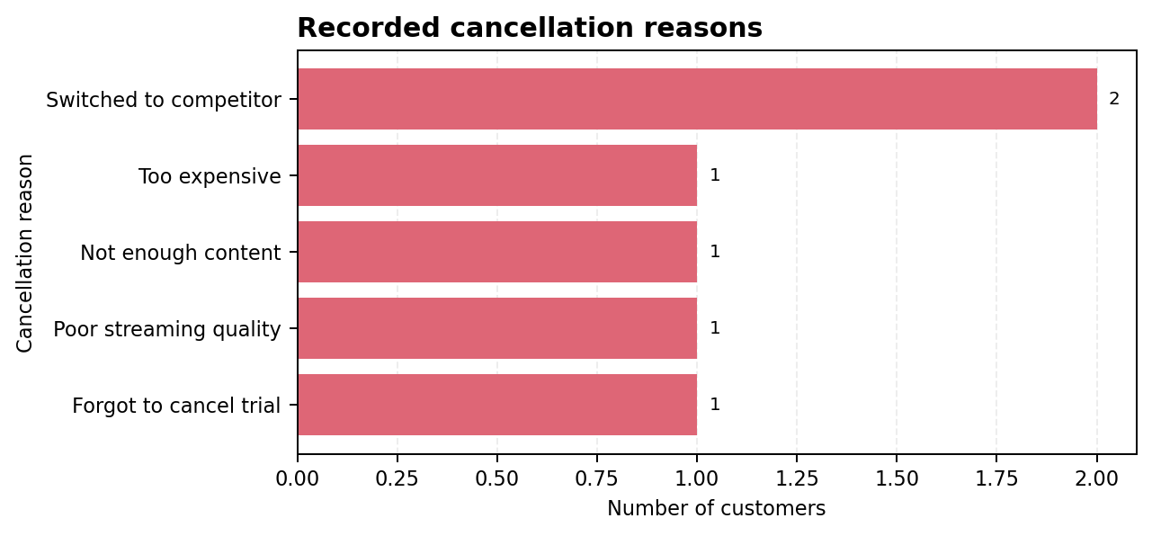
Q5. Which states show the highest observed churn? | Karnataka: 100.0%
Karnataka has 2 customers and both are marked churned. Meghalaya has 2 churned among 3 customers; Telangana has 1 among 2. These small denominators mean the percentages are unstable.
State | Customers | Churned | Churn rate
Karnataka | 2 | 2 | 100.0%
Meghalaya | 3 | 2 | 66.7%
Telangana | 2 | 1 | 50.0%
Delhi | 4 | 1 | 25.0%
Kathmandu | 2 | 0 | 0.0%
Maharashtra | 3 | 0 | 0.0%
Nagaland | 1 | 0 | 0.0%
Rajasthan | 2 | 0 | 0.0%
Uttar Pradesh | 2 | 0 | 0.0%

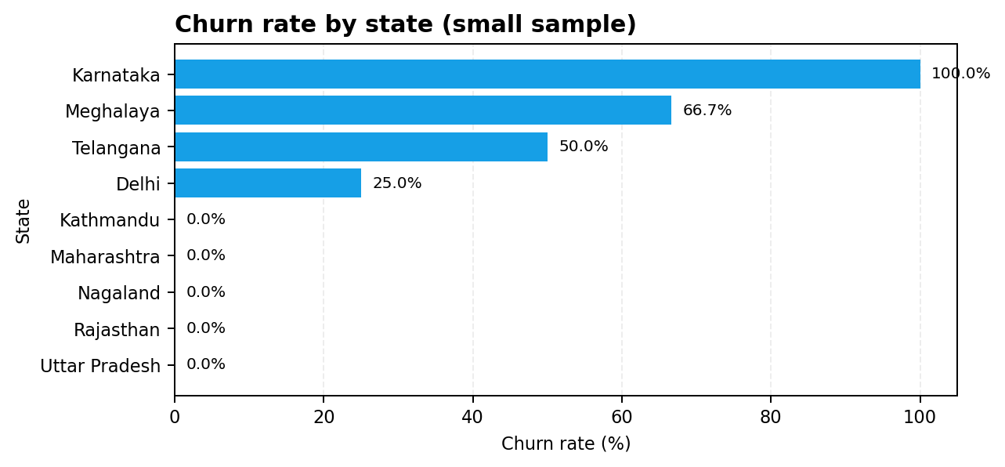
Q6. Does churn differ by gender in this sample? | Female: 33.3%; Male: 22.2%
Female customers have a higher observed churn rate in this dataset, but this does not establish gender as a cause or justify treating customers differently.
Gender | Customers | Churned | Churn rate
Female | 12 | 4 | 33.3%
Male | 9 | 2 | 22.2%

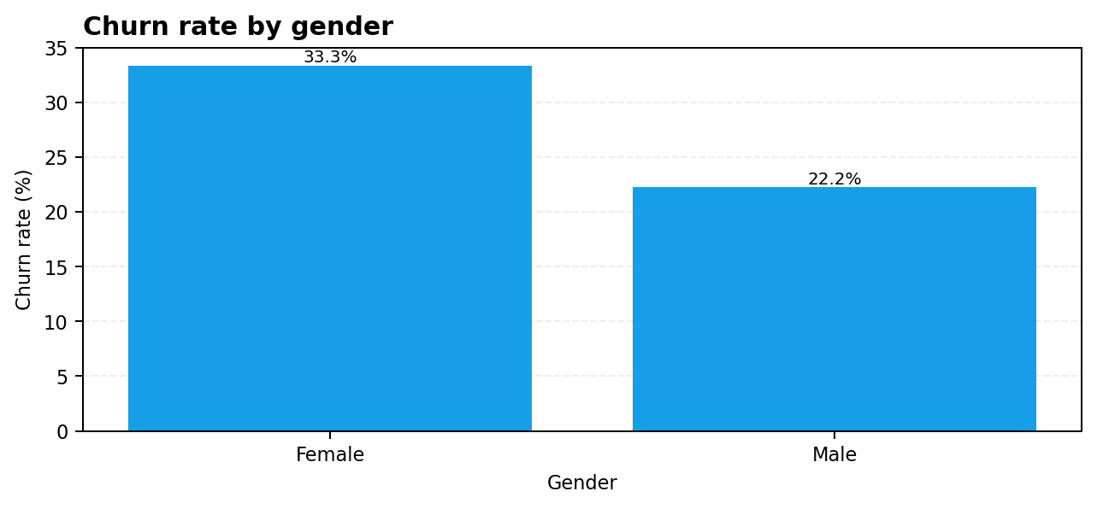
Q7. What is the average customer value? | Average CLTV = 823.52
Average monthly charges are 18.85. The dataset does not specify a currency, so the report does not attach a currency symbol.
Q8. Can we make a reliable satisfaction conclusion? | CSAT available for 7/21 records
The mean of non-missing CSAT values is 42.14. Because 14 records have no CSAT value, this should not be treated as a complete customer-wide satisfaction estimate.
Q9. Is complaint data complete? | 7/21 records have a complaint date
Complaint date, escalation, CSAT and complaint count fields are partially populated. Any analysis using these fields should report the number of available records.

5. Additional Dashboard Observations
- The supplied dashboard screenshot displays the same value (42.14) in two cards both labelled “Average CSAT.” This appears to be a duplicated KPI label/value and should be checked in the dashboard configuration.
- The screenshot shows a monthly churn trend, but the exported CSV has only 21 records and does not by itself establish a full monthly time series. Verify the date aggregation and filter logic before interpreting the trend.
- The dashboard uses the labels Organic, Paid, and Referral-like source labels. The CSV spells one category “Refferal”; standardize category spelling in the source/model if appropriate, and keep a documented mapping.
- The dashboard has country and state filters, but the CSV contains 19 India records and 2 records with a different country value. Confirm geographic naming conventions before comparing regions.

6. Recommendations
Priority | Recommendation | Reason / next step
1 — High | Review Basic-plan churn | Basic shows 60.0% churn (3/5). Inspect price, plan features, contract terms, and customer feedback before testing an offer.
2 — High | Investigate referral-source records | Referral-labelled records show 83.3% churn (5/6). Validate the category, referral attribution, and whether these customers share a common onboarding or service issue.
3 — High | Capture cancellation reasons consistently | Only 6 of 21 records contain a reason. Make cancellation reason a required structured field where feasible.
4 — Medium | Improve CSAT and complaint completeness | Only 7 records contain CSAT and complaint date data. Increase response capture and monitor missingness.
5 — Medium | Use cautious state-level monitoring | Karnataka's 100% rate is based on only 2 records. Collect more observations before region-specific decisions.
6 — Medium | Validate dashboard KPIs | Fix the duplicated Average CSAT card and verify date grouping, category labels, and filter interactions.
7 — Future | Build a larger time-based churn dataset | Use multiple months and a larger customer cohort to identify trends and test whether retention actions improve outcomes.

7. Limitations & Interpretation Notes
- Sample size is only 21 customers; subgroup rates are highly sensitive to individual records.
- The data is observational. Associations do not prove that a plan, source, gender, or state causes churn.
- The CSV has missing values in cancellation, complaint, escalation, CSAT, and complaint-count fields.
- Currency and units for CLTV and monthly charges are not explicitly documented in the CSV.
- The screenshot contains dashboard summaries that may be based on filters or transformations not reproducible from the CSV alone.
- The report describes the supplied extract, not the full customer population.

8. Conclusion
The supplied extract reports a 28.6% churn rate, with Basic plans and the referral-labelled subscription group showing the highest observed churn rates in their respective comparisons. Switched to competitor is the most frequently recorded cancellation reason. The strongest immediate actions are to validate the dashboard, improve reason/CSAT data completeness, and investigate the highest-churn groups with a larger sample before launching targeted retention policies.

Appendix A — Data dictionary (selected fields)
Field | Meaning used in this report
customerid | Customer identifier; not reproduced in this report.
plan_type | Plan category (Basic, Standard, Premium).
subscription_type | Subscription/acquisition category as provided in the CSV.
churn_flag | Binary outcome: 1 = churned, 0 = not marked churned.
cancellation_reason | Recorded reason for cancellation, where available.
monthly_charges | Monthly charges numeric field; currency not specified.
cltv | Customer lifetime value numeric field; currency not specified.
churn_score | Numeric score field supplied in the export; model meaning/scale not documented.
csat_score | Customer satisfaction score where populated; scale not documented.

Source files: churn_analysis.ipynb, exported_churn_data.csv, and the supplied Customer Churn & Subscription Analytics dashboard screenshot.

