知识框架
Ohy
Chinese knowledge elements:
汉字(梳理)

O
阴平阳平上声去声
曲调melody: l3 3| 3 5| 214| 5 1l
样品字sample character: 噢15哦10嚄₁₅哦10
号表法no.indicator: 1 2 3 4
全家福family photo:
纲（四声） | 目（汉字梳理）
O 1 | 噢15
O 2  O 3  O 4 | 哦10  嚄₁₅  哦10
？ | 丆2仒4乯6迲8猠11硛11旕13筽13鳰13縇15穒16纐21

Ou
阴平阳平上声去声
曲调melody: l3 3| 3 5| 214| 5 1l
样品字sample character: 欧8偶11 怄7
号表法no.indicator: 1 2 3 4
全家福family photo:
纲（四声） | 目（汉字梳理）
Ou 1 | 区4讴6沤7欧8殴8瓯8鸥9  塸14熰15歐15鴎15甌15膒15毆15謳18藲18櫙18  鏂19鷗22
Ou 2 | 呕7嘔14  吘7  偶11腢13蕅15耦15藕18
Ou 4 | 沤7怄7慪14漚14

Chinese-western knowledge fusion:
汉-英(对应)
O
阴平阳平上声去声
曲调melody: l3 3| 3 5| 214| 5 1l
样品字sample character: 噢15哦10嚄₁₅哦10
号表法no.indicator: 1 2 3 4
知识对应knowledge counterpart:

O 1
叹词， 如 exclamation, eg.
噢！这么大的望远镜！
Oh, how big the telescope.

O 2
叹词， 如 exclamation, eg.
哦，这是太离奇了！
Oh, it is too odd.

O 3
叹词， 如 exclamation, eg
嚄，怎么会发生这样的事！
Oh, how on earth this has happened.

O 4
叹词， 如 exclamation, eg.
哦，我现在算弄明白了。
Oh, now I understand it.

Ou
阴平阳平上声去声
曲调melody: l3 3| 3 5| 214| 5 1l
样品字sample character: 欧8偶11 怄7
号表法no.indicator: 1 2 3 4
知识对应knowledge counterpart:

Ou 1
欧几里得Euclid
欧几里得空间Euclidean space
欧几里得拓扑Euclidean topology
欧拉Leonhard Euler
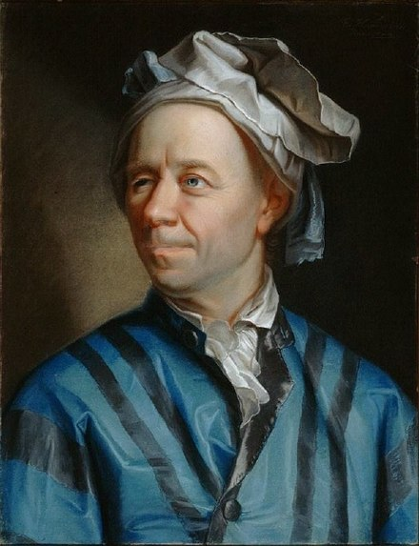
Leonhard Euler 15 April 1707 – 18 September 1783) was a Swiss mathematician瑞士数学家, physicist物理学家, astronomer天文学家, logician逻辑学家 and engineer工程师, who made important and influential discoveries in many branches of mathematics, such as infinitesimal calculus无穷小微积分 and graph theory图论, while also making pioneering contributions to several branches such as topology拓扑 and analytic number theory解析数论. He also introduced much of the modern mathematical terminology现代数学术语 and notation符号, particularly for mathematical analysis数学分析, such as the notion of a mathematical function数学函数符号. He is also known for his work in mechanics力学, fluid dynamics流体动力学, optics光学, astronomy天文学, and music theory音乐理论.
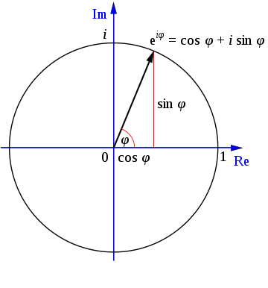
Euler is well known in analysis for his frequent use and development of power series幂级数, the expression of functions as sums of infinitely many terms, such as
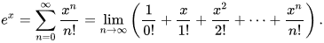
Notably, Euler directly proved the power series expansions for e and the inverse tangent function反正切函数. His daring use of power series enabled him to solve the famous Basel problem巴塞尔问题 in 1735 :
∑ n = 1 ∞ 1 n 2 = lim n → ∞ ( 1 1 2 + 1 2 2 + 1 3 2 + ⋯ + 1 n 2 ) = π 2 6 . {\displaystyle \sum _{n=1}^{\infty }{1 \over n^{2}}=\lim _{n\to \infty }\left({\frac {1}{1^{2}}}+{\frac {1}{2^{2}}}+{\frac {1}{3^{2}}}+\cdots +{\frac {1}{n^{2}}}\right)={\frac {\pi ^{2}}{6}}.}
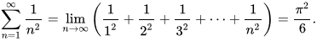
Euler also discovered the formula V − E + F = 2 {\displaystyle V-E+F=2} relating the number of vertices, edges and faces of a convex polyhedron凸多面体, and hence of a planar graph平面图. The constant in this formula is now known as the Euler characteristic欧拉示性数 for the graph (or other mathematical object), and is related to the genus of the object物体的种属. The study and generalization概括 of this formula, specifically by Cauchy柯西 and L'Huilier吕伊利埃, is at the origin of topology.

欧拉-马歇罗尼常数
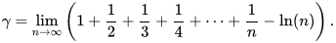

In 1757 he published an important set of equations for inviscid flow无黏流动, that are now known as the Euler equations欧拉方程. In differential form, the equations are:
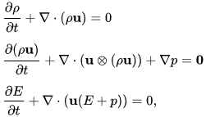
where其中：
- ρ is the fluid mass density瘤体质量密度,
- u is the fluid velocity vector流体速度向量, with components u, v, and w,
- E = ρ e + ½ ρ (u² + v² + w²) is the total energy per unit volume单位容积, with e being the internal energy per unit mass for the fluid,
- p is the pressure压力,
- ⊗ denotes the tensor product张量积, and
- 0 being the zero vector零向量.
Euler is also well known in structural engineering for his formula giving the critical buckling load临界屈曲荷载 of an ideal strut理想的支撑物, which depends only on its length and flexural stiffness抗弯刚度:
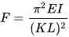
where其中：
- F = maximum or critical force最大或临界力 (vertical load on column柱子上的垂直荷载),
- E = modulus of elasticity弹性模数,
- I = area moment of inertia面积惯性矩,
- L = unsupported length of column柱子的无支撑长度,
- K = column effective length factor柱子的有效长度因子, whose value depends on the conditions of end support of the column, as follows.
For both ends pinned两端均受压 (hinged转折, free to rotate自由转), K = 1.0.
For both ends fixed两端均固定, K = 0.50.
For one end fixed and the other end pinned, K = 0.699…
For one end fixed and the other end free to move laterally一端固定另一端横向自由移动, K = 2.0.
- K L is the effective length of the column柱子的有效长度
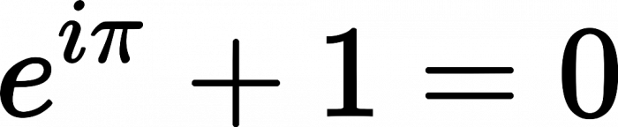
欧拉恒等式 Euler’s identity
欧拉示性数Euler characteristic
欧盟EU---European Union:
Austria
Belgium
Bulgeria
Croatia
Cyprus
Czech republic
Denmark
Estonia
Finland
France
Germany
Greece
Hungary
Ireland
Italy
Latvia
Lithuania
Luxembourg
Malta
Netherland
Poland
Portugal
Romania
Slovakia
Slovenia
Spain
Sweden
United kingdom (brexit in 2016)
疑欧派Euroskeptics
欧氏几何Euclidean geometry vs nonEuclidean geometry
一维是直线
二维是面
三维是体
欧元euro
欧洲Europe
Pro-Europe亲欧洲的
Eurovision 欧洲电视网
欧洲计算机制造商协会 ECMA--- Europe computer manufacturer association
ECMAScript = JavaScript
欧洲之星Eutostar

殴打to assault, to maul
殴打to beat up (the man)

Ou 3
偶氮azotine
偶尔occasionally, once i a while, now and then
to flare occasionally偶尔爆发
偶发事件，机遇，巧合happenstance
偶然by accident
promiscuous偶然的
to stumble upon偶然发现
serendipitous偶然发现的
偶遇to come across
偶像idol

呕吐vomiting

Ou 4
怄气to be sulky, to be irritated

Western knowledge elements:
字符(含义)
形式语言
(formal language)

Οο omicron short o
单个字母：

（这个希腊字母在数学和科技中的指代）
Ο represents大写时代表:
1. big O notation (may be represented by an uppercase Latin O)
大O标记（可用拉丁大写O代表）函数的渐进行为的介
o represents小写时代表:
1. small o notation (may be represented by a lowercase Latin o)
小o标记（可用拉丁小写o代表）坐标原点

Ωω omega long o
单个字母：

（这个希腊字母在数学和科技中的指代）

Ω represents大写时代表:
1. the SI unit measure of electrical resistance, the ohm
欧姆---电阻的国际单位制测度
2. angular velocity / radian frequency (rev/min)
角速度/弧频（转数/分钟）
3. the right ascension of the ascending node (RAAN) or Longitude of the ascending node in astronomy and orbital mechanics
在天文学和轨道力学中升交点的赤经(RAAN)或升交点的经度
4. the rotation rate of an object, particularly a planet, in dynamics
物体的转速，尤其是动态学中行星的转速
5. the omega constant 0.5671432904097838729999686622...
欧米加常数
6. an asymptotic lower bound related to big O notation
渐进下界与大写O标记有关
7. in probability theory and statistical mechanics, the set of possible distinct system
states
在概论和统计力学中的可能的不同系统状态集
8. a solid angle
立体角
9. the omega baryon
欧米伽重子
10. the arithmetic function counting a number's prime factors
计量一个数的素因子数量的算数函数
11. the density parameter in cosmology
宇宙学中的密度参数
ω represents小写时代表:
1. angular velocity / radian frequency (rad/sec)
角速度/弧频（弧/秒）
2. the argument of periapsis in astronomy and orbital mechanics
天文学和轨道力学中的近点辐角
3. a complex cube root of unity — the other is ω² — (used to describe various ways of calculating the dcrete Fourier transform)
统一复数立方根---其它为ω²---（用于描述计算离散傅里叶变换的各种方法）
4. the differentiability class (i.e. C^ω) for functions that are infinitely differentiable because they are complex analytic
可微性类适合于因其为复变函数论而可以无限微分的函数
5. the first infinite ordinal
第一无限主序
6. the omega meson
欧米伽重子
7. the set of natural numbers in set theory (although or N is more common in other areas of athematics)
集合论中的自然数集合（广泛用于数学的各个领域）
8. an asymptotically dominant quantity related to big O notation
渐进主导量与大写O标记有关
9. in probability theory, a possible outcome of an experiment
概论，试验的可能结果
10. in economics, the total wealth of an agent in general equilibrium theory
在经济学的一般均衡理论中，代理人的总财富
11. vertical velocity in pressure-based coordinate systems (commonly used in atmospheric dynamics)
压力坐标系中的铅锤速度（常用与大气动力学中）
12. the arithmetic function counting a number's distinct prime factors
计量一个数的素因子数量的算数函数
13. a differential form (esp. on an analytic space)
微分形式（特别，关于解析空间）
14. the symbol ϖ, a graphic variant of π, is sometimes construed as omega with a bar over it; see π
有时在欧米伽上方加上一横道ϖ作为π的图形变异
15. the last carbon atom of a chain of carbon atoms is sometimes called the ω (omega) position, reflecting that ω is the last letter of the Greek alphabet. This nomenclature can be useful in describing unsaturated fatty acids.
碳链的最后一个碳原子有时被称为ω位，表明为希腊字母表的最后一个字母。
这样的命名在描述非饱和脂肪酸时很有用。
字符串：
ω-3---欧米伽3脂肪酸
ω-6---欧米伽6脂肪酸

O o
单个字母：

（这个拉丁字母在数学和科技中的指代）
O represents大写时代表：
1. the order of asymptotic behavior of a function (upper bound); see Big O notation
函数渐进行为的介（上界）

— the origin of the coordinate system in Cartesian coordinates
笛卡尔坐标中坐标系统的原点
2. the circumcenter of a triangle or other cyclic polygon, or more generally the center of a circle
三角形的外接圆心，或其它环形多边形的外接圆心，或更一般的圆心
o represents 小写时代表：
1. the order of asymptotic behavior of a function (strict upper bound); see Little o notation
（同上）（严格上界）
2. the order of an element in a group
群中的元的介
字符串：
Oled--- organic electroluminescence display有机电子发光显示器(芯片)
基板basilar plate, placode, basal lamina
阴极cathode
阳极anode
空穴注入层HIL--- hole injection layer
空穴传输层HTL--- hole transmission layer
空穴阻挡层HBL--- hole blocking layer
电子注入层EIL--- electronic injection layer
电子传输层ETL--- electronic transmission layer
电子阻挡层EBL--- electronic blocking layer
发光层emission layer

OO---Object Oriented面向对象

