### Object model

The analysis object model, depicted with UML class diagrams, includes classes, attributes, and operations. The analysis object model is a visual dictionary of the main concepts visible to the user.

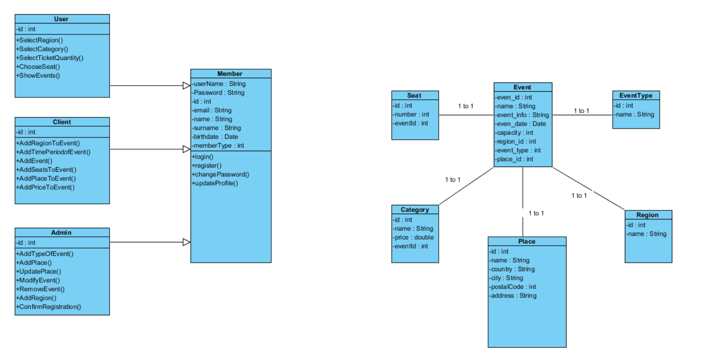

### Dynamic model

The dynamic model is depicted with sequence diagrams and with state machines. Sequence diagrams represent the interactions among a set of objects during a single use case. State machines represent the behavior of a single object (or a group of very tightly coupled objects). The dynamic model serves to assign responsibilities to individual classes and, in the process, to identify new classes, associations, and attributes to be added to the analysis object model.

When working with either the analysis object model or the dynamic model, it is essential to remember that these models **represent user-level concepts, not actual software classes or components.**

**SEQUENCE DIAGRAMS**

**1-) AddTimePeriodofEvent**

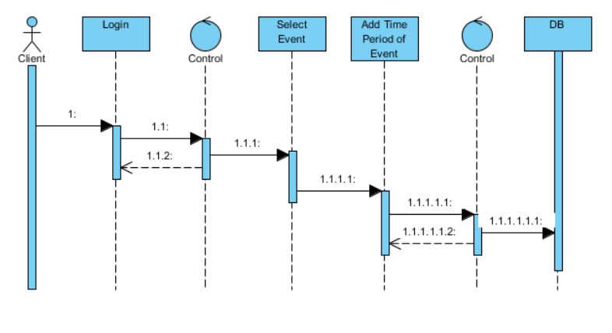

**2-) AddEvent**

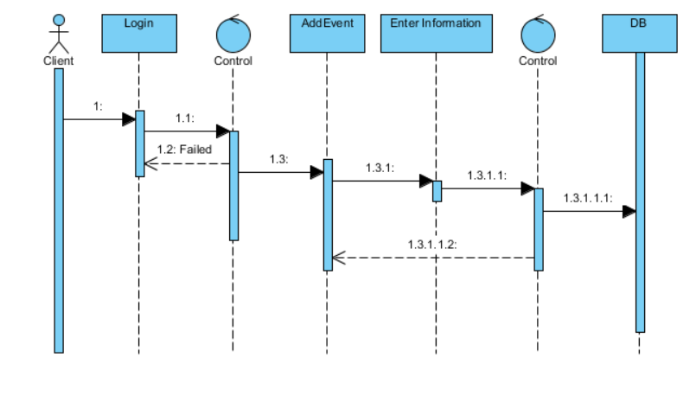

**3-) AddPlace**

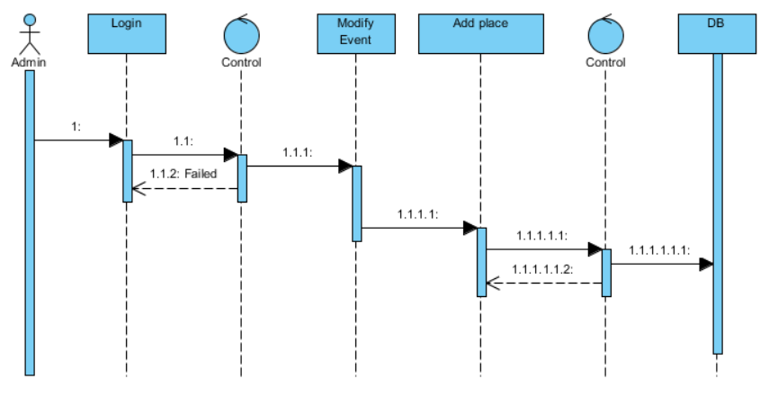

**4-) AddPlacetoEvent**

