### Use case model

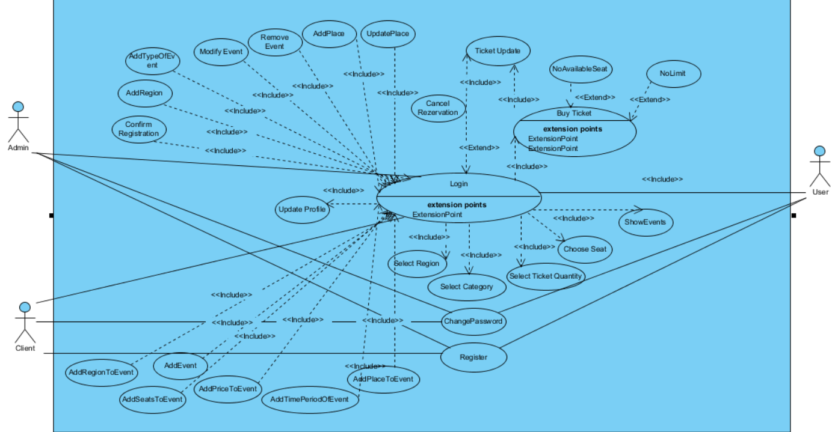

**Use Case 1:**

|  |
| --- |
| *Use case name:* Login |
| *Participant actors:* User, OR Admin, OR Client |
| *Flow of events:* 1. The user first enters to Online Ticket System system.    2. Online Ticket System presents the “Login Form” to the user.  3. The user enters his/her username into username text field on the screen, also enters his/her password into password text field on the screen. Lastly, the user sends a request to Online Ticket System by using login button on the screen to be logged in.  4. Online Ticket System checks the username ,password and user type from the “User” table so that Online Ticket System allows the user to login. |
| *Entry Condition:* The user enters to login screen. |
| *Exit Condition:* The user is logged in to Online Ticket System |
| *Quality Requirements:* The user cannot login cause of wrong username or password |

**Use Case 2:**

|  |
| --- |
| *Use case name:* UpdateProfile |
| *Participant actors:* Customer ,OR Admin,OR Orginizer |
| *Flow of events:* 1. The user sends a request to Online Ticket System to update his/her personal information which are his/her identification, and address, credit card Information.  2. Online Ticket System offers the “Personal Information Form” by using the “User” table. Then, displays it on the screen so that the user can update fields he/she wishes to.  3. The user edits the fields he/she wants, then he/she submits the form by using the update button to be updated.  4. Online Ticket System updates the information into the “User” table. Finally, it displays the “Acknowledgement Notice” to the user. |
| *Entry Condition:* The user is logged into Online Ticket System.  The user chooses Update Information option on the screen. |
| *Exit Condition:* Information of the user has been updated and the user has received an acknowledgement message. |
| *Quality Requirements* : The user has received an explanation indicating why form could not updated. |

**Use Case 3:**

|  |
| --- |
| *Use case name:* AddEvent |
| *Participant actors:* Client |
| *Flow of events:* 1. The Client logs in Online Ticket System.  2. Client enters “Add Event” button.  3. Client select place ,region, date, categories, seats and writes prices for categories. After that Client enters “Add” button.  4. Online Ticket System receives these and add this event to DB. Then, displays message that is “Your event is added” on the screen so that the user can add event. |
| *Entry Condition:* The Client is logged into Online Ticket System.  The Client chooses add event option on the Client Home Page. |
| *Exit Condition:* The Client has seen message on the screen. |
| *Quality Requirements:* The Client has received an explanation indicating why the event could not be added. |

**Use Case 4:**

|  |
| --- |
| *Use case name:* ShowEvents |
| *Participant actors:* User |
| *Flow of events:* 1. The User sends a request to Online Ticket System to see all events on the screen.  2. Online Ticket System displays all events on the screen. |
| *Entry Condition:* The User selects Show Events option on the screen. |
| *Exit Condition:* The User shows all of the available events on screen |
| *Quality Requirements:* The User has received an explanation indicating why the list could not be showed. |

**Use Case 5:**

|  |
| --- |
| *Use case name:* SelectCategory |
| *Participant actors:* User |
| *Flow of events:*  1.User logs into the Online Ticket System.  2.User select region on the event page.  3.User select the category filter for events.  4.And User can show events of selected category in selected region |
| *Entry Condition:* The user is logged into Online Ticket System.  The user chooses “Filter Events” button on the screen. |
| *Exit Condition:* The user has viewed selected category |
| *Quality Requirements:* The user has received an explanation indicating why the category could not be selected. |