NSAA Project and Operation Archives

The NSAA was officially founded on october 8th 2019 and since then a bunch of important events have occurred.This archive folder covers the history of the numerous numbers of operations and even more info. ⬇️

Project Half Cash

Date: Oct 7th to Dec 9th

Description: When the NSAA was first founded, Zane decided to make the first operation of the NSAA. While it was wasn’t considered a operation back then, it is a operation now. Half cash was meant to be wildcash cut in halves or quarters and then these pieces of wildcash could be taped together to make a whole wildcash.

**GOAL:** To make a wildcash currency system and change the way we use wildcash.

Aftermath: **This Project was a failure.** Nobody wanted the half cash since it was not accepted as a form of currency for the school and it was more Convenient to just earn whole wildcash from other sources.

Operation Rabbit Hole

Date: Nov 14th to Dec 2nd 2019

Description: A little backstory to this Operation: Zane Miller and Harrison Steed found a picture of a rabbit with a QR code near in Mr. Kirkland’s class. They decided to scan it and behold, They found a intricate game and puzzles. This is where the operation begins. The NSAA takes the link and posts it so all members could try to solve it and soon the hunt begins. After a while,not much is discovered so Rahat, a member of the NSAA decides to make a theory that it’s a game that they will play in class and everybody agrees. Soon it is confirmed by Zane that the site is indeed a game they will play at the end of the school year.

**GOAL**: Find our what the heck the rabbit hole is and solve it’s mysteries.

Aftermath: **This project was successful.** The NSAA correctly guessed what it was and solved the mystery.

Operation: Enhanced Dirt

Date: Dec 18th to Dec 20th 2019

Description: On December 18th 2019 a squishy ball was found OUTSIDE the fence of the old football. Now you may know these balls cost 25 wildcash meaning they sell well and are fun to play with. The NSAA organizes a team to locate and retrieve the squishy ball. The team consists of, tristian, Zane, and Rahat, there was also a plan involved in getting the ball back inside the fence. However, disaster stuck as we were not allowed to go outside on the rest of the days and winter break was fast approaching. On the last day of school (before winter break) Zane had to go leave school before we could even do the thing. After that a NEW football field and track finished construction and we could not travel back for a longer time. In the end the squishy ball was nowhere to be found and the operation was called off.

**GOAL:** find and retrieve the squishy ball from outside the fence during P.E

Aftermath: **This project was a horrible failure.** The combined unlucky streak and bad timing lead to disaster; this operation was a giant failure for the NSAA.

**Project Special Collections**

Date: Dec 18th 2019 to NOW

Description:When the NSAA discovered different natural types of wildcash, The organization decided to collect all types and variations of wildcash there is. We classified these wildcash into 2 types, natural wildcash and Manmade wildcash. Natural wildcash is wildcash given out by teachers or are wildcash that

were created by the school/teachers. Manmade cash was wildcash that was changed by anybody to be different in many ways. The NSAA collected all types of natural cash possible and made lots of Manmade ones. In the second semester of the 2019-2020 school year, a photo album will be modified and turned into a museum for all the wildcash collected. The special wildcash **can be bought with normal wildcash.** The project is still currently being worked on but the museum has begun construction.

**GOAL:**Collect all types and variation of wildcash and make new types as well. During the second semester, make a museum for these types of wildcash with captions.

***Current progress:*** All is going well and we have found dozens of types of wildcash. Here are a few types of wildcash found/created.

**MULTICASH**

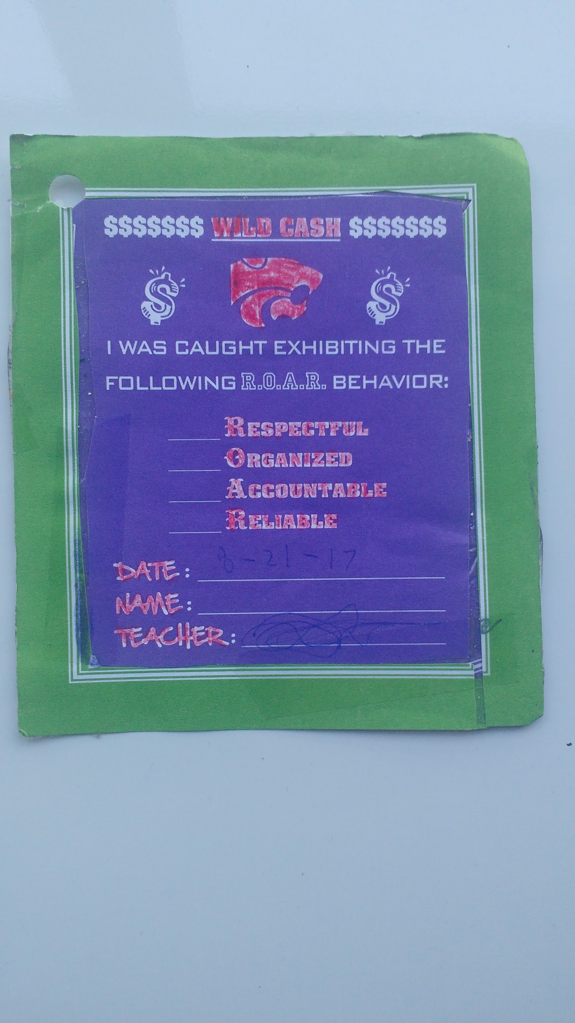**COUNTERCASH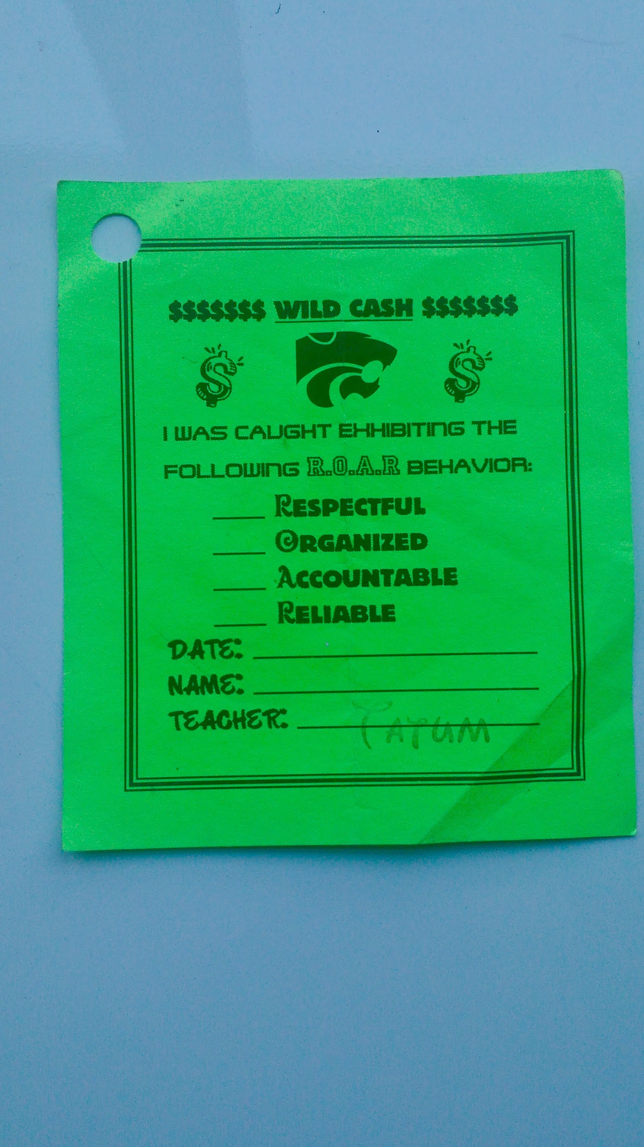PURPLE CASH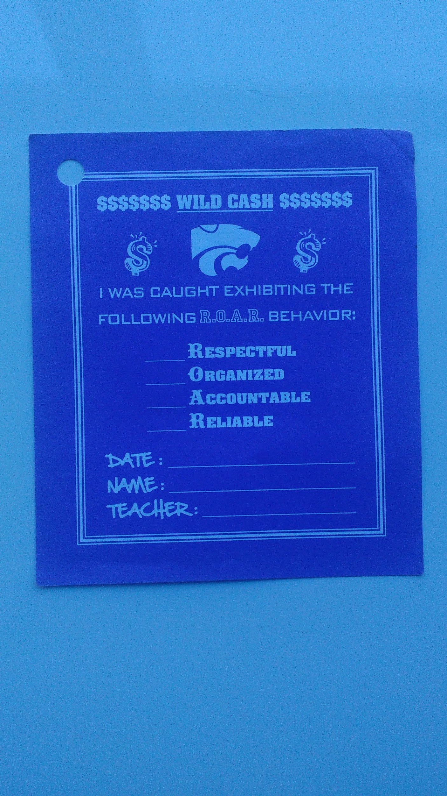ACASH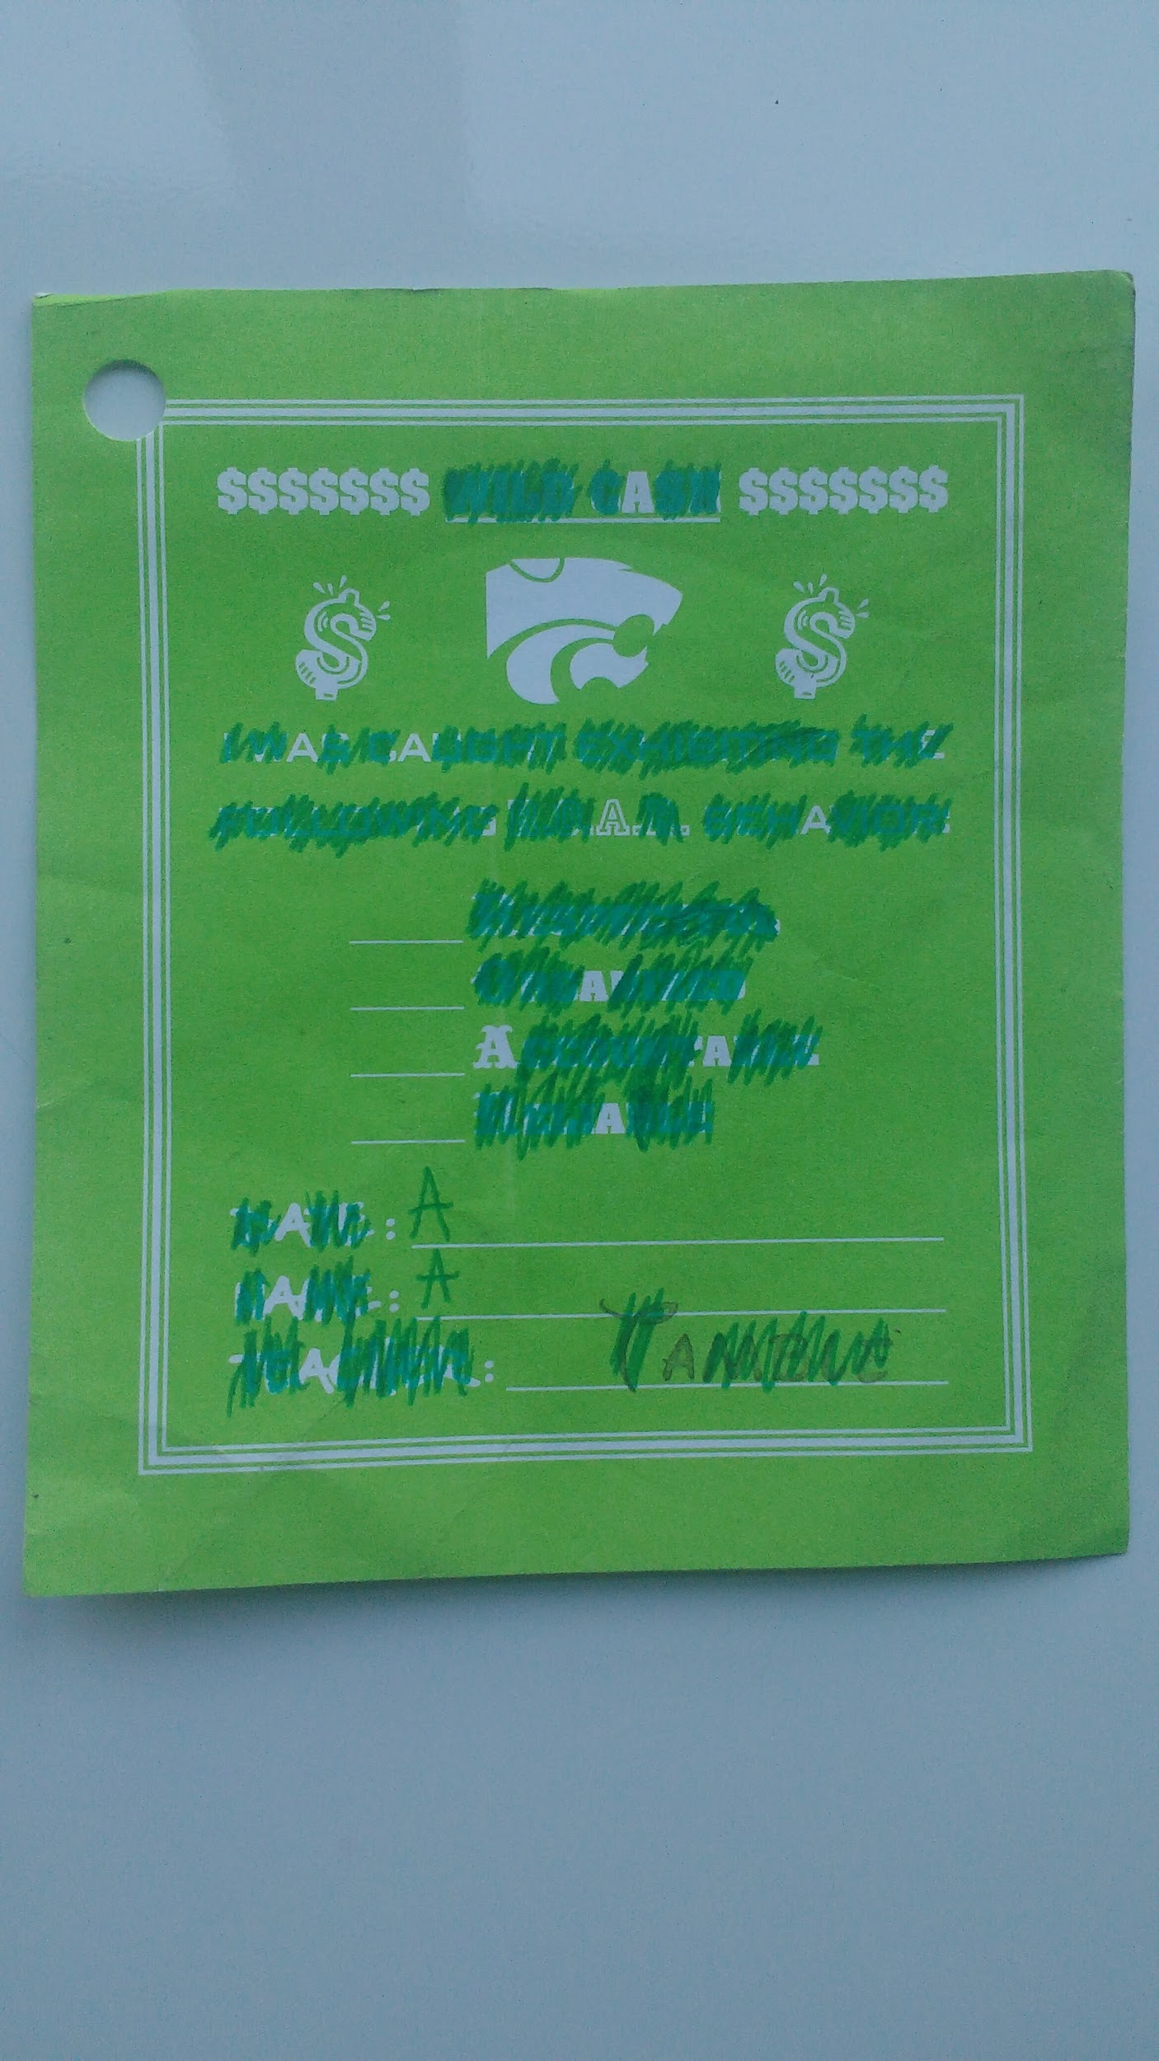SLIM CASH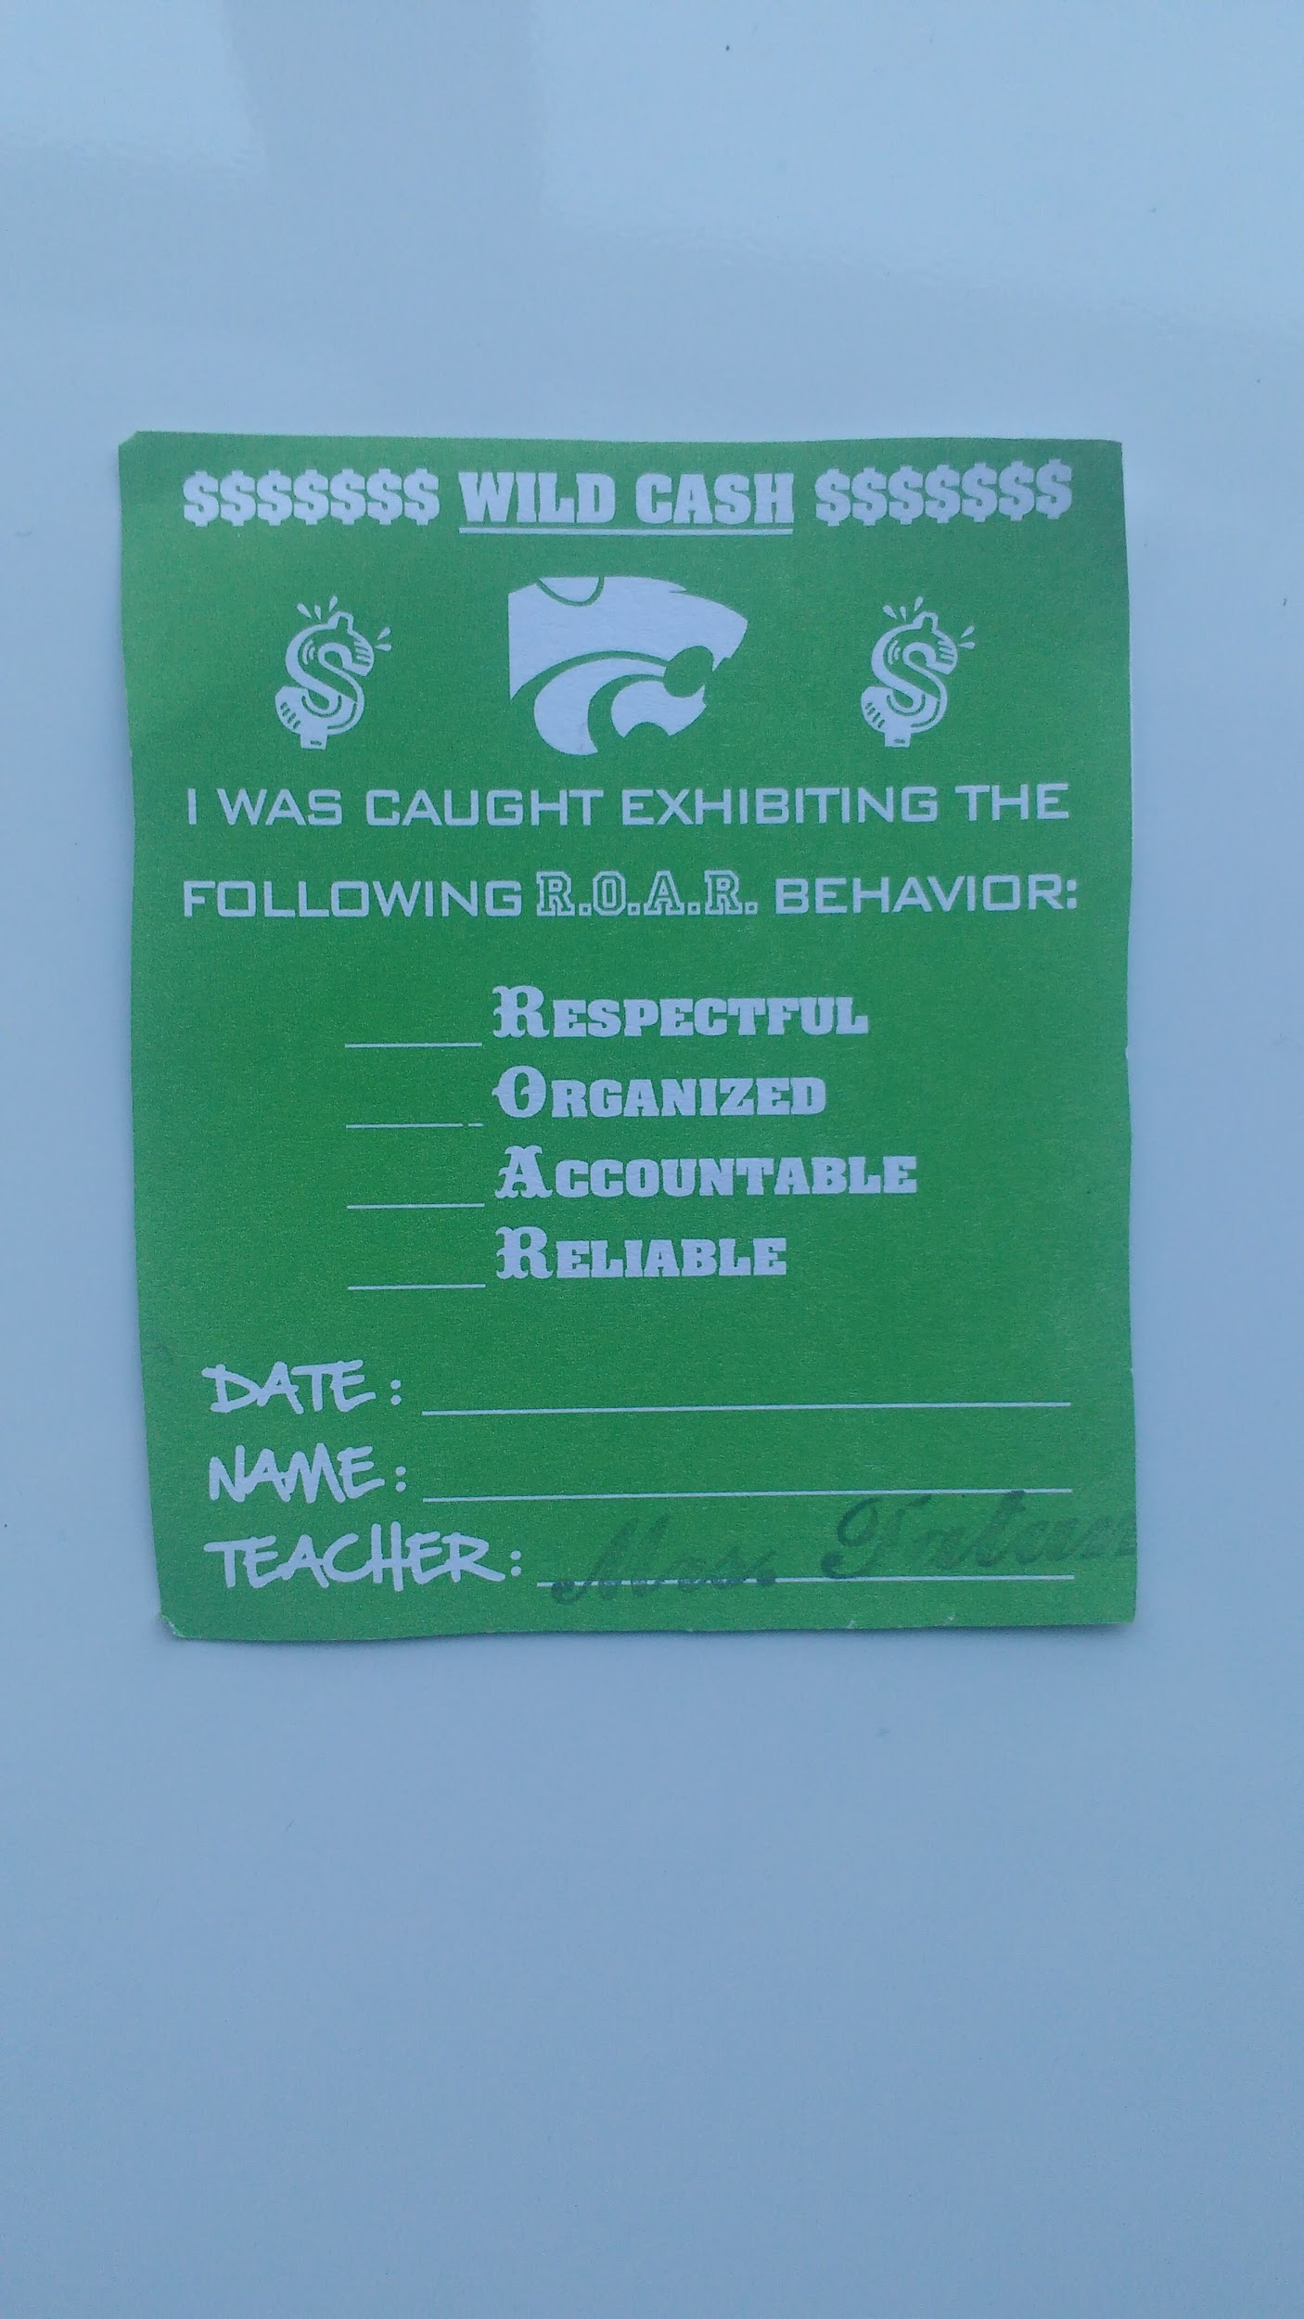YELLOW CASH(part of the rainbow cash series)**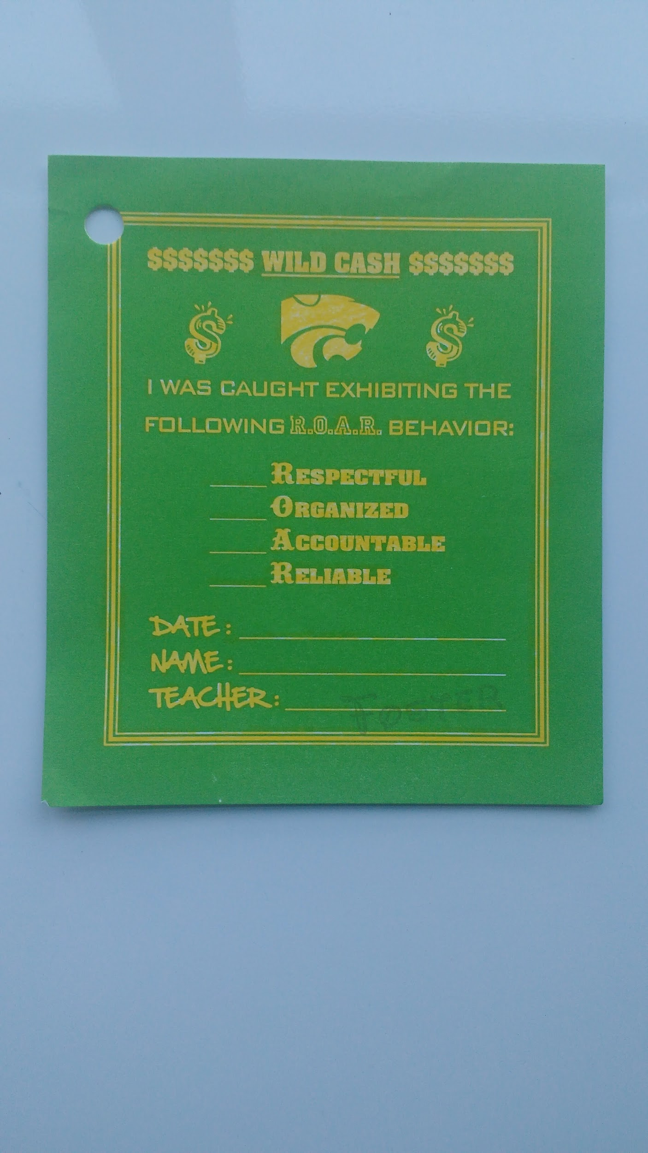

**Eeeeeeeeeeeeeeeeeeeeeeeeehhhhehheehuehoeubeiuhieuheiuhekuehiuehieuh**

Project ARP ( Associate Recruitment Program)

Date: Dec 20 2019 - now

Description: Rahat Hasan, co-owner of the NSAA, decided to launch a new program called ARP which stands for associate recruitment program. This program was launched in order to hire for members for the NSAA since a lot of members were fired

This made it so any members of the NSAA could recruit new members who had 20 wildcash(old) or have already filled out the new member google form(new). As a result, Jared nix, Nick something, Gabriel, and Jamison Christ were hired. No new members have been hired for a month now.

**Goal:** Hire more members for the NSAA and expand its reach in the school.

Progress: Four people were hired and not much else has happened. It is current not being used much.

Operation Trash Can

Date: Jan 24 2020 to now

Description: This idea was founded by Zane Miller. If wildcash is found in a trash can, in pieces or intact, they can take it out and recycle it. If the wildcash is broken or damaged it can be taped back together.

**Goal:** Find wildcash in trash cans and tape them if needed.

Current Progress: A good amount of wildcash has been recovered from trash cans though there may be other ways to get wildcash.

Operation RTFDS

Date: Jan 27 2020

Description: On January 27th 2020 Zane Miller organized a raid for the NSAA and raided pasta Harrison’s server. The raid consisted of crab rave spam and funny random pictures. The funny thing is, the owner (pasta Harrison) watched in horror as we ruined his discord sever with no mercy. The raid was successful.

**GOAL:** Raid the fricken discord server with crab rave and rick roll

Aftermath: **This Operation was a success.** Almost everybody in the NSAA participated and the raided server will forever be scared by crab rave

CREDITS TO-

Zane Miller- provided the dates and some information for the operations

Harrison steed- provided all the pictures