**Instructions for updating folder permissions**

File and Folder permissions work in the order of Allow then Deny. This means every user with the ‘View corporate files and folders’ permission is allowed to view all files and folders. This permission spefically allows the user to have the Corporate files link in their navigation. See screenshot below on how to set this permission.

To allow Chintan Mody permissions, follow the steps below.

1. Update Mody’s profile and allow access to Corporate files

–––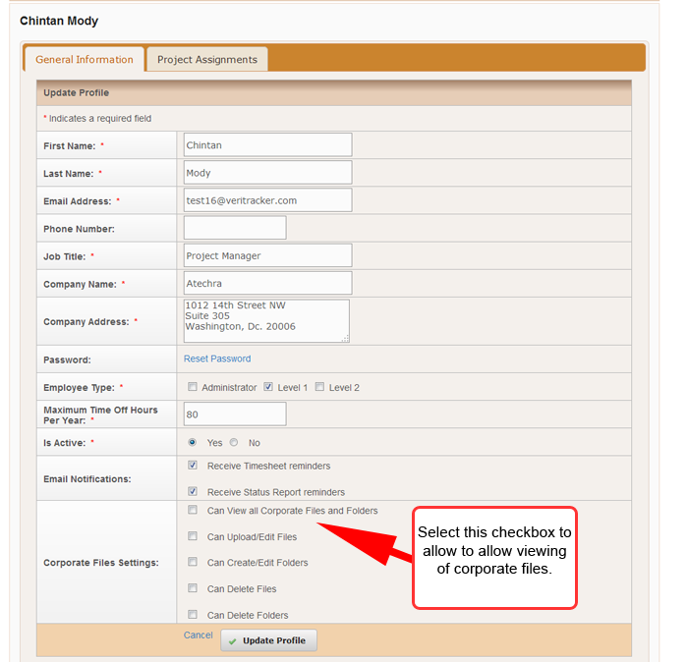

1. Click the Corporate files link.
2. Click the information icon in the row containing the folder you want to grant or deny permissions.

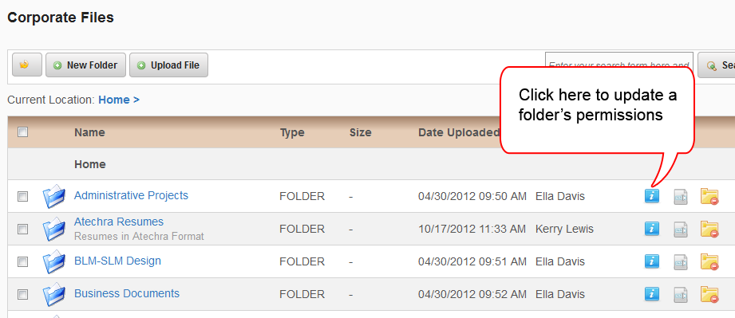

1. In the “Deny Access” row, click the ‘X’ icon against the name Chintan Mody to Allow access.
2. To deny a user currently allowed, type their name in the textarea.

