Coursework answers:

The jobs took roughly 2 minutes each. Once I managed to get SSH and pooling working on Windows. The stopped lags for s3 log transfers and the start time for each machine.
I used a 4 node cluster.

1)
Pairs:
FOR:
"the" | "0.13421729130023"
"her" | "0.07455012853470437"
"a" | "0.06778514409416858"
"it" | "0.030577729671221757"
"his" | "0.02854823433906102"
"him" | "0.02435394398592883"
"i" | "0.02191854958733595"
"me" | "0.02191854958733595"
"you" | "0.02070085238803951"
"my" | "0.017994858611825194"

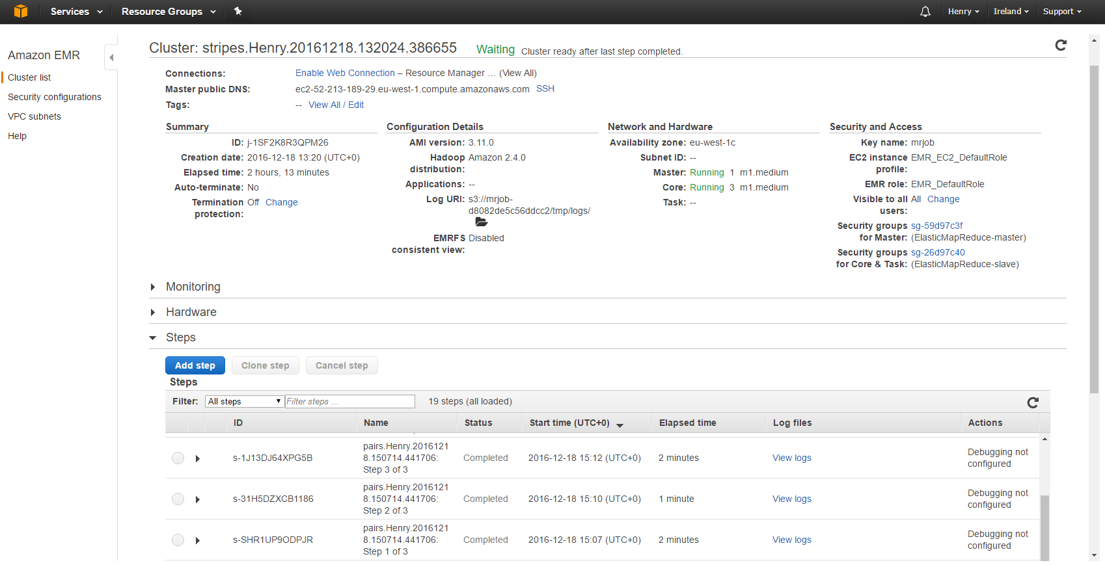
Note: Mrjob selected an available cluster. It ran the pairs task but was originally set up for stripes, hence the name conflict.

Stripes:
FOR:
"the" | 0.13421729130023
"her" | 0.07455012853470437
"a" | 0.06778514409416858
"it" | 0.030577729671221757
"his" | 0.02854823433906102
"him" | 0.02435394398592883
"i" | 0.02191854958733595
"me" | 0.02191854958733595
"you" | 0.02070085238803951
"my" | 0.017994858611825194

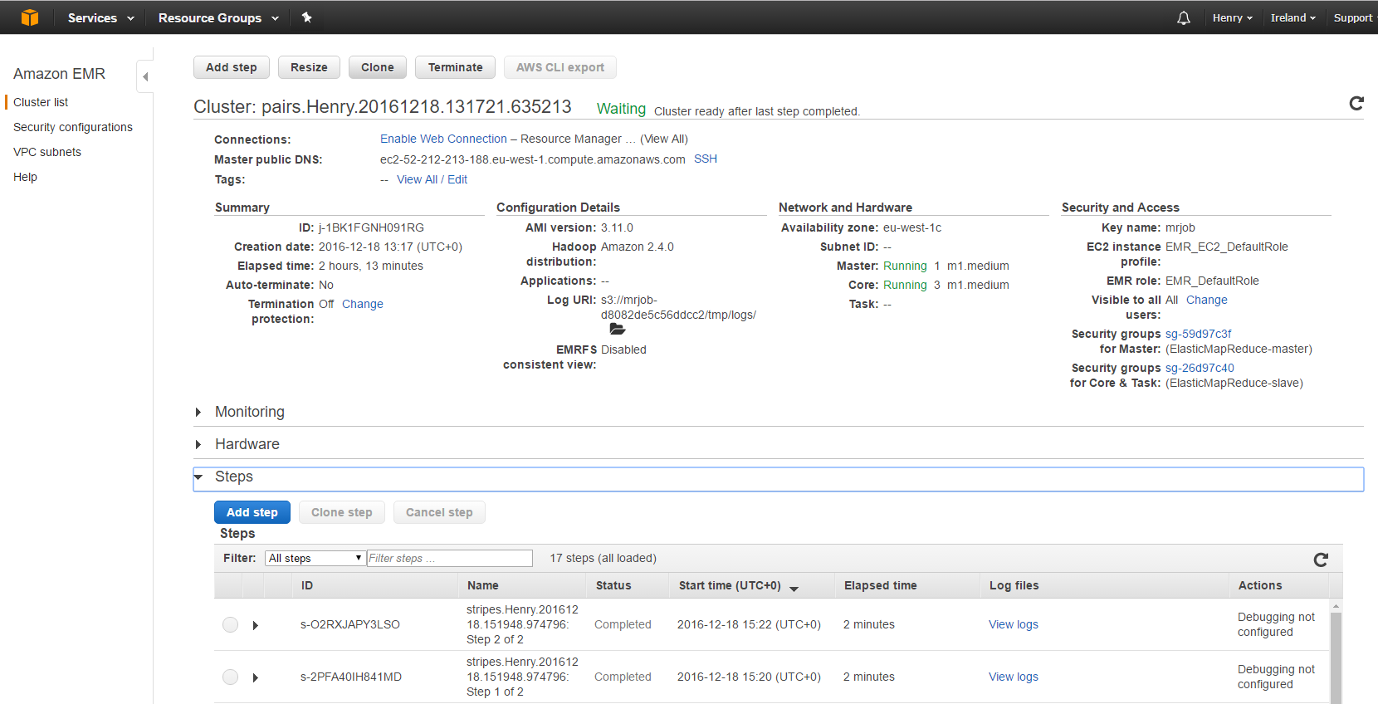
Note: Mrjob selected an available cluster. It ran the stripes task but was originally set up for pairs, hence the name conflict.

2b)

