Homework 1

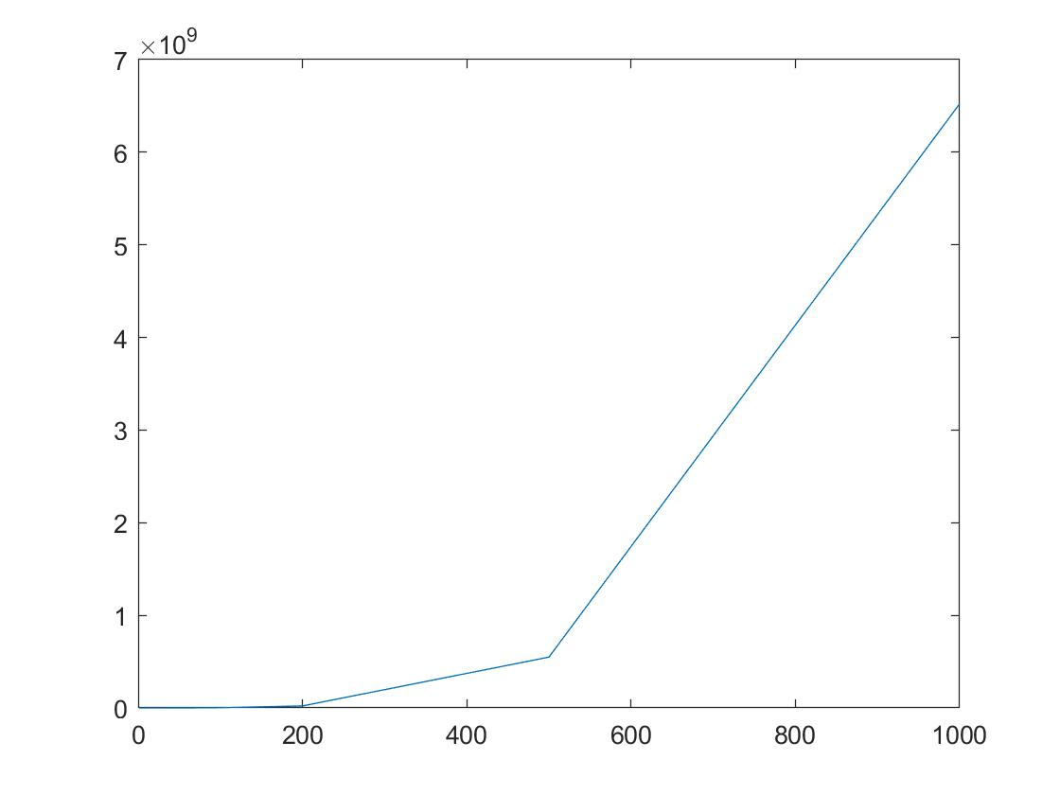

Homework 2:

The following are reasons why trees are preferred over hash tables:

1. Trees are easily scalable whereas hash tables require rehashing/chaining/linear probing and is easy to run out of space.
2. When making the hash table, you have to consider how much space to allocate before creating one and not all situations can estimate how much space will be required.
3. Rehashing will take O(N) and is significantly longer than O(logN).
4. Trees are guaranteed to work in O(logN) if they are properly balanced whereas hash tables are dependent on the amount of chaining/linear probing and may be longer than O(1).
5. The BST’s sort input in order, but hash tables do not.

Homework 3:

Use a hash table to keep track of the addresses of the double linked-list contents and use the double linked-list to keep track of the websites. A unique key can be kept for each website and if the new website exists, already, the existing entry can be moved to the beginning of the list. If a new website is input, it will be put to the beginning of the list and the last entry of the list will be deleted.