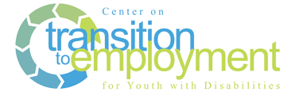

Flow of Service Worksheet

*Developed by: Kelli Crane, TransCen, Inc.*

Directions: Map the *flow of services* for students.

1. **Determine student outcomes**

On the timeline, indicate when the following *outcomes* occur for the majority of targeted students:

* VR intake
* VR case opened
* Paid employment
* Application in postsecondary training or education
* Enrollment in postsecondary training or education
* Connections/linkages to other agencies to obtain and/or maintain employment post high school

1. **Student services**

On the timeline, indicate when the following *services* occur for the students:

* When is discovery happening – assesses student’s career area preferences and interests?
* When does student receive soft skill training?
* When does student receive skills training workplace behaviors?
* When does student receive self-determination skills training?
* When does student receive work experiences (e.g., job shadows, worksite tours, unpaid work experience)?
* When is the plan for employment developed (e.g., job development plan)?
* When are the families engaged?
* When does benefits counseling occur?

1. **Determine what each partner offers**

|  |  |  |  |  |  |
| --- | --- | --- | --- | --- | --- |
|  | 4 years prior to exit (Freshman year) | 3 years prior to exit (Sophomore year) | 2 years prior to exit (Junior year) | 1 years prior to exit (Senior year) | 1 year post exit |
| Student Outcomes |  | | | | |
| Student Services |  | | | | |
| Potential Role of VR |  | | | | |
| Potential Role of Schools |  | | | | |
| Potential Role of CRPs |  | | | | |
| Potential Role of Families |  | | | | |
| Other (AEA, WIA) |  | | | | |