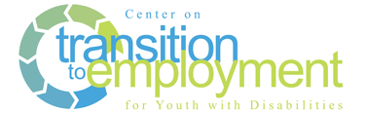

Curriculum Development Using A Mapping Framework

Outcome

Each community will identify outcomes that will develop students’ ability to work in integrated, competitive employment and ensure all students with disabilities have access to developing these skills prior to exiting high school.

Completed framework will be used to:

* Communicate expectations to students, families, employers and community
* Develop a comprehensive ‘Flow of Services’
* Develop course content, materials and supportive activities
* Ensure that all students continue to access skill development necessary in preparation for competitive integrated employment

|  |  |  |  |  |  |
| --- | --- | --- | --- | --- | --- |
| **Student Learning Outcome** (Key Content Area)Focused on Competitive Employment | **Curricular Content**   * Skills * Activities | **When/Where** | **Who’s Responsible** | **Data Elements** | **Student Engagement** |
| Outcomes that will develop students’ ability to work and be successful in integrated competitive employment.  Definitions developed for each content area. | Essential learning to achieve the outcome.  Activities and methods used to teach the identified skill  Identify materials. | When:   * During school year * Summer * Which grade   Where:   * Core class * Elective * Sped * In community   Connections to:   * 21st century skills and career pathways * local flow of services | This refers to who will deliver and/or support the skill development in various settings.  May include:   * General Educator * Special Educator * VR Counselor * Other service providers | How will you know if students are achieving the outcome?  Look at data elements in group aggregate to inform program/ curriculum and individual student to inform student progress and identify areas of need | How do we know if students are engaged in the learning process? Is this different by outcome area?  Examples: Employer reports, attendance in class, level of involvement in IEP development, student survey |