Northvolt Information Summary (July 2024)

# Summary

Swedish police investigate three unexplained deaths at an electric vehicle battery plant . Police in northern Sweden looking into the unexplained deaths of men who died shortly after working at a battery plant in the Arctic . Northvolt AB reported a widening loss for last year after the company struggled to ramp up production of battery cells for electric cars at its factory in Sweden . BASF pulls the plug on Chile investment plans amid a slowdown in electric-vehicle adoption . Hydrovolt To Open Battery Recycling Facility in France. The facility will open in the town of Hordain in what is becoming known as France's Battery Valley, as four major battery production facilities are set to open .

# Articles

## 1. Tracking the EV battery factory construction boom across North America

Link: https://techcrunch.com/2024/07/20/tracking-the-ev-battery-factory-construction-boom-across-north-america/

Sentiment: NEGATIVE (Score: 0.99)

Summary: Tracking the EV battery factory . factory construction boom across North America .

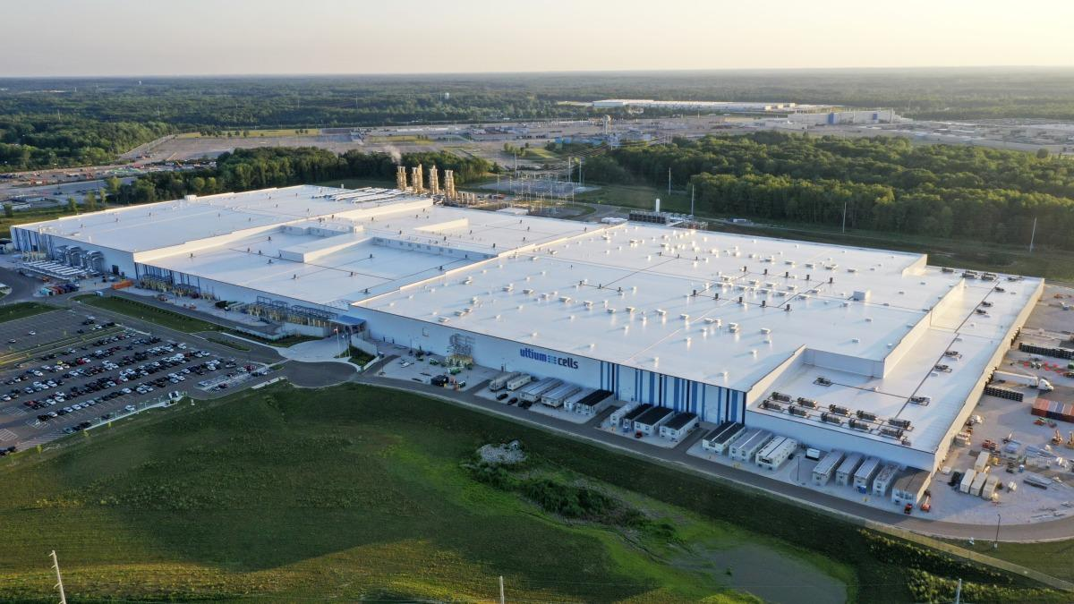

----------------------------------------

## 2. Turmoil Disrupts Swedish Brands Northvolt & Volvo

Link: https://cleantechnica.com/2024/07/08/turmoil-disrupts-swedish-brands-northvolt-volvo/

Sentiment: NEGATIVE (Score: 1.00)

Summary: Turmoil Disrupts Swedish Brands Northvolt & Volvo . Northvolt and Volvo are both encountering headwinds that may delay their electric



----------------------------------------

## 3. Swedish Police Investigate Series of Unexplained Deaths at Electric Vehicle Battery Factory

Link: https://www.breitbart.com/europe/2024/06/27/swedish-police-investigate-series-of-unexplained-deaths-at-electric-vehicle-battery-factory/

Sentiment: NEGATIVE (Score: 0.97)

Summary: Swedish Police Investigate Series of Unexplained Deaths at Electric Vehicle Battery Factory . Police in northern Sweden looking into the unexplained deaths of men who died shortly after

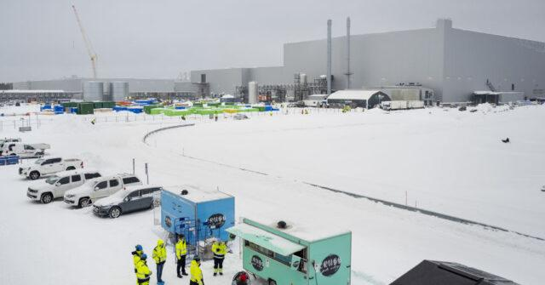

----------------------------------------

## 4. Swedish police investigate three unexplained deaths at an electric vehicle battery plant

Link: https://www.startribune.com/swedish-police-investigate-three-unexplained-deaths-at-an-electric-vehicle-battery-plant/600376579/

Sentiment: NEGATIVE (Score: 0.99)

Summary: Swedish police investigate three unexplained deaths at an electric vehicle battery plant in the Arctic . Police want to find out whether the deaths are linked, whethethe police say .



----------------------------------------

## 5. BASF Pulls Plug on Chile Investment Plans Amid EV Slowdown

Link: https://finance.yahoo.com/news/basf-pulls-plug-chile-investment-070714965.html

Sentiment: NEGATIVE (Score: 0.94)

Summary: BASF SE has abandoned plans to invest in lithium mining assets in Chile . The move comes amid a slowdown in electric-vehicle adoption



----------------------------------------

## 6. Hydrovolt To Open Battery Recycling Facility In France

Link: https://www.ibtimes.com/hydrovolt-open-battery-recycling-facility-france-3735716

Sentiment: POSITIVE (Score: 0.99)

Summary: The facility will open in the town of Hordain in what is becoming known as France's Battery Valley . Four major battery production facilities



----------------------------------------

## 7. Swedish police investigate three unexplained deaths at an electric vehicle battery plant

Link: https://abcnews.go.com/International/wireStory/swedish-police-investigate-unexplained-deaths-electric-vehicle-battery-111469598

Sentiment: NEGATIVE (Score: 0.96)

Summary: Swedish police investigate three unexplained deaths at an electric vehicle battery plant . Police are looking into the deaths of three men who died within a short



----------------------------------------

## 8. Northvolt considers cutting back aggressive expansion plans

Link: https://biztoc.com/x/9470bf44e0dab931

Sentiment: NEGATIVE (Score: 1.00)

Summary: Europe’s leading battery maker recently lost a $2bn BMW contract as it struggles to produce at scale . Northvolt considers cutting



----------------------------------------

## 9. Northvolt says EV battery plant project near Montreal will continue ‘as planned’

Link: https://financialpost.com/commodities/energy/electric-vehicles/northvolt-montreal-ev-battery-plant-project-will-continue

Sentiment: NEGATIVE (Score: 0.86)

Summary: Northvolt says it will continue construction of a $7-billion factory on Montreal's South Shore 'as planned' Northvolt said it

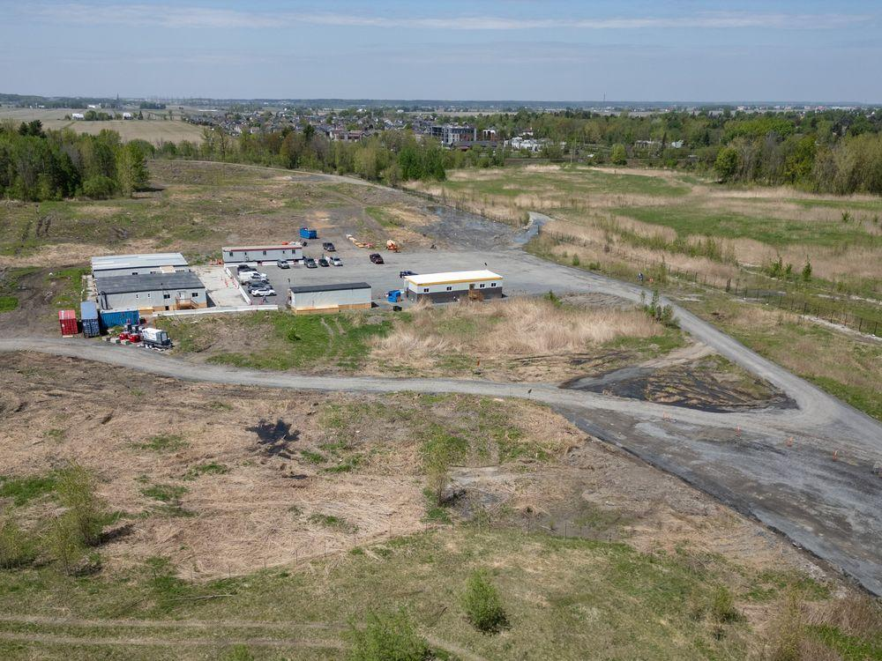

----------------------------------------

## 10. Northvolt Loss Triples to $1 Billion on Battery Ramp-Up Trouble

Link: https://financialpost.com/pmn/business-pmn/northvolt-loss-triples-to-1-billion-on-battery-ramp-up-trouble

Sentiment: NEGATIVE (Score: 1.00)

Summary: Northvolt AB reported a widening loss for last year after the company struggled to ramp up production of battery cells for electric cars at its factory



----------------------------------------