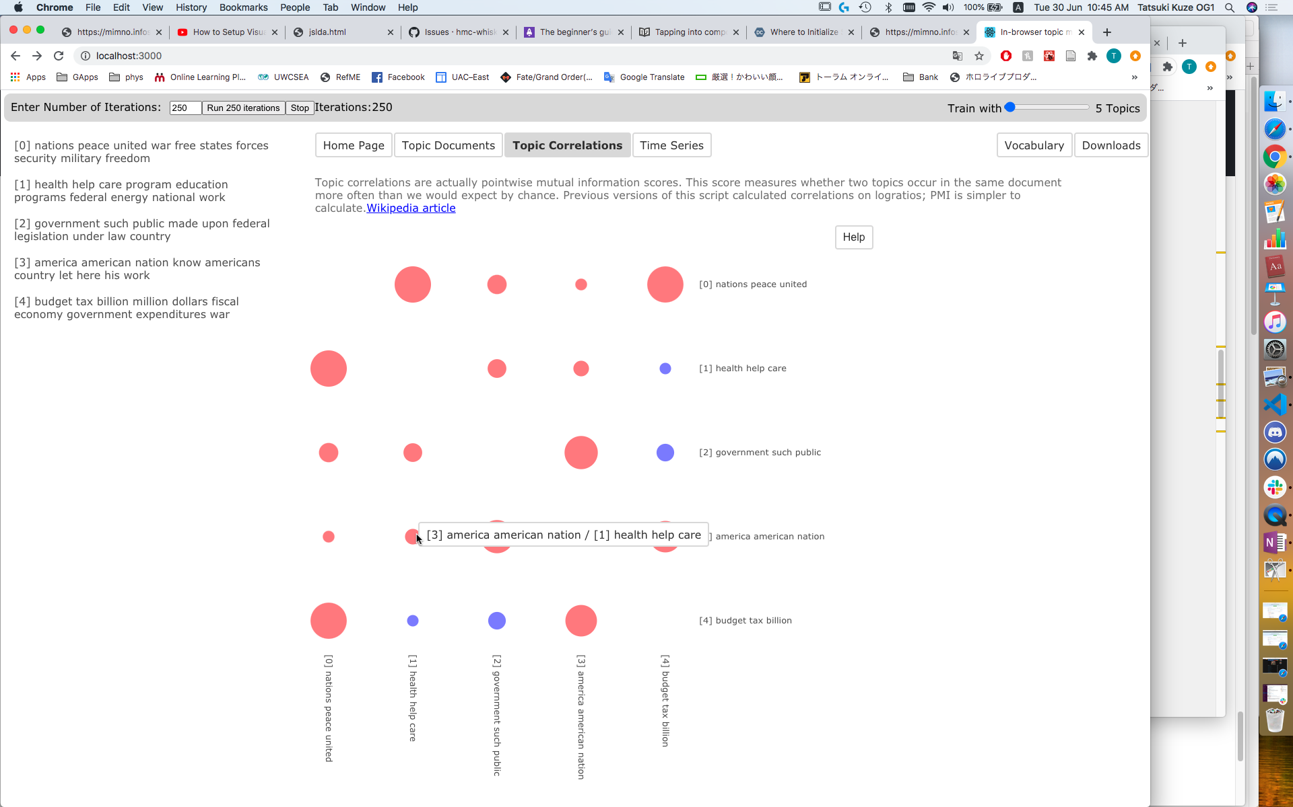

List of generated topics

(3 most common words from the topic)

On hover, shows the two topics which the circle represents

Negative pointwise mutual information is red, positive is blue. The size depicts the magnitude of the measurement.