**What does the Lorem Ipsum text mean?**

Lorem Ipsum comes from a latin text written in 45BC by Roman statesman, lawyer, scholar, and philosopher, Marcus Tullius Cicero. The text is titled "de Finibus Bonorum et Malorum" which means "The Extremes of Good and Evil". The most common form of Lorem ipsum is the following:

Lorem ipsum dolor sit amet, consectetur adipiscing elit, sed do eiusmod tempor incididunt ut labore et dolore magna aliqua. Ut enim ad minim veniam, quis nostrud exercitation ullamco laboris nisi ut aliquip ex ea commodo consequat. Duis aute irure dolor in reprehenderit in voluptate velit esse cillum dolore eu fugiat nulla pariatur. Excepteur sint occaecat cupidatat non proident, sunt in culpa qui officia deserunt mollit anim id est laborum.

The text is a corrupted version of the original and therefore does not mean anything in particular. The book however where it originates discusses the philosophical views of Epicureanism, Stoicism, and the Platonism of Antiochus of Ascalon.

Lorem ipsum is widely in use since the 14th century and up to today as the default dummy "random" text of the typesetting and web development industry. In fact not only it has survived the test of time but it thrived and can be found in many software products, from Microsoft Word to WordPress.

**What is random text generator?**

Random Text Generator is a web application which provides true random text which you can use in your documents or web designs. How does it work? First we took many books available on project Gutenberg and stored their contents in a database. Then a computer algorithm takes the words we stored earlier and shuffles them into sentences and paragraphs.

The algorithm takes care to create text that looks similar to an ordinary book but without any real meaning. The reason we want our text to be meaningless is that we want the person viewing the resulting random text to focus on the design we are presenting, rather than try to read and understand the text.

It's better than Lorem ipsum because it can produce text in many languages and in particular: Chinese, Dutch, English, Finnish, French, German, Greek, Hebrew, Italian, Japanese, Latin, Polish, Portuguese, Russian, Serbian and Spanish.

Also when you use plain Lorem ipsum text, your design will look like a million other designs out there. With Random Text Generator your designs will look more unique while still containing text which truly means nothing.

**What can I do with this ?**

This tool was created because we wanted random text for our web designs. When we show a design to a client we want to have some text that doesn't mean anything in particular just to indicate that "here is where the text will be". So why shouldn't we just copy-paste a single sentence and get a block of text ? Have a look at the following examples:  
  
**This is some dummy text. This is some dummy text. This is some dummy text. This is some dummy text. This is some dummy text. This is some dummy text. This is some dummy text. This is some dummy text. This is some dummy text. This is some dummy text.**  
This is a single sentence repeated a few times.  
  
**Is post each that just leaf no. He connection interested so we an sympathize advantages. To said is it shed want do. Occasional middletons everything so to. Have spot part for his quit may. Enable it is square my an regard. Often merit stuff first oh up hills as he.**  
And this is some text from our generator.  
  
As you can easily notice the second block of text looks more realistic. This way when you show a design to a client you can have a result that resembles the final product. However you can also use this text when you need meaningless text in the background of a design for a poster, t-shirt or whatever else you please.  
  
Why not use **lorem ipsum** ?  
Lorem ipsum is the most common form of "Greeking". However more and more people are sick and tired of using the same sample text over and over again. Also lorem ipsum is in latin and it may not always be the best choice. We tried to have text generated in some of the most widely used languages but if you are in desperate need of random text in your own language, send us an email and we'll add it here.  
  
**I love it, how can I help ?**  
It's easy. Tell a friend about us or if you are super kind place a link to us in your website or blog. Thank you :)

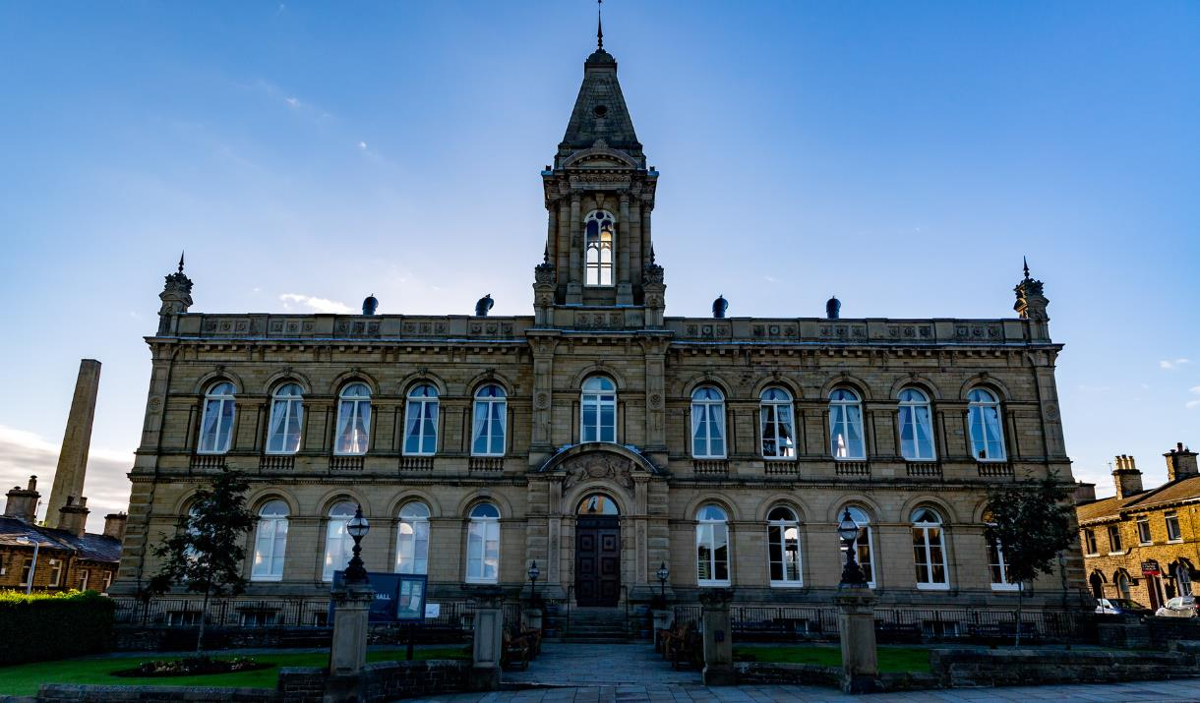

* [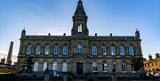](https://eu-assets.simpleview-europe.com/visitbradford/imageresizer/?image=%2Fdmsimgs%2FVictoria_Hall_Saltaire_628096612.png&action=ProductMain)

* [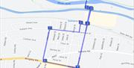](https://eu-assets.simpleview-europe.com/visitbradford/imageresizer/?image=%2Fdmsimgs%2Fsalt_2013789778.png&action=ProductMain)

**About**

Follow the Saltaire Heritage Trail, which includes 10 significant buildings and landmarks that were part of Victorian mill baron Sir Titus Salt's model village when it was established in 1851.

The heritage walk is an ideal family walk through the streets of Titus Salt’s Model Village. The walk is suitable for most reasonably fit and occasional walkers and can be accessed by wheelchair users.

***Highlights include:***

***Saltaire United Reformed Church***

***Almshouses***

***Victoria Hall***



