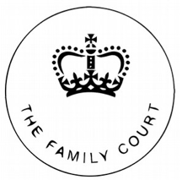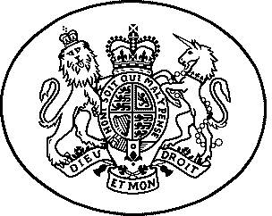

**In the Family Court sitting in the  
Carlisle Combined Court**

**General Order**

**The Matrimonial Causes Act 1973  
The Marriage of Doris Duck and Davey Duck**

**Case No: 1708940824018030**

**Order made by District Judge Mumford on 26 February 2024 SITTING AT the Family Court at the Carlisle Combined Court.**

**The parties**

1. The applicant is Doris Duck The respondent is Davey Duck

**It is ordered that**

This is a general order

Dated: 26 February 2024

Carlisle Combined Court, Courts of Justice, Earl Street, Carlisle, CA1 1DJ. Tel: 0300 303 0642, email: LancashireandCumbriaFRC@justice.gov.uk