Welsh Translation Request Form | Ref:

Please note:

All work submitted to the Welsh Language Unit must be sent to the generic email address:

welsh.language.unit.manager@justice.gov.uk

Business Hours:

Monday to Thursday 09:00-17:00 Friday 09:00-16:30

Enquiries: 01286 669 800

REMEMBER……

 Original files only  Check contents  Explain abbreviations and acronyms  Realistic timescales
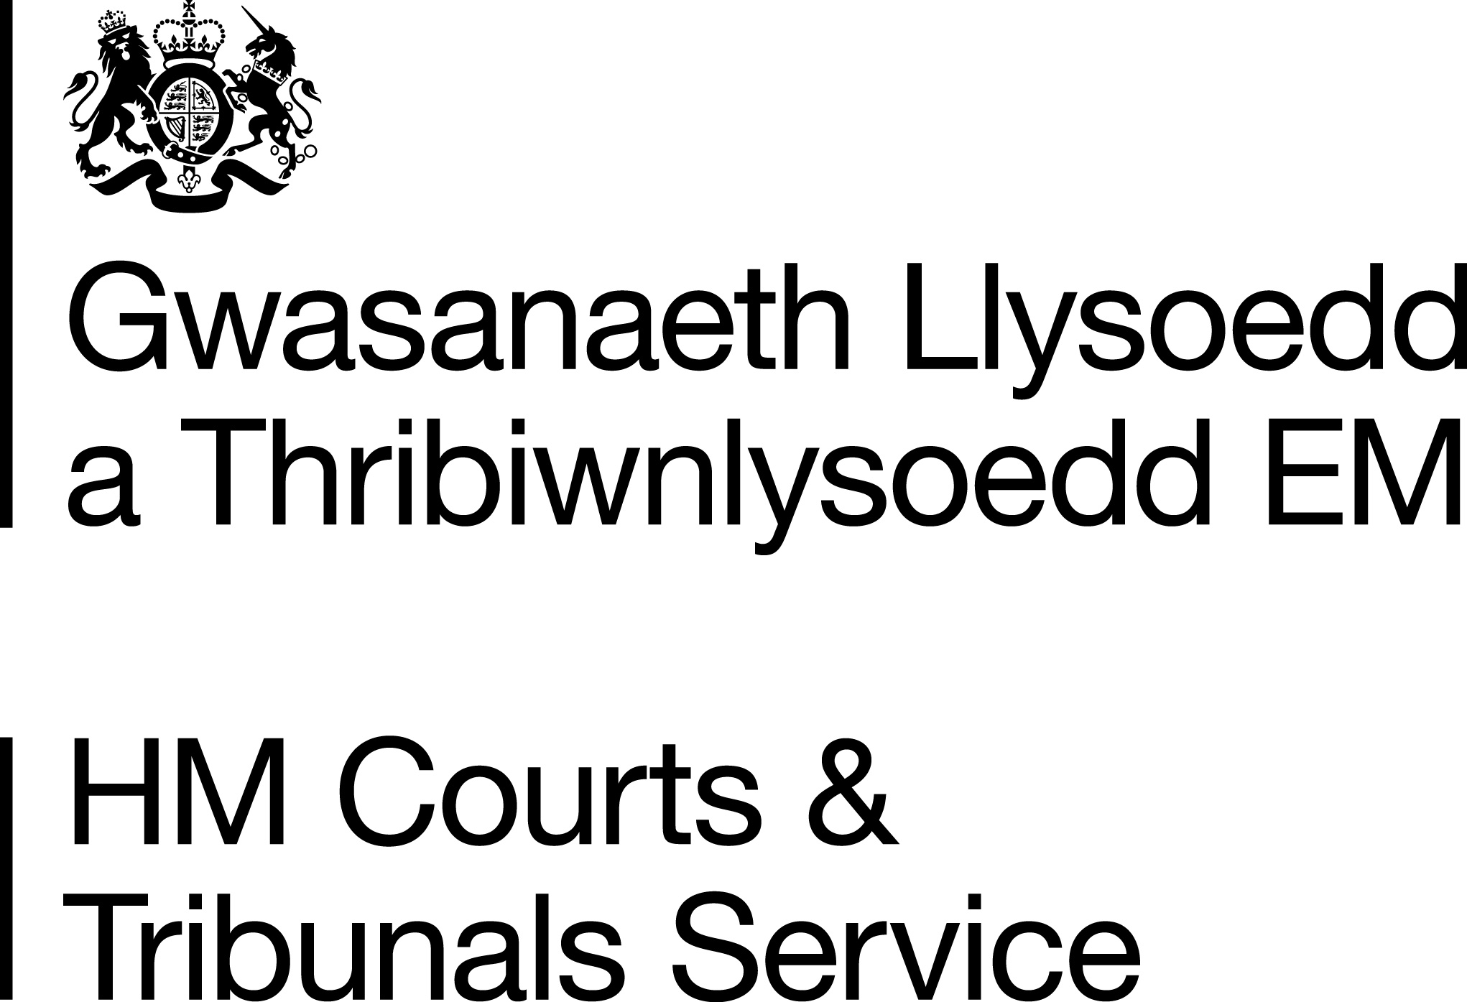
For customer use | Name | <<name>>
For customer use | Department/Office | <<department>>
For customer use | Email / Telephone number | <<contactInformation>>
For customer use |  | Case number/Ref: <<familyManCaseNumber>>
  <<cs_{(project.ctsc)}>>  <<else>>  <<es_>> | CTSC | <<cs_{(project.reform)}>>  <<else>>  <<es_>> | Reform
  <<cs_{(layout.digitalProject)}>>  <<else>>  <<es_>> | Digital Project
For customer use | Description of work | Details (please specify):  <<description>>
For customer use | Translation
  <<cs_{(translate.welshToEnglish)}>>  <<else>>  <<es_>> | Welsh  English
  <<cs_{(translate.englishToWelsh)}>>  <<else>>  <<es_>> | English  Welsh
For customer use | Layout
  <<cs_{(layout.bilingual)}>>  <<else>>  <<es_>> | Bilingual
  <<cs_{(layout.mirrorImage)}>>  <<else>>  <<es_>> | Mirror Image
  <<cs_{(layout.other)}>>  <<else>>  <<es_>> | Other
For customer use | Word count | <<wordCount>>
For customer use | Required date of return | <<dateOfReturn>>

 | Date request received:
 | Translation |  |  |  |  | Trados  No Match  ………………………
 | To be completed by: | _____ /______/_____
 | Design |  |  |  |  | ARTWORK Requested :
 | To be completed by: | _____ /______/_____
 | Proofread |  |  |  |  | Word Count =
 | To be completed by: | _____ /______/_____
 | Deadline |  |  |  |  |  | Invoice
 | Date returned to customer |  |  |  |  |  | 5PM – marked as done

WLU Guidelines

Type of Work | Turnaround Time
Libra Offences, Results and Variable Text | received before 1pm – same working day  received after 1pm – by noon the following day
Urgent free text translations sent from CTSC’s in relation to various digital work | within 24 business hours
Libra Orders & Notices, SJP, ‘Reply’ to a Jury Summons, County Court Orders | within 24 business hours
Letters and Press Notices | Within 24 business hours, but depends on current workload.
Consultation Paper | Please contact us to discuss.

- All requests must be submitted to the generic Welsh.language.unit.manager@justice.gov.uk address not to individual members of staff.
- E-mail translations - If e-mails are sent requesting a translation, we will supply a translation of up to 75 words without having to fill in our request form. If the translation content exceeds 75 words then the email will be returned to the sender attaching the request form to be filled in.
- Original files only - We cannot process PDF documents. Please send the original files in the format that the document was produced in (Word, Excel, Indesign etc.).
- Artwork Files – In order for us to produce a Welsh/Bilingual version of your work, we require all the files used to create the English version. Please supply images, document fonts etc.
- Final Versions – Unless discussed, we only accept final versions. We do not accept draft versions.
- Amendments – All amendments or changes to your work must be highlighted or show tracked changes for us to action. When requesting changes or amendments, please state the reference number provided by the Welsh Language Unit in any future correspondence.
- Explain abbreviations and acronyms – In order for us to provide a correct translation, please ensure that abbreviations and acronyms are explained and the full versions are given.
- Check content – Please ensure that you have thoroughly proofread your document prior to sending it to us. It is your responsibility to correct any spellings or grammatical errors.
- Public Consultations – the Welsh Language Unit must be consulted at an early stage to ensure that both English and Welsh versions are published simultaneously.

