PCS-frontend business flow onboarding
New joiner guide based on repository behaviour observed on 23 May 2026
This document explains PCS-frontend as a business flow rather than a code tour. It focuses on what the service is trying to achieve for court users, which external systems it relies on, how data moves between those systems, and where the current codebase still has placeholders or incomplete handoffs.
Primary user groups | Citizen defendants and legal representatives working on possession claim cases
Main business capabilities | Respond to a claim, make a general application, view dashboard/tasks, and upload or view case documents
Authoritative systems | CCD for case state, CDAM for binary files, pcs-api for access-code validation, Fee Register for fee pricing

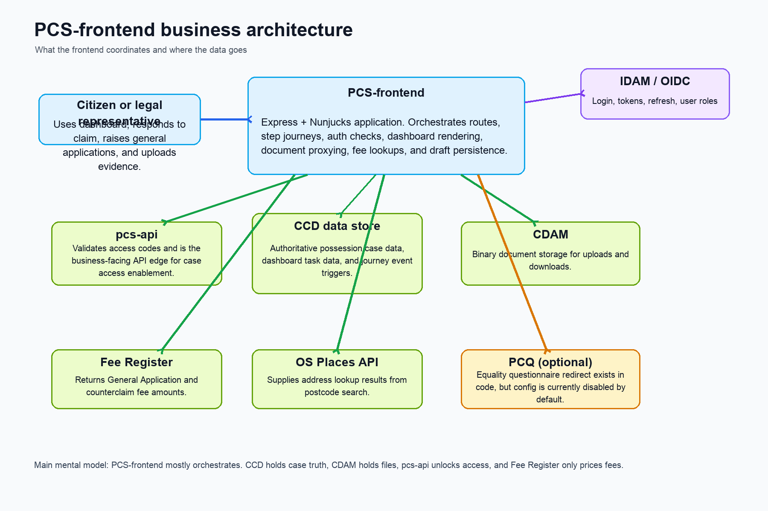

1. What PCS-frontend is responsible for
- It is the orchestration layer for possession-claim journeys. It does not own the legal case record itself.
- It decides which screens a user sees, validates user/session access, renders dashboard and forms, and turns user answers into backend-compatible payloads.
- It persists journey answers mainly by calling CCD event-trigger endpoints, so business truth is pushed into the case platform rather than retained only in browser/session state.
- It also acts as a safe proxy around document upload and download, postcode lookup, and fee lookup integrations.

2. End-to-end newcomer mental model
- A user authenticates through OIDC/IDAM and lands in the frontend with a session and access token.
- The frontend validates case access using the case reference middleware before opening a protected case journey.
- For some users, pcs-api is used first to validate an access code, which effectively unlocks the case for the user.
- Once inside a journey, the step engine decides what the next business question is based on case data and previous answers.
- Most respond-to-claim answers are saved back to CCD as draft data after each step, so the journey can resume safely and can branch based on authoritative case state.
- Supporting actions such as document upload, document download, fee lookup, and postcode lookup are delegated to specialist services.
- The dashboard is effectively the front door into active work. It is built from task and notification data returned from CCD dashboard event triggers.

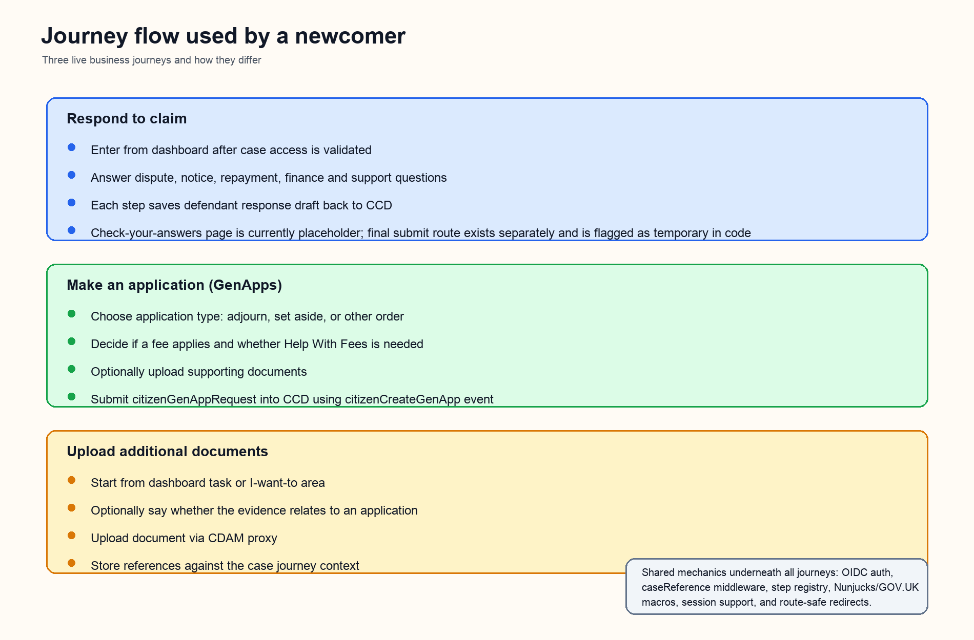

3. The three business journeys

Respond to claim
This is the largest and most business-rich journey. A user arrives from the case dashboard after case access has been confirmed. The journey then asks the defendant to confirm or correct the claim context and capture their response. The step flow branches heavily based on existing case facts coming from CCD, for example whether the property is in Wales, whether notice was served, whether tenancy dates are known, whether the case contains rent arrears grounds, and whether a counterclaim is being made.
- Business themes covered: identity/contact details, tenancy details, notice details, dispute position, counterclaim, repayment/payment agreements, household and finance circumstances, support needs, equality/diversity, and final review.
- Persistence model: `useSessionFormData` is disabled for this journey, so the main intent is CCD-backed draft persistence rather than session-only storage.
- Draft save mechanism: helpers such as `saveDraftDefendantResponse` call CCD validate/update draft APIs and then refresh `validatedCase` in memory so later routing uses the updated truth.
- Document uploads inside this journey are treated specially: files go to CDAM, and the returned references are saved into the possession-claim response structure in CCD.
- Current-state note: the `check-your-answers` template is still a placeholder, and the separate `/final-submit` route is explicitly labelled in code as a temporary testing route.

Make an application (GenApps)
This journey lets a user raise a general application against an existing possession case. The user chooses what they want the court to do, whether a fee applies, whether Help With Fees is needed, whether the application should be shared with other parties, what order is being requested, and whether supporting documents should be attached. At the end, the frontend packages the journey into a `citizenGenAppRequest` payload and submits it to CCD using the `citizenCreateGenApp` event.
- Application types currently modelled: adjourn the hearing, set aside the order, or ask the court to make another order.
- Fee logic is conditional. The app uses Fee Register lookups to show fee amounts and guidance, especially for general applications and counterclaims.
- Supporting documents for GenApps are session-backed until submission, then included in the CCD request payload.
- Current-state note: the button copy can say “Continue to payment”, but this repository shows fee awareness and CCD submission logic rather than a fully wired payment-service handoff. That is an implementation inference from the codebase, not a business-policy statement.

Upload additional documents
This is a shorter supporting journey used when the user needs to add more evidence after the main case exists. It starts from the dashboard or “I want to” area, optionally asks whether the evidence relates to an application, and then accepts document uploads through the frontend proxy into CDAM-backed storage.
- Purpose: operational evidence upload rather than full claim response capture.
- Routing is lighter than the other journeys, but the same auth and case-validation guardrails apply.

4. Integration map and why each dependency exists
Integration | Why PCS-frontend calls it | Key observed behaviour | Business impact
OIDC / IDAM | Authenticate users and refresh access tokens | Protected routes use `oidcMiddleware`; near-expiry tokens are refreshed automatically | Users stay signed in and protected routes can trust access tokens
pcs-api | Validate access codes against a case | POST `/cases/{caseId}/validate-access-code` returns success/failure and is used before starting respond-to-claim for access-code users | Unlocks case participation for users who need a code before they can respond
CCD data store | Read case data, fetch dashboard task data, save drafts, and submit events | Uses START -> SUBMIT event-trigger pattern such as `respondPossessionClaim`, `dashboardView`, and `citizenCreateGenApp` | Acts as the authoritative possession case system
CDAM | Store and stream uploaded documents | Upload, delete, and binary download are proxied through frontend routes rather than exposing storage URLs directly | Keeps evidence handling controlled and tied to the user session/case context
Fee Register | Calculate court fees | Calls `/fees-register/fees/lookup` with configured fee keywords for general applications and counterclaims | Explains fee consequences and supports Help With Fees decisions
OS Places API | Look up addresses from a postcode | Frontend exposes an auth-protected postcode lookup endpoint and formats OS results into UI-friendly address lines | Improves address entry quality and reduces manual error
PCQ | Potential redirect into equality questionnaire | Code exists for health-check + redirect + draft update, but config has PCQ disabled by default | Optional future onboarding point, not active by default in current config
HMCTS common UI components | Render consistent shared header/footer patterns, especially for legal representatives | Legal-rep pages use `@hmcts-cft/cft-ui-component-lib` plus GOV.UK and MOJ macros | Keeps experience aligned with wider HMCTS interface conventions

5. Data ownership: what lives where
Data type | Primary store | How PCS-frontend uses it | Why it matters
Authenticated user identity and tokens | Session + OIDC provider | Session carries access/refresh/id tokens and user roles | Needed before any protected case action can happen
Case truth and dashboard tasks | CCD | Case middleware hydrates `validatedCase`; dashboard uses CCD dashboard event trigger data | Routing decisions and task visibility depend on this truth
Respond-to-claim draft answers | CCD draft via update/validate APIs | Each step updates possession-claim draft structures and refreshes the case model | Supports resume, branching, and backend alignment
General application draft answers | Session until final submission, then CCD | Step builder stores journey answers, then `citizenGenAppRequest` is posted to CCD at check-your-answers | Lets the app collect a compound request before submission
Uploaded document binaries | CDAM | Frontend uploads/deletes/streams files via proxy routes | Binary evidence is stored outside CCD payload bodies
Uploaded document references | CCD or session depending on journey | Respond-to-claim stores references in CCD-backed defendant documents; GenApps keeps them in a session bucket until submit | Important difference for debugging and user recovery
Fee amounts | Fee Register response | Looked up on demand using configured fee keywords | Used to explain costs, not to author case truth

6. Shared platform mechanics that a new joiner should know
- Journey registration is centralised. `journeyRegistry` defines all journeys, and `registerAllJourneys` mounts them automatically.
- The step engine is shared. A route is really a configured step definition plus a flow config, not a one-off controller per page.
- Branching usually comes from `showCondition` functions that inspect the hydrated CCD case model.
- The frontend uses GOV.UK and MOJ macros heavily for standard page furniture, and overlays HMCTS CFT component-library headers/footers for legal-representative scenarios.
- Safe redirect helpers are used widely to prevent open redirect issues when users move between dashboard and journeys.
- Case access is enforced twice in practice: the user must be authenticated, and the case reference middleware must be able to retrieve the case through CCD event-trigger access validation.

7. Route-to-business meaning map
Route area | Business meaning | Implementation note
`/dashboard/:caseReference` | Primary worklist and navigation hub for a case | Driven by CCD dashboard task/notification data plus “I want to” links
`/case/:caseId/access-code` | Entry point for users who need to unlock claim-response access | Calls pcs-api validation before redirecting into respond-to-claim
`/case/:caseReference/respond-to-claim/...` | Main defendant response journey | Most business complexity sits here
`/case/:caseReference/make-an-application/...` | General application journey | Builds and submits `citizenGenAppRequest`
`/case/:caseReference/upload-additional-documents/...` | Evidence upload support journey | Shorter, task-driven workflow
`/case/:caseReference/view-documents` | Read-only view of structured case documents | Uses validated case data plus CDAM binary streaming
`/case/:caseReference/view-hearing-documents` and `/view-orders-and-notices` | Future-facing case document pages | Currently simple render routes rather than rich data workflows
`/case/:caseReference/final-submit` | Temporary separate final-submit path for claim response | Code comments explicitly say temporary testing route

8. Honest current-state notes for a new joiner
- The business intention is stronger than some page implementations. A few pages are placeholders or shell routes even though the wider journey structure is clearly defined.
- Respond-to-claim final review/submission is not yet presented as a polished end-to-end production flow in this repository snapshot. The placeholder check-your-answers template and temporary final-submit route are the strongest signals.
- PCQ integration should be read as dormant capability. The middleware exists, but default config disables it.
- “Fee and pay” in the current code is primarily fee discovery and fee guidance. I did not find a full outbound payment-service integration in this repository snapshot.
- Legal-representative experience has explicit shared-component integration and a slightly different step ordering, so testing both user types matters.

9. The shortest way to explain PCS-frontend to the next new joiner
PCS-frontend is the orchestration layer for possession-claim self-service work. It authenticates the user, validates they can access a case, asks them the right questions in the right order, and pushes their answers into the case platform. CCD is the source of case truth, CDAM stores uploaded files, pcs-api handles access-code validation, Fee Register prices fee-related actions, and the frontend mainly coordinates all of that into a journey a user can complete safely.
If you remember only one thing, remember this: the frontend is not the case system. Its job is to make the business process navigable while keeping the user, case, and supporting integrations in sync.

