PCS-frontend CI/CD onboarding guide
New joiner explanation of GitHub flow, Jenkins pipelines, E2E execution, and environment-variable wiring
This guide explains the delivery system around PCS-frontend as a new engineer would need to understand it on day one. It is based on the repository files available here: Jenkinsfiles, package scripts, Playwright config, test setup code, and Helm values. Where the HMCTS shared Jenkins library owns implementation details, I call those points informed inference rather than pretending this repository shows everything.
Primary CI/CD engine | Jenkins using HMCTS shared pipeline library, not GitHub Actions
Main delivery paths | PR preview flow, master/AAT flow, scheduled nightly matrix, optional Sauce cross-browser matrix
Main test technologies | Jest for unit/contract tests, Playwright for UI and E2E journeys, Allure/JUnit for reporting, Pact for consumer contracts
Most important practical idea | Environment variables and PR labels materially change what gets deployed, what backend is targeted, and which tests run

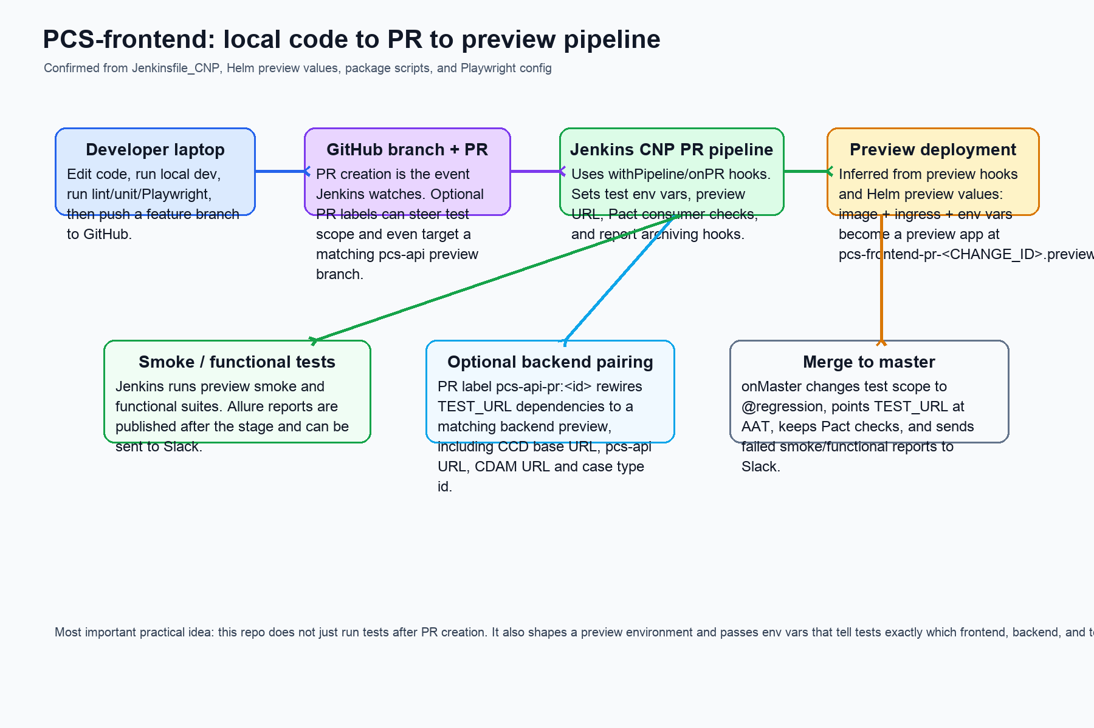

1. The high-level delivery model
PCS-frontend follows a GitHub-to-Jenkins delivery model. Developers work locally on a branch, push that branch to GitHub, and open a pull request. Jenkins then runs the PR-oriented CNP pipeline declared in `Jenkinsfile_CNP`. That pipeline sets preview-specific environment variables, triggers tests against a preview deployment, and publishes reports. After merge, the same repository switches into master/AAT behaviour with a different test scope and Slack-reporting behaviour.
- This repo strongly suggests preview environments per PR because `TEST_URL` is set to `https://pcs-frontend-pr-${CHANGE_ID}.preview.platform.hmcts.net`.
- Preview deployment details are partly inferred because the shared `Infrastructure` library owns some pipeline stages, but the repo clearly provides preview Helm values and preview URLs.
- Master builds target AAT by setting `TEST_URL` to `https://pcs.aat.platform.hmcts.net/` and `E2E_TEST_SCOPE` to `@regression`.

2. Local developer flow before a PR exists
A new joiner should think of local work in two layers: application execution and confidence checks.
- Application execution: `yarn start:dev` starts the app with docker dependencies; `yarn start:dev:pcs-local` points the frontend at a locally running pcs-api stack; `USE_VAULT=false` can be used when working offline.
- Code confidence: `yarn lint`, `yarn test:unit`, `yarn test:functional`, `yarn test:smoke`, or `yarn test:E2e` are the main repo-level test scripts.
- Husky/lint-staged are present, so developers should expect formatting and linting pressure before code reaches shared branches.
- Environment setup matters locally too. The README and config files show local tests still need values such as `TEST_URL`, `PCS_FRONTEND_IDAM_SECRET`, `PCS_API_URL`, and `DATA_STORE_URL_BASE`.

3. What happens when code becomes a PR
Once a feature branch becomes a pull request, Jenkins CNP logic takes over. The on-PR branch of `Jenkinsfile_CNP` sets environment variables, optionally reads labels from GitHub, and hooks into preview test/report stages.
- `NODE_CONFIG_ENV` is forced to `test`, so the application and test helpers resolve test-oriented config values.
- Core service URLs are injected for the PR run: `PCS_API_URL`, `DATA_STORE_URL_BASE`, `CDAM_URL`, `XUI_BASE_URI`, and `CASE_TYPE_ID`.
- `TEST_URL` is pointed at the PR preview hostname using the Jenkins `CHANGE_ID`.
- Pact consumer checks are enabled in PR mode through the shared pipeline DSL.
- Allure output is cleared before functional and full-functional preview stages, and reports are archived after smoke/functional/full-functional stages.

4. PR labels that change pipeline behaviour
This project uses GitHub labels as an operational control surface. That is a very practical detail for a new joiner because it means you can influence a PR pipeline without changing code.
Label pattern | Effect | Why it matters
`e2e-tag:<tag>` | Overrides `E2E_TEST_SCOPE` | Lets the PR run a tag such as `@smoke`, `@PR`, or another chosen slice instead of the default
`e2e-spec:<text>` | Sets `E2E_SPEC` | Narrows Playwright to spec files whose paths contain the keyword(s)
`enable_all_page_functional_tests` | Sets `ENABLE_ALL_PAGE_FUNCTIONAL_TESTS=true` | Turns on multiple validation categories in Playwright config
`enable_content_validation` / `enable_visibility_validation` / `enable_error_messages_validation` / `enable_navigation_tests` | Sets matching booleans to true | Lets the PR opt into deeper page-functional coverage
`pcs-api-pr:<id>` | Rewires backend-related URLs to a matching pcs-api preview branch | Critical when frontend work depends on backend changes that are not yet in shared AAT services

5. How preview deployment is wired for a PR
The repo’s preview Helm values show how the deployed preview app is parameterised. This is how a newcomer should picture it: Jenkins builds or selects an image, passes service URLs into Helm values, and publishes the preview app under a PR-specific ingress host.
- `values.preview.template.yaml` injects `IMAGE_NAME`, `SERVICE_FQDN`, `PCS_API_URL`, `CDAM_URL`, `CCD_URL`, `CASE_TYPE_ID`, and `XUI_BASE_URI`.
- That tells us preview deployments are not hard-coded to a single backend. Jenkins can swap those URLs per PR, especially for frontend/backend paired change testing.
- The normal shared values file also shows production-style env var names such as `PCS_API_URL`, `CCD_URL`, `OIDC_REDIRECT_URI`, `OIDC_ISSUER`, `FEE_SERVICE_URL`, and `CDAM_URL`.

6. The E2E execution model
PCS-frontend E2E is more than “open browser and click around”. The repository uses Playwright setup phases and API helpers to prepare data and tokens first, then the browser journey runs on top of that prepared state.
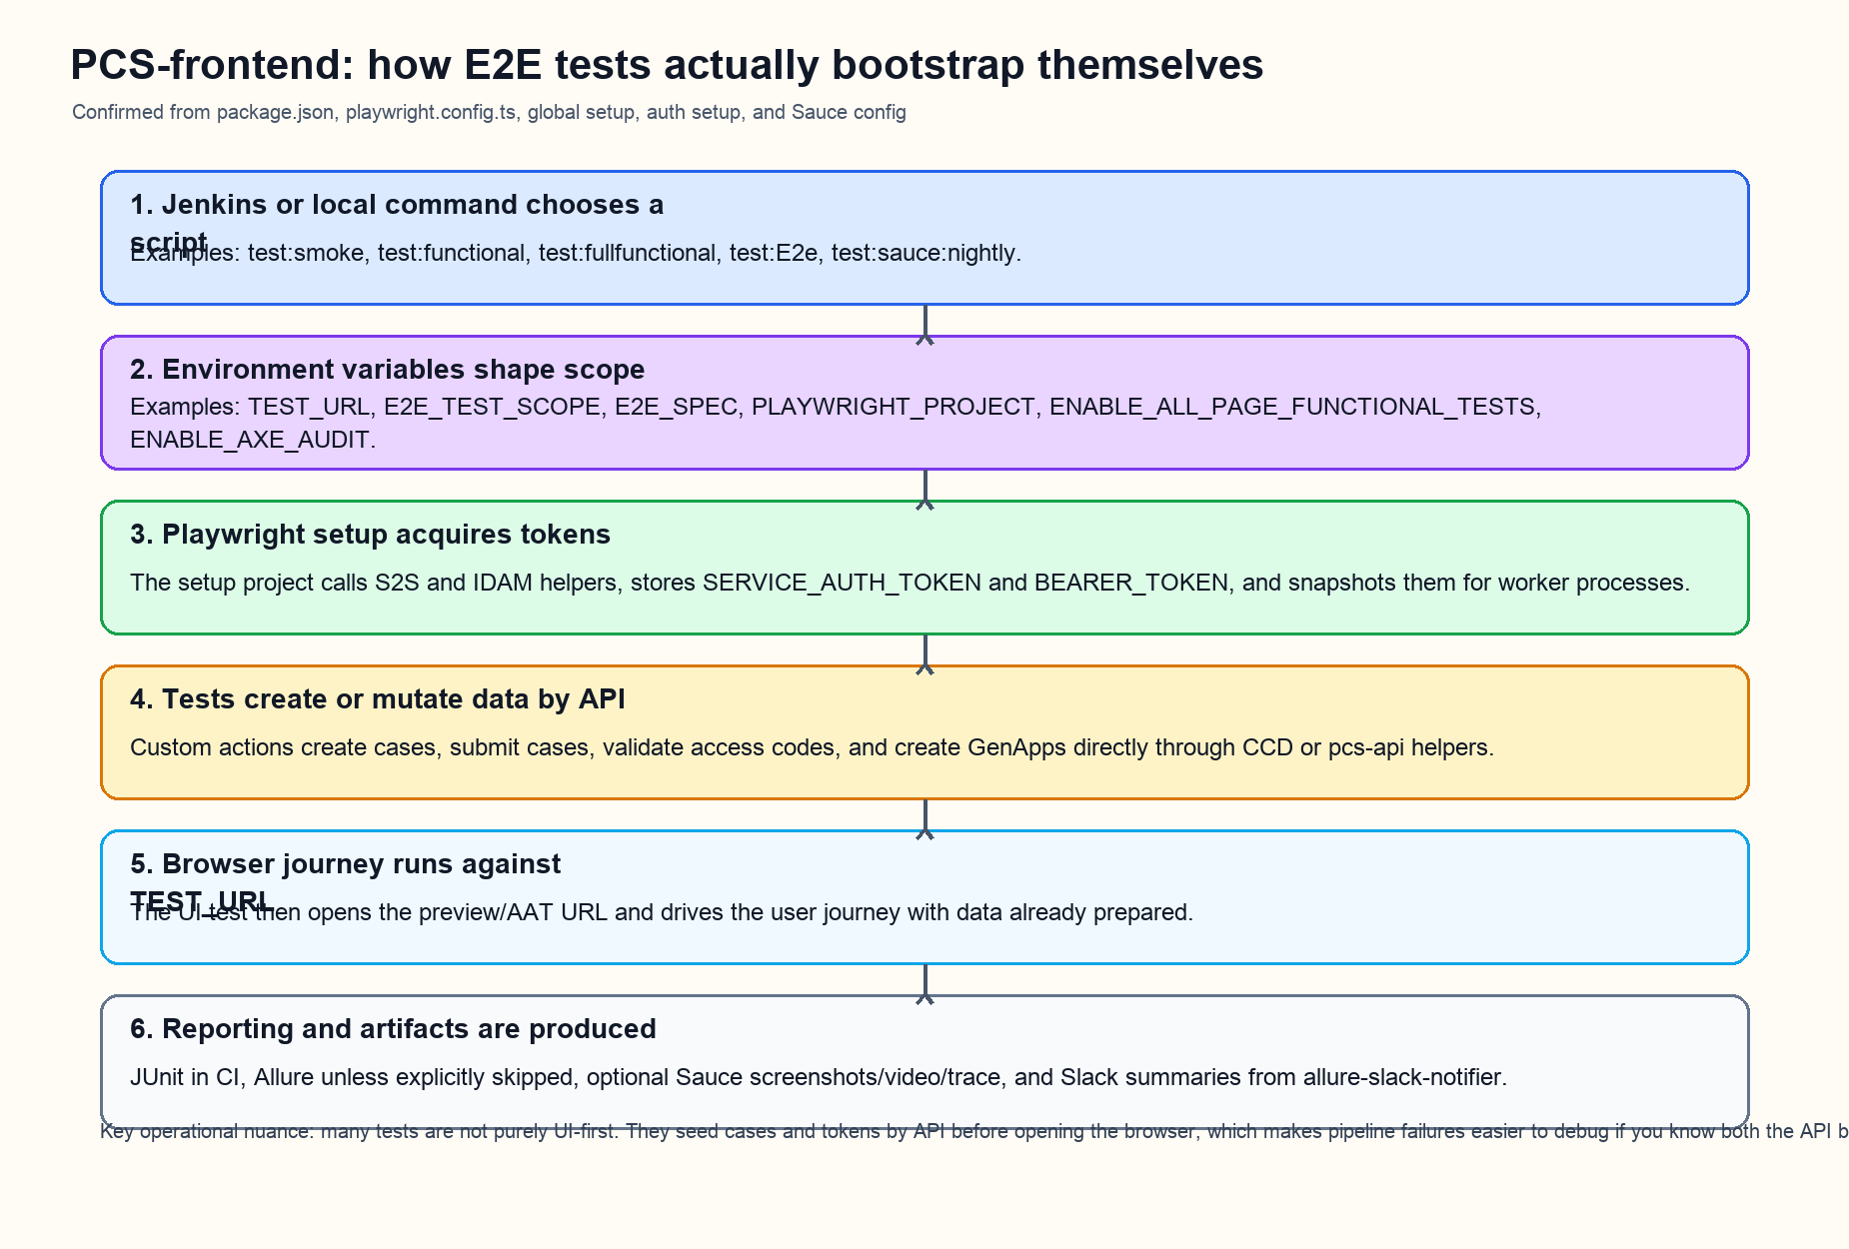
- `playwright.config.ts` reads env vars to decide which test files to include, which tag grep to apply, which browser project to run, whether to capture Allure, and whether to enable extra page-functional validations.
- The Playwright `setup` project runs first. `auth.setup.ts` obtains S2S and IDAM tokens and snapshots them into `src/test/ui/.auth/setup-env.json` for worker reuse.
- `global-setup.config.ts` derives environment-specific IdAM/S2S/DM URLs from `ENVIRONMENT` when needed, which is especially relevant in nightly runs across `aat`, `demo`, `perftest`, and `ithc`.
- Many tests seed case data by API before opening the UI. For example, helpers create cases, submit cases, validate access codes, and create general applications directly against API endpoints.

7. The most important environment variables for E2E
Variable | Who sets it | What it controls | Practical meaning
`TEST_URL` | Jenkins PR/master/nightly or local shell | Base frontend URL under test | The browser opens this host for all UI journeys
`NODE_CONFIG_ENV` | Jenkins or local shell | Config profile | Usually `test` in pipelines; local `pcs-local` can point to local backend
`E2E_TEST_SCOPE` | Jenkins, PR label, or local shell | Playwright grep tag | Chooses slices like `@PR`, `@regression`, `@nightly`, or custom tags
`E2E_SPEC` | Jenkins or local shell | Spec path filtering | Runs only tests whose file names match the provided keywords
`PLAYWRIGHT_PROJECT` | Nightly matrix stage or local shell | Browser/device project | Examples: `chrome`, `firefox`, `webkit`, `edge`, `mobile-ios`
`ENABLE_ALL_PAGE_FUNCTIONAL_TESTS` | PR label or nightly parameter | Master switch for extra validation modes | If true, Playwright config turns on multiple sub-flags automatically
`ENABLE_CONTENT_VALIDATION` / `ENABLE_VISIBILITY_VALIDATION` / `ENABLE_ERROR_MESSAGES_VALIDATION` / `ENABLE_NAVIGATION_TESTS` | PR labels or inherited from all-page flag | Specific page-functional validation categories | Useful when debugging a narrow class of page regression
`ENABLE_AXE_AUDIT` | Nightly parameter | Accessibility audit execution | Controls whether axe auditing participates in E2E runs
`PCS_API_URL`, `DATA_STORE_URL_BASE`, `CDAM_URL`, `XUI_BASE_URI`, `CASE_TYPE_ID` | Jenkins or Helm | Backend topology under test | These decide which backend landscape the frontend and API bootstrap helpers will hit
`PCS_FRONTEND_IDAM_SECRET`, `IDAM_PCS_USER_PASSWORD`, `IDAM_PCS_USER_PASSWORD_B64` | Azure Key Vault via Jenkins | Authentication into test helper services | Without these, token bootstrap and login flows cannot succeed
`ENVIRONMENT` | Nightly pipeline | Derived infra URL family | Lets setup code build AAT/demo/perftest/ITHC IdAM/S2S/DM URLs when explicit values are absent
`PLAYWRIGHT_SKIP_ALLURE` and `PLAYWRIGHT_SAUCE_FULL_JOURNEY_ARTIFACTS` | Sauce config | Reporting/artifact behaviour | Sauce skips Allure and forces richer artifact capture

8. How package scripts map to pipeline behaviour
Script | What it really does | Where it is used
`yarn test:smoke` | Runs Playwright in Chrome with `@health` grep and produces Allure | PR/master smoke stages
`yarn test:functional` | Runs Chrome Playwright with `E2E_TEST_SCOPE` grep and produces Allure | PR/master functional stages
`yarn test:fullfunctional` | Runs all Chrome Playwright specs with no grep narrowing | PR full-functional preview stage
`yarn test:E2e` | Installs Playwright browsers, then runs one chosen Playwright project and produces Allure | Nightly matrix browser/device stages
`yarn test:sauce:nightly` | Runs SauceCTL using `.sauce/config-sauce-nightly.yml` | Cross-browser nightly/cloud runs
`yarn test:pact` and `yarn pact:publish` | Run and publish consumer contracts | Pact consumer flow enabled by Jenkins pipeline
`yarn fortifyScan` | Runs the Java-based Fortify wrapper | Nightly pipeline enables Fortify scanning

9. Master / AAT behaviour after merge
When code is merged, `Jenkinsfile_CNP` switches into `onMaster()` behaviour. This matters because the same repository starts behaving like a shared-environment guardian rather than a PR-isolation pipeline.
- `E2E_TEST_SCOPE` becomes `@regression`.
- `TEST_URL` becomes the AAT hostname rather than a preview host.
- Functional and smoke results are still archived, and failures or unstable results trigger Slack notifications using `allure-slack-notifier.ts`.
- This is the closest thing in-repo to “post-merge safety net” behaviour.

10. Nightly pipeline model
`Jenkinsfile_nightly` is the repo’s scheduled and parameterised confidence pipeline. It is much more configurable than the PR flow and is designed to teach a new joiner how this team broadens coverage outside the default PR path.
- A cron trigger runs on weekdays using Jenkins `H 07 * * 1-5`.
- The nightly pipeline accepts parameters for target environment, Playwright spec filter, grep tag, page-functional switches, axe auditing, browser/device toggles, and Sauce cross-browser suites.
- It derives `ENVIRONMENT`, `TEST_URL`, `E2E_TEST_SCOPE`, and `E2E_SPEC` from those parameters.
- It then runs E2E per selected browser/device by setting `PLAYWRIGHT_PROJECT` for each stage.
- If Sauce suites are selected, the pipeline populates `SAUCE_SUITE_NAMES` and enables cross-browser cloud execution.
- Nightly also enables Fortify scanning and Slack notifications to `#pcs-tech` / `#hdp-qa-e2e-test-results` depending on stage type.

11. Sauce cross-browser flow
Sauce is handled as a deliberate second path, not as the same thing as the local/Jenkins VM Playwright run.
- `.sauce/config-sauce-nightly.yml` pins a Playwright version supported by Sauce, sets `CI=true`, injects test/service secrets, and enables rich journey artifacts such as screenshots, video, and traces.
- The shell wrapper `src/test/ui/sauceCrossbrowser/sauce-run.sh` loops across `SAUCE_SUITE_NAMES` if Jenkins selected multiple suites.
- Because Sauce sets `PLAYWRIGHT_SKIP_ALLURE=true`, the reporting profile is intentionally different from the normal Jenkins VM path.
- The suite names in Sauce config must stay aligned with `selectedSauceSuites()` in `Jenkinsfile_nightly`, which is a practical maintenance trap a new joiner should remember.

12. Contract testing and security scanning
This repo’s CI/CD is not just UI regression. It also includes contract and security concerns.
- Pact consumer tests live under `src/test/contract/consumer`.
- Pact publication uses the current Git short SHA as the consumer version and a branch-derived tag when publishing to the pact broker.
- PR and master flows enable Pact consumer roles through the shared pipeline DSL.
- Nightly enables Fortify scanning using the Java wrapper script.

13. How a new joiner should debug pipeline failures
- If the browser test fails very early, inspect setup-token generation first. The failure may be in S2S or IDAM bootstrap before any page is opened.
- If the UI points at the wrong data or backend behaviour, inspect `TEST_URL`, `PCS_API_URL`, `DATA_STORE_URL_BASE`, `CDAM_URL`, and `CASE_TYPE_ID` first.
- If a PR behaves differently from local runs, compare PR labels because labels can change test scope and backend pairing.
- If only one subset of tests ran, inspect `E2E_TEST_SCOPE`, `E2E_SPEC`, and `PLAYWRIGHT_PROJECT`.
- If Sauce results differ from Jenkins VM results, remember the execution profile differs: Sauce uses different Playwright versioning, artifact settings, and cloud browsers.
- If page-functional validations suddenly appear, check `ENABLE_ALL_PAGE_FUNCTIONAL_TESTS` or the individual validation flags.

14. The shortest practical explanation for the next new joiner
Your local code becomes meaningful to the platform when you push a branch and open a PR. That PR triggers Jenkins, which may deploy a preview app, wire the app to a chosen backend topology, and then run selected Playwright/Jest/Pact checks. The test suite is highly environment-driven: URLs, test tags, spec filters, browser projects, and feature-like validation flags are all injected by pipeline environment variables or PR labels. If you understand that control plane, you will understand most of the repo’s CI/CD behaviour.
The best mental model is this: GitHub carries the change, Jenkins decides the execution path, Helm/environment variables define the target topology, setup code obtains tokens and data, and Playwright finally exercises the user journeys.

