

Department for Constitutional Affairs

Document

CCBC – MCOL Update

Version 1.5

30th August 2006



Statement of Confidentiality

This document is proprietary to Electronic Data Systems Limited, (EDS), its parent company Electronic Data Systems Corporation and any of that corporation’s subsidiaries. The document is supplied in confidence and except for the purpose of evaluation by the Department should not be disclosed or otherwise revealed to outside parties without the prior written consent of EDS.
These limitations are commercial in nature and are not in any way intended to restrict continuing business between the Department and EDS.

Copyright

Copyright in this work is vested in EDS and the document is issued in confidence for the purpose only for which it is supplied. It must not be reproduced in whole or in part or used for tendering or manufacturing purposes except under an agreement or with the consent in writing of EDS and then only on the condition that this notice is included in any such reproduction. No information as to the contents or subject matter of this document or any part thereof arising directly or indirectly there from shall be given orally or in writing or communicated in any manner whatsoever to any third party being an individual firm or company or any employee thereof without the prior consent in writing of EDS.

-EDS is a registered mark and the EDS logo is a trademark of Electronic Data Systems Corporation.
-EDS is an equal opportunity employer and values the diversity of its people.

Copyright ©2005 Electronic Data Systems Corporation. All rights reserved.

DOCUMENT AUTHORISATION

DOCUMENT TITLE
DOCUMENT REFERENCE | ISSUE

 | NAME | SIGNATURE | DATE
AUTHORS | Wael khalil |  | 30-08-06
REVIEWERS | Rania M.Abdel Azim
AUTHORISED BY

Overview

The circuit is designed to
- At 8.00am MCOL executes the existing load functions. These update the CODE_CREDITORS table (for the CODE 1999), and insert rows into the TAPES table (one for judgements and one for warrants) and rows into the TAPE_FILES table (one for judgements and one for warrants). It then inserts rows in the LOAD_JUDGEMENTS table (for a judgement load) and the LOAD_WARRANTS table (for a warrant load).

- At 7.00pm a PolarLake XML circuit will be executed. This will take the data that has been inserted earlier in the morning in the Media Centre database and copy it across to the SUPS CCBC database. The data will be taken across exactly as it is, certain sequence number will need to be regenerated in order to be relative to the SUPS CCBC database. Finally, the STATUS column of the TAPE_FILES table in the Media Centre database will be set to “T” to indicate that the data has been transferred to SUPS.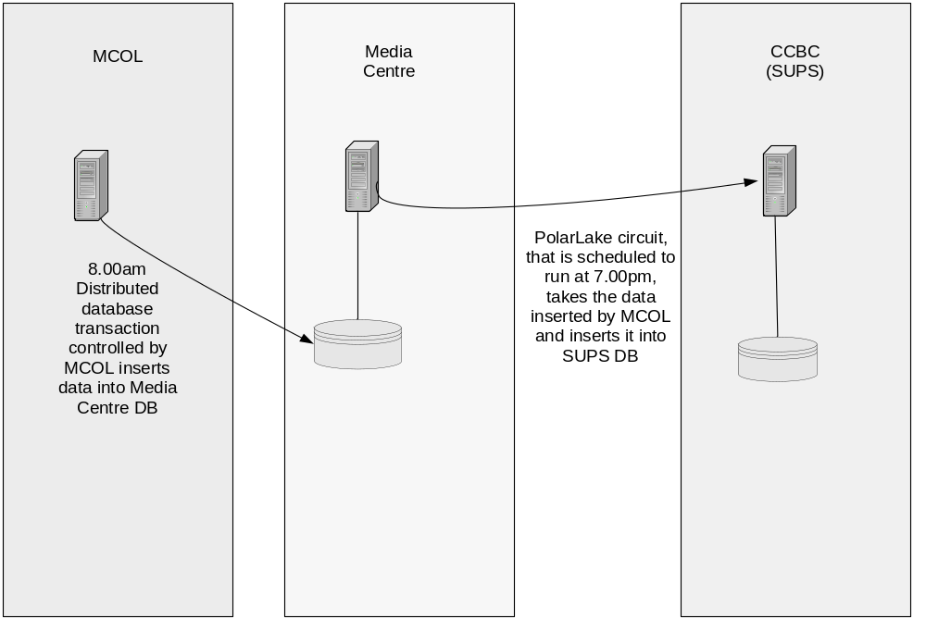

Pre-requisites:

Props File:
- All environment variables which are used in the circuit, should be defined in the props file(which is located in properties folder), like:
  - ccbc_home: which represents the home directory of caps system.
  - DB variables: like the user names and passwords, the connect string,..
  - ccbc_load_judgments_xmlt_port: the XMLT port of the load_judgments circuit to which the startup.xml file will be sent ( and ccbc_load_warrants_xmlt_port which represents the XMLT port of the load_warrants circuit).
  - ccbc_load_judgments_xmlt_boot_port: the XMLT port of the the load_judgments boot circuit, into which the shutdown command will be sent to shut the circuit down (and ccbc_load_warrants_xmlt_boot_port which represents the XMLT port of the load_warrants circuit).
  - snmp_address and snmp_port: the host address to which the exception message will be sent when a fatal error occurs
Start the circuit:
- To start the load_judgments circuit, you have first to define the variable ccbc_circuits_home found in the start_mcol_load_judgments_bootcircuit.sh shell script, which represents the ccbc home directory(and the same for start_mcol_loadwarrants_bootcircuit.sh for load_warrants circuit)
- Then run the start_mcol_load_judgments_bootcircuit.sh to start load_judgments (and start_mcol_load_warrants_bootcircuit.sh for load-warrants).

Circuit Side:
- take the data that has been inserted earlier in the morning in the Media Centre database and copy it across to the SUPS CCBC database. The data will be taken across exactly as it is, certain sequence number will need to be regenerated in order to be relative to the SUPS CCBC database. Finally, the STATUS column of the TAPE_FILES table in the Media Centre database will be set to “T” to indicate that the data has been transferred to SUPS.

Implementation

CCBC_MCOL_Load_Judgements.cir

The circuit is implemented as follows:
- In the main view, JOB:

1.1 In the Exception sequence:
- Print message component: to print a message if there is an exception.
- Add Process Variable component: to send a X to the send heart beat view.
- PolarLake Interpreter component : which will run the send heart beat view.
- SNMP Trap component : to send a SNMP signal if there is a fatal error occurred to a server defined by the variable {pl$snmp_address} on port {pl$snmp_port} which defined in the .props file of the system.
- JDOM Processor component: to ensure sending of the snmp trap to the server.
- Run Script component : to print the output exception if an exception occurred.
- PolarLake Interpreter components : which will run the shutdown_circuit view .

1.2 In the shutdown sequence:
- Print message component: to print a message if a shutdown message is send to the main view.
- Add Process Variable component: to send a F to the send heart beat view.
- A PolarLake Interpreter components : which will run the send heart beat .
- Retrieve Document component : which will retrieve the XML file shutdown_command.xml using FILE Retrieve component , to send a shutdown X-path to the shutdown sequence in the JOB view .
- Send to Channels component: which will send the retrieved XML command to the boot circuit port which declared by the following variable ccbc_load_judgements_boot_xmlt_port.

1.3 In the JOB sequence:

- Print message component: to print a message when the circuit start processing.
- 2 DB Start components : which will start the legacy and the casm databases.
- Add Process Variable component: to send a S to the send heart beat view.
- PolarLake Interpreter component : which will run the send heart beat view.
- 2DB SQL components: the first to select the sequences from legacy DB and map it to a process variable named LAST_JG_SEQ, the second DB SQl selects tapes and TAPE_FILES records from legacy DB and map the output to the global circuit schema MCOL.
- PolarLake Interpreter component : which will run the BATCH view.
- 2 DB Commit components : which will commit the changes done in the legacy and casm databases
- Retrieve Document component : which will retrieve the XML file shutdown_command.xml using FILE Retrieve component , to send a shutdown X-path to the shutdown sequence in the JOB view .
- Send to Channels component: which will send the retrieved XML command to the boot circuit port which declared by the following variable ccbc_load_judgements_xmlt_port.
- In BATCH View:

- Print message component: to show the status.
- Add Process Variable component: to send a S to the send heart beat view.
- 3 PolarLake Interpreter components : which will run the Update_National_Coded_Parties ,LOAD_JUDGEMENTS and the send heart beat views .

- In Update_National_Coded_Parties View:

- Print message component: to show the status.
- Add Process Variable component: to send a S to the send heart beat view.
- PolarLake Interpreter component : which will run the send heart beat view.
- DB Stored procedure component : to run the SET_SUPS_APP_CTX
- DB Update component: which will update the LAST_JG_SEQ record in the NATIONAL_CODED_PARTIES table using the global circuit schema MCOL.
- DB SQL: which selects rows from tapes and tapes_files.
- PolarLake Interpreter component : which will run the Tape_Tapes_files_insertion view.
- In TAPES_TAPE_FILES INSERTION View:

- Print message component: to show the status.
- Add Process Variable component: to send a S to the send heart beat view.
- PolarLake Interpreter component : which will run the send heart beat view.
- 3 DB SQL component: which will select next value from tapes_sequence and tapes_files_sequnce, inserts into tapes and tape_files.

- In LOAD_JUDGEMENTS View:

- Print message component: to show the status.
- DB SQL component: which will select some rows from LOAD_JUDGMENTS table in the legacy DB using the global circuit schema MCOL to store the selected rows.

- DB Insert component : which will insert the selected rows in the previous step in the table LOAD_JUDGMENTS in the casm DB using the global circuit schema MCOL .

- 2 PolarLake Interpreter component : which will run the UPDATE_CLAIMANT_ADDRESSES ant the UPDATE_CLAIMANT_SOLICITOR_ADDRESSES views
- 2 DB SQL component: which will update the STATUS record in the TAPE_FILES table .

- In UPDATE_CLAIMANT_ADDRESSES View :
- Print message component: to show the status.
- Add Process Variable component: to send a S to the send heart beat view.
- PolarLake Interpreter component : which will run the send heart beat view.
- Add Process Variable component: to set the variables vn_addr_id and vn_party_id .
    - 3 DB SQL component: which will select , inserts and updates in GIVEN_ADDRESSES table .

- In UPDATE_CLAIMANT_SOLICITOR_ADDRESSES View :
- Print message component: to show the status.
- Add Process Variable component: to send a S to the send heart beat view.
- PolarLake Interpreter component : which will run the send heart beat view.
- Add Process Variable component: to set the variables vn_s_addr_id ,vn_s_party_id and vn_party_case_number .
      - 3 DB SQL component: which will select , inserts and updates in GIVEN_ADDRESSES table .

MCOL_Load_Warrants.cir

The circuit is implemented as follows:
- In the main view, JOB:

1.1 In the Exception sequence:
- Print message component: to print a message if there is an exception.
- Add Process Variable component: to send a X to the send heart beat view.
- PolarLake Interpreter component : which will run the send heart beat view.
- SNMP Trap component : to send a SNMP signal if there is a fatal error occurred to a server defined by the variable {pl$snmp_address} on port {pl$snmp_port} which defined in the .props file of the system.
- JDOM Processor component: to ensure sending of the snmp trap to the server.
- Run Script component : to print the output exception if an exception occurred.
- PolarLake Interpreter components : which will run the shutdown_circuit view .

1.2 In the shutdown sequence:
- Print message component: to print a message if a shutdown message is send to the main view.
- Add Process Variable component: to send a F to the send heart beat view.
- A PolarLake Interpreter components : which will run the send heart beat .
- Retrieve Document component : which will retrieve the XML file shutdown_command.xml using FILE Retrieve component , to send a shutdown X-path to the shutdown sequence in the JOB view .
- Send to Channels component: which will send the retrieved XML command to the boot circuit port which declared by the following variable ccbc_load_warrants_boot_xmlt_port.

1.3 In the JOB sequence:

- Print message component: to print a message when the circuit start processing.
- 2 DB Start components : which will start the legacy and the casm databases.
- Add Process Variable component: to send a S to the send heart beat view.
- PolarLake Interpreter component : which will run the send heart beat view.
- 2DB SQL components: the first to select the sequences from legacy DB and map it to a process variable named LAST_JG_SEQ, the second DB SQl selects tapes and TAPE_FILES records from legacy DB and map the output to the global circuit schema MCOL.
- PolarLake Interpreter component : which will run the BATCH view.
- 2 DB Commit components : which will commit the changes done in the legacy and casm databases
- Retrieve Document component : which will retrieve the XML file shutdown_command.xml using FILE Retrieve component , to send a shutdown X-path to the shutdown sequence in the JOB view .
- Send to Channels component: which will send the retrieved XML command to the boot circuit port which declared by the following variable ccbc_load_warrants_xmlt_port.
- In BATCH View:

- Print message component: to show the status.
- Add Process Variable component: to send a S to the send heart beat view.
- 3 PolarLake Interpreter components : which will run the Update_National_Coded_Parties ,LOAD_WARRANTS and the send heart beat views .

- In Update_National_Coded_Parties View:

- Print message component: to show the status.
- Add Process Variable component: to send a S to the send heart beat view.
- PolarLake Interpreter component : which will run the send heart beat view.
- DB Stored procedure component : to run the SET_SUPS_APP_CTX
- DB Update component: which will update the LAST_WT_SEQ record in the NATIONAL_CODED_PARTIES table using the global circuit schema MCOL.
- DB SQL: which selects rows from tapes and tapes_files.
- PolarLake Interpreter component : which will run the Tape_Tapes_files_insertion view.
- In TAPES_TAPE_FILES INSERTION View:

- Print message component: to show the status.
- Add Process Variable component: to send a S to the send heart beat view.
- PolarLake Interpreter component : which will run the send heart beat view.
- 3 DB SQL component: which will select next value from tapes_sequence and tapes_files_sequnce, inserts into tapes and tape_files.

- In LOAD_WARRANTS View:

- Print message component: to show the status.
- DB SQL component: which will select some rows from LOAD_WARRANTS table in the Mcol DB using the global circuit schema MCOL to store the selected rows.

- DB Insert component : which will insert the selected rows in the previous step in the table LOAD_ WARRANTS in the casm DB using the global circuit schema MCOL .

- 2 PolarLake Interpreter component : which will run the UPDATE_CLAIMANT_ADDRESSES ant the UPDATE_CLAIMANT_SOLICITOR_ADDRESSES views
- 2 DB SQL component: which will update the STATUS record in the TAPE_FILES table .

- In UPDATE_CLAIMANT_ADDRESSES View :
- Print message component: to show the status.
- Add Process Variable component: to send a S to the send heart beat view.
- PolarLake Interpreter component : which will run the send heart beat view.
- Add Process Variable component: to set the variables vn_addr_id and vn_party_id .
    - 3 DB SQL component: which will select , inserts and updates in GIVEN_ADDRESSES table .

- In UPDATE_CLAIMANT_SOLICITOR_ADDRESSES View :
- Print message component: to show the status.
- Add Process Variable component: to send a S to the send heart beat view.
- PolarLake Interpreter component : which will run the send heart beat view.
- Add Process Variable component: to set the variables vn_s_addr_id ,vn_s_party_id and vn_party_case_number .
      - 3 DB SQL component: which will select , inserts and updates in GIVEN_ADDRESSES table .

Output
update NATIONAL_CODED_PARTIES table (for the CODE 1999), and insert rows into the TAPES table (one for judgements and one for warrants) and rows into the TAPE_FILES table (one for judgements and one for warrants). It then inserts rows in the LOAD_JUDGEMENTS table (for a judgement load) and the LOAD_WARRANTS table (for a warrant load).

Shutdown:
- To shut the circuit down, a Retrieve Document is used at the end of the main view, to retrieve the shutdown.xml file which contains an xml tag of <shutdown> and send it to the data circuit itself using a Send To Channels component.
- This will lead to entering the shutdown.seq Sequence, as it has the X-Path of /shutdown. This sequence contains a Retrieve Document that retrieves the shutdowncommand.xml file and sends it to the bootcircuit to stop the server.

Heartbeat:
- To track the processing of the circuit, a heartbeat is used.

Heartbeat view:
  - DB Start: to start a transaction for heartbeat.
  - DB SQL: which inserts some values into the PL_XML _STATUS.
  - DB Commit: to commit the transaction.
- Before calling the heartbeat view, we should add variable to assign a value for the status (S for start,H for heartbeat, X for error, and F for finishing).

SNMP Trap:
- We use a SNMP Trap component to send a message for the support team when a fatal error occurs.

