

Department for Constitutional Affairs

Document

CCBC – MCOL Update

Version 1.1

17th JULY 2006



Statement of Confidentiality

This document is proprietary to Electronic Data Systems Limited, (EDS), its parent company Electronic Data Systems Corporation and any of that corporation’s subsidiaries. The document is supplied in confidence and except for the purpose of evaluation by the Department should not be disclosed or otherwise revealed to outside parties without the prior written consent of EDS.
These limitations are commercial in nature and are not in any way intended to restrict continuing business between the Department and EDS.

Copyright

Copyright in this work is vested in EDS and the document is issued in confidence for the purpose only for which it is supplied. It must not be reproduced in whole or in part or used for tendering or manufacturing purposes except under an agreement or with the consent in writing of EDS and then only on the condition that this notice is included in any such reproduction. No information as to the contents or subject matter of this document or any part thereof arising directly or indirectly there from shall be given orally or in writing or communicated in any manner whatsoever to any third party being an individual firm or company or any employee thereof without the prior consent in writing of EDS.

-EDS is a registered mark and the EDS logo is a trademark of Electronic Data Systems Corporation.
-EDS is an equal opportunity employer and values the diversity of its people.

Copyright ©2005 Electronic Data Systems Corporation. All rights reserved.

Overview

The circuit is designed to for each row of the MCOL_DATA table in the SUPS database the circuit will insert it in the MCOL_DATA table in the Media Centre database, the circuit will then delete that row from the table in the SUPS database.

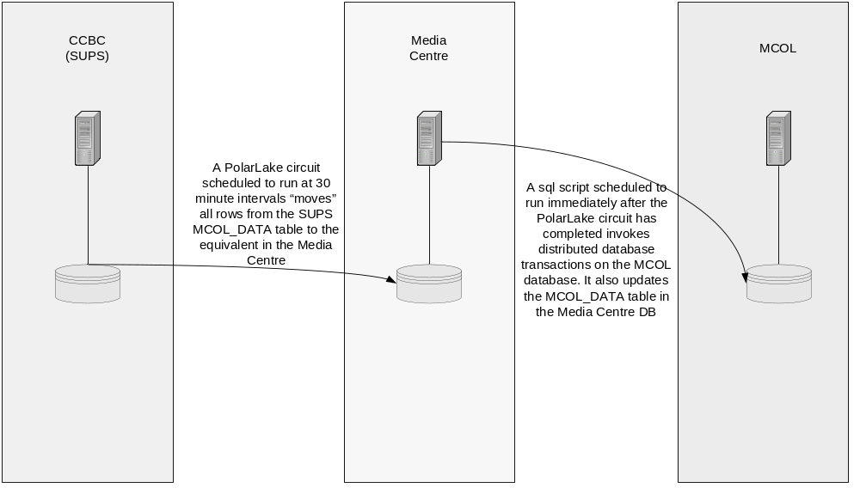

Pre-requisites:

Props File:
- All environment variables which are used in the circuit, should be defined in the props file(which is located in properties folder), like:
  - ccbc_home: which represents the home directory of ccbc system.
  - DB variables: like the user names and passwords, the connect string,..
  - datacircuit_xmlt_port: the XMLT port of the data circuit to which the startup.xml file will be sent.
  - bootcircuit_xmlt_port: the XMLT port of the boot circuit, into which the shutdown command will be sent to shut the circuit down.
  - snmp_address and snmp_port: the host address to which the exception message will be sent when a fatal error occurs
Start the circuit:
- To start the circuit, you have first to define the variable ccbc_circuits_home found in the start_ccbc_update_mcol_status_bootcircuit.sh shell script, which represents the ccbc home directory.
- Then run the start_ccbc_update_mcol_status_bootcircuit.sh .

Implementation

The circuit is implemented as follows:
- In the main view, JOB:

1.1 In the Exception sequence:
  - Print message component: to print a message if there is an exception.
  - Add Process Variable component: to send a X to the send heart beat view.
    - PolarLake Interpreter component : which will run the send heart beat view.
    - SNMP Trap component : to send a SNMP signal if there is a fatal error occurred to a server defined by the variable {pl$snmp_address} on port {pl$snmp_port} which defined in the .props file of the system.
  - JDOM Processor component: to ensure sending of the snmp trap to the server.
    - Run Script component : to print the output exception if an exception occurred.
    - PolarLake Interpreter components : which will run the shutdown_circuit view .

1.2 In the shutdown sequence:
    - Print message component: to print a message if a shutdown message is send to the main view.
    - Add Process Variable component: to send a F to the send heart beat view.
    - 2 PolarLake Interpreter components : which will run the send heart beat and shutdown server views respectively .

1.3 In the JOB sequence:
    - Print message component: to print a message when the circuit start processing.
  - 2 DB Start components : which will start the legacy and the casm databases.
    - Add Process Variable component: to send a S to the send heart beat view.
    - PolarLake Interpreter component : which will run the send heart beat view.
  - PolarLake Interpreter component : which will run the BATCH view.
  - JDOM Processor component: to ensure finishing of the BATCH view successfully .
  - 2 DB Commit components : which will commit the changes done in the legacy and casm databases.
    - PolarLake Interpreter components : which will run the shutdown_circuit view .

- In BATCH View:
  - 3 PolarLake Interpreter components : which will run the GET_ROWS,INSERT_ROWS,DELET_ROWS views respectively.

- In GET_ROWS View:
  - Exception sequence : with print message to handle the case if there is no rows found
  - DB SQL component: which will select all the rows from MCOL_DATA table in the casm DB using the schema ucccbc_mcol_update_schema.xsd to store the selected rows.
  - Print message component: to show the status.
  - JDOM Processor component: to run the selection successfully .

- In INSERT_ROWS View:
  - DB Insert component : which will insert the selected rows in the previous view in the table MCOL_DATA in the legacy DB using the schema ucccbc_mcol_update_schema.xsd to get data stored in it.
  - Print message component: to show the status.

- In DELET_ROWS View:

  - DB Delete component: which will delete the inserted rows in the previous view from the MCOL_DATA in the casm DB.
    - Add Process Variable component: to send a H to the send heart beat view.
    - PolarLake Interpreter component : which will run the send heart beat view.
  - Print message component: to show the status.

- In Pacage_invoke View:

  - DB Start component : which will start the the casm database.
  - DB Stored Procedure component : to run the stored procedure P_DATA_TO_OLS in the package OLS_CCBC_PACKAGE.
  - Print message component: to show the status.
  - DB Commit component : which will commit the changes done in the casm database.

- In shutdown server view:

  - Retrieve Document component : which will retrieve the XML file shutdown.xml using FILE Retrieve component , to send a shutdown command to the circuit.
    - Send to Channels component: which will send the retrieved XML command to the boot circuit port which declared by the following variable ccbc_mcol_update_xmlt_boot_port.

- In shutdown_circuit view:

  - Retrieve Document component : which will retrieve the XML file shutdown_command.xml using FILE Retrieve component , to send a shutdown X-path to the shutdown sequence in the JOB view .
    - Send to Channels component: which will send the retrieved XML command to the boot circuit port which declared by the following variable ccbc_mcol_update_xmlt_port..

- In send heart beat View:

  - Print message component, to print a message of sending a heart beat.
  - Add Process Variable component: to set the variable pv_circuit_name with the circuit name.
  - DB start component: to start sups database
  - DB insert component: to insert heart beat information to PL_XML_STATUS table in sups cpc schema
  - DB commit component: to commit changes in sups DB.

Output

All the rows will moved from the table MCOL_DATA in the casm DB to the table MCOL_DATA in the legacy DB.

