**Home Page**

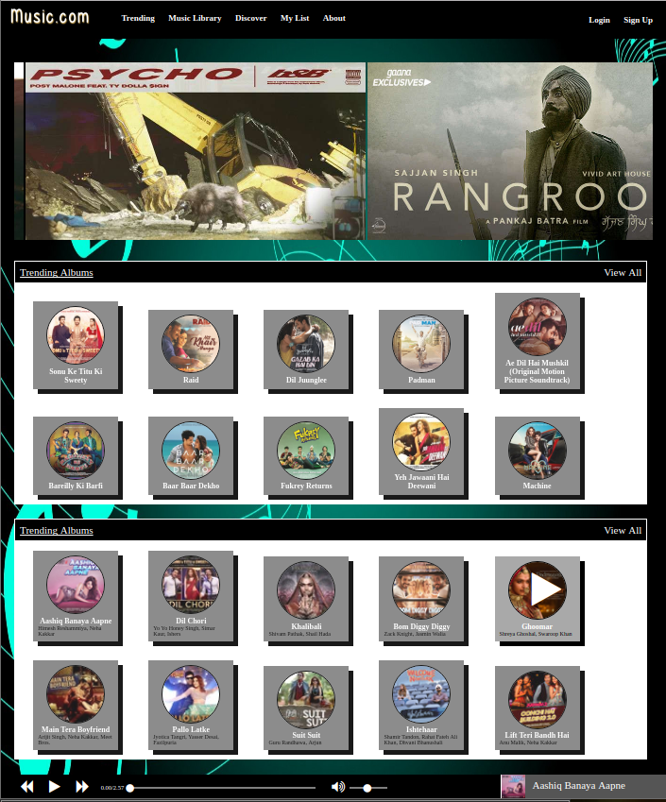

**Index.html (homepage file)**

<html>

<head>

<title>Welcome To Music.com</title>

<link rel="stylesheet" type="text/css" href="font-awesome/css/font-awesome.css">

<link rel="stylesheet" type="text/css" href="style.css">

<link rel="icon" href="img/icon.png" type="image/png" sizes="16x16">

<style>

.slider-area{

width:95%;

height:400px;

overflow:hidden;

padding:20px;

}

.slider-container{

width:5800px;

margin-top:auto;

margin-bottom:auto;

}

.slider-item{

display: inline;

}

</style>

</head>

<body>

<script src="header.html"></script>

<script src="js/data.js"></script>

<script src="jquery/jquery-1.11.3.min.js"></script>

<div class="main-area">

<script src="equlizer.html"></script>

<div class="slider-area" id="sliderArea">

<div class="slider-container" id="sliderContainer">

<script>

for(i=2;i<10;i++){

document.write(`

<div class="slider-item">

<a href="album-list-page.html"><img src="img/poster/poster_`+i+`.jpg" alt=""></a>

</div>

`);

}

</script>

</div>

</div>

<div class="trending-album-area">

<div class="home-trending-title">

Trending Albums

<a href="trending.html" class="sp-link">View All</a>

</div>

<div class="trending-album-list" id="trendingAlbumsContainer">

</div>

</div>

<div class="trending-album-area">

<div class="home-trending-title">

Trending Albums

<a href="trending.html" class="sp-link">View All</a>

</div>

<div class="trending-album-list" id="trendingSongsContainer">

</div>

</div>

</div>

<script src="music-player.html"></script>

</body>

</html>

<script src="js/script.js"></script>

<script>

trendingAlbumsContainer=document.getElementById("trendingAlbumsContainer");

trendingSongsContainer=document.getElementById("trendingSongsContainer");

window.onload=function(){

loadTrendingAlbums();

loadTrendingTracks();

//loadList(gridListContainer);

sliderArea.onmousemove=sliderMouseMove;

}

function sliderMouseMove(e){

sliderArea.scrollLeft=(e.x - 50) * 4

}

function loadTrendingTracks(){

trendingSongsContainer.innerHTML="";

for(i=0;i<=39;i+=4){

var t=trendingSongs[i];

var imgPath="img/songs/track_"+t.id;

trendingSongsContainer.innerHTML+=`

<div class="grid-item" data-id="`+t.id+`" onclick="changeSong(`+(t.id%10)+`,this);">

<div class="grid-play-btn" style=""><i class="fa fa-play" style="display:block;margin-top:auto;margin-bottom:auto;"></i></div>

<img src="`+imgPath+`" alt="">

<div class="grid-title">`+t.title+`</div>

<div class="grid-album">`+t.artist+`</div>

</div>

`;

}

}

function loadTrendingAlbums(){

trendingAlbumsContainer.innerHTML="";

for(i=0;i<=39;i+=4){

var t=trendingAlbums[i];

var imgPath="img/album/album_"+t.id;

trendingAlbumsContainer.innerHTML+=`

<a href="album-list-page.html">

<div class="grid-item" data-id="`+t.id+`" >

<div class="grid-play-btn" style=""><i class="fa fa-play" style="display:block;margin-top:auto;margin-bottom:auto;"></i></div>

<img src="`+imgPath+`" alt="">

<div class="grid-title">`+t.name+`</div>

<div class="grid-album"></div>

</div>

</a>

`;

}

}

</script>

**Music Library Page**

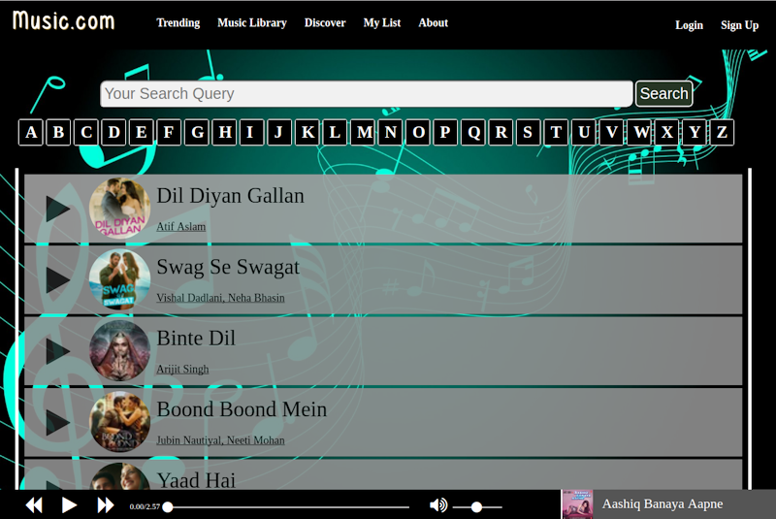

**Music-library.html (for music library page)**

<html>

<head>

<title>Music Library - Music.com</title>

<link rel="stylesheet" type="text/css" href="font-awesome/css/font-awesome.css">

<link rel="stylesheet" type="text/css" href="style.css">

<link rel="icon" href="img/icon.png" type="image/png" sizes="16x16">

<style type="text/css">

.atoz-list{

margin-top:20px;

text-align: center;

}

.atoz-item{

width:18px;

margin-left:5px;

background:black;

border:1px solid white;

color:white;

border-radius: 3px;

font-size: 27px;

padding: 5px;

padding-left:10px;

padding-right:10px;

cursor:pointer;

float: left;

font-weight: bold;

}

</style>

</head>

<body>

<script src="header.html"></script>

<script src="js/data.js"></script>

<div class="main-area">

<script src="equlizer.html"></script>

<div class="search-area" style="text-align:center;">

<input type="text" placeholder="Your Search Query" style="width:70%;display:inline;font-size:25px;padding:5px;">

<input type="submit" value="Search" style="display:inline;font-size:25px;padding:5px;">

</div>

<div class="atoz-list"></div>

<script>

var ta=65;

for(ta=65;ta<91;ta++){

var char=String.fromCharCode(ta);

document.write(`

<div class="atoz-item" onclick="loadCharList('`+char+`')"> `+char+`</div>

`);

}

</script>

<div class="my-list-container" id="myListContainer" style="margin-top:100px;">

</div>

</div>

<script src="music-player.html"></script>

</body>

</html>

<script src="jquery/jquery-1.11.3.min.js"></script>

<script src="js/script.js"></script>

<script>

myListContainer=document.getElementById("myListContainer");

window.onload=function(){

loadCharList();

}

function loadCharList(c){

myListContainer.innerHTML="";

for(i=2;i<=99;i+=4){

var t=trendingSongs[i];

if(!(t.title.charAt(0)==c) && c ){

//console.log(t.title.charAt(0)==c);

continue;

}

var imgPath="img/songs/track_"+t.id;

myListContainer.innerHTML+=`

<div class="my-list-item" onclick="changeSong(`+(t.id%10)+`,this);">

<div class="play-btn-div">

<i class="fa fa-play"></i>

</div>

<div class="list-item-img">

<img src="`+imgPath+`" alt="">

</div>

<div class="list-item-details">

<div class="my-list-title">`+t.title+`</div>

<div class="my-list-album">`+t.artist+`</div>

</div>

</div>

`;

}

}

</script>

**Trending Page**

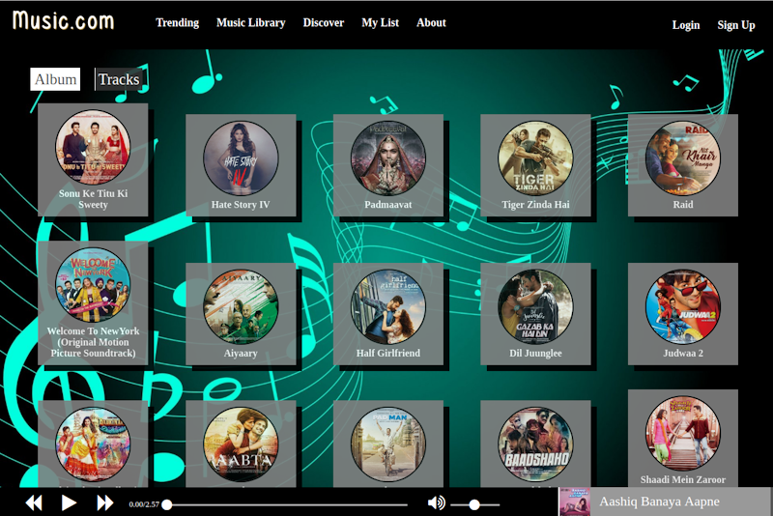

**Trending.html (for trending page)**

<html>

<head>

<title>Trending - Music.com</title>

<link rel="stylesheet" type="text/css" href="font-awesome/css/font-awesome.css">

<link rel="stylesheet" type="text/css" href="style.css">

<link rel="icon" href="img/icon.png" type="image/png" sizes="16x16">

</head>

<body>

<script src="header.html"></script>

<script src="js/data.js"></script>

<script src="jquery/jquery-1.11.3.min.js"></script>

<div class="main-area">

<script src="equlizer.html"></script>

<div class="album-item-switch">

<span class="cat-active" id="loadAlbums" onclick="loadAlbums()">Album</span>

<span id="loadTracks" onclick="loadTracks()">Tracks</span>

</div>

<div class="grid-list-container" onload="loadList(this)" id="gridListContainer">

<!-- <a href="">

<div class="grid-item">

<img src="img/img1.png" alt="">

<div class="grid-title">SomeTitle is here</div>

<div class="grid-album">Album name</div>

</div>

</a> -->

</div>

</div>

<script src="music-player.html"></script>

</body>

</html>

<script src="js/script.js"></script>

<script>

function loadTracks(){

$("#loadTracks").addClass("cat-active");

$("#loadAlbums").removeClass("cat-active");

loadTrendingTracks();

}

function loadAlbums(){

$("#loadTracks").removeClass("cat-active");

$("#loadAlbums").addClass("cat-active");

loadTrendingAlbums();

}

gridListContainer=document.getElementById("gridListContainer");

window.onload=function(){

//loadList(gridListContainer);

loadTrendingAlbums();

}

function loadTrendingTracks(){

gridListContainer.innerHTML="";

for(i=0;i<=39;i++){

var t=trendingSongs[i];

var imgPath="img/songs/track_"+t.id;

gridListContainer.innerHTML+=`

<div class="grid-item" data-id="`+t.id+`" onclick="changeSong(`+(t.id%10)+`,this);">

<div class="grid-play-btn" style=""><i class="fa fa-play" style="display:block;margin-top:auto;margin-bottom:auto;"></i></div>

<img src="`+imgPath+`" alt="">

<div class="grid-title">`+t.title+`</div>

<div class="grid-album">`+t.artist+`</div>

</div>

`;

}

}

function loadTrendingAlbums(){

gridListContainer.innerHTML="";

for(i=0;i<=39;i++){

var t=trendingAlbums[i];

var imgPath="img/album/album_"+t.id;

gridListContainer.innerHTML+=`

<a href="album-list-page.html">

<div class="grid-item" data-id="`+t.id+`" >

<div class="grid-play-btn" style=""><i class="fa fa-play" style="display:block;margin-top:auto;margin-bottom:auto;"></i></div>

<img src="`+imgPath+`" alt="">

<div class="grid-title">`+t.name+`</div>

<div class="grid-album"></div>

</div>

</a>

`;

}

}

</script>

**Album List Page**

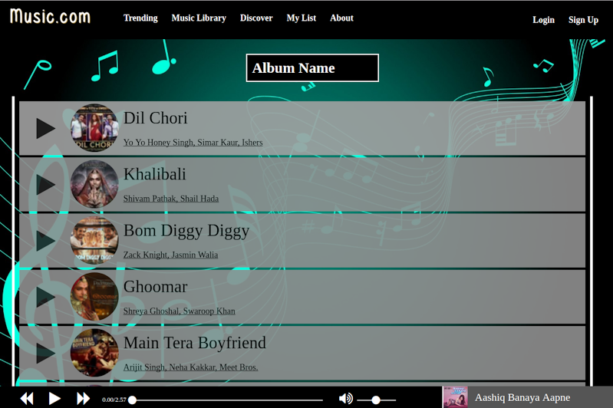

**Album-list-page.html(for Album list page)**

<html>

<head>

<title>Album List</title>

<link rel="stylesheet" type="text/css" href="font-awesome/css/font-awesome.css">

<link rel="stylesheet" type="text/css" href="style.css">

<link rel="icon" href="img/icon.png" type="image/png" sizes="16x16">

<style type="text/css">

.album-page-title{

color:white;

font-size: 30px;

background: black;

width:250px;

padding: 10px;

border:2px solid white;

font-weight: bold;

margin:auto;

margin-bottom: 30px;

}

</style>

</head>

<body>

<script src="header.html"></script>

<script src="js/data.js"></script>

<script src="jquery/jquery-1.11.3.min.js"></script>

<div class="main-area">

<script src="equlizer.html"></script>

<div class="album-page-title">

Album Name

</div>

<div class="my-list-container" onload="loadList(this)" id="myListContainer">

</div>

</div>

<script src="music-player.html"></script>

</body>

</html>

<script src="js/script.js"></script>

<script>

myListContainer=document.getElementById("myListContainer");

window.onload=function(){

loadMyList();

}

function loadMyList(){

myListContainer.innerHTML="";

for(i=4;i<=30;i+=4){

var t=trendingSongs[i];

var imgPath="img/songs/track_"+t.id;

myListContainer.innerHTML+=`

<div class="my-list-item" onclick="changeSong(`+(t.id%10)+`,this);">

<div class="play-btn-div">

<i class="fa fa-play"></i>

</div>

<div class="list-item-img">

<img src="`+imgPath+`" alt="">

</div>

<div class="list-item-details">

<div class="my-list-title">`+t.title+`</div>

<div class="my-list-album">`+t.artist+`</div>

</div>

</div>

`;

}

}

</script>

**Discover page**

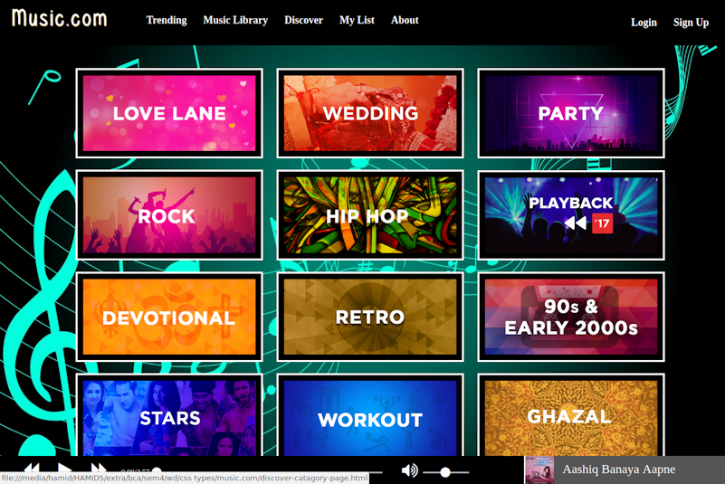

**Discover.html (for Discover page)**

<html>

<head>

<title>Discover Your Music - Music.com</title>

<link rel="stylesheet" type="text/css" href="font-awesome/css/font-awesome.css">

<link rel="stylesheet" type="text/css" href="style.css">

<link rel="icon" href="img/icon.png" type="image/png" sizes="16x16">

<style>

.discover-list{

align-content:center;

text-align: center;

}

.discover-item{

display: inline-block;

margin:10px;

padding: 10px;

border: 3px solid white;

background: black;

}

.discover-item img{

width:300px;

transition: transform 0.2s;

cursor: pointer;

}

.discover-item img:hover{

transform: scale(1.1, 1.1);

}

</style>

</head>

<body>

<script src="header.html"></script>

<script src="js/data.js"></script>

<script src="jquery/jquery-1.11.3.min.js"></script>

<div class="main-area">

<script src="equlizer.html"></script>

<div class="discover-list" id="discoverList">

<div class="discover-item">

<img src="img/genre/genre_2">

</div>

</div>

</div>

<script src="music-player.html"></script>

</body>

</html>

<script src="js/script.js"></script>

<script>

gridListContainer=document.getElementById("gridListContainer");

discoverList=document.getElementById("discoverList");

window.onload=function(){

loadDiscoverList();

}

function loadDiscoverList(){

discoverList.innerHTML="";

for(i=2;i<=25;i++){

var imgPath="img/genre/genre_"+i;

discoverList.innerHTML+=`

<a href="discover-catagory-page.html">

<div class="discover-item">

<img src="img/genre/genre_`+i+`">

</div>

</a>

`;

}

}

</script>

**Discover Category Playlist Page**

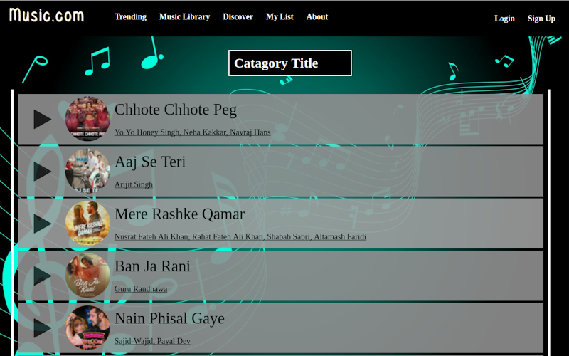

**Discover-category-page.html(for discover category page)**

<html>

<head>

<title>Catagory Songs - Music.com</title>

<link rel="stylesheet" type="text/css" href="font-awesome/css/font-awesome.css">

<link rel="stylesheet" type="text/css" href="style.css">

<style type="text/css">

.discover-catagory-title{

color:white;

font-size: 30px;

background: black;

width:250px;

padding: 10px;

border:2px solid white;

font-weight: bold;

margin:auto;

margin-bottom: 30px;

}

</style>

</head>

<body>

<script src="header.html"></script>

<script src="js/data.js"></script>

<script src="jquery/jquery-1.11.3.min.js"></script>

<div class="main-area">

<script src="equlizer.html"></script>

<div class="discover-catagory-title">

Catagory Title

</div>

<div class="my-list-container" onload="loadList(this)" id="myListContainer">

</div>

</div>

<script src="music-player.html"></script>

</body>

</html>

<script src="js/script.js"></script>

<script>

myListContainer=document.getElementById("myListContainer");

window.onload=function(){

loadMyList();

}

function loadMyList(){

myListContainer.innerHTML="";

for(i=3;i<=50;i+=4){

var t=trendingSongs[i];

var imgPath="img/songs/track_"+t.id;

myListContainer.innerHTML+=`

<div class="my-list-item" onclick="changeSong(`+(t.id%10)+`,this);">

<div class="play-btn-div">

<i class="fa fa-play"></i>

</div>

<div class="list-item-img">

<img src="`+imgPath+`" alt="">

</div>

<div class="list-item-details">

<div class="my-list-title">`+t.title+`</div>

<div class="my-list-album">`+t.artist+`</div>

</div>

</div>

`;

}

}

</script>

**My List page**

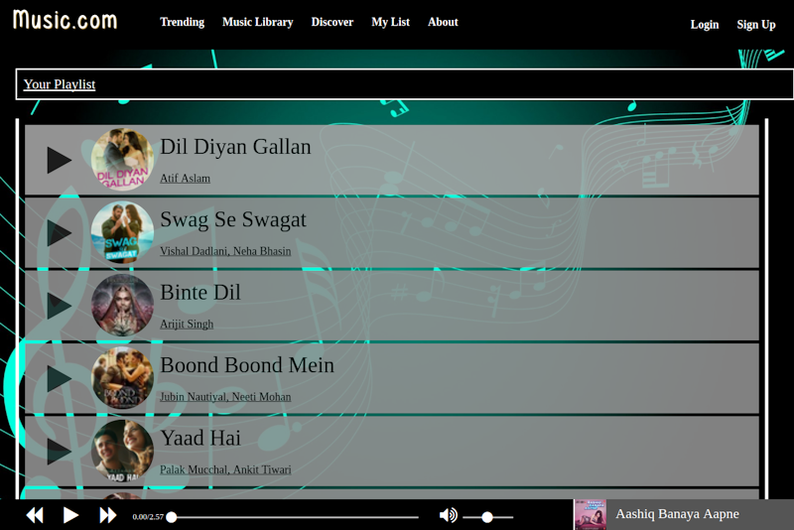

**Mylist.html (for my playlist page)**

<html>

<head>

<title>Your Playlist - Music.com</title>

<link rel="stylesheet" type="text/css" href="font-awesome/css/font-awesome.css">

<link rel="stylesheet" type="text/css" href="style.css">

<link rel="icon" href="img/icon.png" type="image/png" sizes="16x16">

<style type="text/css">

</style>

</head>

<body>

<script src="header.html"></script>

<script src="js/data.js"></script>

<div class="main-area">

<script src="equlizer.html"></script>

<div class="home-trending-title" style="margin-bottom: 30px;">

Your Playlist

</div>

<div class="my-list-container" onload="loadList(this)" id="myListContainer">

<!-- <div class="my-list-item">

<div class="list-item-img">

<img src="img/img1.png" alt="">

</div>

<div class="list-item-details">

<div class="my-list-title">SomeTitle is here</div>

<div class="my-list-album">Album name</div>

</div>

<div class="play-btn-div">

<i class="fa fa-play"></i>

</div>

</div> -->

</div>

</div>

<script src="music-player.html"></script>

</body>

</html>

<script src="jquery/jquery-1.11.3.min.js"></script>

<script src="js/script.js"></script>

<script>

myListContainer=document.getElementById("myListContainer");

window.onload=function(){

loadMyList();

}

function loadMyList(){

myListContainer.innerHTML="";

for(i=2;i<=99;i+=4){

var t=trendingSongs[i];

var imgPath="img/songs/track_"+t.id;

myListContainer.innerHTML+=`

<div class="my-list-item" onclick="changeSong(`+(t.id%10)+`,this);">

<div class="play-btn-div">

<i class="fa fa-play"></i>

</div>

<div class="list-item-img">

<img src="`+imgPath+`" alt="">

</div>

<div class="list-item-details">

<div class="my-list-title">`+t.title+`</div>

<div class="my-list-album">`+t.artist+`</div>

</div>

</div>

`;

}

}

</script>

**About Page**

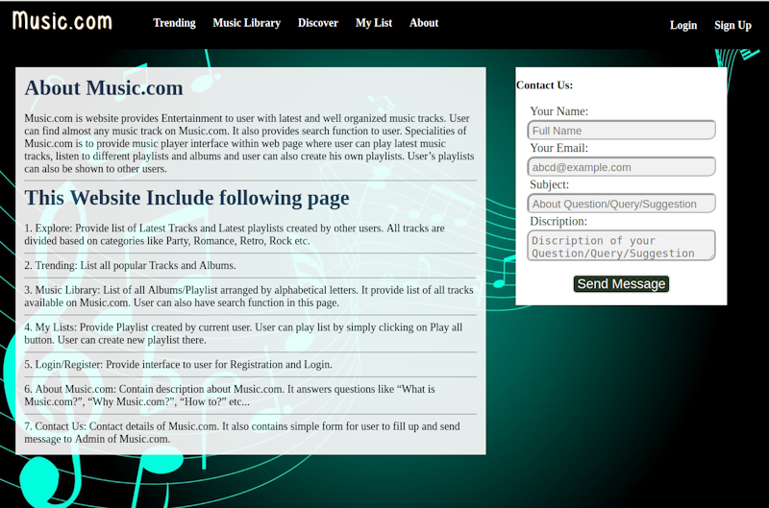

**about.html (for About Page)**

<html>

<head>

<title> About - Music.com</title>

<link rel="stylesheet" type="text/css" href="font-awesome/css/font-awesome.css">

<link rel="stylesheet" type="text/css" href="style.css">

<link rel="icon" href="img/icon.png" type="image/png" sizes="16x16">

<style type="text/css">

</style>

</head>

<body>

<script src="header.html"></script>

<script src="js/data.js"></script>

<script src="jquery/jquery-1.11.3.min.js"></script>

<div class="main-area">

<script src="equlizer.html"></script>

<div class="discription-background">

<div class="discription-title">

About Music.com

</div>

<div class="discription-content">

Music.com is website provides Entertainment to user with latest and well organized music tracks. User can find almost any music track on Music.com. It also provides search function to user. Specialities of Music.com is to provide music player interface within web page where user can play latest music tracks, listen to different playlists and albums and user can also create his own playlists. User’s playlists can also be shown to other users.

</div>

<hr>

<div class="discription-title">

This Website Include following page

</div>

<div class="discription-content">

1. Explore: Provide list of Latest Tracks and Latest playlists created by other users. All tracks are divided based on categories like Party, Romance, Retro, Rock etc.<hr>

2. Trending: List all popular Tracks and Albums.<hr>

3. Music Library: List of all Albums/Playlist arranged by alphabetical letters. It provide list of all tracks available on Music.com. User can also have search function in this page. <hr>

4. My Lists: Provide Playlist created by current user. User can play list by simply clicking on Play all button. User can create new playlist there. <hr>

5. Login/Register: Provide interface to user for Registration and Login. <hr>

6. About Music.com: Contain description about Music.com. It answers questions like “What is Music.com?”, “Why Music.com?”, “How to?” etc...<hr>

7. Contact Us: Contact details of Music.com. It also contains simple form for user to fill up and send message to Admin of Music.com.

</div>

</div>

<div class="contact-form-background">

<h3>Contact Us: </h3>

<div class="contact-form">

<form action="" method="POST" onsubmit="return false;" name="contactForm">

<table>

<tbody id="contactFormTable">

<tr><td><span class="form-item-heading">Your Name: </span></td></tr>

<tr><td>

<input type="text" name="name" placeholder="Full Name" required>

</td></tr>

<tr><td><span class="form-item-heading">Your Email: </span> </td></tr>

<tr><td>

<input type="text" name="email" placeholder="abcd@example.com" required>

</td></tr>

<tr><td><span class="form-item-heading">Subject: </span> </td></tr>

<tr><td>

<input type="text" name="Subject" placeholder="About Question/Query/Suggestion" required>

</td></tr>

<tr><td><span class="form-item-heading">Discription: </span></td></tr>

<tr><td>

<textarea name="discription" placeholder="Discription of your Question/Query/Suggestion" required></textarea>

</td></tr>

<tr><td>

<input type="submit" name="submit" value="Send Message">

</td></tr>

</tbody>

</table>

</form>

</div>

</div>

</div>

<script src="music-player.html"></script>

</body>

</html>

<script src="js/script.js"></script>

**Common Files**

**header.html (header for all pages)**



document.write(`

<script src="login-popup.html"></script>

<script src="signup-popup.html"></script>

<script src="js/notie.js"></script>

<div class="header">

<div id="menu-icon" class="menu-icon" style="display:none"><i class="fa fa-bars"></i></div>

<h1 class="main-title"><a href="index.html">Music.com</a></h1>

<div class="header-menu">

<ul>

<a href="trending.html"><li class="header-menu-item">Trending</li></a>

<a href="music-library.html"><li class="header-menu-item">Music Library</li></a>

<a href="discover.html"><li class="header-menu-item">Discover</li></a>

<a href="mylist.html"><li class="header-menu-item">My List</li></a>

<a href="about.html"><li class="header-menu-item">About</li></a>

</ul>

</div>

<div class="login-area">

<a href="#" class="header-menu-item" onclick="hidePopup('signupPopup');showPopup('loginPopup')">Login</a>

<a href="#" class="header-menu-item" onclick="hidePopup('loginPopup');showPopup('signupPopup',10)">Sign Up</a>

</div>

</div>

`);

**Music-player.html (Put Music Player Control on Every page)**

musicPlayer.png

firstTrack=trendingSongs[0];

document.write(`

<audio src="mp3/music0.mp3" id="mp3Now"></audio>

<div class="music-player">

<div class="music-player-controls">

<i class="fa fa-backward control" id="backward"></i>

<i class="fa fa-play control" id="play-pause"></i>

<i class="fa fa-forward control" id="forward"></i>

<div class="player-timeline-div">

<div class="player-time"><span id="songPlayed"></span>/<span id="songLength"></span></div>

<div class="player-timeline">

<i class="fa fa-circle" id="timeline-circle" style="margin-left:-2px;"></i>

</div>

</div>

<div class="volume-control">

<i class="control fa fa-volume-up" id="volume-button"></i>

<div id="volume-scale">

<i class="fa fa-circle" id="volume-circle" style="margin-left:30px;"></i>

</div>

</div>

</div>

<div class="current-playlist">

<div class="current-song" id="currentSong" onclick="toggleCurrentPlaylist()">

<div class="current-playlist-item">

<div class="cpi-image">

<img src="img/songs/track_`+firstTrack.id+`" alt="">

</div>

<div class="cpi-details">

<div class="cpi-title">`+firstTrack.title+`</div>

</div>

</div>

</div>

<div class="playlist-container" style="height:0px;" id="cpiContainer">

<div class="current-playlist-item">

<div class="cpi-image">

<img src="img/album/album_1" alt="">

</div>

<div class="cpi-details">

<div class="cpi-title">This my title</div>

</div>

</div>

</div>

</div>

</div>

`);

cpiContainer=document.getElementById("cpiContainer");

loadcpiContainer();

function loadcpiContainer(){

cpiContainer.innerHTML="";

for(i=2;i<=99;i+=4){

var t=trendingSongs[i];

var imgPath="img/songs/track_"+t.id;

cpiContainer.innerHTML+=`

<div class="current-playlist-item" data-id="`+t.id+`" onclick="changeSong(`+(t.id%10)+`,this);">

<div class="cpi-image">

<img src="`+imgPath+`" alt="">

</div>

<div class="cpi-details">

<div class="cpi-title">`+t.title+`</div>

</div>

</div>

`;

}

}

**Login-popup.html (Provide Login Popup for every page)**

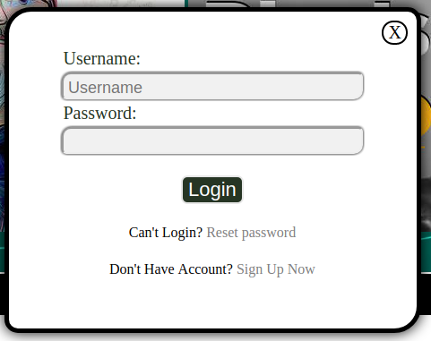

document.write(`

<div class="login-popup" id="loginPopup">

<a onclick="hidePopup(this.parentElement.id)" class="close-button" style="position: absolute;right:10px;top:10px;">X</a>

<form action="" method="POST" onsubmit="return validateLogin(this);" name="loginForm">

<table>

<tbody id="contactFormTable">

<tr><td><span class="form-item-heading">Username: </span></td></tr>

<tr><td>

<input type="text" name="username" placeholder="Username">

</td></tr>

<tr><td><span class="form-item-heading">Password: </span> </td></tr>

<tr><td>

<input type="password" name="password">

</td></tr>

<tr><td>

<input type="submit" name="submit" value="Login" style="">

</td></tr>

<tr>

<td style="text-align:center;padding-top:20px;">

Can't Login?<a href="#" style="color:grey"> Reset password</a>

</td>

</tr>

<tr>

<td style="text-align:center;padding-top:20px;">

Don't Have Account?<a href="#" onclick="hidePopup('loginPopup');showPopup('signupPopup',10);" style="color:grey"> Sign Up Now</a>

</td>

</tr>

</tbody>

</table>

</form>

</div>

`)

**Signup-popup.html (Provide Signup Popup for every page)**

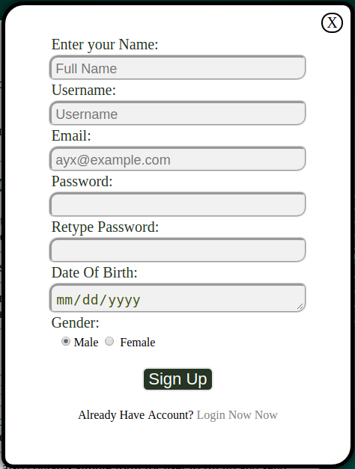

document.write(`

<div class="signup-popup" id="signupPopup">

<a onclick="hidePopup(this.parentElement.id)" class="close-button" style="position: absolute;right:10px;top:10px;">X</a>

<form action="" method="POST" onsubmit="return validateSignup(this)" name="signupForm">

<table>

<tbody id="contactFormTable">

<tr><td><span class="form-item-heading">Enter your Name: </span></td></tr>

<tr><td>

<input type="text" name="name" placeholder="Full Name" >

</td></tr>

<tr><td><span class="form-item-heading">Username: </span></td></tr>

<tr><td>

<input type="text" name="username" placeholder="Username" >

</td></tr>

<tr><td><span class="form-item-heading">Email: </span></td></tr>

<tr><td>

<input type="text" name="email" placeholder="ayx@example.com" >

</td></tr>

<tr><td><span class="form-item-heading">Password: </span></td></tr>

<tr><td>

<input type="password" name="password" placeholder="" >

</td></tr>

<tr><td><span class="form-item-heading">Retype Password: </span></td></tr>

<tr><td>

<input type="password" name="repassword" placeholder="" >

</td></tr>

<tr><td><span class="form-item-heading">Date Of Birth: </span> </td></tr>

<tr><td>

<input type="date" name="dob" placeholder="mm/dd/yyyy">

</td></tr>

<tr><td><span class="form-item-heading">Gender: </span> </td></tr>

<tr><td style="padding-left:30px;">

<input type="radio" name="gender" checked value="male">Male

<input type="radio" name="gender" value="female"> Female

</td></tr>

<tr><td>

<input type="submit" name="submit" value="Sign Up" style="">

</td></tr>

<tr>

<td style="text-align:center;padding-top:20px;">

Already Have Account?<a href="#" onclick="hidePopup('signupPopup');showPopup('loginPopup');" style="color:grey"> Login Now Now</a>

</td>

</tr>

</tbody>

</table>

</form>

</div>

`)

**Style.css(Provide Common Style for every page)**

:root{

--color-background2: #000000;

--color-background3: #743d0d;

--color1: #523114;

--color-font1: #fffeff;

--color-font2: #522c00;

--color3: #3f3f40;

--color-background-all: #fbeeca;

--color5: black;

--color-font1-hover: #efc464;

--color-font2-hover: yellow;

--color8: yellow;

--color9: yellow;

--color10: yellow;

}

@font-face {

font-family: Musical;

src: url(fonts/musical3.ttf);

}

body{

margin: 0px;

max-width:100%;

}

a{

text-decoration: none;

color:white;

}

body::before{

content: "";

background-image: url(img/music-background5.jpg);

background-size: 100% 100%;

background-attachment: fixed;

height:105%;

width:105%;

position: fixed;

top:-10px;

left:-10px;

z-index: -1;

}

.header{

height:80px;

width:100%;

background-color: var(--color-background2);

position: fixed;

-box-shadow: 0px 1px 10px var(--color-font1-hover);

text-shadow: 1px 1px 1px var(--color-font1-hover);

opacity: 1;

z-index: 1;

}

.header h1{

color:white;

font-size: 40px;

margin: 10px;

float: left;

margin-left:20px;

font-family: Musical;

letter-spacing: 5px;

}

.main-titled::before{

content: "";

background-image: url(img/music-background-blur.png);

background-size: cover;

position: absolute;

top:-10px;

left:-10px;

height:inherit;

width:inherit;

}

.login-area{

float:right;

margin-top:20px;

margin-right: 20px;

}

.login-btn{

color:var(--color-font1);

background-color: var(--color-background2);

font-size:25px;

text-decoration: none;

padding: 5px;

margin: 5px;

border-radius: 15px 15px 15px 15px;

padding-left: 8px;

padding-right: 8px;

font-weight: bold;

box-shadow: 1px 1px 4px var(--color-font1-hover);

}

.login-btn:hover{

color: var(--color-font1-hover);

text-shadow: 1px 1px 1px var(--color-font2);

}

.header-menu{

float:left;

}

.header-menu ul{

list-style-type: none;

}

.header-menu-item{

display: inline-block;

font-size: 18px;

-background: linear-gradient(to right,var(--color-background-all) -200% ,var(--color-background2) 50%,var(--color-background-all) 300% );

font-weight: bold;

padding:10px;

padding-top: 10px;

padding-bottom: 10px;

margin-left:5px;

transition: all 0.5s;

color:var(--color-font1);

text-shadow: none;

-box-shadow: 0px 1px 1px var(--color-font1);

}

.header-menu-item a{

text-decoration: none;

}

.header-menu-item:hover{

color: var(--color-background2);

background:linear-gradient(to right,var(--color-font1) 1% ,var(--color-font1) 5%,var(--color-background2) 250% );

}

.main-area{

padding-top:110px;

padding-left:2%;

margin-bottom: 100px;

z-index: -2;

}

.container-area{

height:300px;

overflow-y: hidden;

overflow-x: scroll;

width:1000px;

}

.container-inner{

height:300px;

width:5000px;

}

.container-item{

display: inline-block;

border: 1px solid blue;

padding: 5px;

padding-bottom: 20px;

}

.container-item span{

display: block;

text-align: center;

color:#9bd32f;

font-size: 20px;

}

.container-item img{

height:180px;

width:180px;

border-radius: 180px;

}

.album-item-switch{

width:fit-content;

padding:5px;

}

.cat-active{

background-color: white !important;

color:rgba(50,50,50,0.9) !important;

}

.album-item-switch span{

background-color: rgba(50,50,50,0.9);

border-left: 1px solid white;

padding:5px;

color:white;

font-size:25px;

margin-left:20px;

cursor: pointer;

}

.grid-item{

width:160px;

background-color:grey;

padding:10px;

opacity: 0.9;

box-shadow: 10px 10px 0px black;

display: inline-block;

margin:20px;

margin-left:3%;

transition: background-color 0.5s;

cursor: pointer;

}

.grid-item:hover{

opacity: 1;

background-color: darkgrey;

}

.grid-item:hover .grid-play-btn{

display: block;

}

.grid-play-btn{

position:absolute;

font-size:80px;

height:inherit;

width:inherit;

text-align:center;

padding:20px;

color:white;

display:none;

}

.grid-item img{

height: 120px;

width:120px;

margin:auto;

display: block;

border-radius: 150px;

border: 2px solid black;

}

.grid-title{

margin:auto;

text-align: center;

margin-top:5px;

font-weight: bold;

color:white;

}

.grid-album{

color:black;

font-size: 12px;

}

.music-player{

height:50px;

position: fixed;

bottom: 0px;

background-color: var(--color-background2);

width:100%;

text-align: center;

user-select: none;

}

.music-player-controls{

position: absolute;

left: 10px;

bottom:0px;

}

.control{

display: inline-block;

font-size:30px;

color: var(--color-font1);

margin-left:30px;

margin-bottom: 10px;

cursor: pointer;

}

.control:hover{

text-shadow: 1px 1px 3px var(--color-background-all);

}

.volume-control{

display: inline-block;

}

#volume-scale{

margin-left:5px;

width:80px;

display: inline-block;

background: linear-gradient(rgba(0,0,0,0) 40%, var(--color-font1) 50%, rgba(0,0,0,0) 60%);

text-align: left;

}

#volume-circle{

font-size:20px;

cursor: pointer;

color: var(--color-font1);

}

.player-timeline{

display: inline-block;

width:400px;

height:20px;

background: linear-gradient(rgba(0,0,0,0) 40%, var(--color-font1) 50%, rgba(0,0,0,0) 60%);

margin-left:55px;

text-align: left;

-background-color: green;

}

#timeline-circle{

font-size:20px;

cursor: pointer;

margin-left:10px;

color: var(--color-font1);

}

.player-timeline-div{

display: inline-block;

height: 20px;

margin-left:20px;

}

.player-time{

position:absolute;

font-size: 13px;

top:10px;

color:var(--color-font1);

}

/*

Equlizer Style Sheet

*/

.eqBox{

display: none;

}

.eqBox .child{

height:400px;

width:20px;

margin-left:10px;

display:inline-block;

background: linear-gradient(to top, black, grey,red);

transition: height 0.05s;

position:relative;

}

.eqBox .child1{

height:100px;

width:6px;

display:inline-block;

background: linear-gradient(to top, red, yellow,red);

margin-top:0px;

transition: all 0.3s;

position:relative;

visibility:hidden;

}

.equlizer{

display: inline-block;

position: fixed;

left:50px;

bottom: 100px;

z-index: -1;

}

/*

mylist css

*/

.my-list-container{

-background: #F9F9F9;

border-left: 5px solid white;

border-right: 5px solid white;

width:95%;

padding:5px;

}

.my-list-item{

background-color: #909090;

margin:5px;

padding: 5px;

display: flex;

cursor: pointer;

transition: background-color 0.5s;

opacity: 0.9;

}

.my-list-item:hover{

background-color: #C0C0C0;

opacity: 1;

}

.list-item-img{

width:100px;

}

.my-list-item img{

height:100px;

width:100px;

border-radius: 100px;

}

.list-item-details{

padding: 10px;

}

.my-list-title{

font-size: 35px;

}

.my-list-album{

font-size: 18px;

text-decoration: underline;

margin-top:20px;

}

.play-btn-div{

margin:30px;

font-size: 50px;

margin-top:auto;

margin-bottom: auto;

color:#202020;

}

/* form elements

*/

input[type=text] ,textarea,input[type=password],input[type=date]{

width:90%;

margin:auto;

display: block;

border-radius: 10px 5px 10px 5px;

font-size: 18px;

padding: 5px;

padding-bottom: 0px;

color:#445511;

outline: none;

box-shadow: 0px 0px 4px black;

background:#f1f1f1;

resize:vertical;

}

input[type=submit]{

background-color: 263524;

color: white;

border: 2px solid #e7e7e7;

font-size: 22px;

margin-left:30px;

border-radius: 7px;

margin:auto;

margin-top:20px;

cursor: pointer;

display: block;

}

/*

Login/Signup popup

*/

.login-popup{

background: white;

position: fixed;

z-index: 10;

display: block;

left:30%;

top:-200%;

width:30%;

padding: 3%;

border: 5px solid black;

box-shadow: 0px 0px 25px black;

border-radius: 30px 15px 30px 15px;

display: block;

}

.signup-popup{

background: white;

position: fixed;

z-index: 10;

display: block;

left:30%;

top:-200%;

width:30%;

padding: 3%;

border: 5px solid black;

box-shadow: 0px 0px 25px black;

border-radius: 30px 15px 30px 15px;

display: block;

}

.close-button{

color:black;

border-radius:50px;

border:2px solid black;

font-size:20px;

padding-left:5px;

padding-right:5px;

cursor: pointer;

}

.close-button:hover{

background: black;

color:white;

}

/*

About page

*/

.discription-background{

float:left;

background:white;

max-width: 60%;

padding:15px;

opacity: 0.9;

}

.discription-title{

font-size: 35px;

color:#263955;

margin-bottom: 20px;

font-weight: bold;

}

.discription-content{

font-size: 18px;

font-family: Ringbearer;

}

.contact-form-background{

width:90%;

float:left;

background: white;

width:28%;

margin-left:50px;

}

.form-item-heading{

margin-left:20px;

font-size: 20px;

color:#263524;

}

form{

width:100%;

}

table{

width: inherit;

}

#contactFormTable{

width: 100%;

}

/* current Playlist */

.current-playlist{

width: 350px;

height:50px;

float:right;

background: #555555;

border-left:2px solid white;

}

.current-playlist-item{

width:345px;

height:50px;

margin-bottom: 5px;

background:#555555;

cursor: pointer;

overflow: hidden;

}

.current-playlist-item:hover{

background: #999999;

}

.cpi-image img{

height:50px;

width:50px;

float:left;

}

.cpi-details{

color:white;

text-align:left;

float:left;

}

.cpi-title{

margin-left:5px;

font-size:22px;

padding:10px;

}

.playlist-container{

-border:1px solid gold;

position: absolute;

bottom:50px;

width:350px;

background:black;

overflow-y: scroll;

overflow-x: hidden;

height:500px;

}

/* home extra css */

.trending-album-area{

background: white;

margin-bottom: 30px;

width:97%;

}

.home-trending-title{

color:white;

font-size:22px;

text-decoration: underline;

padding: 10px;

border-bottom:3px solid white;

border:2px solid white;

background: black;

}

.sp-link{

text-decoration: none;

float:right;

}

.sp-link:hover{

text-shadow: 1px 1px 4px grey;

}

**Js/script,js (Common JavaScript file for every page)**

timelineCircle=document.getElementById("timeline-circle");

volumeCircle=document.getElementById("volume-circle");

audio=document.querySelector("#mp3Now");

songPlayed=document.querySelector("#songPlayed");

songLength=document.querySelector("#songLength");

audio.volume=0.4;

audio.onplaying=audioOnPlaying;

audio.onpause=audioOnPause;

audio.onloadedmetadata=function(){

songLength.innerHTML=secondToMin(audio.duration);

songPlayed.innerHTML="0.00";

}

window.playing=false;

timelineCircle.onmousedown=function(){

//document.onmousemove=timelineCircleMove;

}

document.onmouseup=function(){

document.onmousemove=null;

}

//timelineCircle.parentElement.onclick=timelineClick;

timelineCircle.parentElement.onmousedown=timelineClick;

volumeCircle.parentElement.onmousedown=volumeClick;

function volumeCircleMove(e){

e.stopPropagation();

window.e=e;

var oldMargin=parseInt(volumeCircle.style.marginLeft);

if(oldMargin+e.movementX >=0 && oldMargin+e.movementX <=75){

var tm=oldMargin+e.movementX;

//audio.currentTime=audioCurrentTime(tm);

audio.volume=Math.abs((tm / 80))

volumeCircle.style.marginLeft=(tm)+"px";

}

}

function timelineCircleMove(e){

e.stopPropagation();

window.e=e;

var oldMargin=parseInt(timelineCircle.style.marginLeft);

if(oldMargin+e.movementX >=-2 && oldMargin+e.movementX <=400){

var tm=oldMargin+e.movementX;

//audio.currentTime=audioCurrentTime(tm);

console.log(audioCurrentTime(tm)+"->"+tm);

audio.currentTime=audioCurrentTime(tm);

timelineCircle.style.marginLeft=(tm)+"px";

}

}

function timelineClick(e){

console.log(audioCurrentTime(e.offsetX));

timelineCircle.style.marginLeft=(e.offsetX-10)+"px";

audio.currentTime=audioCurrentTime(e.offsetX);

document.onmousemove=timelineCircleMove;

}

function volumeClick(e){

console.log(audioCurrentTime(e.offsetX));

volumeCircle.style.marginLeft=(e.offsetX-10)+"px";

audio.volume=Math.abs((e.offsetX / 80))

document.onmousemove=volumeCircleMove;

}

function audioCurrentTime(px){

var tLen=400;

return Math.floor(px/tLen * audio.duration);

}

function timeToPx(tm){

var tLen=400;

return Math.floor(tm/ audio.duration * tLen);

}

/* equlizer codes */

childs=document.querySelectorAll(".eqBox .child");

eqBox=document.querySelectorAll(".eqBox")[0];

window.canEqulize=true;

var isChrome = !!window.chrome && !!window.chrome.webstore;

try{

if(isChrome && location.protocol=="file:"){

window.canEqulize=false;

}

else{

audioContext = new AudioContext();

source = audioContext.createMediaElementSource(audio);

analyser = audioContext.createAnalyser();

analyser.fftSize=512;

source.connect(analyser);

analyser.connect(audioContext.destination);

}

}

catch(e){

console.log(e);

}

function animate(){

var freqData = new Uint8Array(analyser.frequencyBinCount);

analyser.getByteFrequencyData(freqData);

for(i=0;i<32;i++){

var ii=i*4;

childs[i].style.height=(freqData[ii]*3)+"px";

}

}

/* equlizer codes */

$("#play-pause").click(function(){

$(this).toggleClass("fa-play");

$(this).toggleClass("fa-pause");

togglePlay();

});

function togglePlay(){

if(window.playing){

audio.pause();

}

else{

audio.play();

}

}

function changeSong(num,e){

audio.src="mp3/music"+num+".mp3";

var imgPath="img/songs/track_"+num;

var t=trendingSongs[num];

$("#currentSong").find("img").attr("src",imgPath);

$("#currentSong").find(".cpi-title").text(t.title);

audio.play();

if($(".main-area .fa-pause").hasClass("fa-pause")){

$(".main-area .fa-pause").addClass("fa-play")

$(".main-area .fa-pause").removeClass("fa-pause");

}

$(e).find(".fa-play").addClass("fa-pause");

if($("#play-pause").hasClass("fa-play")){

$("#play-pause").toggleClass("fa-play");

$("#play-pause").toggleClass("fa-pause");

}

}

function audioOnPause(){

window.playing=false;

clearInterval(window.timeUpdateInterval);

if(window.canEqulize){

eqBox.style.display="none";

clearInterval(window.equlizerInterval);

}

}

function audioOnPlaying(){

window.playing=true;

window.timeUpdateInterval=setInterval(timeUpdated,500);

if(window.canEqulize){

window.equlizerInterval=setInterval(animate,33);

setTimeout(function(){

eqBox.style.display="block";

},100);

}

}

function secondToMin(sec){

sec=Math.floor(sec);

var min=Math.floor(sec/60);

min+=(sec%60)/100;

return min.toFixed(2);

}

function timeUpdated(){

timelineCircle.style.marginLeft=Math.floor(timeToPx(audio.currentTime) -5)+"px";

songPlayed.innerHTML=secondToMin(audio.currentTime);

//console.log("playing");

}

function showPopup(id,per=30){

$("#"+id).animate({top:per+"%"})

}

function hidePopup(id){

$("#"+id).animate({top:"-200%"})

}

function validateSignup(frm){

console.log("jhi");

window.frm=frm;

if(frm.name.value == ""){

notie.error("Please Enter Full Name");

return false;

}

else if(frm.username.value == ""){

notie.error("Please Enter username");

return false;

}

else if(frm.username.value.length < 8){

notie.error("Username should not be less then 8 characters");

return false;

}

else if(frm.email.value.indexOf("@")== -1 || frm.email.value.indexOf(".",frm.email.value.indexOf("@"))==-1||frm.email.value.indexOf("@") > frm.email.value.indexOf(".",frm.email.value.indexOf("@"))){

notie.error("Enter valid email");

return false;

}

else if(frm.password.value == "" || frm.password.value.length < 8){

notie.error("Password Must be atleast 8 characters long");

return false;

}

else if(frm.password.value != frm.repassword.value){

notie.error("Retype Password Do not match");

return false;

}

else if(frm.dob.value == ""){

notie.error("Enter Date of Birth");

return false;

}

notie.success("Registeration Successful");

hidePopup("signupPopup");

$("#loginArea").hide();

return false;

}

function validateLogin(frm){

if(frm.username.value == ""){

notie.error("Please Enter username");

return false;

}

else if(frm.password.value == ""){

notie.error("Please Enter password");

return false;

}

notie.success("Login Successful");

hidePopup("loginPopup");

$("#loginArea").hide();

return false;

}

function toggleCurrentPlaylist(){

if($("#cpiContainer").height() <=10){

$("#cpiContainer").animate({height:"500px"});

}

else{

$("#cpiContainer").animate({height:"0px"});

}

}

**Js/notie.js (Provide Notification Functions for every page)**

window.notie={

success: function(msg,time=2000){

notiePopup.innerHTML=msg;

notiePopup.style.top="0px";

notiePopup.style.backgroundColor="green";

setTimeout(function(){

notiePopup.style.top="-70px";

},time);

},

error: function(msg,time=2000){

notiePopup.innerHTML=msg;

notiePopup.style.top="0px";

notiePopup.style.backgroundColor="red";

setTimeout(function(){

notiePopup.style.top="-70px";

},time);

}

}

document.write(`

<div id="notiePopup" style="height:40px;width:100%;position: fixed;top:-80px;left:0px;background: green;color:white;z-index:20;transition: top 0.3s;font-size:35px;text-align:center;font-weight:bold;padding:10px;">hello</div>

`);

window.notiePopup=document.getElementById("notiePopup");

**equlizer.html (Provide Equlizer code for every page)**

document.write(`

<div class="equlizer">

<div class="eqBox">

<div class="child1"></div>

<div class="child"></div>

<div class="child"></div>

<div class="child"></div>

<div class="child"></div>

<div class="child"></div>

<div class="child"></div>

<div class="child"></div>

<div class="child"></div>

<div class="child"></div>

<div class="child"></div>

<div class="child"></div>

<div class="child"></div>

<div class="child"></div>

<div class="child"></div>

<div class="child"></div>

<div class="child"></div>

<div class="child"></div>

<div class="child"></div>

<div class="child"></div>

<div class="child"></div>

<div class="child"></div>

<div class="child"></div>

<div class="child"></div>

<div class="child"></div>

<div class="child"></div>

<div class="child"></div>

<div class="child"></div>

<div class="child"></div>

<div class="child"></div>

<div class="child"></div>

<div class="child"></div>

<div class="child"></div>

</div>

</div>

`);